

AMERICAN INTERNATIONAL UNIVERSITY–BANGLADESH (AIUB)

Faculty of Science and Technology

Dept. of Computer Science

COURSE: SOFTWARE ENGINEERING

Fall 2025-2026

Section: V

Group No: 09

Software Requirement Specification [SRS] Document On

Smart Route BD

Supervised By: ZINNIYA TAFFANNUM PRITEE

Submitted By

Name |  | ID
1. | Shafayat Jamil | 23-55457-3
2. | Anika Tabassum | 23-55070-3
3. | Radia Hasan Zarin | 23-55065-3
4. | Arpa Saha | 23-54519-3
5.

Table of Contents

1. INTRODUCTION 3
2. SCOPES & FEATURES 4-5
2.1 Scope 1 4
2.2 Scope 2 4
2.3 Scope 3 4-5
3. USE CASE DIAGRAM 6-7
4. USER STORY TABLE 8-9
5. REQUIREMENT TRACEABILITY MATRIX 10
5.1 Functional Requirements 10
5.2 Non-Functional Requirements 10

INTRODUCTION

1.1 Background to the Problem
Public transportation in Bangladesh, particularly in Dhaka and other major cities, serves as the lifeline for millions of daily commuters including students, office workers, and daily wage earners. Despite its critical importance to urban mobility and economic activity, the public transportation sector remains plagued by systemic challenges that create significant barriers to efficient, affordable, and predictable travel experiences.
Traditional navigation in Bangladesh's public transport system relies heavily on fragmented information sources, word-of-mouth guidance, local knowledge, and trial-and-error experiences. This antiquated approach leads to confusion, uncertainty, financial exploitation, and time wastage for commuters who lack centralized, reliable, and real-time information about routes, fares, schedules, and travel disruptions.
Although digital mapping platforms exist globally, they fail to adequately address the unique complexities of Bangladesh's unorganized public transportation network, which includes inconsistent fare structures, unofficial route variations, frequent service disruptions, undocumented construction activities, and cultural events that significantly impact daily commuting patterns.

Some key challenges include:
1. Lack of transparency regarding standardized fare information, leading to frequent overcharging and exploitation of unfamiliar commuters.
2. Uncertain route options that result in longer travel times, multiple unnecessary transfers, and increased transportation costs.
3. Absence of real-time disruption alerts about construction zones, festivals, political gatherings, and road closures that cause unexpected delays.
4. Limited accessibility for tourists, students from outside districts, and visitors who are unfamiliar with local transportation systems and route networks.
This project aims to design and deploy an intelligent digital navigation platform that not only organizes route planning and fare transparency but also creates a more accessible, trustworthy, and efficient public transportation ecosystem. By leveraging modern mapping technologies, real-time data integration, and community-driven verification systems, the platform will streamline commuter experiences, reduce travel uncertainty, and establish transparency in Bangladesh's urban transportation landscape.

Root Causes:
The main problem is that commuters in Bangladesh lack access to reliable, centralized, and real-time information about public transportation routes, fares, and disruptions. This fundamental gap creates daily navigation challenges, financial uncertainty, and time wastage. These problems stem from several interconnected systemic issues:

1. Unorganized and Undocumented Transportation Network:
Bangladesh's public transportation operates without standardized route documentation or official fare regulations.
Bus routes frequently change based on operator decisions, traffic conditions, or informal agreements without public notification.
No centralized database exists to track route variations, fare structures, or service schedules across different transportation cooperatives.

2. Information Asymmetry and Exploitation:
Experienced local commuters possess route knowledge through years of trial-and-error, while newcomers remain vulnerable to misinformation and overcharging.
Fare structures vary inconsistently between different buses on the same route, creating opportunities for exploitation.
Commuters, especially students and tourists, often pay significantly more than necessary due to lack of fare transparency and negotiation disadvantages.

3. Absence of Real-Time Disruption Communication:
Construction activities, political events, and cultural festivals regularly disrupt established routes without advance public notice.
Commuters discover road closures and diversions only upon arrival, leading to significant delays and forced route changes.
No formal system exists to communicate traffic conditions, alternative routes, or estimated delay durations to affected travelers.

4. Digital Infrastructure Gap:
Existing global mapping platforms like Google Maps provide limited accuracy for Bangladesh's complex public transportation network.
These platforms lack integration with local bus routes, fare information, and real-time operational updates specific to Bangladesh.
No locally developed solution addresses the unique characteristics, informal operations, and cultural context of Bangladesh's transportation system.

5. Trust and Verification Challenges:
Potential platform users may receive conflicting route information from different sources, creating confusion about reliability.
Without proper verification mechanisms, crowd-sourced information risks becoming inaccurate or deliberately misleading.
Establishing credibility requires robust administrative oversight, systematic data verification, and continuous quality control measures.

1.2 Selection of Process Model
For the development of Smart Route BD, we have selected the Agile Software Development Model, specifically following the Scrum framework. Agile is an iterative and incremental development approach that emphasizes flexibility, continuous collaboration, and regular user feedback throughout the development lifecycle. Since Smart Route BD is a dynamic, user-centric platform addressing complex real-world transportation challenges, its requirements will inevitably evolve based on commuter experiences, administrative feedback, and real-time operational insights.
In each sprint cycle, functional components of the system—such as user registration and authentication, route search and planning algorithms, fare calculation engines, real-time traffic integration, community reporting mechanisms, administrative verification dashboards, and bus operator portals—will be developed, tested, and delivered incrementally. This approach enables early prototype testing, continuous user validation, rapid bug fixes, and systematic improvement of platform features based on real-world usage patterns.
Agile development operates through short, focused development cycles known as sprints (typically 2-3 weeks), during which specific tasks are planned, designed, developed, tested, and reviewed collaboratively. This methodology aligns perfectly with Smart Route BD's dynamic requirements, integration with external APIs (mapping and traffic services), emerging features (such as predictive analytics and AI-based route optimization), and the critical need for frequent stakeholder feedback from commuters, administrators, and transportation operators.
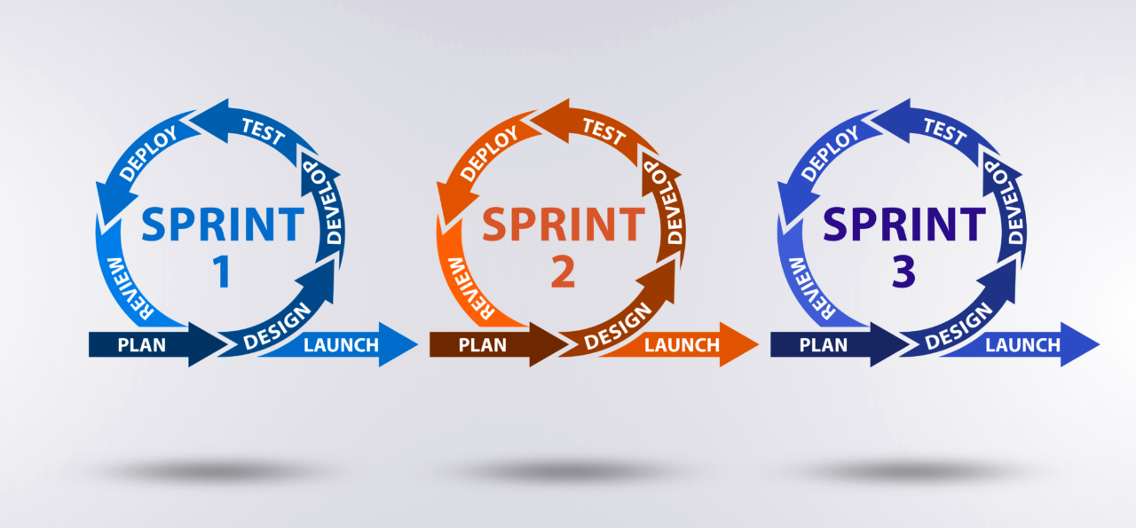
Fig:Agile software Development Model

Criteria-Based Evaluation of Agile Model for Smart Route BD
Criteria | Agile Model Advantage for Smart Route BD
Changing Requirements | Agile supports continuous adaptation as Smart Route BD features may evolve based on commuter feedback, traffic patterns, and transportation network changes.
Small & Cross-functional Team | Scrum enables close collaboration between developers, UI/UX designers, database administrators, and QA testers within focused sprint cycles.
Rapid Prototyping & Feature Testing | Advanced features like real-time traffic integration, GPS tracking, and community verification systems require iterative testing and continuous refinement.
Frequent Feedback from Stakeholders | Commuters, administrators, and bus operators can provide feedback during sprint reviews to improve route accuracy, usability, and system reliability.
Risk Management | Agile helps identify and resolve risks related to API integration failures, data accuracy issues, security vulnerabilities, and performance bottlenecks early in development.
Delivery of MVP | Allows early release of core Smart Route BD features (basic route search and fare calculation) for real-world user testing, validation, and gradual feature expansion.
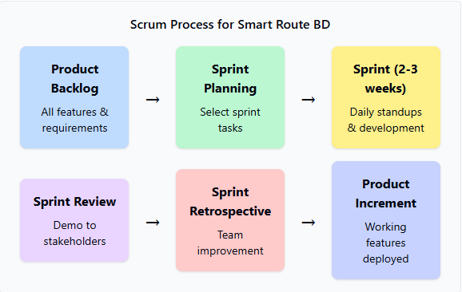

Justification with Evidence
The selection of the Agile model for the Smart Route BD project is justified based on the following comprehensive considerations:

1. Changing Requirements
As Smart Route BD addresses dynamic real-world transportation challenges, feature requirements such as route algorithms, fare calculation models, traffic data integration methods, and user interface designs will evolve continuously. The transportation network itself changes frequently due to new routes, fare adjustments, infrastructure developments, and operational modifications. Agile's iterative approach supports continuous refinement and feature adaptation without disrupting ongoing development workflows or requiring complete project restarts.

2. Team Size and Skills
The development team consists of four cross-functional members (Shafayat Jamil, Anika Tabassum, Radia Hasan Zarin, and Arpa Saha) who bring diverse skills in software development, database management, UI/UX design, and quality assurance. This small, cohesive team can collaborate efficiently using Scrum practices such as daily stand-up meetings, sprint planning sessions, collaborative code reviews, and retrospective improvement discussions, ensuring transparent communication and rapid problem-solving.

3. Time Constraints
Scrum's sprint-based approach (2-3 week cycles) allows the Smart Route BD project to be divided into manageable, time-boxed tasks with clear deliverable milestones. This structured timeline ensures steady development progress, prevents scope creep, maintains team focus, and enables timely delivery of functional increments that can be demonstrated to supervisors and potential users throughout the Fall 2025-2026 academic semester.

4. User Involvement
Agile enables frequent interaction with potential users (commuters, students, tourists, administrators, and bus operators) through sprint reviews, prototype demonstrations, and feedback collection sessions. Regular user involvement ensures that route search algorithms meet real navigation needs, fare calculations reflect actual pricing structures, alert systems provide genuinely useful information, and the overall platform addresses authentic commuter pain points rather than theoretical assumptions.

5. Frequent Testing and Quality Assurance
The iterative nature of Agile ensures continuous testing throughout development cycles, enabling early detection of bugs, performance bottlenecks, security vulnerabilities, and usability issues. Each sprint includes dedicated testing phases where route calculation accuracy, map integration functionality, database query performance, real-time alert delivery, and community reporting mechanisms are systematically validated. This continuous quality assurance approach prevents critical defects from accumulating and ensures faster system improvements based on test results and user feedback.

6. Integration Complexity
Smart Route BD requires integration with multiple external services including mapping APIs (for route visualization), traffic data APIs (for real-time conditions), GPS systems (for location tracking), and potentially government transportation databases. Agile's incremental development approach allows these complex integrations to be implemented, tested, and refined gradually across multiple sprints, reducing integration risks and ensuring each external service connection is thoroughly validated before moving to the next integration challenge.
2. SOFTWARE REQUIREMENTS SPECIFICATIONS (SRS) / PRODUCT REQUIREMENTS DOCUMENT (PRD)

2.1 Scopes and Features

Scope of the System
The Smart Route BD system aims to build a transparent, efficient, and intelligent public transportation navigation platform. It connects commuters, bus operators, administrators, transportation authorities, and external mapping services in one unified digital ecosystem.
The system focuses on:
- Ensuring fare transparency and preventing commuter exploitation
- Providing accurate route information and optimal journey planning
- Delivering real-time traffic updates and disruption alerts
- Enabling community-driven reporting with administrative verification
- Allowing offline access to critical route and fare information
- Supporting multiple user types with role-based functionality
This system improves trust, accessibility, and efficiency in Bangladesh's urban public transportation network, particularly benefiting students, tourists, daily commuters, and unfamiliar travelers navigating complex city routes.
- Key Features
- User Management: Secure registration, login/authentication, and role-based access for commuters, administrators, and bus operators with profile management and saved route preferences
- Route Planning & Navigation: Origin-destination search with multi-route suggestions, accurate fare calculation, travel time estimation, bus stop details, transfer point identification, and step-by-step directions
- Real-Time Information System: Live traffic updates, construction zone alerts, festival/event notifications, route disruption warnings, and alternative route recommendations with GPS integration
- Community Reporting: User-submitted issue reports with photo evidence attachment, fare update submissions, route accuracy ratings, and report status tracking with administrative verification
- Administrative Dashboard: Comprehensive route and fare database management, community report verification system, alert publishing capabilities, user report moderation, and system analytics with usage statistics
- Bus Operator Portal: Schedule and route information management, fare change submissions, service analytics access, and direct communication with system administrators
- Map Integration: Interactive route visualization, GPS location tracking, nearby stop identification, real-time map data synchronization, and integration with external mapping APIs
- Offline Functionality: Cached route maps, stored fare information, saved frequently used routes, and automatic synchronization when internet connectivity returns
- User-Friendly Interface: Bilingual support (Bengali/English), mobile-responsive design, minimal data usage optimization, simple navigation, quick search functionality, and accessibility features
- Future Scope
- AI-Powered Features: Predictive bus arrival times based on historical data, intelligent traffic pattern analysis, optimal route recommendations using machine learning algorithms, and demand forecasting for peak hours
- Service Expansion: Real-time bus tracking with live GPS locations, inter-city bus route integration, multi-modal transport support (rickshaw, CNG, metro rail), and nationwide coverage expansion to all major cities
- Advanced Features: Mobile ticket booking and digital payment integration, QR code-based ticket verification, augmented reality navigation for walking directions, voice-guided turn-by-turn instructions, and personalized commute recommendations
- Enhanced Integration: API partnerships with government transport systems, integration with Bangladesh Road Transport Authority (BRTA) databases, collaboration with city corporations for official route data, and connection with national traffic management systems
- Smart Notifications: Automated disruption detection using traffic sensors, intelligent notification systems based on user preferences and saved routes, real-time bus capacity indicators, crowding alerts for peak hours, and predictive delay warnings
Operational Upgrades: Blockchain-based fare verification for transparency, advanced analytics dashboard for transport authorities, crowd-sourced traffic reporting integration, emergency alert systems for accidents or road hazards, and driver behavior monitoring for safety improvements
2.2. USER STORY TABLE
As A / An | I Want To | So That | Acceptance Criteria
Commuter | Create a user account | I can save routes and receive personalized alerts | OTP is sent to the user's mobile number and a confirmation email is sent
Commuter | Log in using mobile number and password | The system can authenticate me securely | After successful login, commuter dashboard and saved routes are accessible
Commuter | View my profile details | I can see my registration information and preferences | Profile information page is displayed with edit option
Commuter | Update my profile information | My contact details and preferences remain current | Updated information is saved and confirmation message is shown
Commuter | Search for the best route from my location to destination | I can save time and money on my journey | System displays multiple route options with estimated travel time, total fare, and bus stop details sorted by preference
Commuter | View accurate bus fare before starting journey | I can plan my travel budget and avoid overcharging | Fare is calculated automatically based on origin and destination, displayed clearly with no hidden costs
Commuter | Receive real-time alerts about road closures or disruptions | I can avoid delays and choose alternative routes | Push notifications are sent when construction, festivals, or events affect saved or active routes with alternative suggestions
Commuter | Access route information without internet | I can plan my journey in areas with poor network coverage | Previously searched routes, fare information, and bus stop details are cached and accessible offline
Commuter | Report inaccurate route or fare information | The system data remains reliable for all users | Report submission form with photo upload option is displayed and confirmation message is shown
Commuter | View step-by-step directions to destination | I can navigate unfamiliar routes confidently | Turn-by-turn directions with landmarks, boarding and alighting points are provided in Bengali and English
Commuter | Save frequently used routes | I can access them quickly for daily commute | Routes are saved to profile and accessible from dashboard with one-click search
Commuter | Rate route accuracy | I can help improve system data quality | Rating submission is recorded and average rating is displayed
Tourist/Student | Search routes to landmarks and universities | I can reach destinations without local knowledge | Search results show all bus options with stop details and estimated travel time
Tourist/Student | Switch between Bengali and English language | I can use the app in my preferred language | Language toggle option changes all interface text immediately
Bus Operator | Create a bus operator account | I can manage my route information officially | OTP verification and email confirmation are completed

