EXPERIMENT-10
Name: D. Amulya
Roll No: 23481A0550

Aim:To run a Hadoop single node cluster using Docker and execute a simple MapReduce application such as WordCount.

Description:
Hadoop is an open-source framework used for distributed storage and processing of large datasets using HDFS (Hadoop Distributed File System) and the MapReduce programming model. A single node Hadoop cluster means all Hadoop services run on a single machine. Docker containers can be used to quickly deploy Hadoop without installing and configuring it manually.

Prerequisites:
- Docker installed
- Internet connection
- Linux / Ubuntu environment

Procedure:
STEP 1 — Install and Verify Docker
Docker is required to run Hadoop inside a containerized environment. First, ensure Docker is installed on the system.
Check the Docker version using the following command:
docker –version
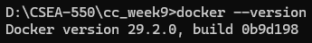

If Docker is not installed, install it using the following commands:
sudo apt update
sudo apt install docker.io

Start the Docker service using:
sudo systemctl start docker
This ensures Docker is active and ready to run containers.
If it doesn’t work or docker desktop is already installed open it by searching in “Start”.
STEP 2 — Pull Hadoop Docker Image
Download the Hadoop Docker image from Docker Hub:
docker pull bde2020/hadoop-base:2.0.0-hadoop3.2.1-java8
This command downloads a preconfigured Hadoop environment.
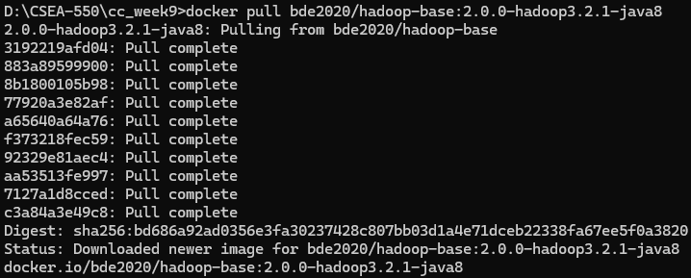
STEP 3 — Run Hadoop Container
Start the Hadoop container using:
docker run -it bde2020/hadoop-base:2.0.0-hadoop3.2.1-java8 bash
This command starts a Docker container and opens a bash terminal inside the container where Hadoop commands can be executed.
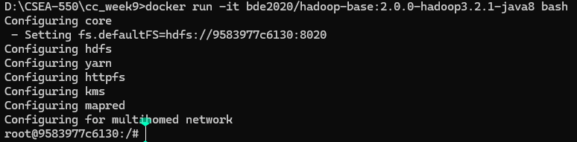
STEP 4 — Verify Hadoop Installation
Check whether Hadoop is installed correctly by running:
hadoop version
If the installation is successful, the Hadoop version details will be displayed on the terminal.
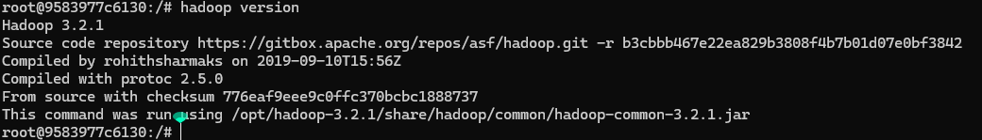
STEP 5 — Create an Input File
Create a sample text file that will be used as input for the WordCount program.
echo "Hello welcome to cloud computing lab hello welcome to docker" > input.txt
This command creates a text file named input.txt containing sample text data.
STEP 6 — Run WordCount MapReduce Program
Execute the WordCount example program included with Hadoop.
hadoop jar $HADOOP_HOME/share/hadoop/mapreduce/hadoop-mapreduce-examples*.jar wordcount file://$(pwd)/input.txt file://$(pwd)/output
This program reads the input file, processes each word, and counts the number of occurrences of each word.
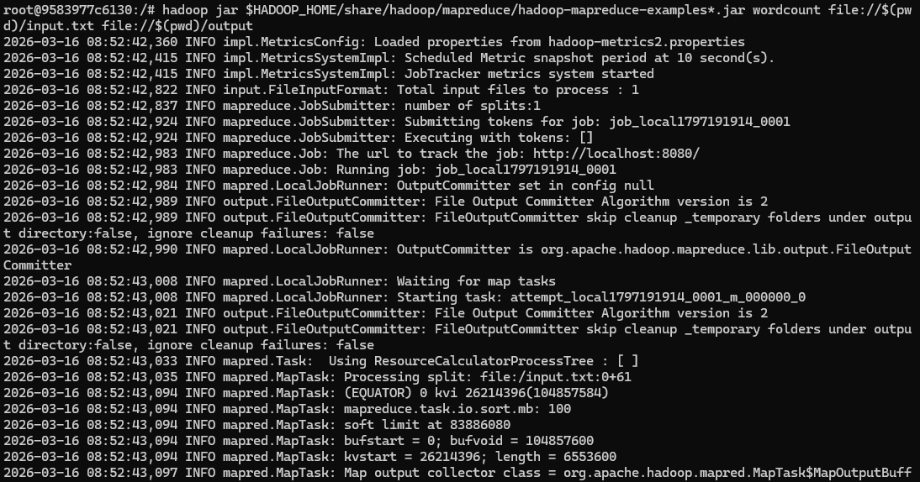
STEP 7 — View Output
Display the output generated by the WordCount program.
cat output/part-r-00000

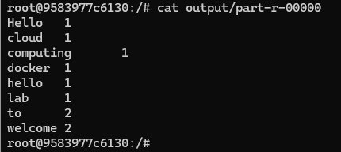

Result:
The Hadoop single node cluster was successfully executed using Docker and the WordCount MapReduce program was run successfully.

