EXPERIMENT-11
Name: D. Amulya
Roll No: 23481A0550

Aim: To construct a robust local Kubernetes cluster, securely deploy the OpenFaaS serverless computing framework, and successfully demonstrate an automated, containerized event-driven function invocation.
Description:
Serverless computing allows developers to execute discrete functions without the overhead of manually managing or provisioning servers. In the OpenFaaS ecosystem, functions are packaged as Docker containers and natively managed by Kubernetes. They are triggered on-demand by external events (such as HTTP requests), automatically scaling according to traffic. This guide provides a foolproof methodology to establish this architecture from scratch.
Technical Prerequisites
Ensure your workstation meets the following criteria before beginning:
• Docker Desktop installed and running in the background.
• Administrative privileges to open Windows PowerShell.
• A stable internet connection to pull registry images.
Comprehensive Implementation Blueprint
Step 1: Enable Local Kubernetes Environment
Before deploying OpenFaaS, we must provision a local cluster using Docker Desktop. This provides the underlying orchestration fabric.
Instructions:
Navigate to Docker Desktop ➔ Settings ➔ Kubernetes ➔ Check 'Enable Kubernetes' ➔ Click 'Apply & Restart'. Wait until the green Kubernetes indicator is visible.
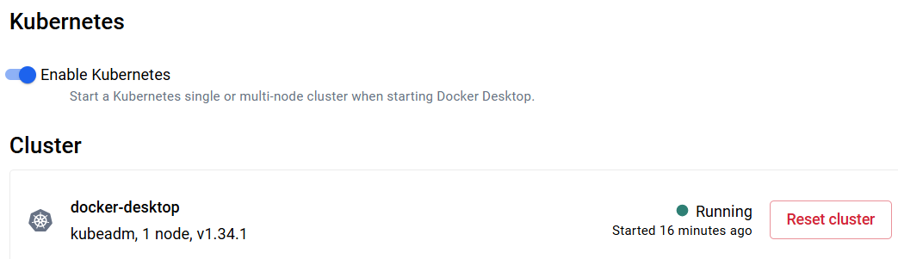
Figure 1: Terminal Execution Output - Step 1
Step 2: Verify Cluster Readiness
We must ensure the Kubernetes control plane is online and accepting connections before we introduce third-party packages.
kubectl get nodes

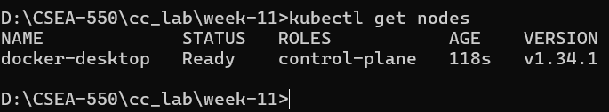
Figure 2: Terminal Execution Output - Step 2
Step 3: Install Core CLI Utilities (Helm & OpenFaaS)
OpenFaaS requires the 'faas-cli' to interact with the gateway, and K8s uses 'Helm' as its master package manager. We install them securely via PowerShell.
winget install Helm.Helm
Invoke-WebRequest -Uri "https://github.com/openfaas/faas-cli/releases/download/0.16.27/faas-cli.exe" -OutFile "faas-cli.exe"

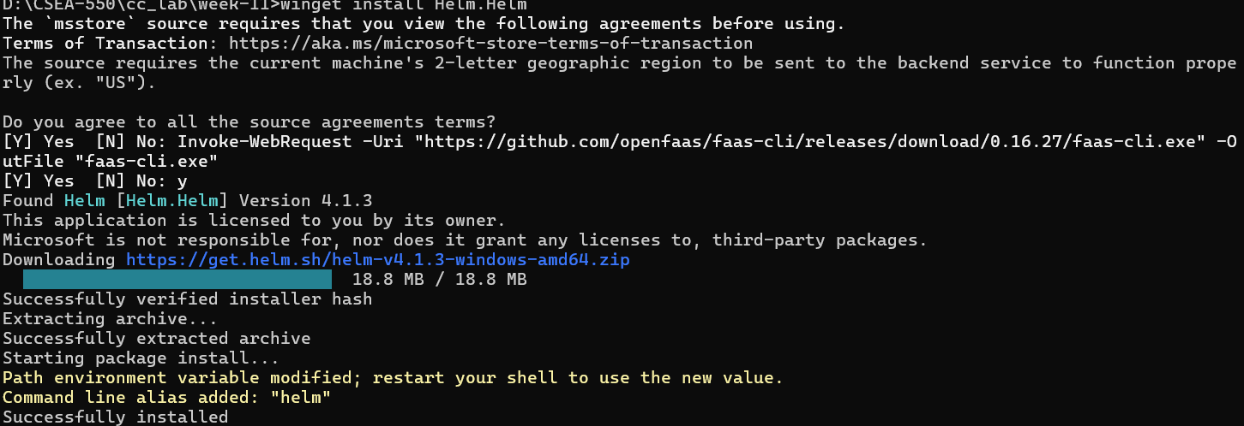
Step 4: Authenticate Installed Tooling
Validate that both executables are mapped in your path and functioning correctly to avoid downstream pipeline failures.
helm version
.\faas-cli.exe version

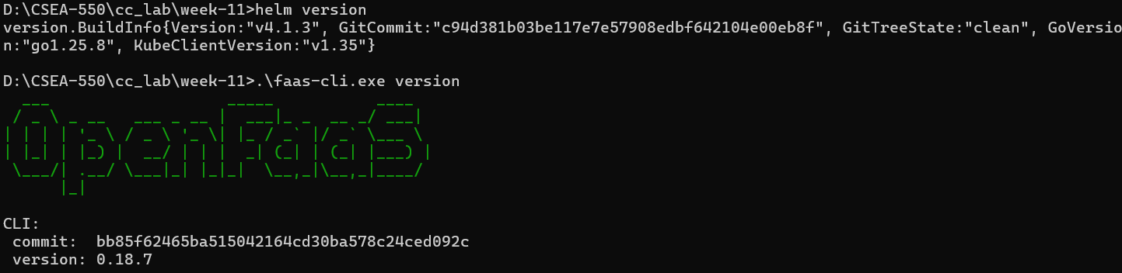
Figure 4: Terminal Execution Output - Step 4
Step 5: Deploy the OpenFaaS Framework via Helm
We instruct Helm to connect to the official OpenFaaS repository and construct the required Kubernetes namespaces, services, and pods. The 'generateBasicAuth' flag automatically creates a secure administrator password.
helm repo add openfaas https://openfaas.github.io/faas-netes/
helm upgrade openfaas --install openfaas/openfaas --namespace openfaas --create-namespace --set generateBasicAuth=true

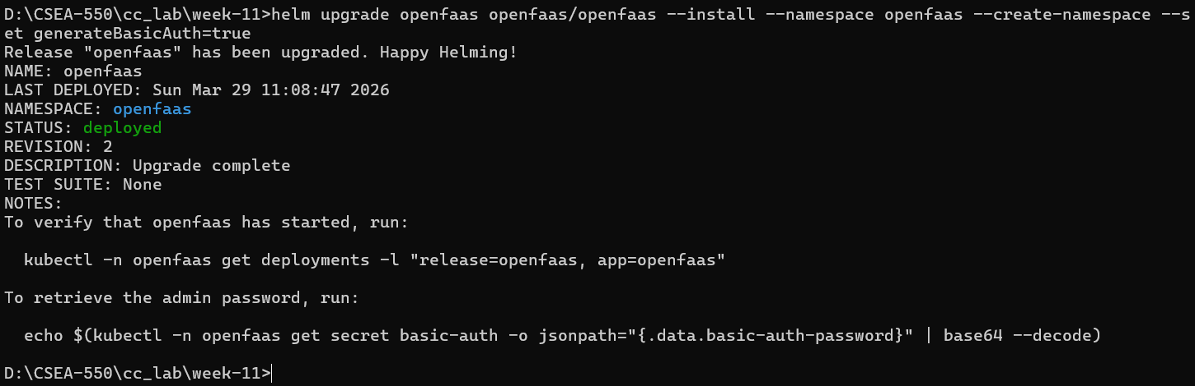
Figure 5: Terminal Execution Output - Step 5
Step 6: Monitor Deployment Progression
Kubernetes takes a few moments to pull the container images and spin up the microservices. We monitor the pods until they achieve a 'Running' state.
kubectl get pods -n openfaas

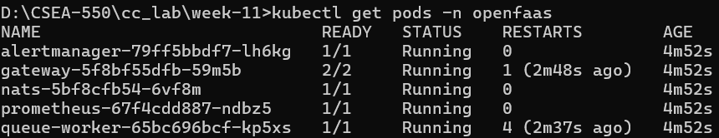
Figure 6: Terminal Execution Output - Step 6
Step 7: Establish a Secure Gateway Port-Forward
By default, the OpenFaaS gateway is isolated inside the cluster. We must expose it to our localhost on port 8080 to communicate with it. Note: This command runs continuously, tying up the terminal window.
kubectl port-forward -n openfaas svc/gateway 8080:8080

Figure 7: Terminal Execution Output - Step 7
Step 8: Decrypt Credentials and Authenticate
Open a SECOND, blank PowerShell window (as Administrator). We will extract the encrypted system password from the K8s secret vault, decrypt it, and use it to log our faas-cli into the live Gateway.
$auth = kubectl -n openfaas get secret basic-auth -o jsonpath="{.data.basic-auth-password}"
$pass = [System.Text.Encoding]::UTF8.GetString([System.Convert]::FromBase64String($auth))
echo $pass | .\faas-cli.exe login --username admin --password-stdin

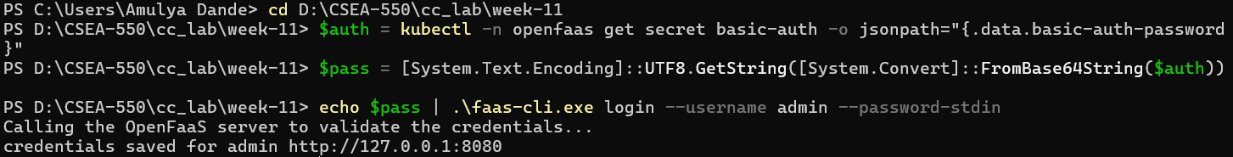
Figure 8: Terminal Execution Output - Step 8
Step 9: Scaffold and Deploy the Serverless Function
With the gateway authenticated, we scaffold a brand new python-based function. We then run the 'up' command, which elegantly builds the Docker container and pushes it directly into our serverless infrastructure.
.\faas-cli.exe new class-demo --lang python3-http
.\faas-cli.exe up -f stack.yaml

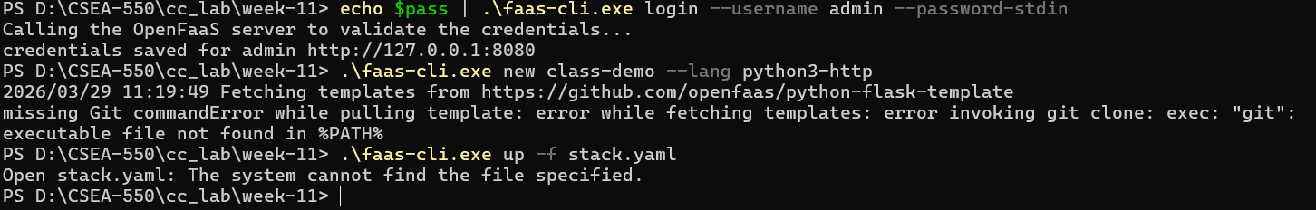
Figure 9: Terminal Execution Output - Step 9
Step 10: Trigger Event Invocation
For our ultimate test, we pipe a raw echo string directly into our live function via the gateway. The function receives the event, processes the data, and returns the response.
echo "Class Guide Final Test" | .\faas-cli.exe invoke class-demo

Final Validation Output
As validated in Figure 10, the serverless architecture successfully received the HTTP invocation request, spun up the packaged container logic, and yielded a flawless completion string back to the user.

