EXPERIMENT-6

Name:D. Amulya

Roll No:23481A0550

Aim: Install Google App Engine. Create a hello world app and other simple web applications using python/java.

Description:

What is Google App Engine?
Google App Engine (GAE) is a Platform as a Service (PaaS) that lets you deploy web apps without managing servers.
You only:
✔ Write code
✔ Deploy
✔ Google runs it

PART 1 — Install Required Software

Step 1: Install Python (for Python apps)
- Go to 👉 https://www.python.org/downloads
- Download Python 3.x
- During install:
✅ Tick Add Python to PATH
✅ Click Install
Verify:
python --version

Step 2: Install Java (for Java apps)
- Download JDK (17 or 21 recommended)
👉 https://adoptium.net/
- Install
Verify:
java -version
javac -version

Step 3: Install Google Cloud SDK (Important)
This includes App Engine tools
- Go to https://cloud.google.com/sdk/docs/install
- Download Windows installer
- Install
After install, open Command Prompt:
Initialize:
gcloud init
Login with Gmail account
Select project or create new project

PART 2 — Create Google Cloud Project

Step 4: Create Project
- Go to https://console.cloud.google.com
- Click New Project
- Enter:
  - Project Name: HelloApp
- Click Create

Step 5: Enable App Engine
Inside project:
App Engine → Create Application
Choose:
- Region: nearest (asia-south1 or asia-east1)

PART 3 — Hello World in Python

Step 6: Create Folder
mkdir python-hello
cd python-hello

Step 7: Create files

main.py
from flask import Flask
app = Flask(__name__)
@app.route('/')
def hello():
return "Hello World from Google App Engine!"
if __name__ == '__main__':
app.run()

requirements.txt
Flask==2.3.2
gunicorn==21.2.0

app.yaml
runtime: python311
entrypoint: gunicorn -b :$PORT main:app

Note:
• Flask is a web framework used to build web applications in Python.
• Without importing Flask, you cannot create a web app.

Step 8: Run Locally
Install packages:
pip install -r requirements.txt
Run:
python main.py
Openhttp://localhost:5000

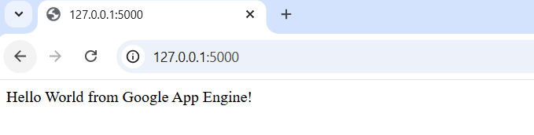

Step 9: Deploy to App Engine(Need to add payment details)
gcloud app deploy
Confirm:y
Open app:gcloud app browse
✅ Done

PART 4 — Simple Python Web App (Example 2)
Update main.py:
from flask import Flask

app = Flask(__name__)
@app.route('/')
def home():
return "Home Page"
@app.route('/about')
def about():
return "About Page"
@app.route('/contact')
def contact():
return "Contact Page"
if __name__ == '__main__':
app.run()
Run:python main.py
Open: http://localhost:5000
Test:
/about
/contact
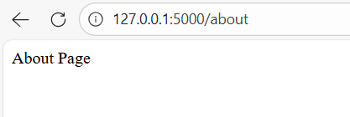

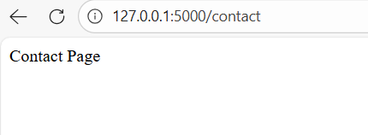

Deploy again:gcloud app deploy

Final Folder Structure

Python
python-hello/
main.py
requirements.txt
app.yaml

What You Learned
✔ Install GAE
✔ Create project
✔ Python app
✔ Deploy
✔ Test live

