EXPERIMENT-7

Name : D. Amulya

Roll No: 23481A0550

Aim: To create and run a Docker container on Windows, install a web server inside it, and map a Windows host directory as a data volume so that changes in host files reflect inside the container.

Objectives
- Install Docker Desktop on Windows
- Run Docker container
- Configure Apache / Flask web server
- Map Windows folder to container
- Access web page through browser

Requirements

Hardware
- Windows 10/11 (64-bit)
- Minimum 4GB RAM (8GB recommended)

Software
- Docker Desktop
- WSL2 enabled
- Internet connection
- Chrome / Edge browser
- PowerShell

Theory
• Docker is a containerization platform used to run applications in isolated environments called containers.
• Docker packages an application along with its dependencies so that it can run consistently on different systems.
• Volume mapping in Docker allows files to be shared between the host system and the container.
• Files created on the host machine (Windows) can also be accessed inside the container.
• Any changes made to the files are reflected immediately in both the host and the container without restarting the container.
Syntax:
docker run -v <host_path>:<container_path>

Procedure

Step 1: Install Docker Desktop
- Download Docker Desktop:
https://www.docker.com/products/docker-desktop/
- Install with:
✔ Use WSL 2 instead of Hyper-V
- Restart system
- Open Docker Desktop and wait until it shows Docker Engine Running

Verify Installation
Open PowerShell:
docker --version
docker run hello-world
Output: Docker installed successfully.
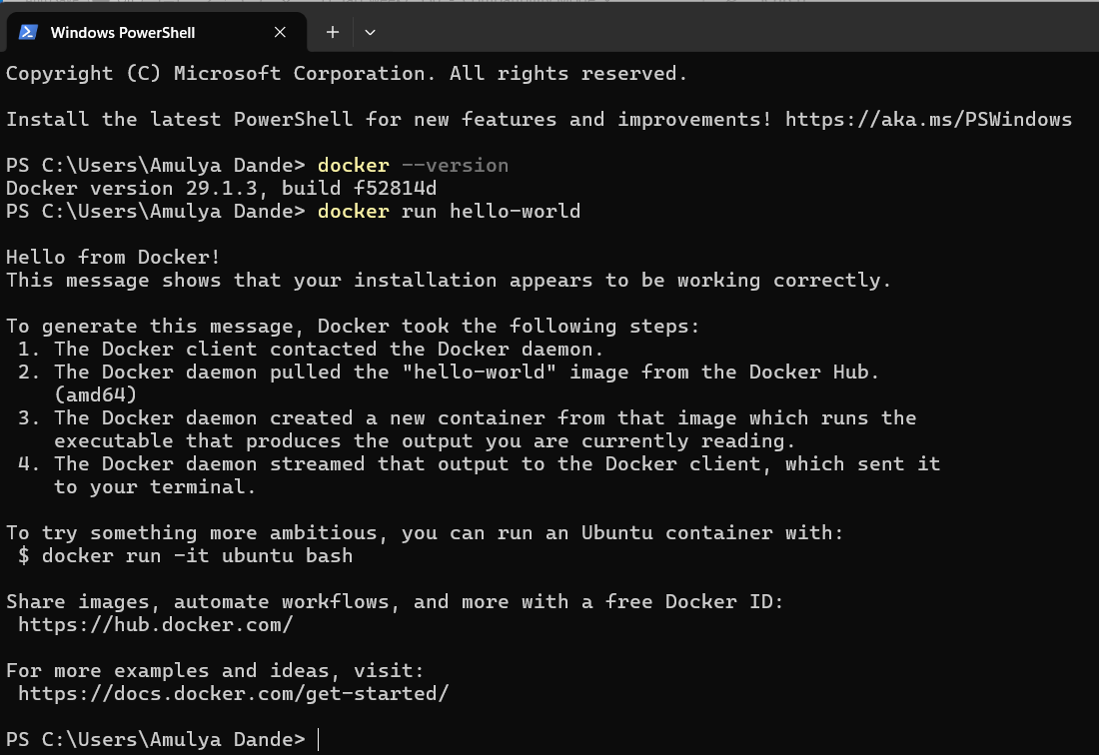

Step 2: Create Project Folder (Host Machine)
Open PowerShell:
mkdir D:\CSEA-550\cc_lab\EXP-7 \docker-web
cd D:\CSEA-550\cc_lab\EXP-7 \docker-web
mkdir website
Create webpage:
notepad website\index.html
Paste:
<html>
<head>
<title>Docker Web Server</title>
</head>
<body>
<h1>Welcome To CC Lab </h1>
</body>
</html>
Save file.

Method 1 — Apache Web Server Container

Step 3: Pull Apache Image
docker pull httpd
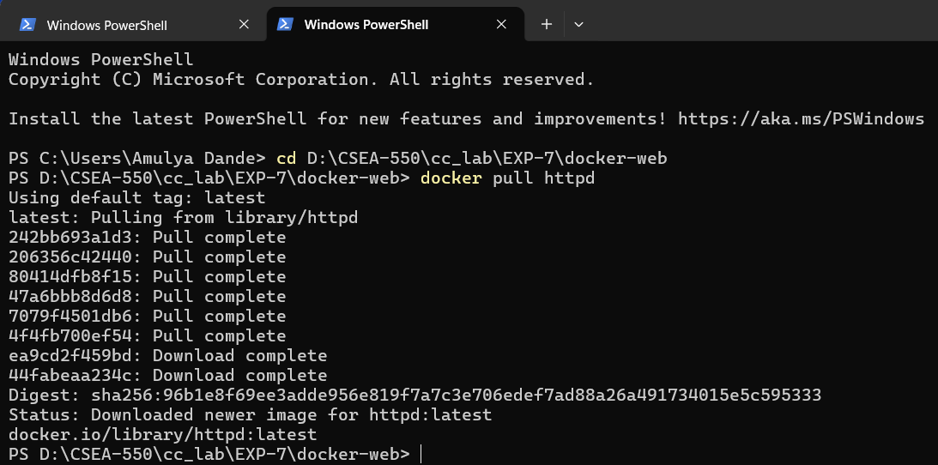

Step 4: Run Container with Volume Mapping

docker run -dit `

-p 5000:80 `

-v D:\CSEA-550\cc_lab\EXP-7\docker-web\website:/usr/local/apache2/htdocs `

--name apache-server httpd

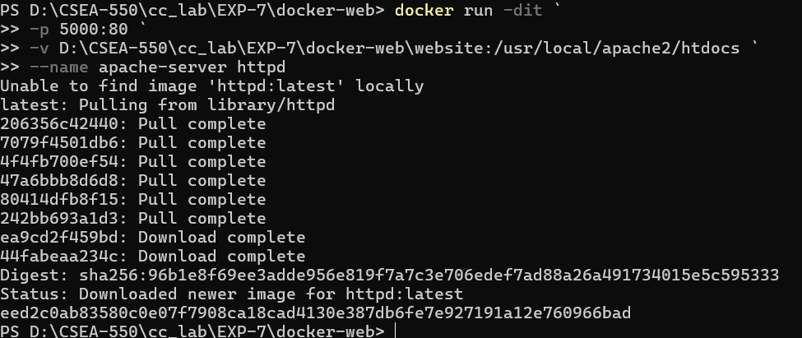

Explanation
- -d → background mode
- -p → port mapping
- -v → share Windows folder to container

Step 5: Verify Container
docker ps

Step 6: Access Webpage
Open browser:
http://localhost:5000
Output: Your HTML page is displayed.


Method 2 — Flask Web Server Container

Step 1: Create Flask Program
notepad app.py
Paste:
from flask import Flask
app = Flask(__name__)
@app.route('/')
def home():
return "Welcome To CC Lab"
app.run(host='0.0.0.0', port=8000)

Step 2: Create Dockerfile
notepad “Dockerfile”
Paste: FROM python:3.9
WORKDIR /app
COPY . .
RUN pip install flask
CMD ["python","app.py"]

Step 3: Build Image
docker build -t flask-server .

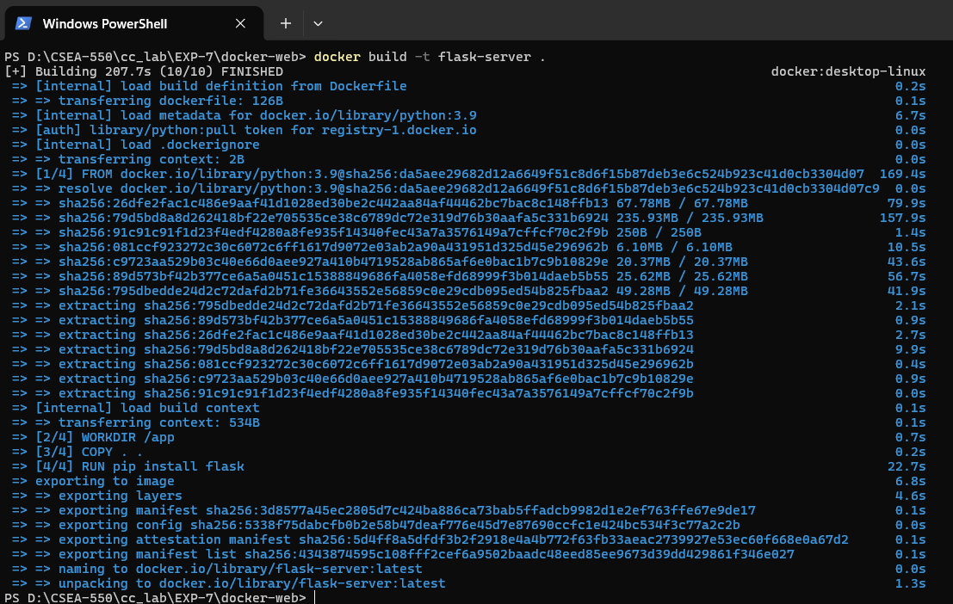

Step 4: Run Container
docker run -d `
-p 8000:8000 `
-v D:\CSEA-550\cc_lab\EXP-7\docker-web:/app `
--name flask-container flask-server

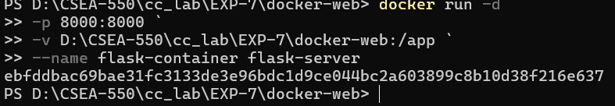

Step 5: Access Flask Page
http://localhost:8000
Output: Flask Server Running Inside Docker (Windows)
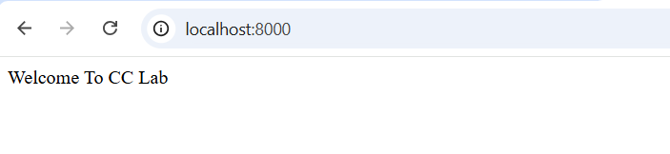

Testing Volume Mapping
Edit file in Windows:
notepad D:\cc_lab\week7\docker-web\website\index.html
Change text → Save → Refresh browser
Changes appear immediately
(No container restart required)


Stop and Remove Container
Stop:docker stop apache-server
Remove:docker rm apache-server
Remove image:docker rmi httpd
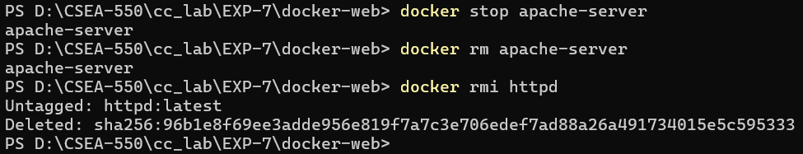

Result
Successfully created and executed a Docker container on Windows, installed a web server, and mapped host directory as a data volume. The webpage updated dynamically using volume mapping.

