EXPERIMENT-8
Name: D. Amulya
Roll No: 23481A0550
Aim:Find a procedure to transfer the files from one virtual machine to another virtual machine. Similarly, from one container to another container.

Description:
✅ VM → VM (Virtual Machine to Virtual Machine)
✅ Container → Container (Docker container to container)

PART 1 — File Transfer Between Two Virtual Machines
Transfer a file from VM-1 to VM-2 over a network.

🧩 Prerequisites
You must have:
- Two Virtual Machines (Linux/Ubuntu recommended)
- Both VMs running
- Network connectivity between VMs
- SSH installed
Example:
VM1 IP → 10.0.2.15
VM2 IP → 10.0.2.3

STEP 1 — Start Both Virtual Machines
- Open VirtualBox / VMware.
- Start VM1 and VM2.
- Login to both systems.
- And check the ip addresses by using following command

ifconfig
- To update or install system by
sudo apt install
- To install network tools by

sudo apt install net-tools

STEP 2 — Check Network Connectivity
On VM1, ping VM2:
ping 10.0.2.3
If replies appear ✅ connection successful.
If not:
- Set network adapter to NAT Network.

STEP 3 — Install SSH Server (on VM2)
SSH allows secure file transfer.
On VM2:

sudo apt install openssh-server

Enable SSH:
sudo systemctl enable ssh
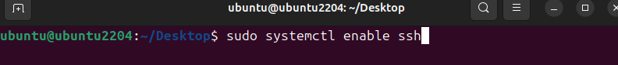
Start SSH:
sudo systemctl start ssh
Check status:
sudo systemctl status ssh
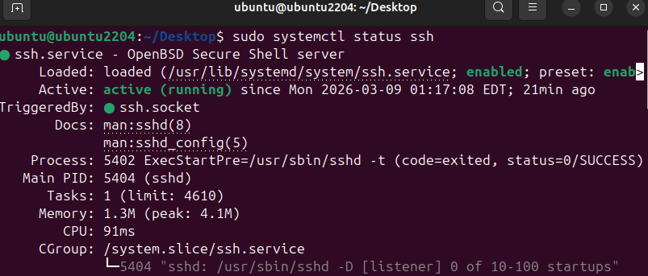

STEP 4 — Create a File in VM1
On VM1:
echo "this is a file from vm1 kali os" > file1.txt

STEP 5 — Transfer File Using SCP
Use scp (secure copy) command.
Syntax:
scp filename username@destinationIP:path
Example:
scp file1.txt ubuntu@10.0.2.15:/home/ubuntu/Desktop
Enter VM2 password when prompted.
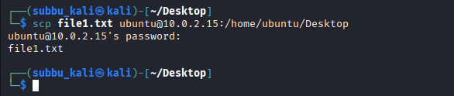

We can also transfer multiple file also like following command
$scp abc.txt file2.txt ubuntu@10.0.2.15:/home/ubuntu/Desktop
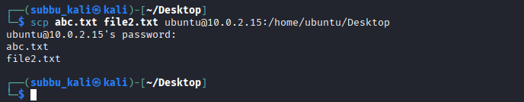

STEP 6 — Verify File on VM2
Login to VM2:
ls
You should see:
abc.txt file1.txt file2.txt
Check content:
cat file1.txt
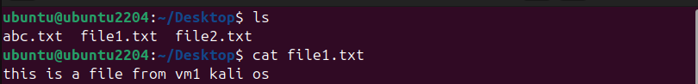
✅ File successfully transferred.

⭐ Alternative Methods (VM → VM)
You can also use:
Method | Command
Rsync | rsync -av file user@IP:/path
FTP | vsftpd server
Shared Folder | VirtualBox shared folder
NFS | Network File System

PART 2 — File Transfer Between Two Docker Containers

Goal
Transfer a file from Container1 → Container2.

🧩 Prerequisites
- Docker installed
- Two running containers
Check Docker:
docker --version

STEP 1 — Create Containers
Create container 1:
docker run -dit --name container-1 ubuntu
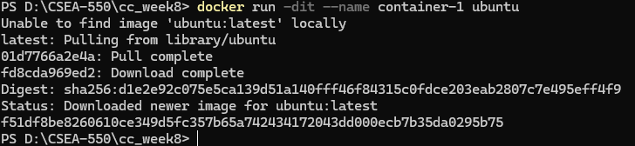
Create container 2:
docker run -dit --name container-2 ubuntu
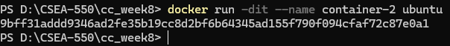

STEP 2 — Create File Inside Container1
Enter container:
docker exec -it container-1 bash
Create file:
echo "Hello from Container1" > data.txt
exit
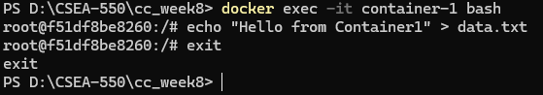

STEP 3 — Copy File from Container1 → Host
Docker containers cannot directly copy files easily without networking or volumes.
Copy to host machine:
docker cp cont1:/data.txt .
Now file exists on host system.
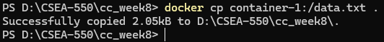

STEP 4 — Copy File from Host → Container2
docker cp data.txt container-2:/data.txt
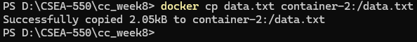

STEP 5 — Verify Inside Container2
Enter container:
docker exec -it container-2 bash
Check file:
cat data.txt
✅ Transfer successful.
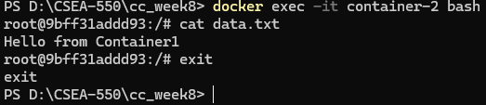

⭐ Direct Container-to-Container Method (Using Shared Volume)

STEP 1 — Create Volume
docker volume create shared_volume

STEP 2 — Run Containers with Same Volume
docker run -dit --name container-1 -v shared_volume:/shared ubuntu
docker run -dit --name container-2 -v shared_volume:/shared ubuntu

Note: in case any error stop and remove it by following commands:
docker stop cont1
docker rm cont1
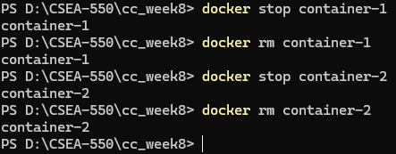

STEP 3 — Create File in Container1
docker exec -it container-1 bash
echo "Shared File" > /shared/test.txt
exit
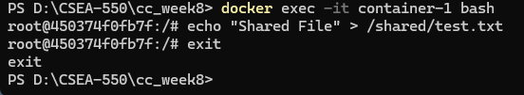

STEP 4 — Access in Container2
docker exec -it container-2 bash
cat /shared/test.txt
✅ Both containers share the file instantly.
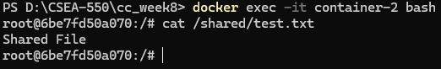
Inside Docker Desktop application:
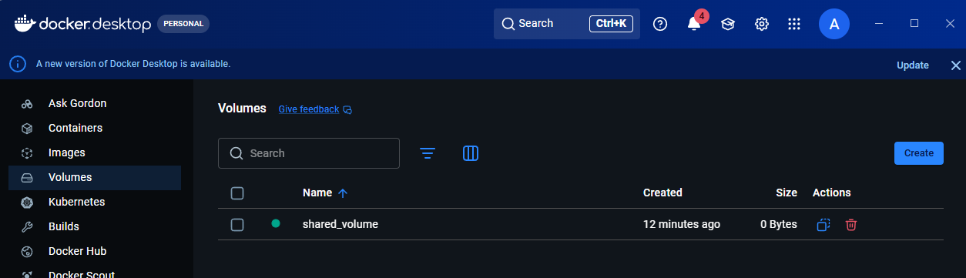

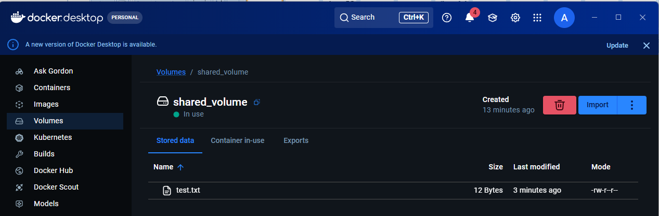

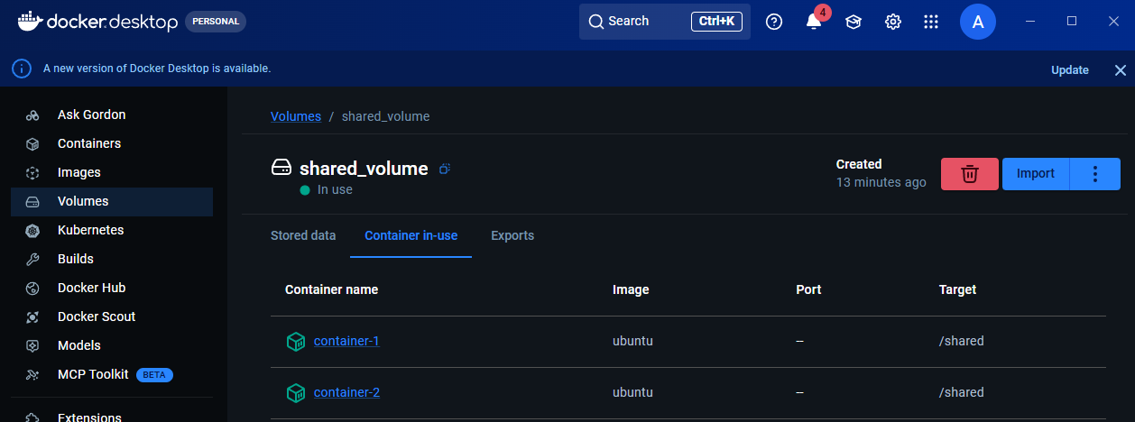

🔥 VM vs Container File Transfer (Quick Comparison)
Feature | VM Transfer | Container Transfer
Network Needed | Yes | Optional
Tool Used | SCP / SSH | docker cp / volumes
Speed | Medium | Fast
Isolation | Full OS | Lightweight
Best Method | SCP | Shared Volume

Final Workflow:

VM → VM
Start VMs
↓
Check network
↓
Install SSH
↓
Use SCP command
↓
Verify file

Container → Container
Create containers
↓
Create file
↓
docker cp OR shared volume
↓
Verify transfer

