Week 5:
Aim: To Create an Amazon EC2/OpenStack instance and set up a web-server on the instance and associate an IP address with the instance. In the process, create a security group allowing access to port 80 on the instance.
Description:

Why Amazon EC2?
Amazon Elastic Compute Cloud (Amazon EC2) is a web service that provides secure, resizable compute capacity in the cloud. Amazon EC2 offers many options that help you build and run virtually any application. With these possibilities, getting started with EC2 is quick and easy to do. This page provides you with the resources to get you started with EC2 instances.
- To create an AWS account for EC2, visit the AWS homepage, sign up with your email, provide contact/payment info (for verification, you get free tier credits), verify your phone, choose a support plan, and complete registration, after which you can sign into the AWS Management Console and launch an EC2 instance from the Compute section
Part 1: Create Your AWS Account
- Go to the AWS Website: Open your browser and go to https://aws.amazon.com/ (or aws. amazon.com/free/ for details on the free tier).
- Start Sign-Up: Click the "Create an AWS Account" button.
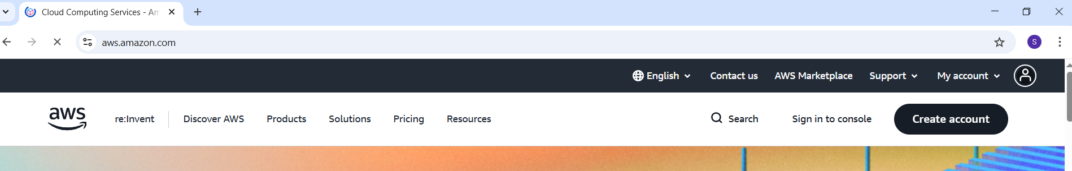
- Enter Account Info: Provide your root user email address and an account name.
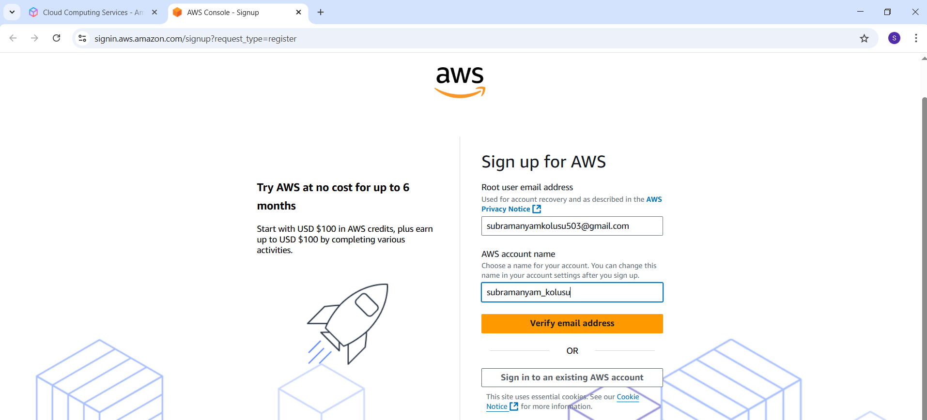
- Verify Email: Enter the verification code sent to your email.
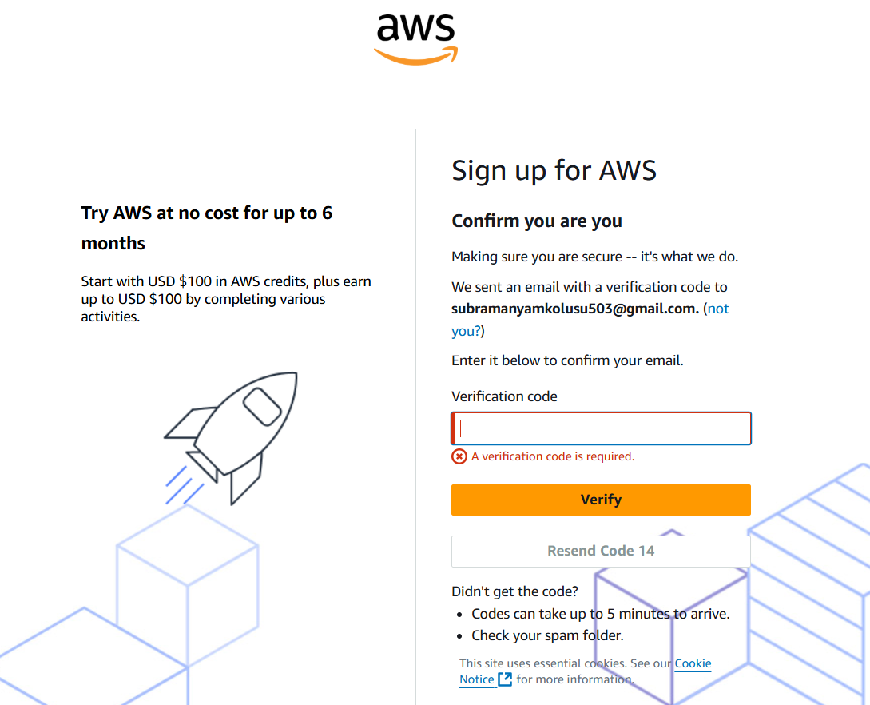
- Set Password: Create a strong password for your root user and continue.
- Contact Information: Select "Personal" or "Business" and fill in your contact details.
- Payment Method: Enter credit/debit card details (used for verification, but you get free tier usage).
- Verify Phone: Enter your phone number and complete the automated call/SMS verification.
- Choose Support Plan: Select a support plan (Basic Support is free).
- Complete Sign Up: Click "Complete sign up" and wait for your account to activate (check your email).

Part 2: Launch Your First EC2 Instance (Once Account is Active)

Create EC2 Instance in AWS (Amazon)
Launching an EC2 instance in AWS allows you to set up a virtual server in the cloud within minutes. This virtual server can host your web apps, run software, or perform automated tasks all without needing a physical machine.
Here, you will learn how to create and configure an Amazon EC2 instance, exploring essential settings like OS selection, instance type, storage, networking, and security. By the end, you will be able to launch and connect to a secure, scalable cloud server.

Steps to Create EC2 Instance in AWS (Amazon)
Follow the below steps to create an EC2 instance in AWS (Amazon):

Step 1: Login and Navigate to EC2 Dashboard
- Log in to your AWS Management Console.
- From the Services menu, choose EC2 under the Compute section.
- Under Resources, click Instances (Running) to view running instances (if any).
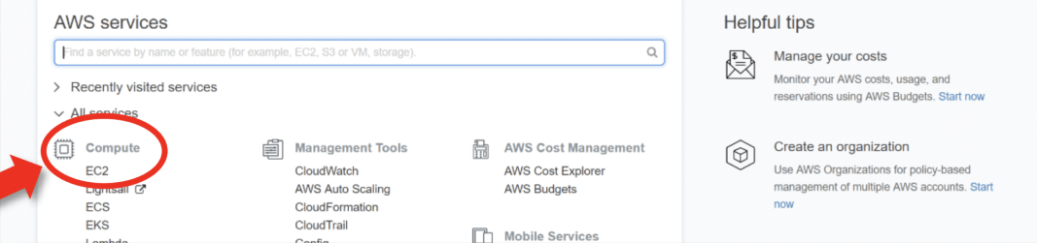
Under Resources >> Click on "Instances running" -- It will show if any EC2 instances are running or not.

Step 2: Launch a New Instance
- Click Launch Instance.
- On the "Launch an Instance" page, enter a name for your instance (e.g., my-first-ec2- server).
- You'll now configure your server settings.
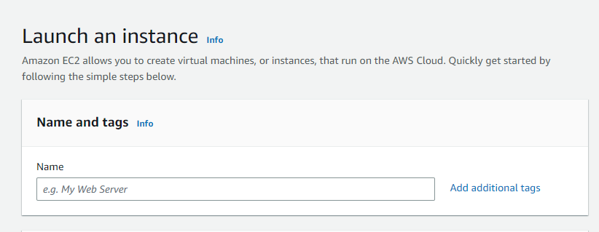Naming instance

Step 3: Choose Amazon Machine Image
- Select an Amazon Machine Image (AMI), which is the OS for your server.
- For beginners, choose Amazon Linux 2, Ubuntu, or Windows, depending on your needs.
- AMIs come preconfigured with OS and some software like templates.
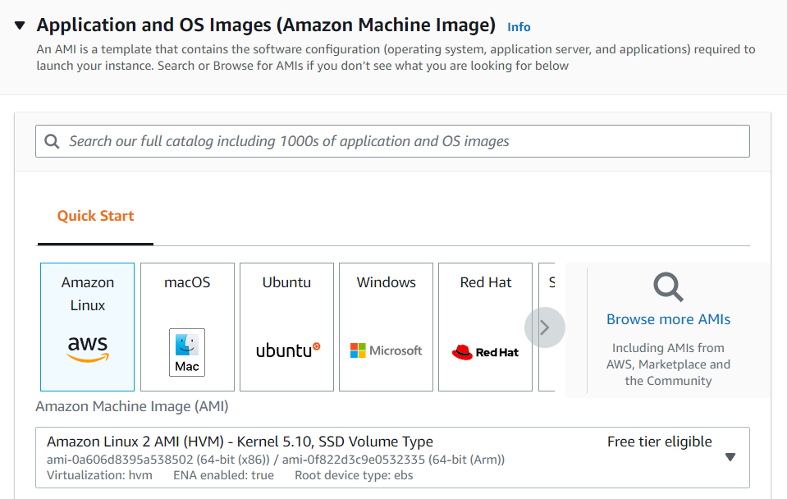Selecting AMI

Step 4: Select Instance Type
- Select the instance type (defines CPU and memory).
- For Free Tier, choose t2.micro — 1 vCPU and 1 GB RAM.
- Avoid selecting higher types like t2.small, t3.medium, etc., unless needed, as they may incur charges.

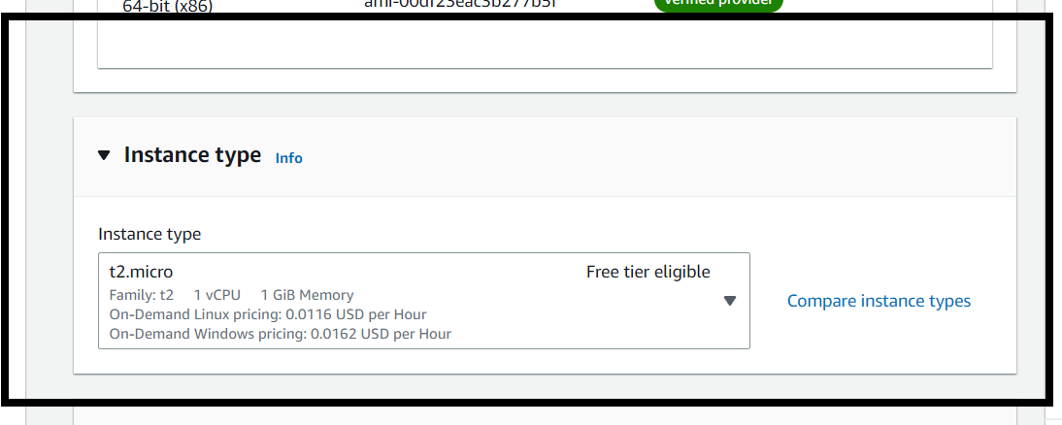Select instance type

Step 5: Configure Key Pair
1. EC2 instances use SSH key pairs for secure access.
2. Click Create new key pair:
- Enter a name.
- Choose file format: .pem for Linux/macOS or .ppk for Windows (for PuTTY).
- Download the key file and save it securely (you won’t be able to download it again).
3. Select the created key pair from the dropdown.
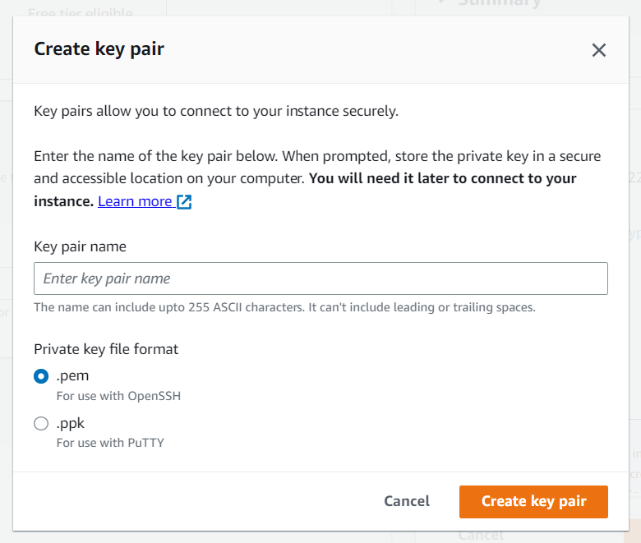Creating key pair

Step 6: Network and Storage Configuration
1. Network Settings: Use the default VPC and subnet unless you have specific networking needs.
2. Firewall (Security Group): Allow SSH (port 22) for Linux or RDP (port 3389) for Windows.
3. Storage Settings:
- Free Tier allows up to 30 GB of General Purpose SSD (gp2).
- Keep default (8 GB) or increase as needed.
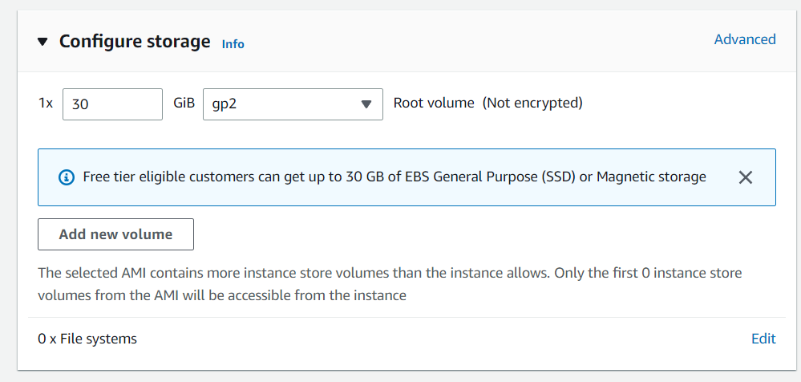

Step 7: Review and Launch
- Review all configurations to ensure they are Free Tier eligible.
- Click Launch Instance.
- You will see a confirmation page. Click View Instances to see your new server being initialized.
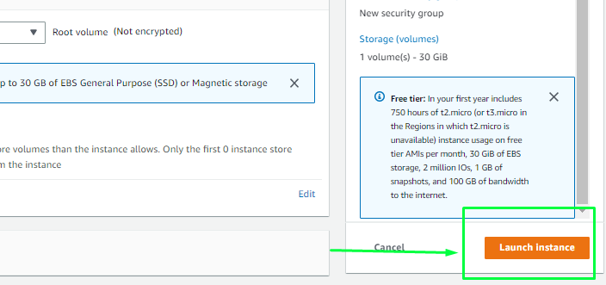

PART 3: Associate Public IP Address

Step 1: Get Public IPv4 Address
- Select the instance
- Copy Public IPv4 address
- Example: 13.xxx.xxx.xxx
📌 This IP is used to access the web server.

PART 4: Connect to EC2 Using PuTTY (Windows)

Step 2: Convert PEM to PPK
- Open PuTTYgen
- Click Load
- Select .pem file
- Click Save private key
- Save as .ppk

Step 3: Login Using PuTTY
- Open PuTTY
- Host Name:
- ec2-user@Public-IP
- Port: 22
- Go to:
- Connection → SSH → Auth → Credentials
- Browse and select .ppk
- Click Open
✅ You are now logged into the EC2 instance.

PART 5: Install and Start Web Server

Step 4: Update System
sudo yum update -y

Step 5: Install Apache Web Server
sudo yum install httpd -y

Step 6: Start Apache Service
sudo systemctl start httpd
sudo systemctl enable httpd

Step 7: Create Web Page
sudo nano /var/www/html/index.html
Add content:
<h1>Welcome to EC2 Web Server</h1>
Save and exit.

PART 6: Access Web Server via Browser (Windows)

Step 8: Open Browser
- Open Chrome / Edge
- Enter:
http://Public-IP
- Output:
Welcome to EC2 Web Server
🎉 Web server is running successfully!

