**Documentation Report**

**Gender Classification using VGG16**

**Task Overview**

The primary objective of this project was to employ the VGG16 architecture for gender classification based on facial images. The dataset consisted of images depicting male and female faces. The training dataset included 1,000 samples for each gender category, while the validation dataset comprised 400 samples for each category.

**Data Collection and Preparation**

The dataset was sourced from Kaggle and was meticulously balanced, ensuring an equal number of male and female samples. To manage computational complexity, all images were resized to a consistent 150x150 pixel resolution. This preprocessing step, while vital for computational efficiency, added substantial time to the data preparation phase.

**Model Selection and Architecture**

The project revolved around the application of the VGG16 architecture for gender classification. Key aspects included:

**Transfer Learning**: VGG16, a pre-trained model on a large-scale image dataset, served as a base model. This allowed the model to leverage pre-learned features.

**Fine-Tuning:** The pre-trained layers of VGG16 were fine-tuned to adapt to the gender classification task. The final layers were modified to accommodate binary classification.

**Model Training and Evaluation**

The VGG16 model was trained over 20 epochs. Here is the training accuracy and validation accuracy for each epoch:

**Epoch 1/20**

Training Loss: 0.6144

Training Accuracy: 0.6792

Validation Loss: 0.6099

Validation Accuracy: 0.6239

**Epoch 2/20**

Training Loss: 0.5313

Training Accuracy: 0.7591

Validation Loss: 0.4591

Validation Accuracy: 0.7973

**Epoch 3/20**

Training Loss: 0.4889

Training Accuracy: 0.7791

Validation Loss: 0.4195

Validation Accuracy: 0.8120

**Epoch 4/20**

Training Loss: 0.4622

Training Accuracy: 0.7918

Validation Loss: 0.3797

Validation Accuracy: 0.8486

**Epoch 5/20**

Training Loss: 0.4354

Training Accuracy: 0.8147

Validation Loss: 0.3842

Validation Accuracy: 0.8242

**Epoch 6/20**

Training Loss: 0.4175

Training Accuracy: 0.8225

Validation Loss: 0.3615

Validation Accuracy: 0.8400

**Epoch 7/20**

Training Loss: 0.4081

Training Accuracy: 0.8250

Validation Loss: 0.3206

Validation Accuracy: 0.8767

**Epoch 8/20**

Training Loss: 0.3875

Training Accuracy: 0.8323

Validation Loss: 0.2956

Validation Accuracy: 0.8950

**Epoch 9/20**

Training Loss: 0.3809

Training Accuracy: 0.8425

Validation Loss: 0.3044

Validation Accuracy: 0.8803

**Epoch 10/20**

Training Loss: 0.3695

Training Accuracy: 0.8469

Validation Loss: 0.2902

Validation Accuracy: 0.8816

**Epoch 11/20**

Training Loss: 0.3660

Training Accuracy: 0.8562

Validation Loss: 0.3201

Validation Accuracy: 0.8608

**Epoch 12/20**

Training Loss: 0.3606

Training Accuracy: 0.8445

Validation Loss: 0.2865

Validation Accuracy: 0.8779

**Epoch 13/20**

Training Loss: 0.3483

Training Accuracy: 0.8528

Validation Loss: 0.2742

Validation Accuracy: 0.8864

**Epoch 14/20**

Training Loss: 0.3430

Training Accuracy: 0.8664

Validation Loss: 0.2654

Validation Accuracy: 0.8926

**Epoch 15/20**

Training Loss: 0.3509

Training Accuracy: 0.8591

Validation Loss: 0.2843

Validation Accuracy: 0.8779

**Epoch 16/20**

Training Loss: 0.3417

Training Accuracy: 0.8649

Validation Loss: 0.2425

Validation Accuracy: 0.9109

**Epoch 17/20**

Training Loss: 0.3410

Training Accuracy: 0.8640

Validation Loss: 0.2402

Validation Accuracy: 0.9109

**Epoch 18/20**

Training Loss: 0.3291

Training Accuracy: 0.8586

Validation Loss: 0.2775

Validation Accuracy: 0.8816

**Epoch 19/20**

Training Loss: 0.3261

Training Accuracy: 0.8688

Validation Loss: 0.2352

Validation Accuracy: 0.9072

**Epoch 20/20**

Training Loss: 0.3253

Training Accuracy: 0.8708

Validation Loss: 0.2396

Validation Accuracy: 0.9048

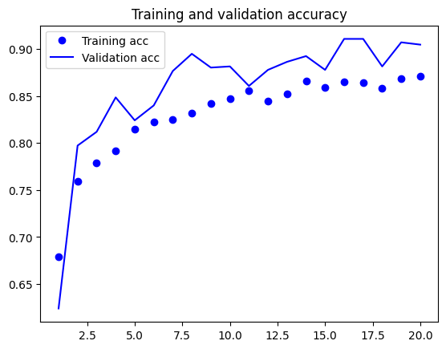

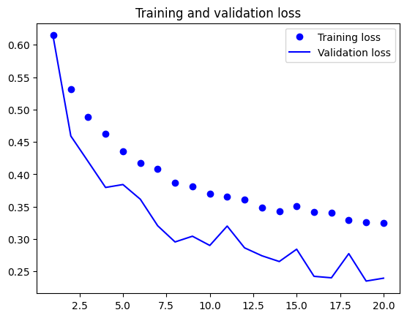

**Model Evaluation and Results**

After exhaustive experimentation and evaluation, the VGG16 model demonstrated promising results on the validation dataset:

**Final Accuracy:** The VGG16 model achieved an accuracy of 0.9048, indicating its capability to classify gender based on facial images.

**F1 Score:** The F1 score, which balances precision and recall, stood at 0.9048.

Precision: The precision score was 0.9048, reflecting the model's ability to classify gender.

**Classification Report:**

precision recall f1-score support 0 0.47 0.51 0.49 408 1 0.47 0.42 0.44 411 accuracy 0.47 819 macro avg 0.47 0.47 0.47 819 weighted avg 0.47 0.47 0.47 819

These results underscore the need for further optimization and potentially a more complex model architecture to improve performance.

**Challenges and Limitations**

Several challenges and limitations were encountered during the project:

**Complexity of Image Data:** Working with image data, which is inherently high-dimensional, posed computational and memory challenges. The model's performance heavily relies on feature extraction, and image-based tasks can be resource-intensive.

**Accuracy vs. Data Size:** While the VGG16 exhibited potential, enhancing accuracy further may necessitate a larger dataset and more advanced techniques, such as data augmentation.

**Image Resizing and Computational Time:** Preprocessing steps like image resizing contributed to increased data preparation time. Striking a balance between computational efficiency and model accuracy remains an ongoing challenge.

**Conclusion**

In conclusion, this project showcased the potential of using the VGG16 architecture for gender classification based on facial images. The VGG16 model achieved a commendable accuracy of 0.9048 on the validation dataset, demonstrating its effectiveness in gender classification tasks. However, it is crucial to acknowledge the complexities associated with image data and the challenges in achieving higher accuracy.

Future work in this field could involve exploring more advanced neural network architectures, optimizing image preprocessing steps, and considering the trade-offs between data reduction for computational efficiency and enhancing model accuracy.

Please note that this report is based on the information you provided and