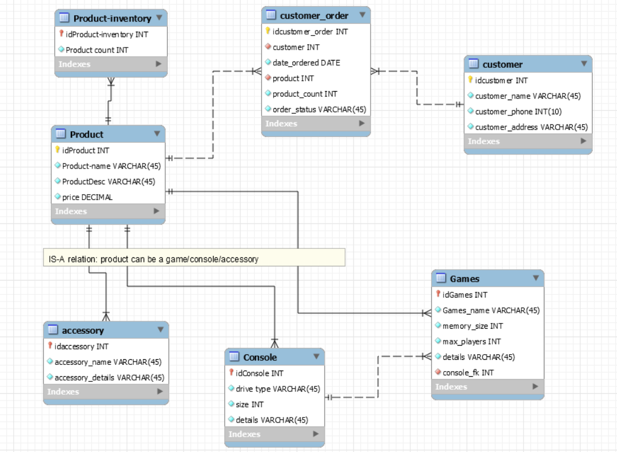

**There is an IS-A relationship (specialization) between products and the three entities(accessory, console, games)**

**Online Game Store Database:**

**Purpose:**

The objective of this application is to maintain records of the different products in the Video Game store as an inventory system, the records of the customers of the store and keeping track of their order history including the order status. Thus this application serves the purpose of an inventory and a transaction system that can be used by the staff, inventory administrator and the customers.

**Scope of the application**:

This application shows the list of different products available in the game store. This allows for a systematic organization of the store’s inventory, order history and products purchased. The application enables the customers to view the status of the orders they placed. As the products are ordered/ when any order is aborted, the inventory status is updated with the current count of products present.

Whenever an item is requested for purchase, after a lookup in the inventory for the availability, the request is approved and the order shows up in the “Customer Orders” table with status “ordered”. If there is no availability, the request is simply be denied with a message displayed to the user regarding the amount of available items of that product.