**OFF-LINE BUILD DOCUMENTATION**

**Following are the major steps for taking offline build for App.**

**PREREQUISITES**

To Install App, you require

- [NodeJS](https://nodejs.org/en/)

- [Ionic Framework](https://ionicframework.com)

After installing the NodeJS and Ionic Framework do the following steps.

1. Unzip the source file.

2. In www/config.js change following tags.

**var server_domain = 'http://tchwr.in/NewCallmycab';**

// **give your domain that admin panel hosted**

**var secret_key = "My_key"; // give your App Key defined in Website Admin settings**

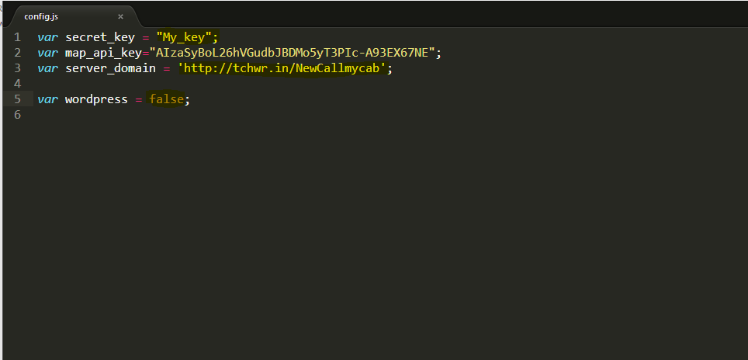

**CUSTOMIZATION**

**For Customization, you can change the following things.**

In config.xml change the following tags.

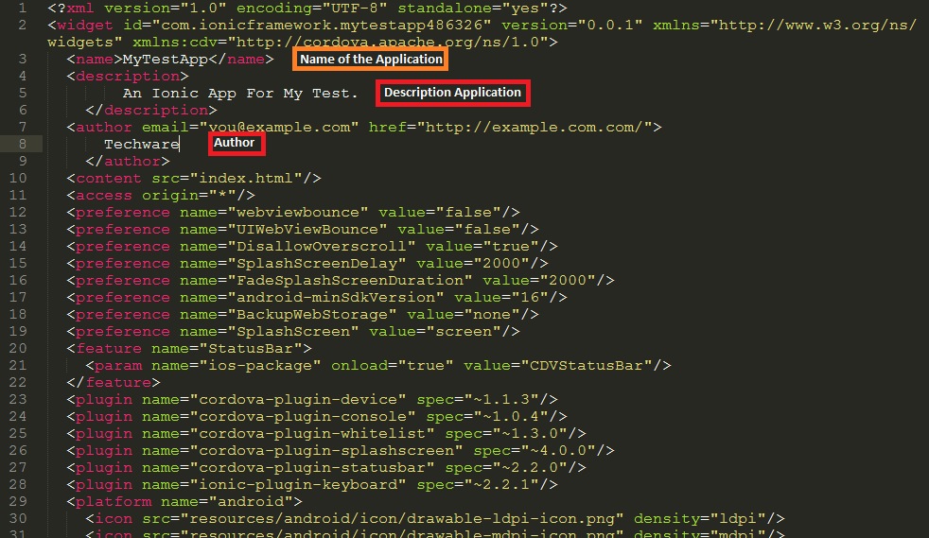

**Change Logo and Launcher**

To Change Logo and Launcher, change the image on /resources.

/android for android application

/ios for IOS application

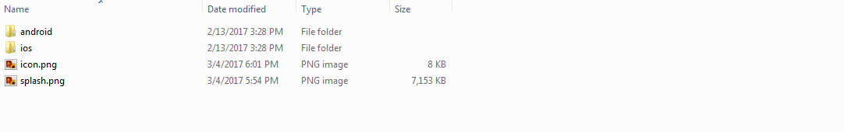

**Warning:-**

Please don't change image name. Please use same image name.

If you go for changing the image name it should also be updated in config.xml.

Make sure to upload images of correct size.

**STEPS TO TAKE OFF-LINE BUILD**

**Java Development Kit (JDK)**

Install [Java Development Kit (JDK) 7](http://www.oracle.com/technetwork/java/javase/downloads/jdk7-downloads-1880260.html) or later.

When installing on Windows you also need to set JAVA_HOME Environment Variable according to your JDK installation path (see [Setting Environment Variables](http://cordova.apache.org/docs/en/6.x/guide/platforms/android/index.html#setting-environment-variables))

**Android SDK**

Install the [Android Stand-alone SDK Tools](http://developer.android.com/sdk/installing/index.html?pkg=tools) or [Android Studio](http://developer.android.com/sdk/installing/index.html?pkg=studio). Proceed with Android Studio if you plan on developing new Cordova for Android plugins or using native tools to run and debug the Android platform. Otherwise, the Android Stand-alone SDK Tools are enough to build and deploy Android applications.

Detailed installation instructions are available as part of installation links above.

**Adding SDK Packages**

After installing the Android SDK, you must also install the packages for whatever [API level](http://developer.android.com/guide/topics/manifest/uses-sdk-element.html#ApiLevels) you wish to target. It is recommended that you install the highest SDK version that your version of cordova-android supports (see above).

Open Android SDK Manager (for example, run android from the terminal) and make sure the following are installed:

1. Android Platform SDK for your targeted version of Android
2. Android SDK build-tools version 19.1.0 or higher
3. Android Support Repository (found under "Extras")

See Android's documentation on [Installing SDK Packages](http://developer.android.com/sdk/installing/adding-packages.html) for more details.

**Setting environment variables**

Cordova's CLI tools require some environment variables to be set in order to function correctly. The CLI will attempt to set these variables for you, but in certain cases you may need to set them manually. The following variables should be updated:

1. Set the JAVA_HOME environment variable to the location of your JDK installation
2. Set the ANDROID_HOME environment variable to the location of your Android SDK installation.

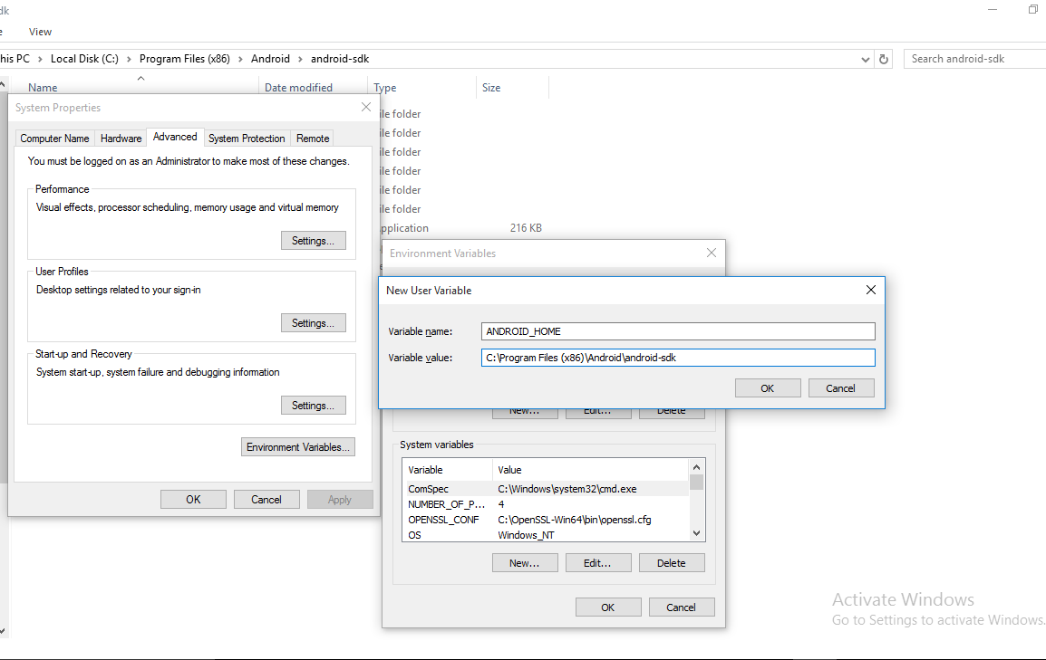

1. It is also recommended that you add the Android SDK's tools and platform-tools directories to your PATH.

**APK BUILD**

**The following are the steps to take offline apk build.**

1. Open NodeJS Command Prompt.

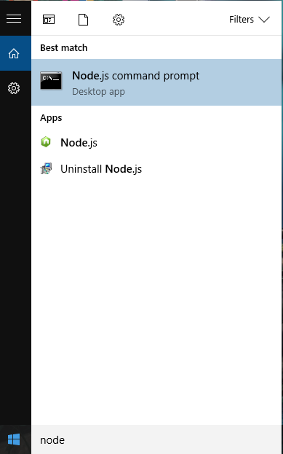

1. Open the project folder via command prompt.

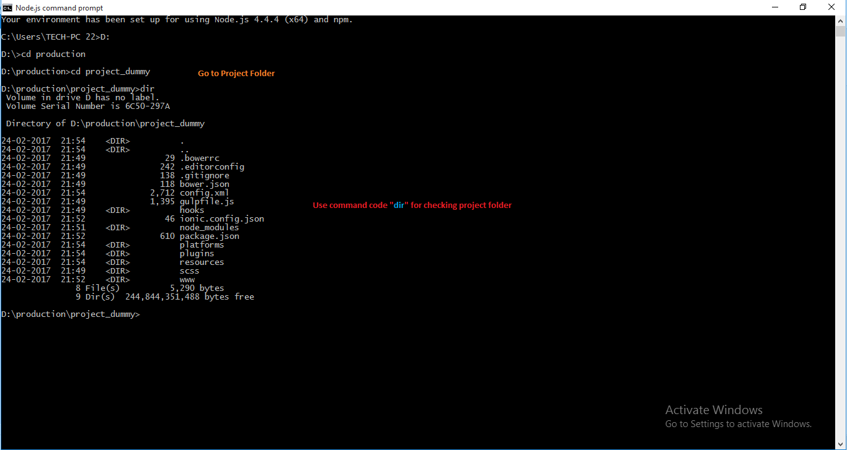

1. For Build, run the below code.

**$ ionic build android**

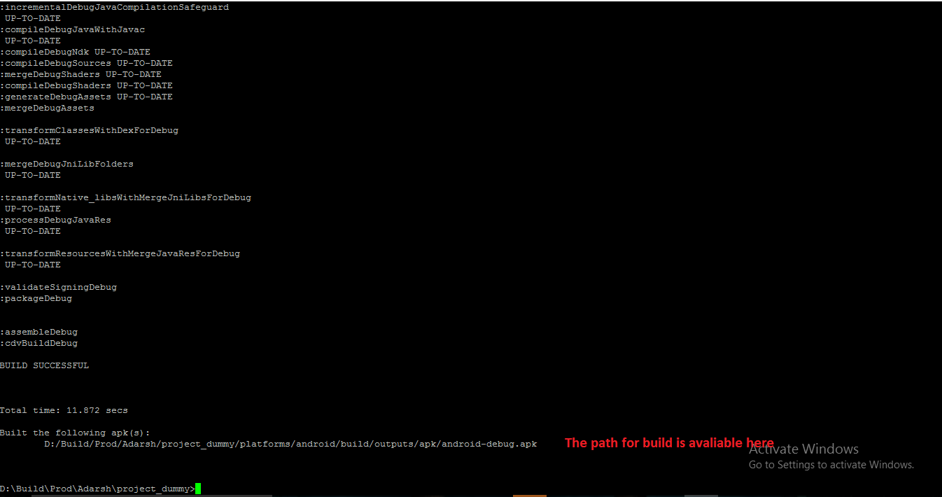

**When success, file apk will be in /platforms/android/build/outputs/apk with name "android-debug.apk".**

**--------END---------**