**ONLINE BUILD DOCUMENTATION**

**The following are the major steps for taking online build.**

**CUSTOMIZATION STEPS**

1. Unzip the source file.

2. In config.xml change following tags

<name> Your app name here </name>

<description>

Your app description here

</description>

<author href="Your website link here " email=" your contact mail here">

Your company name here

</author>

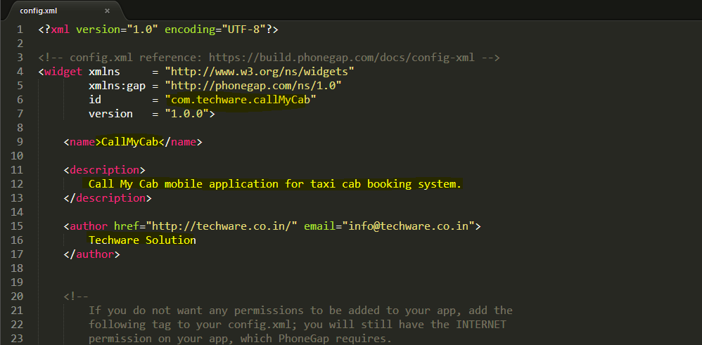

Example:

<name>CallMyCab</name>

<description>

Call My Cab mobile application for taxi cab booking system.

</description>

<author href="http://techware.co.in/" email="info@techware.co.in">

Techware Solution

</author>

3. In folder res\

* Change the icons inside icon folder for each platform (android, ios etc..)

* Change the splash screens inside screen folder for each platform (android, ios etc..)

**Warning:-**

Please don't change image name. Please use same image name.

If you go for changing the image name it should also be updated in config.xml.

Make sure to upload images of correct size.

4. In config.js change the values given below

var server_domain = 'http://tchwr.in/NewCallmycab';

// give your domain that admin panel hosted

var secret_key = "My_key"; // Give secret key same as in admin panel settings

var wordpress = false; // If you purchased wordpress site, set as 'true' else give false

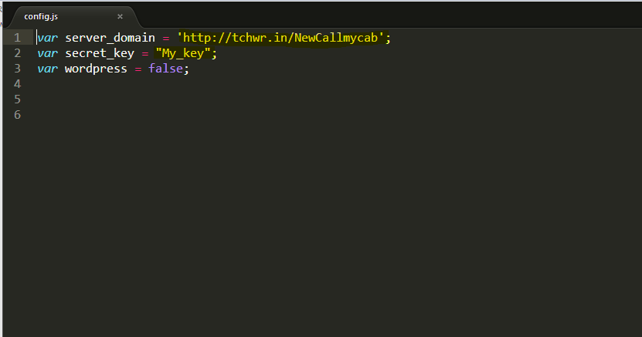

**File location information, if you want to customize.**

5. You can change images and icons inside app in the folder "img"

6. index.html located in root folder and other page html files are inside the "templates" folder.

After making customization ,you have to zip the file for apk build .

**STEPS FOR TAKE ONLINE BUILD**

1. Create an account on https://build.phonegap.com/

2. Upload the www.Zip file to your account in phone gap online build.

3. After the build is completed download the apk, xap and ipa.

4. You can install the app to your phone directly or upload to Apple Store or Google Play store.