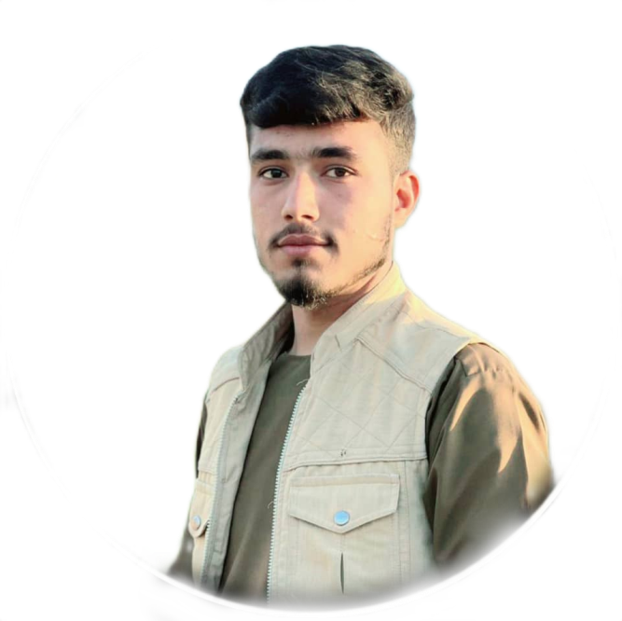

**Student of 4th great of University.**

**Has passed a term of Computer in AKES.**

**Graduated from Shohada Baghlan high school in 2021 .**

**Name: Abid**

**Last Name: Mohammadi**

**Father Name: Hashmatullah**

**Date of Birth: 2002**

**Gender : Male**

**Marital status : Single**

**Nationality: Afghan**

**Religion: Islam**

**Personal Data**

**+93 745242143**

[**m.abid113344@gmail.com**](mailto:m.abid113344@gmail.com)

**Baghlan second street of Fabrika**

**Contacts**

**Worked in sugar Factory in Baghlan .**

**Abid Mohammadi son of Hashmatullah was born in Baghlan province in 2002AD /1382. The main residence of the servant is in Baghlan Province and the current residence in Baghlan Province in Second Street of Fabrika.**

**About Me**

**Education**

**Work Experiences**

**Abid Mohammadi**

**I am a young indvidual and like the challenging jobs & Scholarship to accomplish with excellence by leading an efficent teamwork even in a high pressure environment.**

**Personal Statment**

**Computer Skills**

**Language**

**Hekmat Ahmadi**

**Teacher**

**Email:** [**hekmatahmadi22@gmail.com**](mailto:hekmatahmadi22@gmail.com)

**Call #0796540228**

**Nawid Aslami**

**Doctor**

**Email:** [**aslami665@gmail.com**](mailto:aslami665@gmail.com)

**Call # +93 765489300**

**Referances**

**Negative Language: Pashto**

**Other Language:**

**Dari**

**Pashto**

**English**

**MS Word**

**MS Excel**

**MS Power Point**

**MS Access**

**HTML**

**CSS**

**Java Script**

**MY SQL**

**Graphic Designing**