**RATEIT**

The first page that appears when we visit the website is the homepage. The homepage has a navigation bar. The sections in it are: Book, Movie, Song, Drama Series, About us, Sign UP and Log In. The first four of them will take you to the corresponding item (for viewing only while not logged in). And the latter two will take you either to a sign up form or a registration form. Here is our homepage:

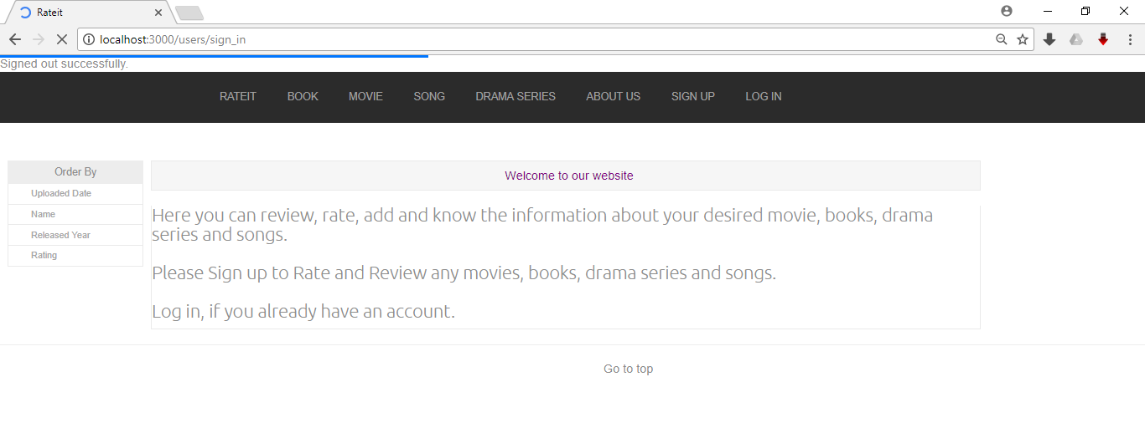

And the Log In page:

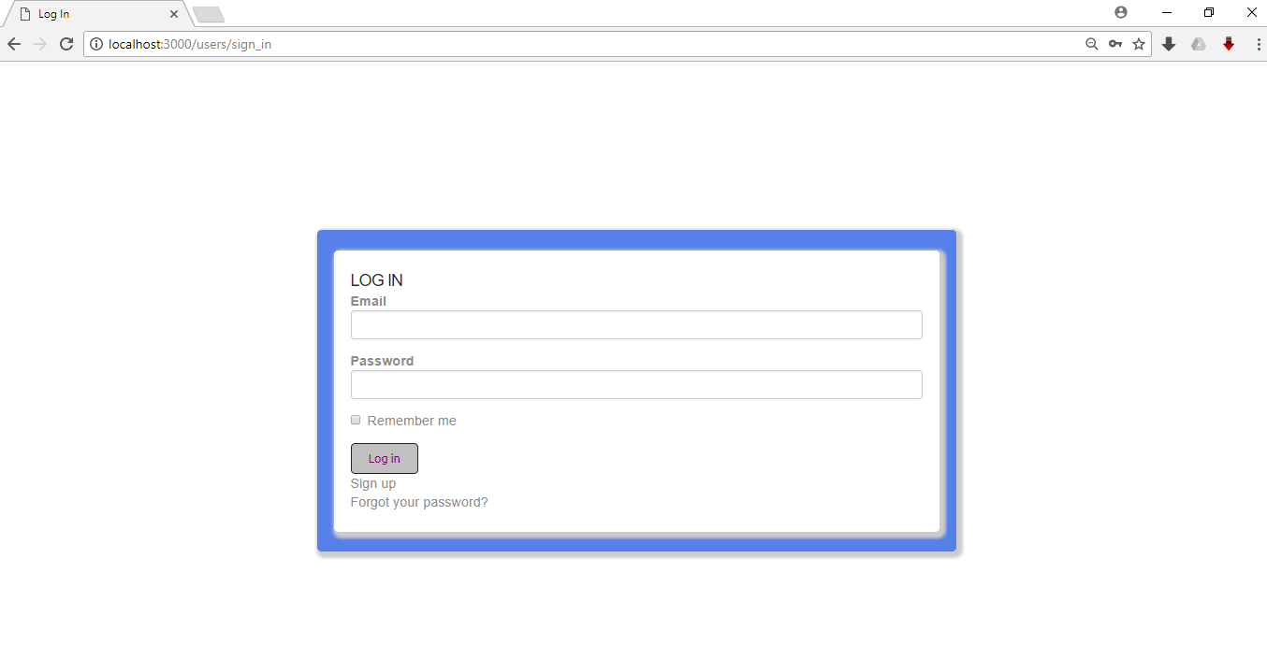

Which will only work if the user has signed up previously.

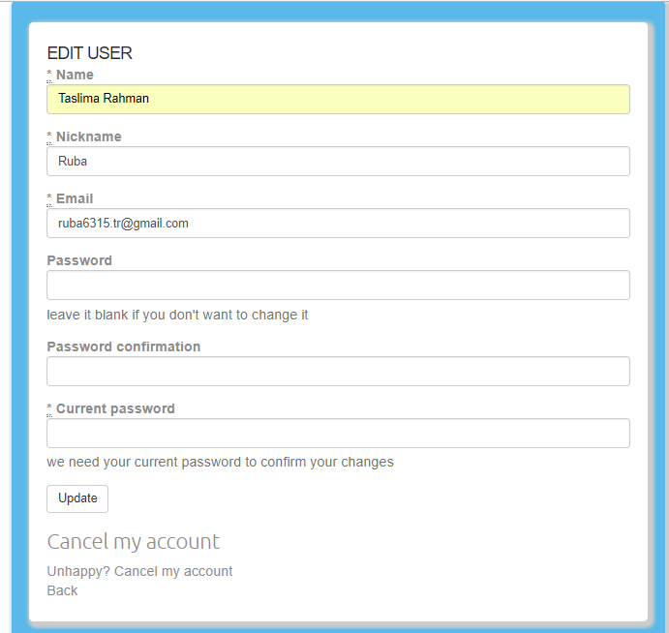

Now let’s take a Look at the registration page, which is also similar to the Edit user information form. Which only has an extra field “Current Password”.

And when a user is successfully logged in (or has just signed up) the homepage will be like: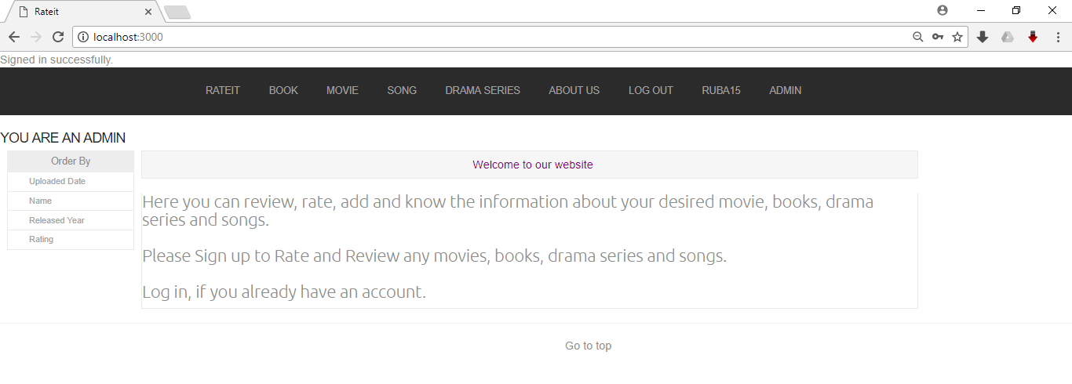

Here we can see that on the navigation panel there is a user tab now. Clicking on which user can edit his/her information.

Now clicking on any of those four (Book as an example) will take user to:

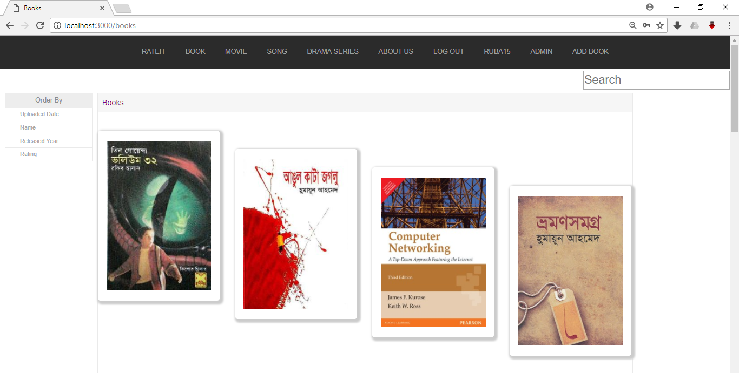

This is the books tab. Where user can search a particular book to see whether it has been added. And if it had been added before then user can click on it to provide-review rating on it. Or simply to see how the previous reviews are in case user is interested in the particular item but hasn’t yet experienced it.

Now, searching for a particular item will yield a page, and clicking on the item will take user to a page. Such as:

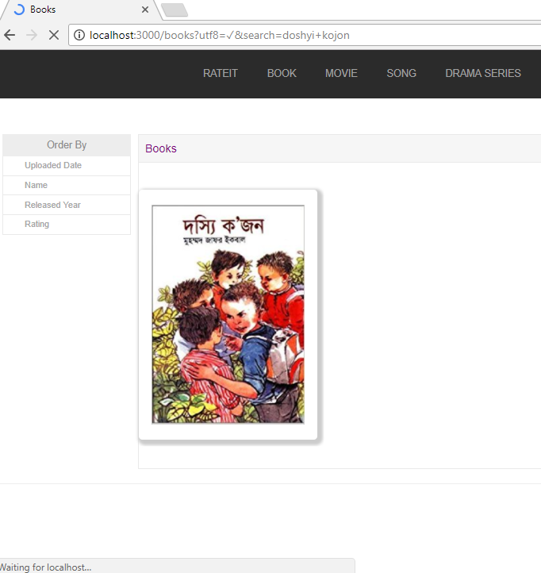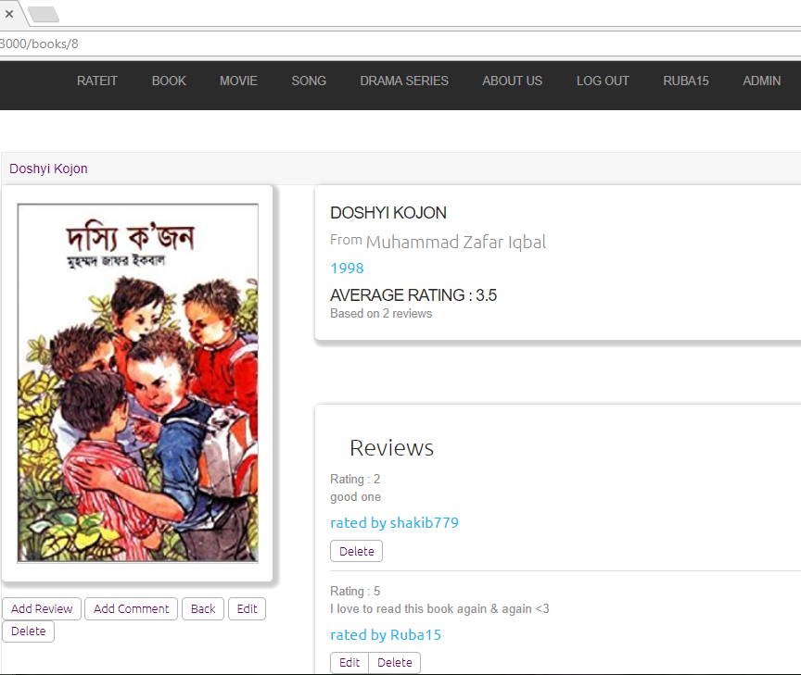

In the latter on we can see that below the name of item we have its descriptions and an average rating based on previous reviews. Also the reviews are shown ordered by when they were posted.

We can also see a user can add review, add comment, edit his/her previous review or even delete a previously made review.

This forms will look as follows:

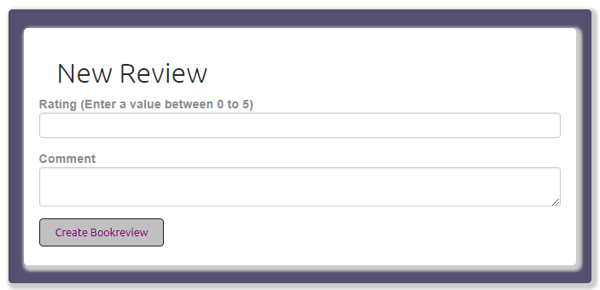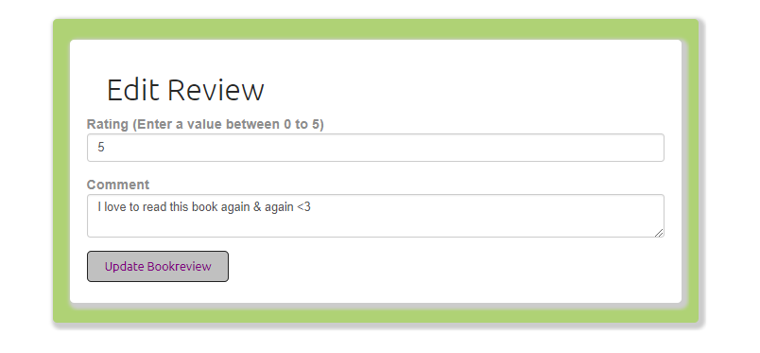

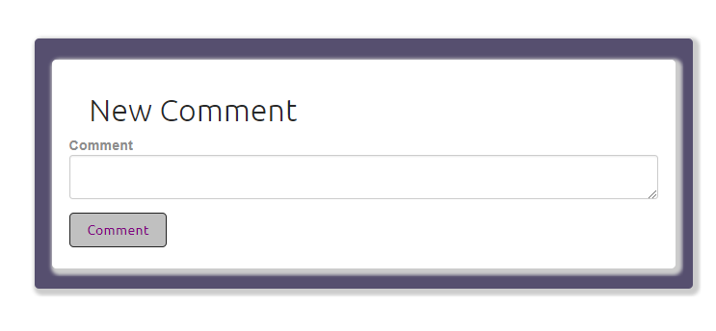

And the create object form will be like:

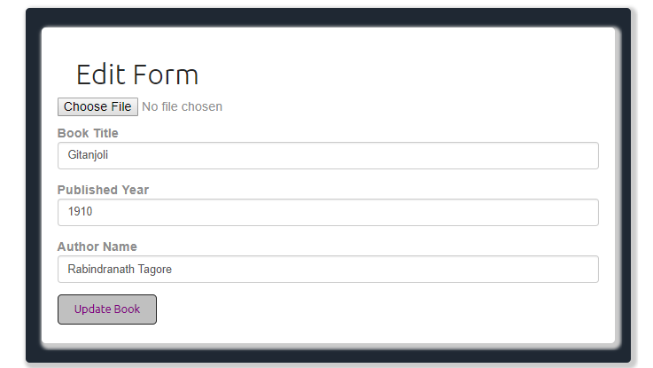

Here on the choose file option user can add an image for the corresponding object (Book/ Movie/ Song/ Drama Series).

This edit form is similar to create object form.

All the edit forms can only be used by the user who created the object/review.

On the left side of every page we have options Order by- “Uploaded date”, “Name”, “Released Year”, “Rating” which will consequently sort the list by either according to the time they have been uploaded to website, by lexicographically, by released year or by average rating.

And one more feature, admin user can authorize a particular adminship as illustrated in this picture:

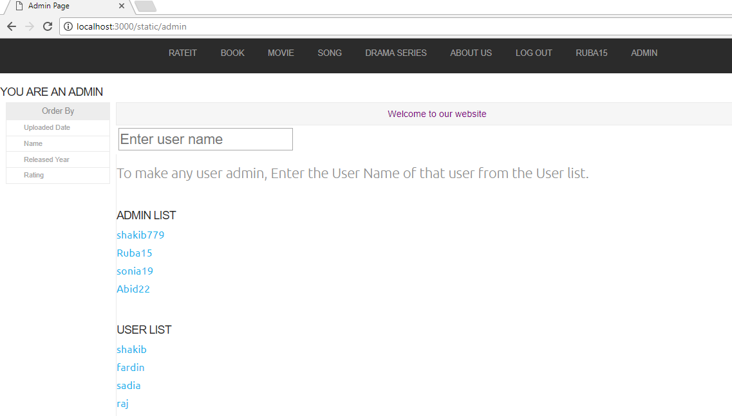

*Future work:*

As our future work we want to add a few facilities. Such as:

1. We plan to add a feature of adding download link for the object if it’s available online. Or even an amazon.com or e-bay link where the item can be bought. This will increase the websites popularity as well as its usefulness.
2. We also plan to add the feature which enables user to mark a particular object as his/her favorite and it will be added to his/her favorite list. This list will be accessible in the users profile page. This favorite marking is kind of bookmarks that we have on browsers.

*Github ulr:*

https://github.com/shakib779/Rateit