|  |  |
| --- | --- |
|  |  |

**CALVIN (Python Version)**

**Fall 2024 Shortcourse**

Prepared by

Mustafa S. Dogan

[msdogan@ucdavis.edu](mailto:msdogan@ucdavis.edu), msahindogan@aksaray.edu.tr

Dates: November, 2024

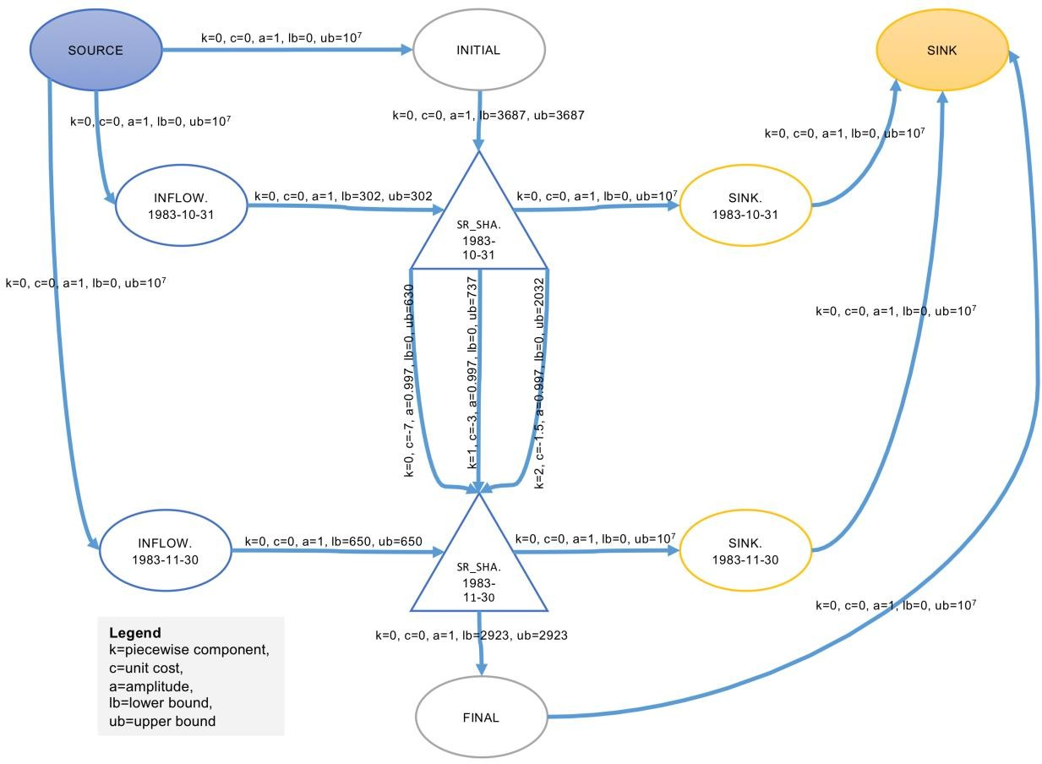

**Date:** November, 2024

**Location:** Zoom (online)

**Registration:** (not needed)

**Shortcourse GitHub Repo:** <https://github.com/msdogan/CALVIN-shortcourse>

# Tentative Agenda and Topics

|  |  |  |  |
| --- | --- | --- | --- |
| **Day** | **Time** |  | **Topics** |
| 1 | 9am-10am | - | Brief introductions, CA water supply system, and Hydroeconomic modeling |
| 10am-11am | - | CALVIN model and components, updated CALVIN hydrology |
| 11am-12pm | - | CALVIN hydrology and economics, components of the model, and software installation |
| 2 |  |  |  |
| 9am-10am | - | Simple reservoir example |
| 10am-11am | - | Creating CALVIN runs (Python version) and running the model |
| 11am-12pm | - | Postprocessing and analyzing results |
|  |  |  |
|  |  |  |  |

# Summary

This shortcourse is intended for those who are interested in California’s water supply system and large-scale water optimization modeling. Mechanics of the CALVIN model will be covered. This crash course introduces open-source CALVIN version modeled in Python-based Pyomo environment, employing faster solvers and giving an opportunity for better representation of the system. It walks through steps for required software installation process for the CALVIN model, as well as creating a model run and postprocessing results.

Recommended readings

* **Original publication of CALVIN** (Draper et al., 2003):

Draper, A. J., Jenkins, M. W., Kirby, K. W., Lund, J. R., & Howitt, R. E. (2003).

Economic-Engineering Optimization for California Water Management. *Journal of Water Resources Planning and Management*, *129*(3), 155–164. https://doi.org/10.1061/(ASCE)0733-9496(2003)129:3(155)

* **Open-source Python version of CALVIN** (Dogan et al., 2018):

Dogan, M. S., Fefer, M. A., Herman, J. D., Hart, Q. J., Merz, J. R., Medellín-Azuara, J., & Lund, J. R. (2018). An open-source Python implementation of California’s hydroeconomic optimization model. *Environmental Modelling & Software*, *108*, 8– 13. <https://doi.org/10.1016/j.envsoft.2018.07.002>

Documentation and related theses/publications: [https://calvin.ucdavis.edu](https://calvin.ucdavis.edu/)