Project Documentation

# Visualizing Housing Market Trends: An Analysis of Sale Prices and Features using Tableau

Company: ABC Company

Internship: SmartBridge Virtual Internship – Data Analytics

Tools Used: Tableau, Excel/CSV

## Executive Summary

This project, developed for ABC Company, analyzes housing market data to uncover insights into the factors influencing house prices and sales trends. By visualizing sales patterns, renovation impacts, and house feature distributions using Tableau, this project equips real estate analysts, marketing teams, and executives with data-driven insights to optimize pricing strategies and enhance market competitiveness.

## Objective

- To visualize and interpret key housing trends using Tableau.  
- To analyze the impact of features like renovations, house age, bathrooms, bedrooms, and floors on sale prices.  
- To assist stakeholders in making informed strategic decisions based on data insights.

## Dataset Overview

Dataset Source: King County Housing Dataset (USA)  
Key Attributes: price, bedrooms, bathrooms, sqft_living, sqft_basement, floors, renovation year, year built, house age, etc.  
Data Enrichment: Additional fields such as years since renovation, house age, and transformation metrics were computed.

## Project Scenarios & Analysis

### Scenario 1: Overall Data Overview

Summary Dashboard showing total records, average sale price, and basement area. Helps orient stakeholders with high-level metrics.

### Scenario 2: Total Sales by Years Since Renovation

Histogram displaying sales distribution by years since renovation. Shows correlation between renovation recency and price.

### Scenario 3: Distribution of House Age by Renovation Status

Pie chart of house ages split by renovation status. Highlights renovated vs. non-renovated homes and age profile.

### Scenario 4: House Age Distribution by Number of Bathrooms, Bedrooms, and Floors

Grouped bar chart comparing house age by features like bathrooms, bedrooms, and floors. Reveals trends in home design over time.

## Dashboard Features

- Filters: Renovation status, house age, number of floors, bathrooms, bedrooms.  
- Charts: Summary panel, histogram, pie chart, grouped bar chart.  
- Interactivity: Clickable elements for deeper analysis.  
- Navigation: Clean layout, intuitive design for real estate professionals.

## Key Insights

- Recently renovated houses have higher sale prices.  
- Older homes are common but less often renovated.  
- Most new homes have 2–3 bedrooms and 1–2 bathrooms.  
- Basement size contributes to higher prices.

## Conclusion

The Tableau dashboard enables deep insights into how housing features influence price trends. ABC Company can use these visualizations to drive strategic decisions, improve pricing models, and better understand the market.

## Future Scope

- Add predictive pricing models using machine learning.  
- Expand to include other counties or states.  
- Embed dashboard in company web portal for stakeholders.

## Deliverables

- Interactive Tableau Dashboard  
- Explanation Video: https://drive.google.com/drive/home  
- This Documentation (PDF format)

## Storyboard Design

To design a storyboard in Tableau, start by defining the key elements and flow of your narrative. Utilize Tableau Analytics' capabilities to create a series of interactive visualizations, such as charts, graphs, and KPI cards, that represent each scene or stage of your story. Arrange these visualizations sequentially on a dashboard, ensuring a logical progression from beginning to end. Incorporate text boxes, annotations, and navigation buttons to provide context, explanation, and interactivity within the storyboard. Customize the design and layout to enhance clarity and engagement, leveraging Tableau's formatting options and templates.

### 1. Dataset (dataset_house.csv)

This is the content of the CSV :

Code snippet

Date,Sale_Price,No of Bedrooms,No of Bathrooms,Flat Area (in Sqft),Lot Area (in Sqft),No of Floors,Waterfront View,No of Times Visited,Overall Grade,Area of the House from Basement (in Sqft),Basement Area (in Sqft),Age of House (in Years),Renovated_or_Not,Zipcode,Latitude,Longitude,Living Area after Renovation (in Sqft),Lot Area after Renovation (in Sqft),Ever_Renovated,Years Since Renovation

190795200000000000,221900,3,1,1180,5650,1,No,2,7,1180,0,65,No,98178,47.5112,-122.257,1340,5650,No,0

190795200000000000,538000,3,2.25,2570,7242,2,No,4,7,2170,400,69,Yes,98125,47.721,-122.319,1690,7639,Yes,26

190795200000000000,180000,2,1,770,10670,1,No,3,6,770,0,87,No,98028,47.7379,-122.233,2720,8062,No,0

190795200000000000,604000,4,3,1960,5000,1,No,3,7,1050,910,50,No,98136,47.5208,-122.393,1860,5000,No,0

190795200000000000,510000,3,2,1680,8080,1,No,3,8,1680,0,33,No,98074,47.6168,-122.045,1800,7503,No,0

190795200000000000,1225000,4,4.5,5420,101930,1,No,3,10,3890,1530,13,No,98053,47.6561,-122.005,4760,101930,No,0

190795200000000000,257500,3,2.25,1715,6819,2,No,3,7,1715,0,29,No,98003,47.3097,-122.327,2238,6819,No,0

190795200000000000,291850,3,1.5,1060,9711,1,No,3,7,1060,0,55,No,98198,47.4095,-122.315,1650,9711,No,0

190795200000000000,229500,3,1,1780,7470,1,No,3,7,1020,760,58,No,98146,47.5123,-122.337,1780,8113,No,0

190795200000000000,323000,3,2.5,1890,6560,2,No,3,7,1890,0,15,No,98038,47.3684,-122.031,2390,7570,No,0

*(This is a snippet. The full content is in your dataset_house.csv file.)*

### 2. HTML Template (templates/index.html)

This is the final version of your index.html file, which includes the Tableau embed code you provided earlier:

HTML

<!DOCTYPE html>

<html lang="en">

<head>

<meta charset="UTF-8">

<meta name="viewport" content="width=device-width, initial-scale=1.0">

<title>Housing Market Trends Dashboard - ABC Company</title>

<style>

body {

font-family: 'Segoe UI', Tahoma, Geneva, Verdana, sans-serif;

margin: 0;

padding: 0;

background-color: #f4f7fa;

color: #333;

}

.container {

max-width: 1200px;

margin: 20px auto;

padding: 30px;

background-color: #ffffff;

border-radius: 10px;

box-shadow: 0 4px 15px rgba(0, 0, 0, 0.1);

}

h1 {

text-align: center;

color: #0056b3;

margin-bottom: 25px;

font-size: 2.5em;

}

p {

text-align: center;

font-size: 1.1em;

line-height: 1.6;

margin-bottom: 30px;

}

.tableau-viz-wrapper {

width: 100%;

/* The height will be controlled by Tableau's embed script,

but you can set a minimum height if needed */

min-height: 600px;

/* Adjust as necessary */

overflow: hidden;

border-radius: 8px;

box-shadow: 0 2px 8px rgba(0, 0, 0, 0.08);

}

.footer {

text-align: center;

margin-top: 40px;

font-size: 0.9em;

color: #666;

}

</style>

</head>

<body>

<div class="container">

<h1>Comprehensive Housing Market Trends Analysis</h1>

<p>Explore key insights into house sale prices and features, including the impact of renovations and property

characteristics, to inform strategic decisions for ABC Company.</p>

<div class="tableau-viz-wrapper">

<div class='tableauPlaceholder' id='viz1750998630132' style='position: relative'><noscript><a href='#'><img

alt='Dashboard 1 '

src='https:&#47;&#47;public.tableau.com&#47;static&#47;images&#47;72&#47;72FJNMZRY&#47;1_rss.png'

style='border: none' /></a></noscript><object class='tableauViz' style='display:none;'>

<param name='host_url' value='https%3A%2F%2Fpublic.tableau.com%2F' />

<param name='embed_code_version' value='3' />

<param name='path' value='shared&#47;72FJNMZRY' />

<param name='toolbar' value='yes' />

<param name='static_image'

value='https:&#47;&#47;public.tableau.com&#47;static&#47;images&#47;72&#47;72FJNMZRY&#47;1.png' />

<param name='animate_transition' value='yes' />

<param name='display_static_image' value='yes' />

<param name='display_spinner' value='yes' />

<param name='display_overlay' value='yes' />

<param name='display_count' value='yes' />

<param name='language' value='en-US' />

<param name='filter' value='publish=yes' />

</object></div>

<script type='text/javascript'>

var divElement = document.getElementById('viz1750998630132');

var vizElement = divElement.getElementsByTagName('object')[0];

if (divElement.offsetWidth > 800) { vizElement.style.width = '1169px'; vizElement.style.height = '854px'; } else if (divElement.offsetWidth > 500) { vizElement.style.width = '1169px'; vizElement.style.height = '854px'; } else { vizElement.style.width = '100%'; vizElement.style.height = '1577px'; }

var scriptElement = document.createElement('script');

scriptElement.src = 'https://public.tableau.com/javascripts/api/viz_v1.js';

vizElement.parentNode.insertBefore(scriptElement, vizElement);

</script>

</div>

<div class="footer">

<p>&copy; 2025 ABC Company. All rights reserved.</p>

</div>

</div>

</body>

</html>

### 3. Images for Documentation

* 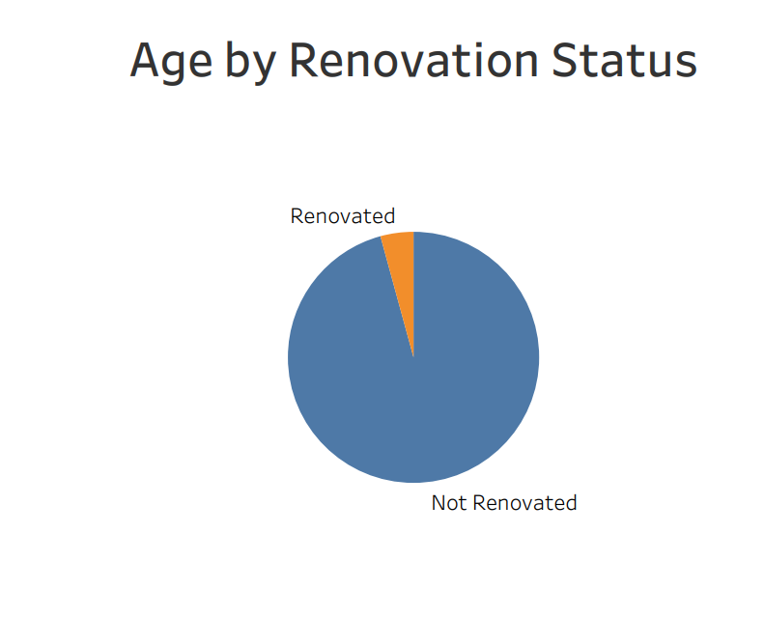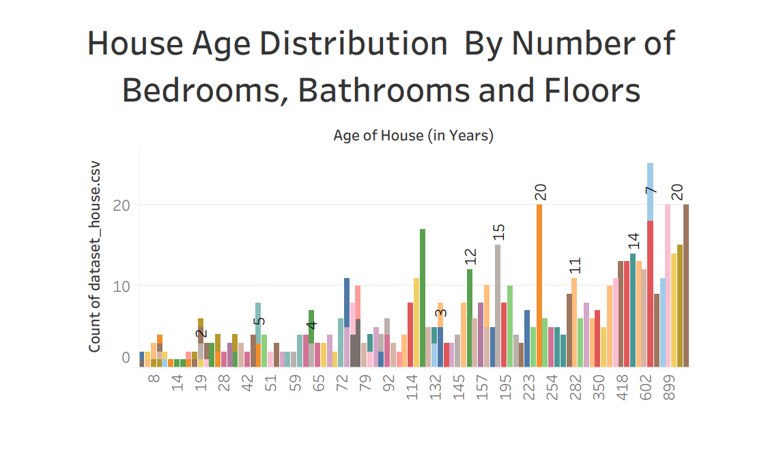

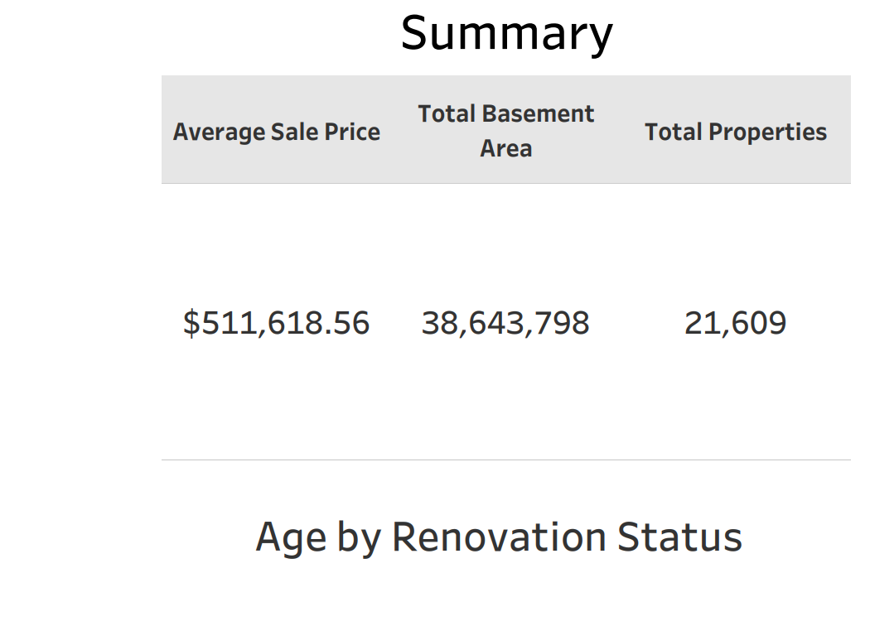

Sources