Project name : Online Ticketing System

Screenshots taken during Execution

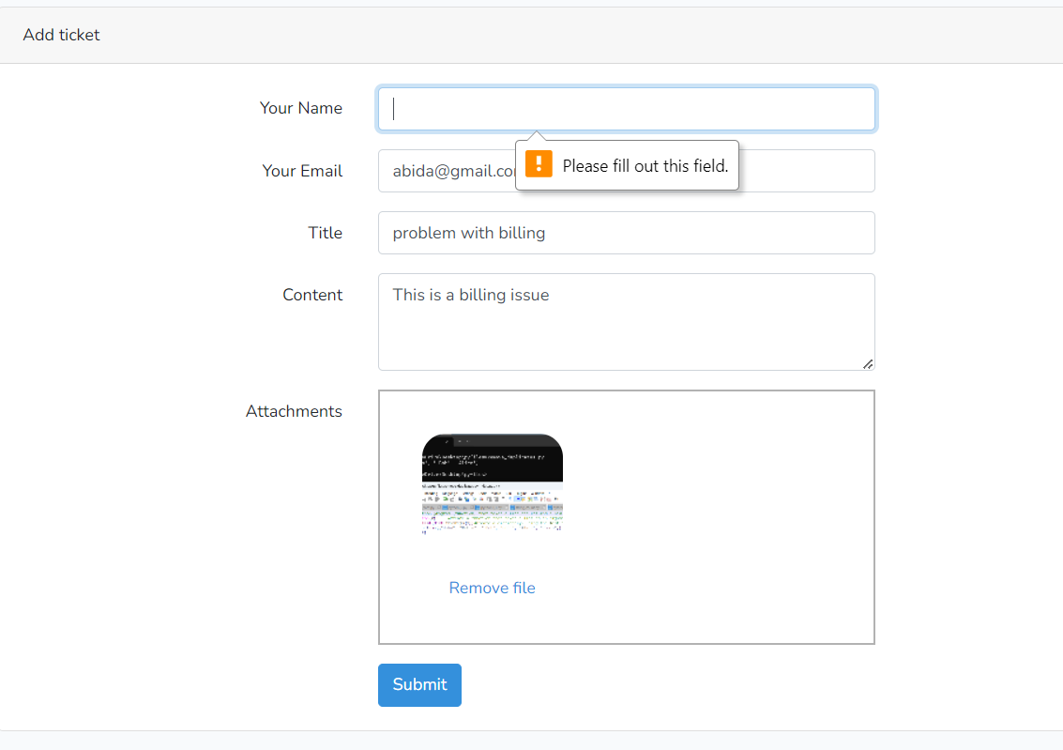

Figure_1: Blank name field not allowed

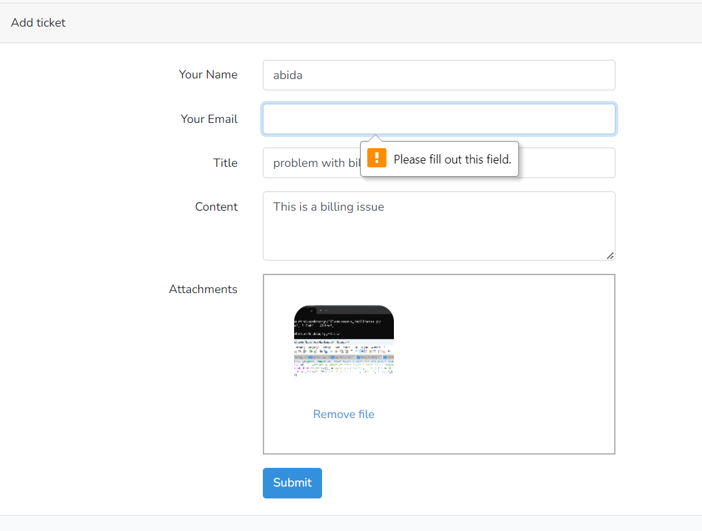Figure_2: Blank Email Field Not Allowed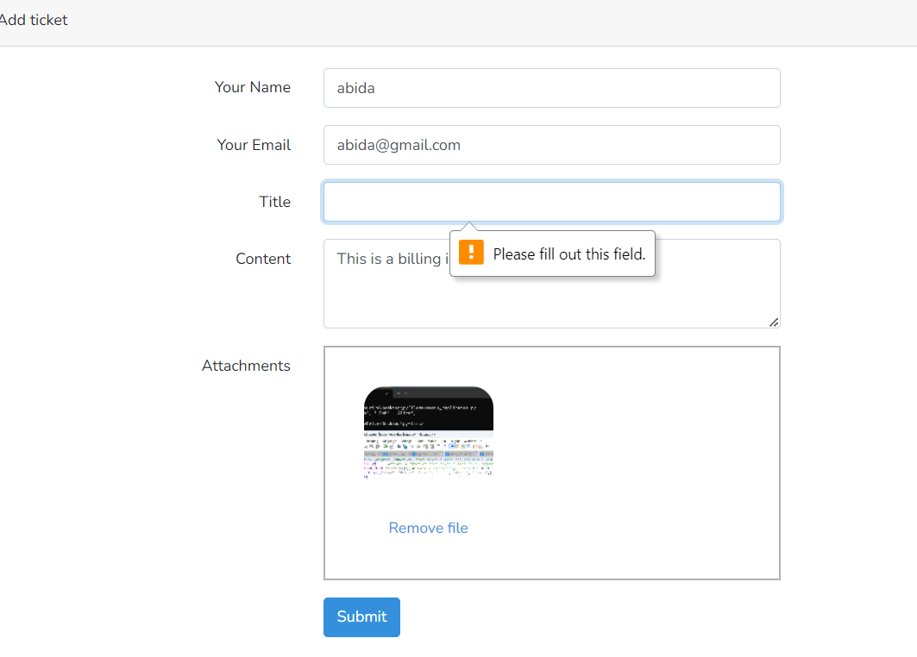 Figure_3: Blank Title Field Not Allowed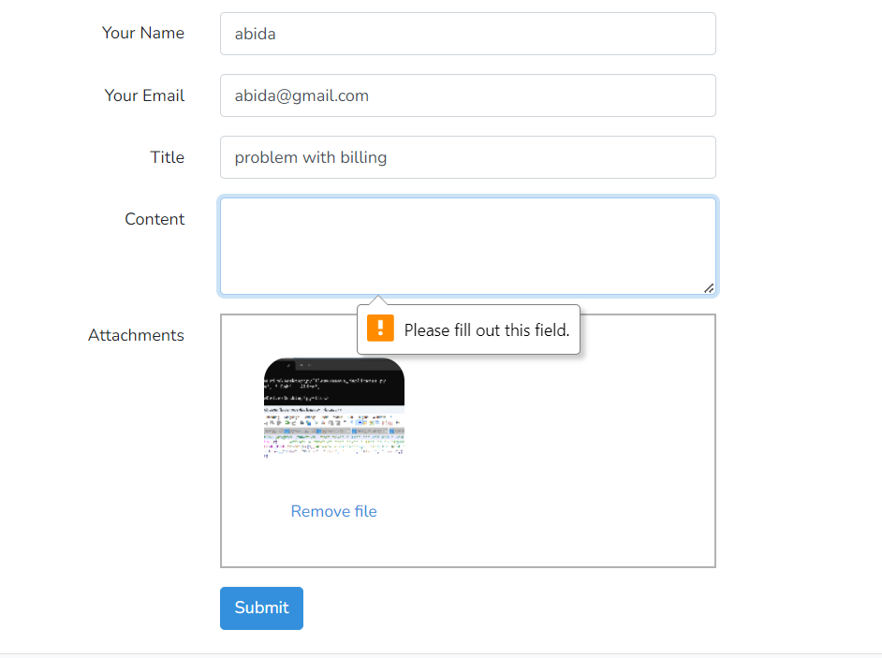 Figure_4: Blank Content field not Allowed

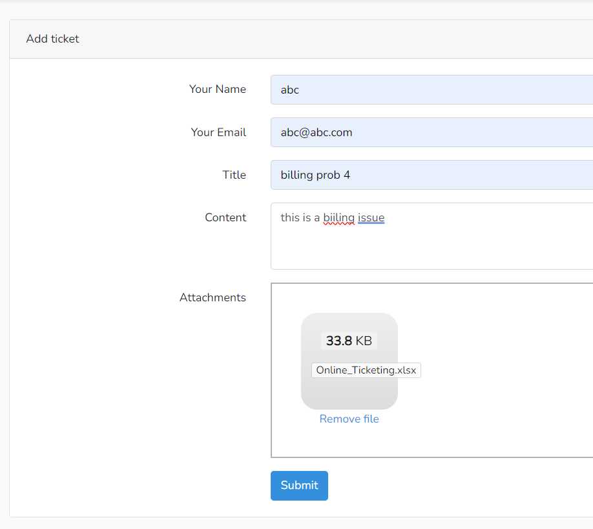 Figure_5: .xls not allowed on Attachment **(Bug_001**)

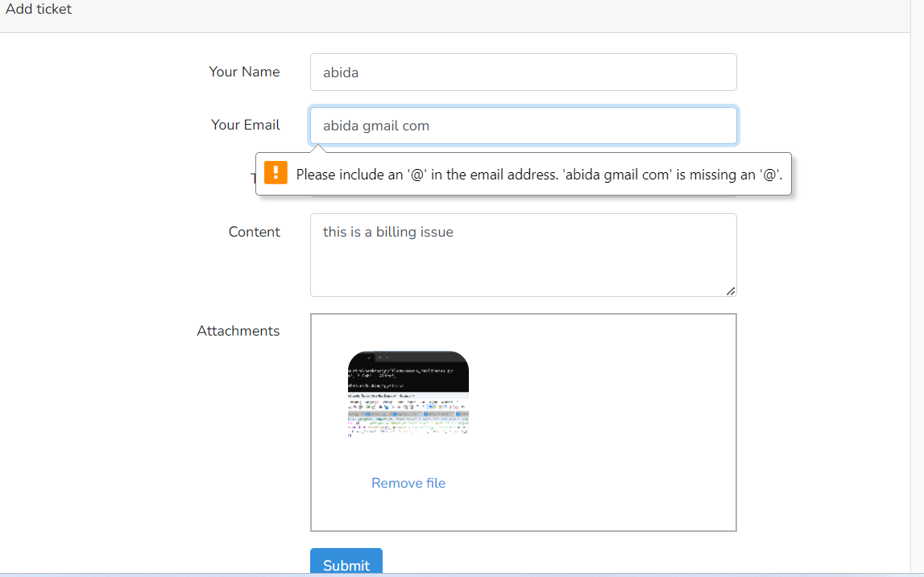

Figure_6: Invalid Email not allowed

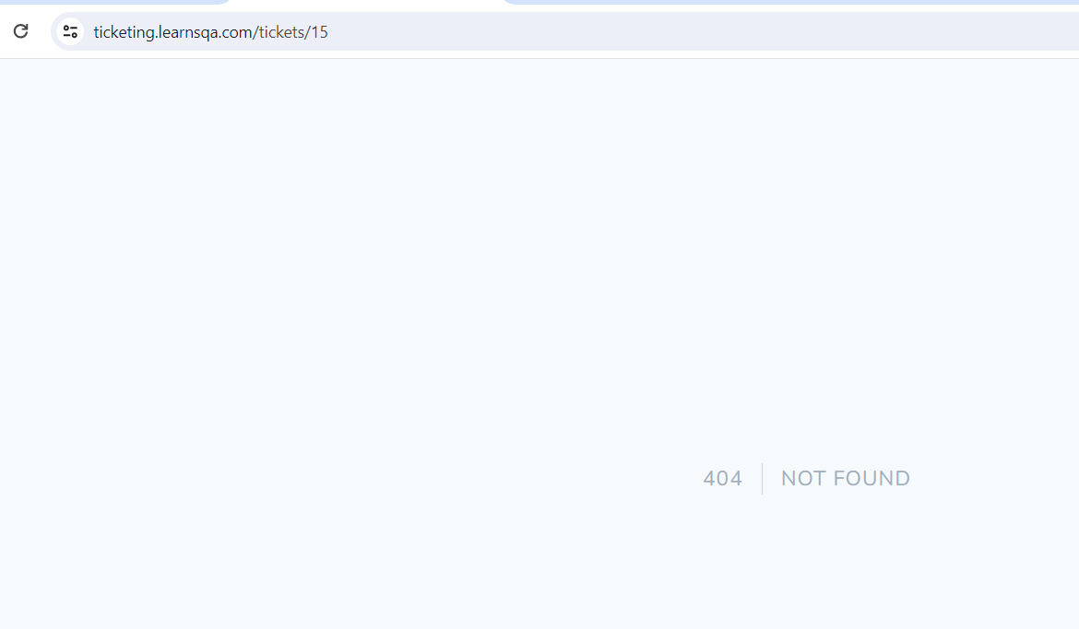

Figure_7: Invalid Ticket Id could not be redirected

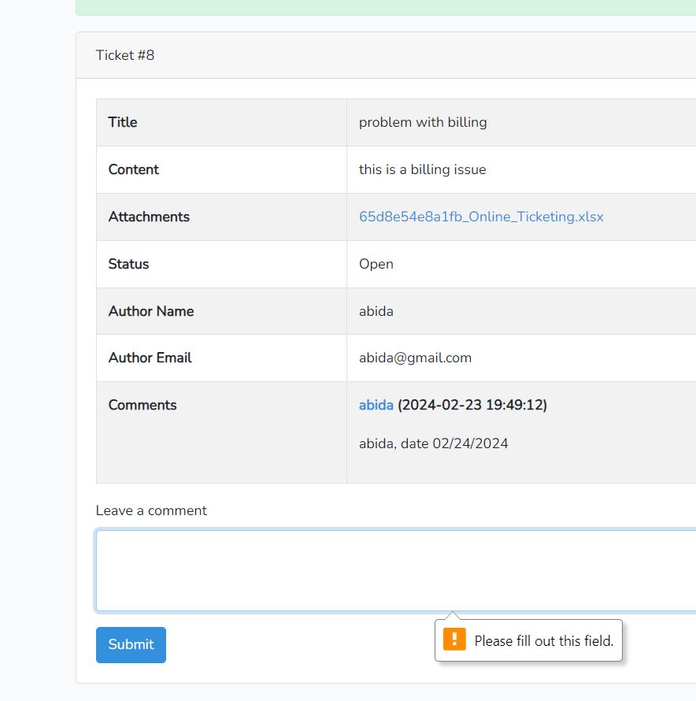 Figure_8: Comment field must be filled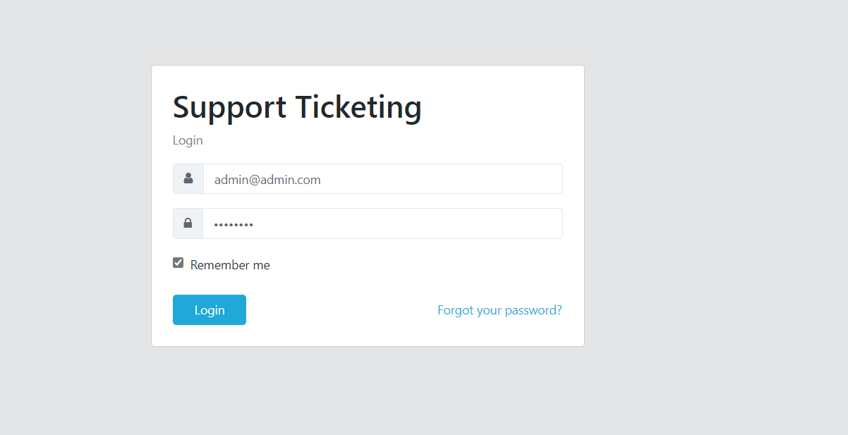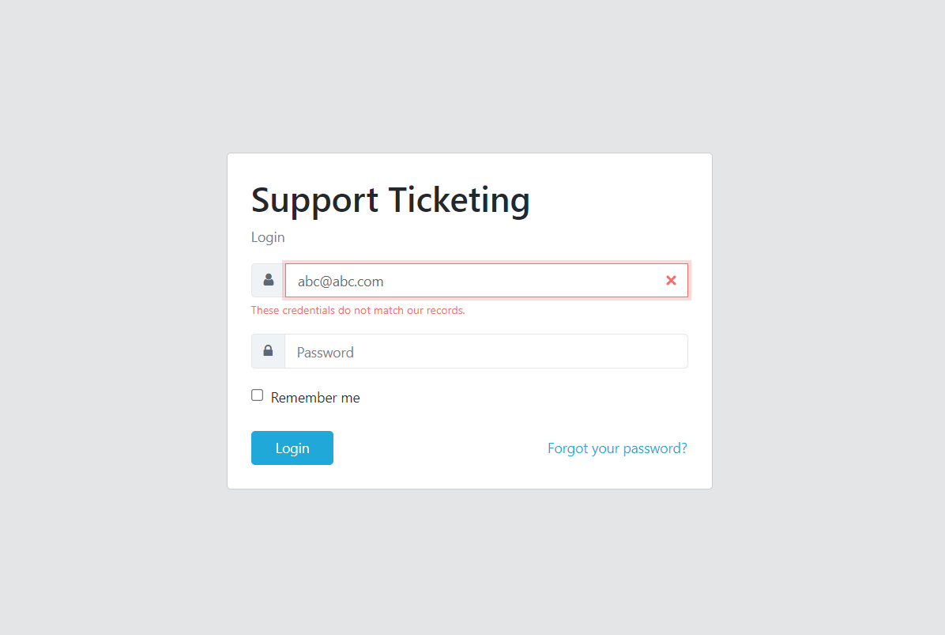 Figure_9: Credential should be matched 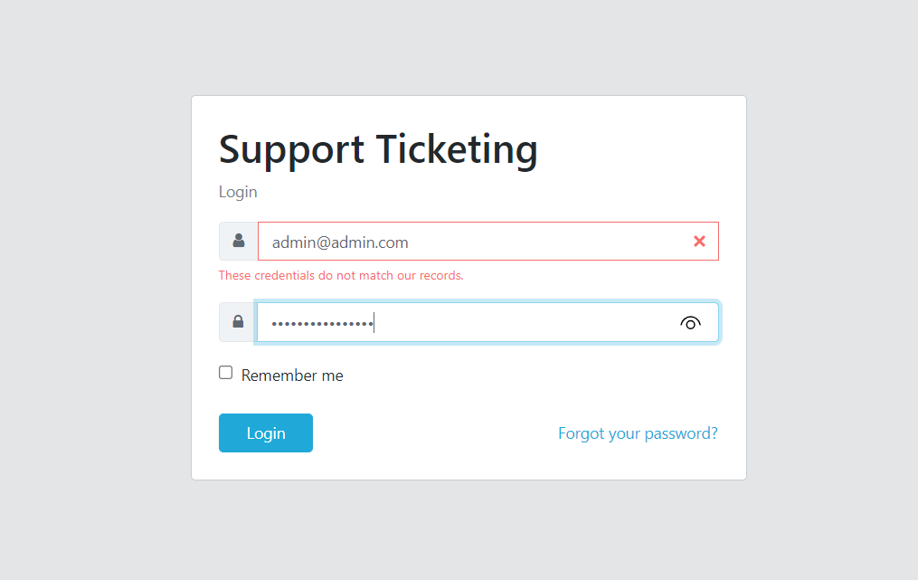 Figure_10:Password masked with (*)

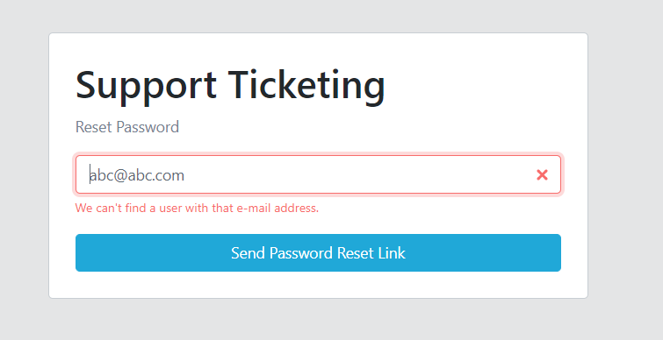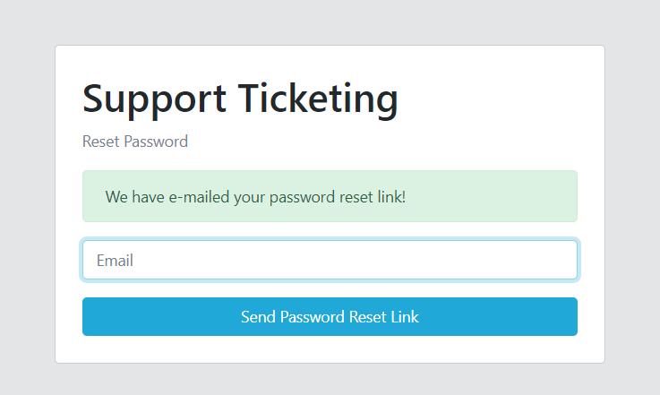 Figure_11: Reset link could be sent

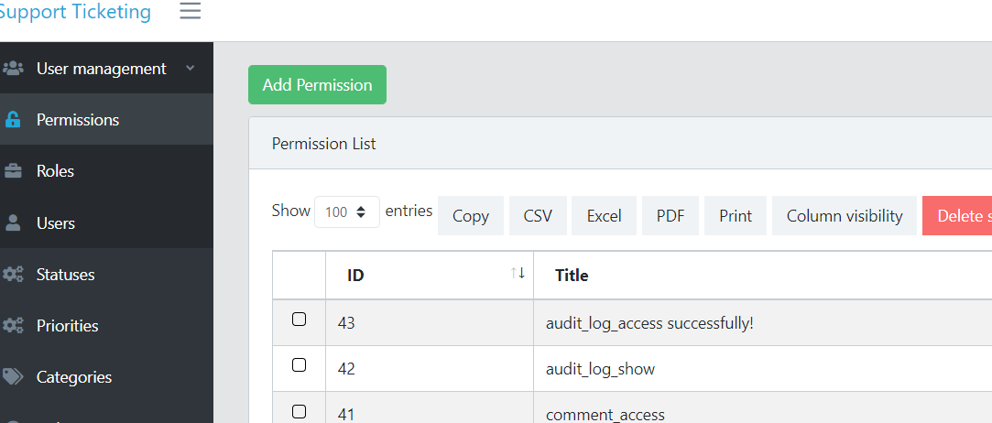

Figure_12: could not redirected to Dashboard(**Bug_002**)

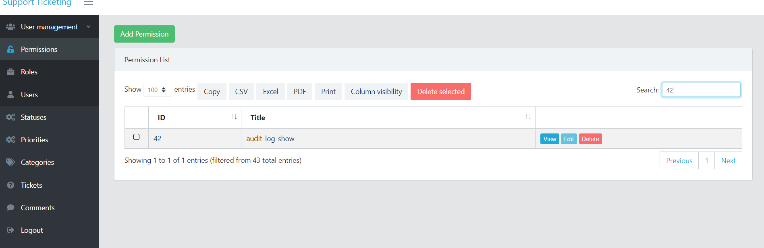 Figure_13:Single permission could be seen by selecting single ID

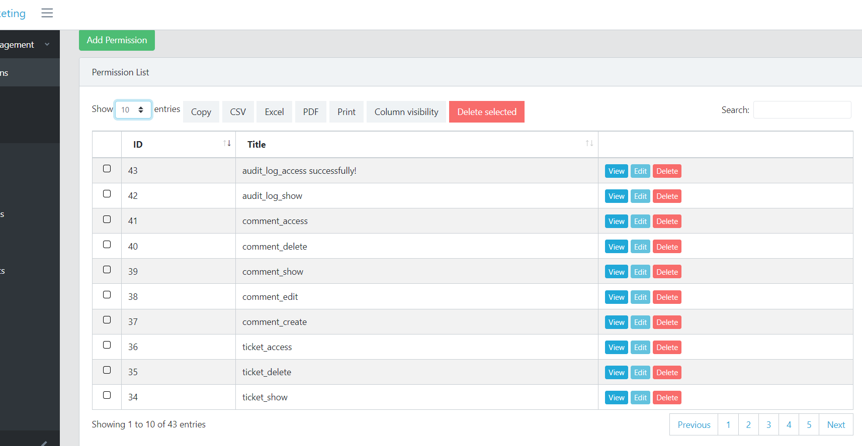 Figure_14:Could be shown the limited entries

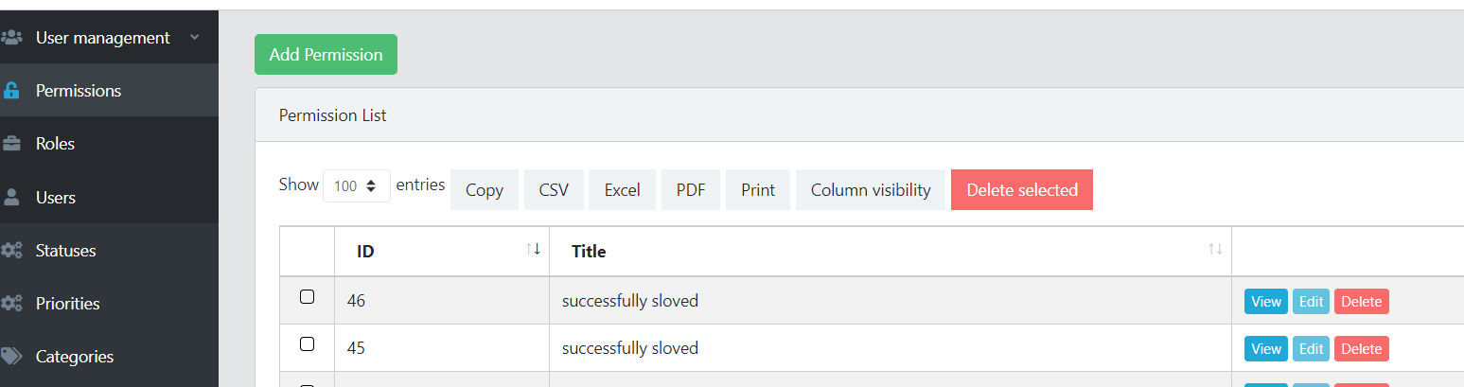 Figure_15: Could be add duplicate Title(Bug_003)

 Figure_16: Could be Update with duplicate Title(Bug_004)