Hatchback:  
Suzuki: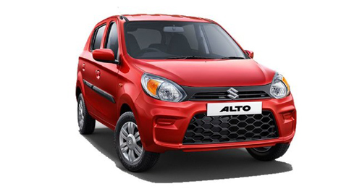Maruti Suzuki Alto Specs and Features

Specifications

| Engine & Transmission | |
| --- | --- |
| Engine Type | F8D |
| Displacement | 796 cc |
| Cylinders | 3 Cylinders Inline |
| Valves | 4 Valves/Cylinder, SOHC |
| Fuel Type | Petrol |
| Max Power (BHP) | 48 bhp @ 6000 rpm |
| Max Torque (NM) | 69 Nm @ 3500 rpm |
| Mileage (ARAI) | 22.05 kmpl |
| Transmission Type | Manual |
| No of gears | 5 Gears |
| Emission Standard | BS 6 |
| Drivetrain | FWD |

| Dimensions & Weight | |
| --- | --- |
| Length | 3445 mm |
| Width | 1515 mm |
| Height | 1475 mm |
| Wheel Base | 2360 mm |
| Kerb Weight | 730 kg |
| Ground Clearance | 160 mm |

| Capacity | |
| --- | --- |
| Doors | 5 Doors |
| Seating Capacity | 5 Persons |
| No. of Seating Rows | 2 Rows |
| Boot Space | 177 litres |
| Fuel Tank Capacity | 35 litres |

| Suspensions, Brakes & Steering | |
| --- | --- |
| Suspension Front | Gas Filled Mc Pherson Strut Torsion Roll Control Device |
| Suspension Rear | Coil Spring, Gas Filled Shock Absorbers With Three Link Rigid Axle And Isolated Trailing Arm |
| Front Brake Type | Disc |
| Rear Brake Type | Drum |
| Min Turning Radius | 4.6 metres |
| Steering Type | Manual |
| Wheels | Steel Rims |
| Spare Wheel | Steel |
| Tyre Size Front | 145 / 80 R12 |
| Tyre Size Rear | 145 / 80 R12 |
| Wheel Size | 12 inches |

FETURE

| Safety, Security & Locks | |
| --- | --- |
| Airbags | 1 Airbags (Driver) |
| Seat Belt Warning | Yes |
| Anti-lock Braking System (ABS) | Yes |
| Electronic Brake-Force Distribution (EBD) | Yes |
| Engine Immobilizer | Yes |

|  |
| --- |
|  |

| Comfort & Convenience | |
| --- | --- |
| Parking Sensors | Rear |

| Doors, Windows, Mirrors & Wipers | |
| --- | --- |
| Anti-glare Mirrors | Manual - Internal Only |
| ORVMs | Internally Adjustable |
| Boot-lid Opener | Internal |
| Exterior Door Handles | Black |
| Interior Door Handles | Unpainted |
| Door Pockets | Front |

| Lighting | |
| --- | --- |
| Headlight Height Adjuster | Yes |
| Tail Lights | Halogen |
| Cabin Lamps | Front |

| Seats, Upholstery & Storage | |
| --- | --- |
| Seat Upholstery | Vinyl |
| Driver Height Adjustable Seat | 4 way manually adjustable (seat forward / back, backrest tilt forward / back) |
| Front Passenger Seat Adjustment | 4 way manually adjustable (seat forward / back, backrest tilt forward / back) |
| Rear Passenger Seats | Bench |
| Interiors | Dual Tone |
| Interior Colours | Dark Grey |
| Cup Holders | Front & Rear |

| Entertainment, Information & Instrumentation | |
| --- | --- |
| Instrument Cluster | Analog |
| Trip Meter | 2 Trips |
| Tachometer | No |

|  |
| --- |
|  |

| Band Warranty | |
| --- | --- |
| Standard Warranty (Years) | 2 |
| Standard Warranty (kilometers) | 40000 |