Touchstone 4: Interactivity and Client-Side Data
Name: Taufiq Uddin
Course: Introduction to Web Development
Date: October 18, 2026
Selected Client: Client A — North Star Bakery

Section 1: Project Link
Working Project Link: https://abidhussain2330.github.io/north-star-bakery-touchstone-3/
Repository Link: https://github.com/Abidhussain2330/north-star-bakery-touchstone-3

Section 2: Implementation Explanation

Feature Purpose
The Products page includes “Save Your Bakery Favorites” feature that lets customers save Artisan Breads, Pastries, and Cakes before starting a pre-order. It supports North Star Bakery’s local customers and event planners by helping them remember categories they want to revisit. Screenshot 1 shows Pastries and Cakes visibly saved with an immediate status update.

User Interaction
A visitor activates a category button with a mouse, keyboard, or touch. JavaScript updates the button label, its aria-pressed state, and the live status message without reloading the page. The same button removes a saved category, and multiple selections remain available after refresh.

Form Validation
The Contact and Pre-Order form checks that the name has at least two characters, the email has a valid format, a pickup date and request type are selected, and item details contain at least five characters. JavaScript prevents invalid submission and places specific feedback beside each field, such as “Enter a valid email address, such as name@example.com.” For valid input, the form explicitly says it was validated locally for this class demonstration and that no order was sent, while preserving the saved name and email for a later visit. Screenshot 2 shows retained invalid entries and nearby feedback.

Data Storage
The site uses localStorage for two meaningful behaviors: favorite product categories and the customer’s name and email after a valid local demonstration submission. Favorites save on each button action and are restored on return; contact details save only after valid input and are pre-filled on the next visit. Stored favorites are normalized to valid, unique bakery categories so corrupted or unexpected data does not break the feature. Screenshot 3 shows restored contact details and the Welcome back message.

Technical Design
The JavaScript uses focused functions including initializeFavorites, initializePreorderForm, validatePreorder, renderFavorites, restoreContactDetails, normalizeFavorites, and localDemoConfirmation. The productCategories and contactFieldIds arrays organize product and form data, while the storageKeys object keeps localStorage names separate from other site data. Validation returns an errors object so the same feedback helper can consistently update each nearby error element.

Challenges Encountered
One challenge was ensuring that a successful client-side validation message could not be mistaken for a real bakery order. I identified the ambiguity during the final review because the original message said the request was ready for review even though there is no order service. I added localDemoConfirmation and automated tests so valid input now clearly states that it was validated locally and that no order was sent.

Section 3: Technical and Submission Checklist
☒ One meaningful JavaScript feature responds to a click, selection, or user input.
☒ The feature updates the page dynamically and clearly supports the client’s goals.
☒ JavaScript is organized into multiple functions rather than one large block.
☒ At least one array or object is used to manage data.
☒ For Advanced performance, at least two arrays or at least two objects are used.
☒ At least two JavaScript validation checks are implemented.
☒ Invalid form submission is prevented.
☒ Clear validation feedback appears near the relevant fields.
☒ Users can correct errors without losing the information they already entered.
☒ localStorage saves meaningful customer data.
☒ Stored data is loaded when the relevant page opens or reloads.
☒ All previous HTML, CSS, navigation, media, and form functionality still works.
☒ The working project link and public repository link are included.
☒ All six explanation sections are complete and use project-specific examples.
☒ At least three screenshots and captions are included below.

Section 4: Screenshots

Screenshot 1: Interactive Feature in Use
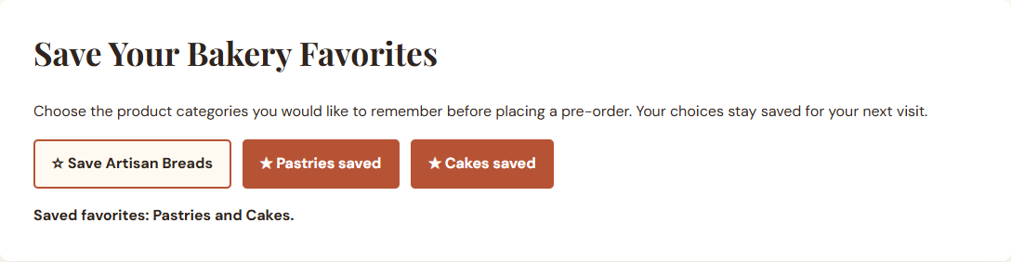
Caption: After the customer saves Pastries and Cakes, both buttons show saved states and the live message confirms both favorites.

Screenshot 2: Form Validation Feedback
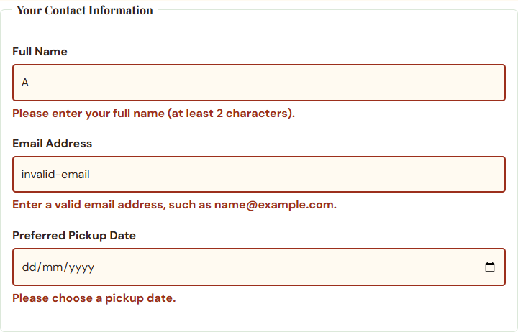
Caption: Invalid name, email, and pickup date values remain visible while specific error messages appear directly beneath their fields.

Screenshot 3: Browser Storage Working
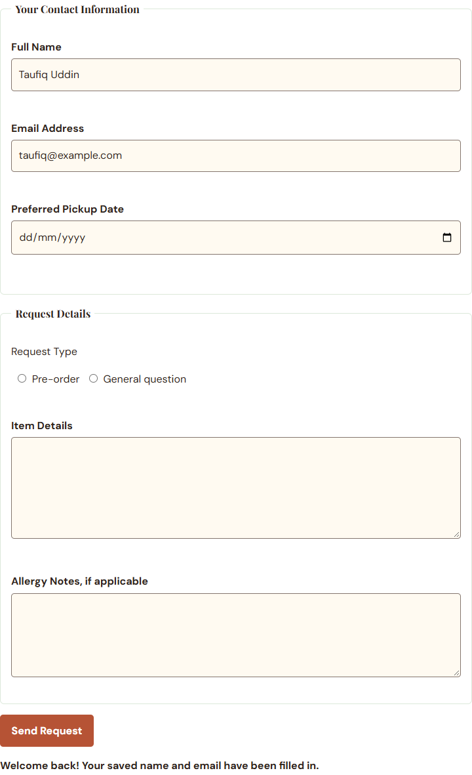
Caption: After a return visit, localStorage restores the saved name and email and displays the Welcome back message.

Section 5: Final Review
☒ The interactive feature works as expected after repeated testing.
☒ The page updates dynamically when the user takes the intended action.
☒ Validation prevents invalid submission and messages appear near fields.
☒ Valid form entries can proceed without unnecessary errors.
☒ Stored data saves and reloads correctly after refreshing or reopening the page.
☒ No JavaScript errors appeared during the completed local and deployed browser tests.
☒ Navigation and relative file paths work across all pages.
☒ The project remains readable and usable at mobile and desktop widths.
☒ The submitted links and all screenshots match the final verified version of the project.
☒ Public GitHub repository link included and opens without requiring login.

