Touchstone 4: Interactivity and Client-Side Data
Name: Taufiq Uddin
Course: Introduction to Web Development
Date: October 14, 2026
Selected Client: Client A — North Star Bakery

Section 1: Project Link
Working Project Link: https://abidhussain2330.github.io/north-star-bakery-touchstone-3/North_Star_Bakery_HTML_Files/
Repository Link: https://github.com/Abidhussain2330/north-star-bakery-touchstone-3

Section 2: Implementation Explanation

Feature Purpose
The Products page now includes a “Save Your Bakery Favorites” feature that lets customers save Artisan Breads, Pastries, or Cakes before they start a pre-order. This supports North Star Bakery’s goal of making it easier for local customers, families, and event planners to return to the product categories they want. Screenshot 1 shows that Pastries is visibly marked as saved and the page immediately confirms the saved selection.

User Interaction
A visitor clicks one of the category buttons, such as “Save Pastries.” JavaScript updates the button label, its pressed state, and the live status message without reloading the page. Clicking the same category again removes it, so customers are always in control of their saved list.

Form Validation
The Contact and Pre-Order form checks that the name has at least two characters, the email has a valid format, a pickup date and request type are selected, and the item details contain at least five characters. JavaScript prevents the form from submitting when any check fails and places a specific message beside the relevant field, such as “Enter a valid email address, such as name@example.com.” Screenshot 2 shows several messages and red field borders at once, while keeping the customer’s entered information available to correct.

Data Storage
The site uses localStorage for two helpful types of data: saved favorite product categories and the customer’s name and email after a valid pre-order request. Favorites are stored as soon as a category button is clicked, and contact details are stored after valid submission. When the user returns, JavaScript reads the stored data and restores it; Screenshot 3 shows the saved name and email already filled in with a “Welcome back” message.

Technical Design
The JavaScript is organized into small functions including initializeFavorites, initializePreorderForm, validatePreorder, renderFavorites, and restoreContactDetails. The productCategories array provides the IDs and labels used to generate favorite buttons, and the contactFieldIds array keeps validation feedback organized across the form. The storageKeys object centrally defines the localStorage names, while the validation function returns an errors object so feedback can be displayed consistently near each field.

Challenges Encountered
A challenge was making validation feedback clear without forcing a customer to restart the form. Native browser messages do not consistently appear next to the affected field, so I added novalidate to the form and used JavaScript to populate dedicated error elements beside each input. Testing in the browser confirmed that the form stays on the page, invalid entries remain visible, and each message clears when the customer corrects that field.

Section 3: Technical and Submission Checklist
☒ One meaningful JavaScript feature responds to a click, selection, or user input.
☒ The feature updates the page dynamically and clearly supports the client’s goals.
☒ JavaScript is organized into multiple functions rather than one large block.
☒ At least one array or object is used to manage data.
☒ For Advanced performance, at least two arrays or at least two objects are used.
☒ At least two JavaScript validation checks are implemented.
☒ Invalid form submission is prevented.
☒ Clear validation feedback appears near the relevant fields.
☒ Users can correct errors without losing the information they already entered.
☒ localStorage saves meaningful customer data.
☒ Stored data is loaded when the relevant page opens or reloads.
☒ All previous HTML, CSS, navigation, media, and form functionality still works.
☒ The working project link and public repository link are included.
☒ All six explanation sections are complete and use project-specific examples.
☒ At least three screenshots and captions are included below.

Section 4: Screenshots

Screenshot 1: Interactive Feature in Use
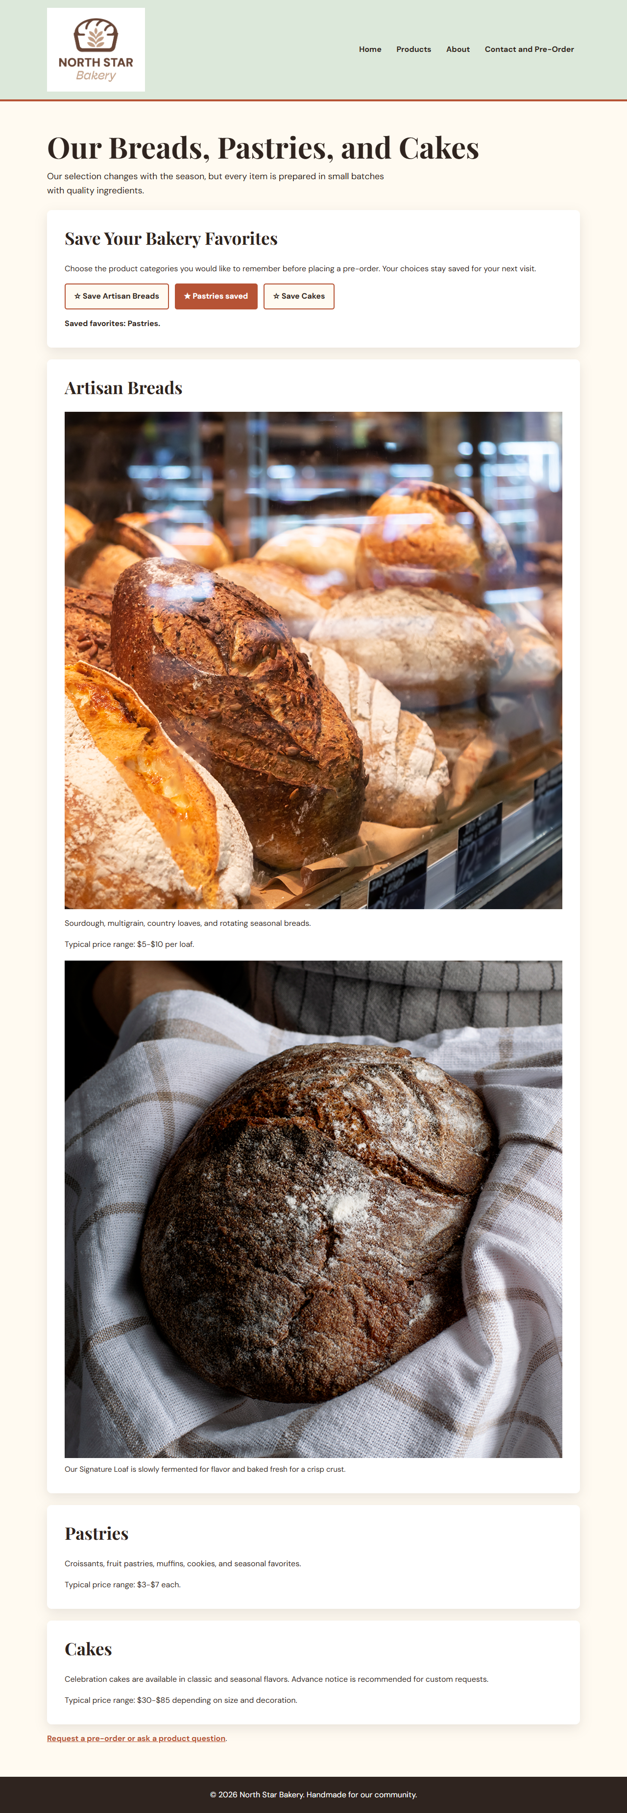
Caption: After the customer clicks Save Pastries, the page changes the button to “Pastries saved” and displays “Saved favorites: Pastries.”

Screenshot 2: Form Validation Feedback
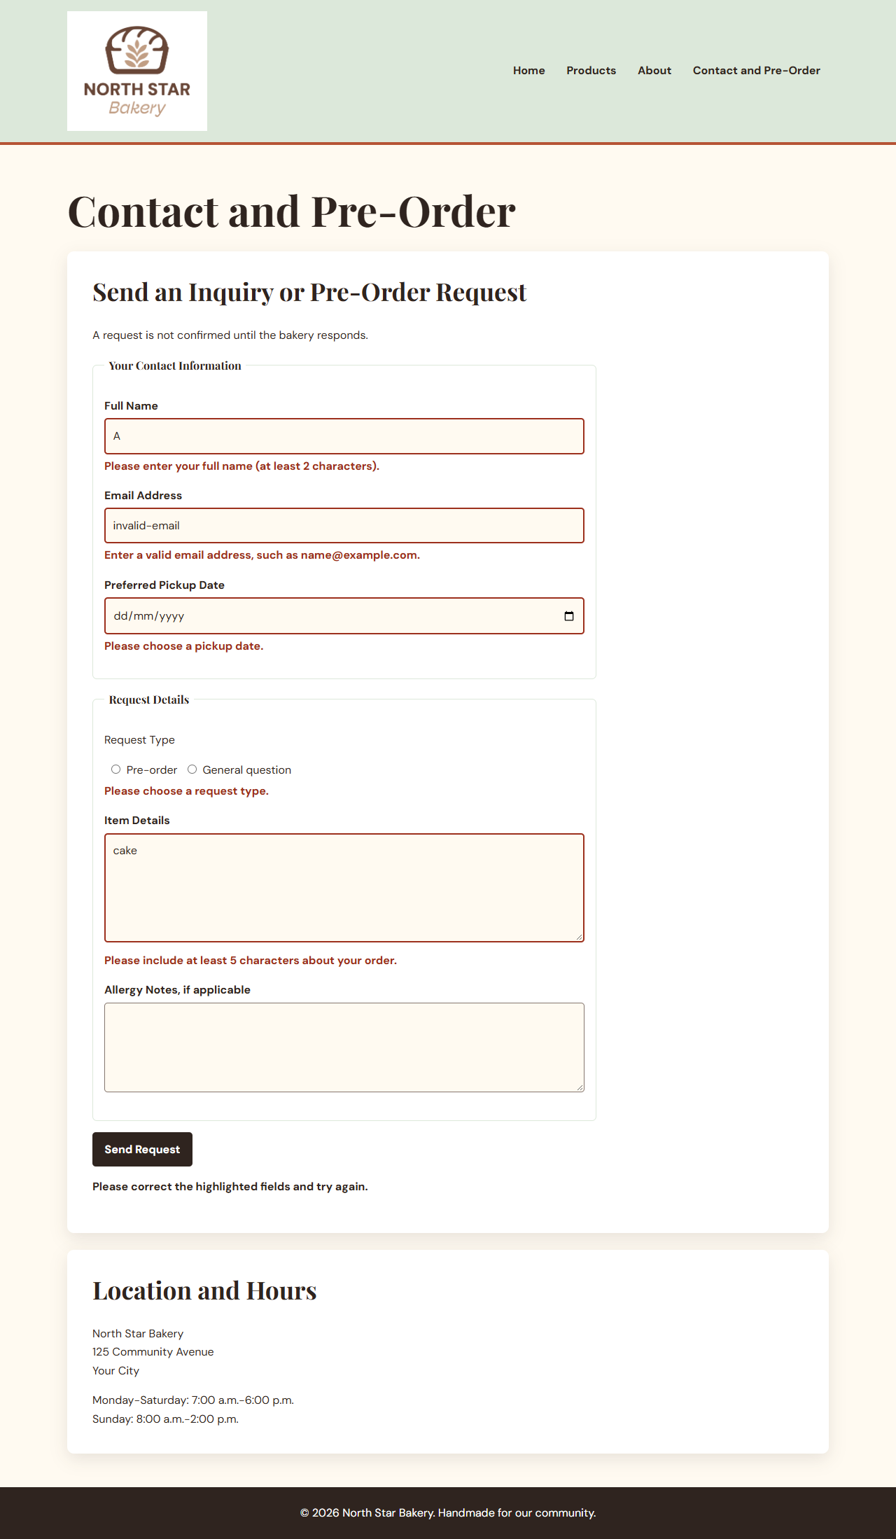
Caption: Invalid name, email, date, request type, and item details each receive a specific nearby error message while submission is prevented.

Screenshot 3: Browser Storage Working
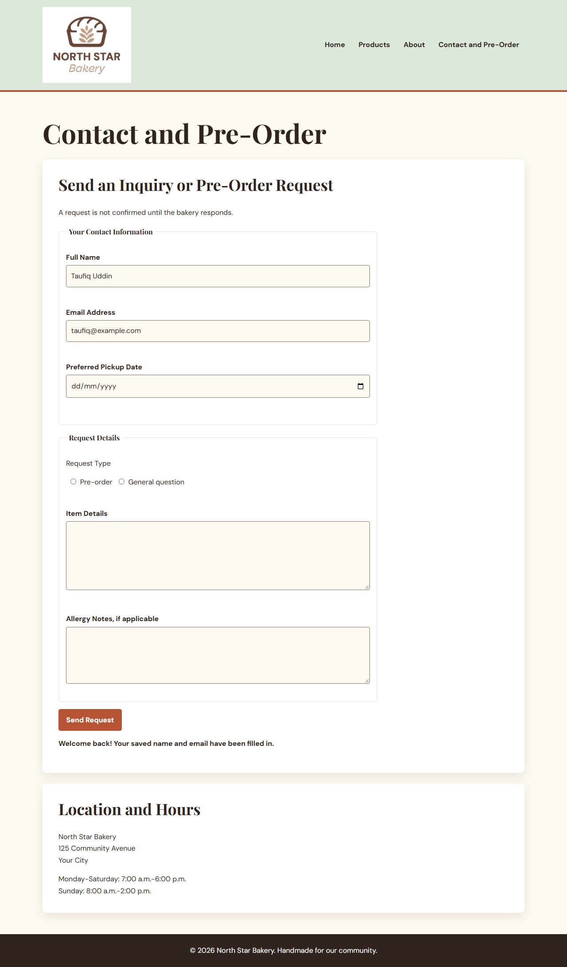
Caption: After a return visit, localStorage restores the saved customer name and email and displays a Welcome back message.

Section 5: Final Review
☒ The interactive feature works as expected after repeated testing.
☒ The page updates dynamically when the user takes the intended action.
☒ Validation prevents invalid submission and messages appear near fields.
☒ Valid form entries can proceed without unnecessary errors.
☒ Stored data saves and reloads correctly after refreshing or reopening the page.
☒ No JavaScript errors appear during normal browser use.
☒ Navigation and relative file paths work across all pages.
☒ The project remains readable and usable at mobile and desktop widths.
☒ The submitted links and all screenshots match the final version of the project.
☒ Public GitHub repository link included and opens without requiring login.

