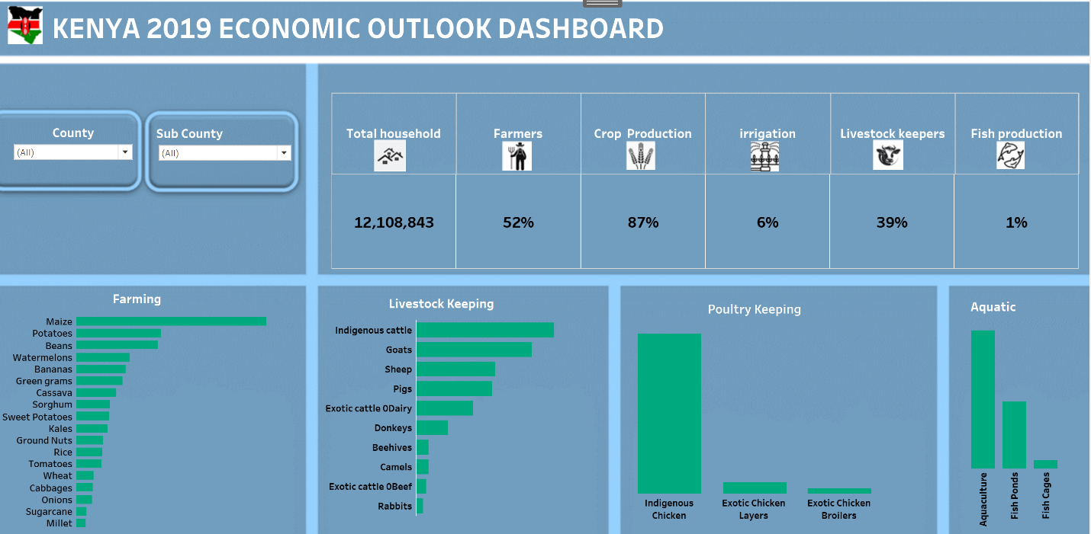Dashboard

GOAL

The purpose of a dashboard is to view the most important KPI’s and results at a glance. Dashboards are an interactive way to see how the company or project perform.

RESULT

By using dashboards, you will discover the right insights in an easy way. You can apply filters yourself and consult different graphs. By immediately having the right information available, correct decisions can be made.

PROJECT DURATION

On average, the development of a dashboard takes 2 weeks – 2 months. The development consists of two phases:

1. selection of KPI’s and design of the dashboard
2. collecting data and dashboard development

**](https://www.linkedin.com/in/abigael-cherotich/)**[](mailto:Abigaelcherotich867@gmail.com)

<https://www.linkedin.com/in/abigael-cherotich/>

[Abigaelcherotich867@gmail.com](mailto:Abigaelcherotich867@gmail.com)

Abigael Cherotich

**Contact**

+254704990012