Gradle

Gradle is an open-source build automation tool that is based on the concept of Apache Maven and Apache Ant.

It is capable of building almost any type of software.

It is designed for the multi-project build, which can be quite large.

It introduces a Java and Groovy-based DSL(Domain Specific Language) instead of XML(Extensible Markup Language) for declaring the project configuration.

It uses a DAG(Directed Acyclic Graph)to define the order of executing the task.

It provides support for the building, testing and deploying software on different platforms.

It has been developed for building automation on many languages and platforms, including java, scala, android, C/C++, and Groovy.

Gradle provides integration with several development tools and servers including eclipse, intelliJ , Jenkins and Android Studio.

Gradle is used by large projects such as Spring projects, Hibernate projects, and Grails Project.

Some leading enterprise companies like LinkedIn and Netflix use gradle.

Ant- Another Neat Tool

* After java build tool
* Drawbacks in MAKE created way to ANT
* XML based script
  + Hard to read
  + Difficult to maintain
* In ANT there are lack of conventions, each and everything has to be specififed from what we need to all the paths of the files.
* Both ANT and Maven are XML based and its hard to understand.

Whereas Gradle is DSL(Domain Specific Language) based, its easy to understand.

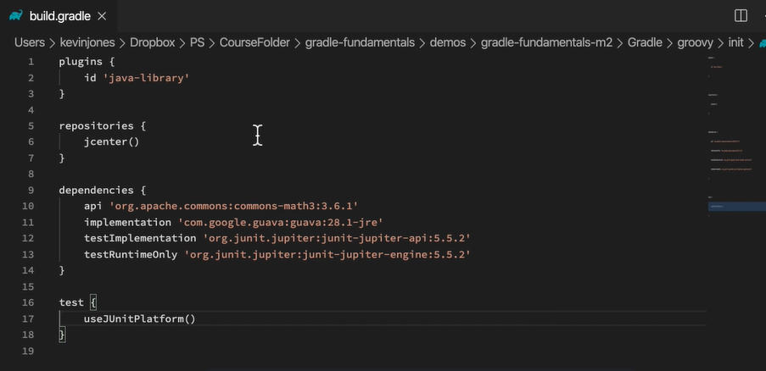

How is gradle used?

* Create a build script
  + Kotlin or Groovy DSL

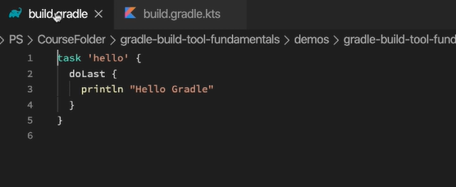

* The build scripts we write defines tasks like build, clean, etc
* We can run the appropriate task from the command line or IDE
* Command : gradle hello