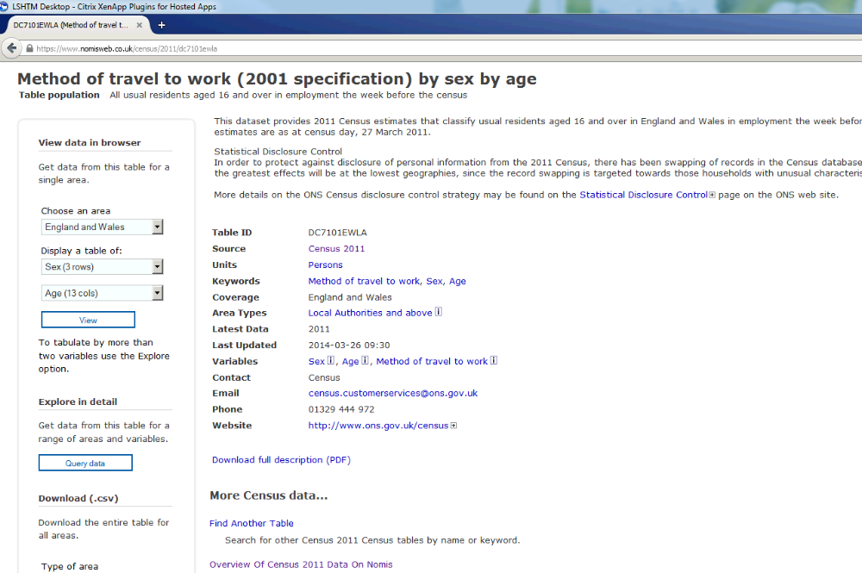
Based on total no., seems to be those age 16-[no maximum] (725 222 cyclists)

