Install MongoDB Community Edition
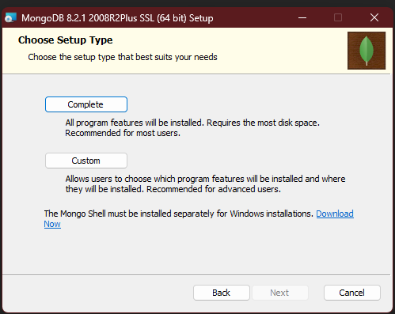
Select Complete.
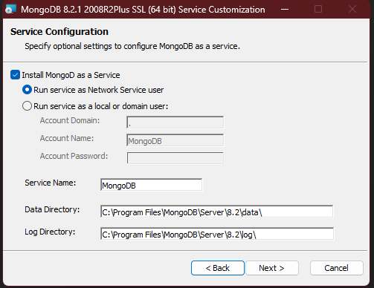
Select Default options and click Next

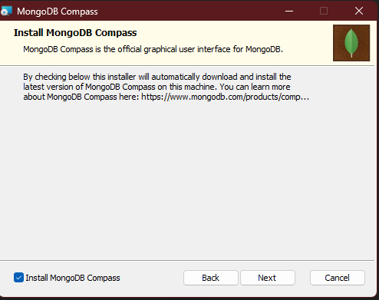
Ensure to check Install MongoDB Compass.

Install MongoDb Shell
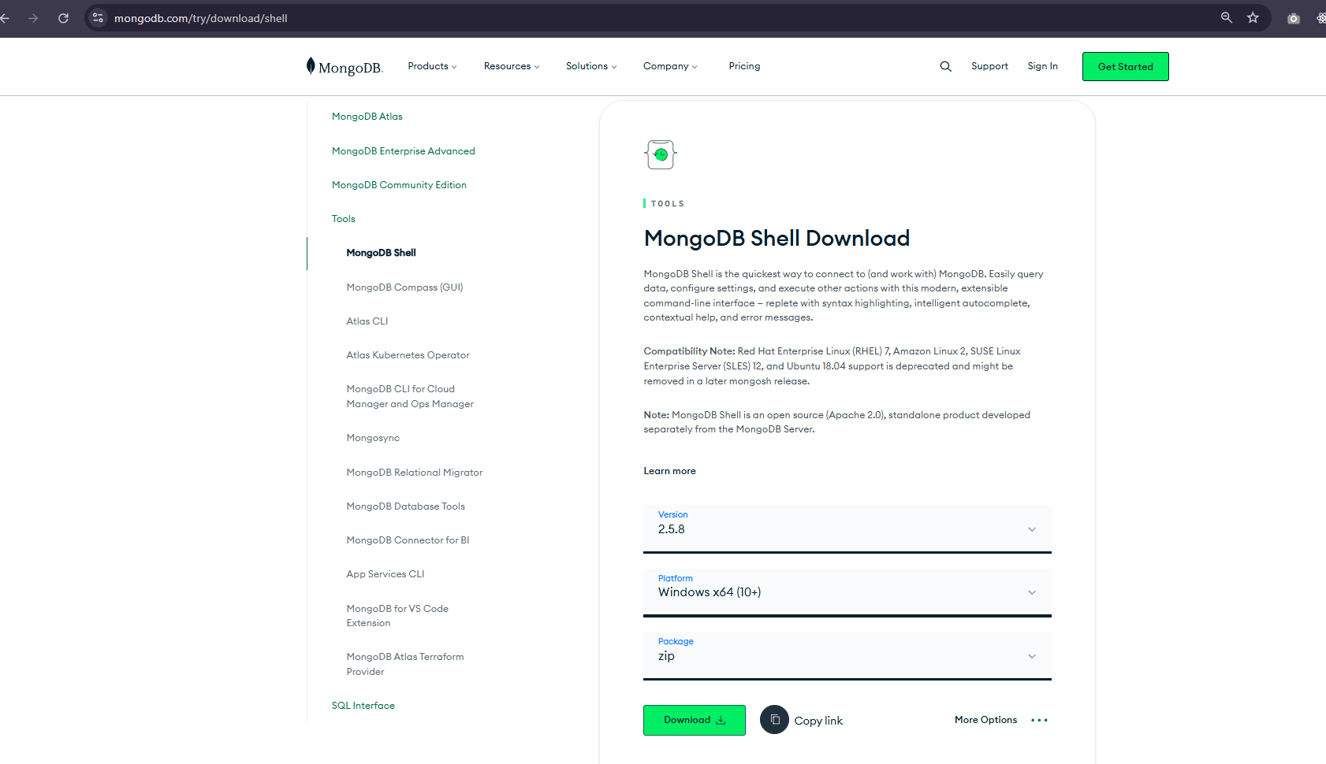
Extract the ZIP folder
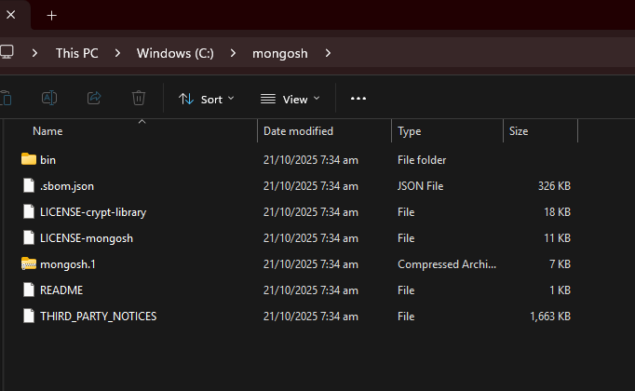
Open Bin folder and Copy the path.
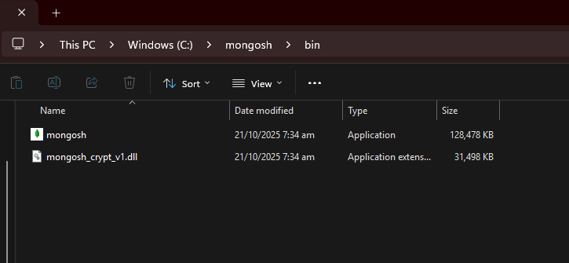
Add the path to the Environment Variables
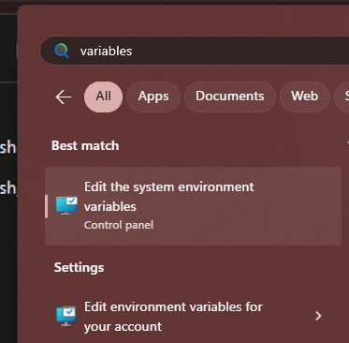

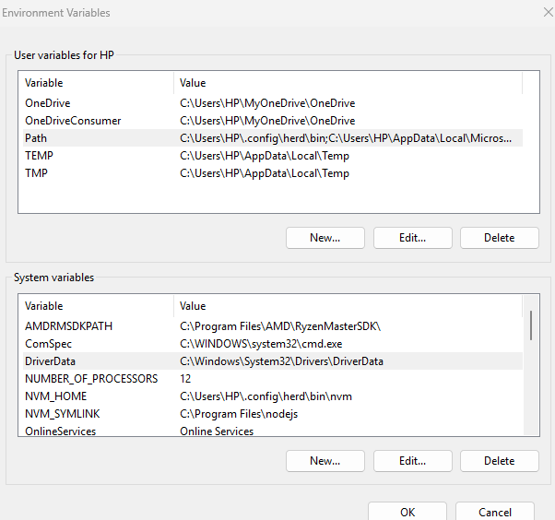
Select PATH and click Edit
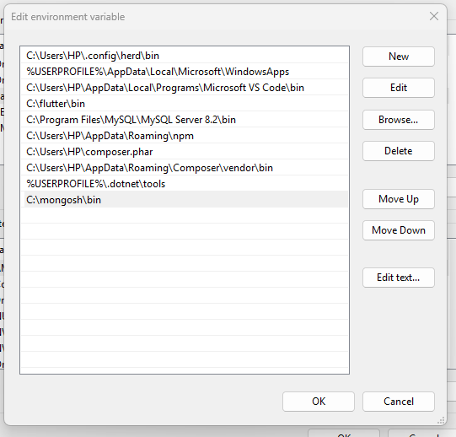\
Click New and paste the path.
Using Visual Studio Code
Install MongoDb Extension
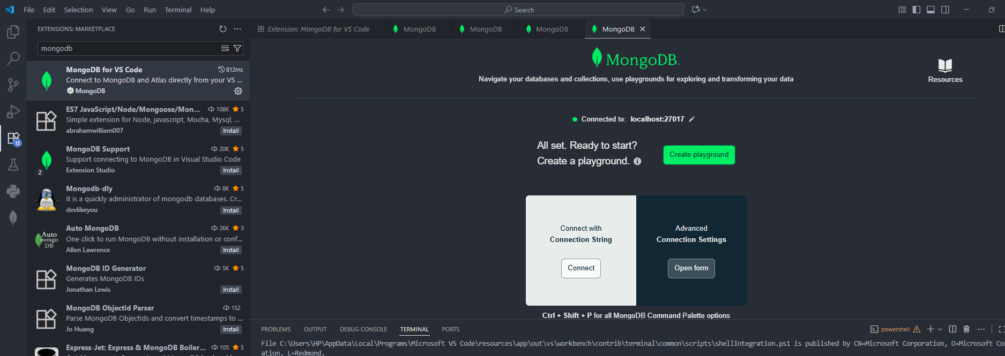
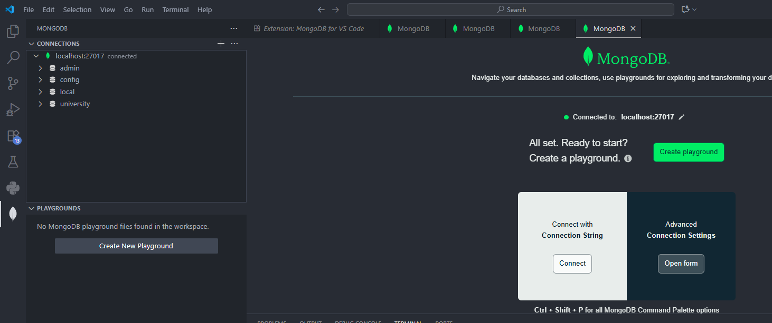
When it asks for Connection String, enter mongodb://localhost:27017
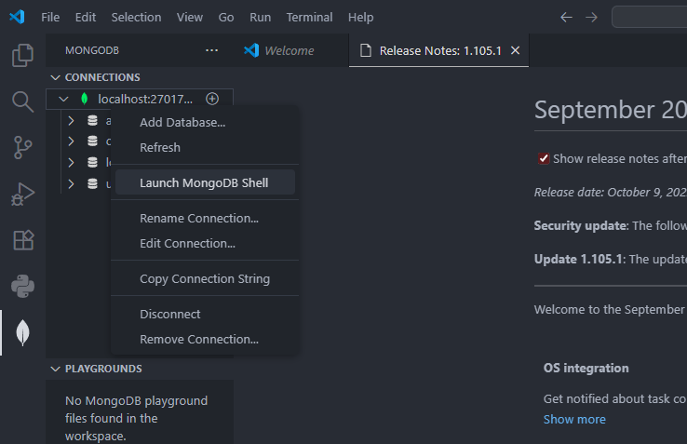
Select Launch MongoDB Shell

