# LABORATORY EXERCISE 5

# ADMIN, TEACHER, AND STUDENT DASHBOARDS

**Learning Objectives**

By the end of this laboratory exercise, students should be able to:

* Differentiate user roles and implement role-based access control (RBAC).
* Create distinct, role-specific dashboards within a single application.
* Develop dynamic navigation bars that change based on user role.
* Utilize CodeIgniter's Session librarry to manage user state and permissions across pages.
* Apply Bootstrap components and layout techniques to create informative and user-friendly dashboard interfaces.
* Implement authorization checks to restrict access to specific functionalities.

**Prerequisite student experiences and knowledge**

Before starting this exercise, students should have:

* Completed Laboratory Exercise 4 (User Authentication).
* A functioning login/registration system with a `users` table containing a `role` field.
* Understanding of CodeIgniter controllers, views, and session management.
* Basic proficiency in HTML, PHP, and Bootstrap grid system & components.
* Ability to write simple SQL queries and use the CodeIgniter Model.

**Background**

Most real-world applications serve different types of users, each with unique privileges and needs. A Learning Management System (LMS) is a prime example, typically involving Administrators (manage system, users, courses), Teachers (create content, manage grades), and Students (view courses, submit work).

This exercise focuses on building upon the authentication system from Lab 4. After a user logs in, they must be redirected to a dashboard tailored to their role. The application must also protect these dashboards, ensuring users cannot access areas reserved for other roles, a concept known as Role-Based Access Control (RBAC).

**Materials/Resources**

* Personal Computer with Internet Access
* XAMPP/WAMP/LAMP server installed
* CodeIgniter Framework (latest version)
* Visual Studio Code or any code editor
* Git and GitHub Account
* Web Browser (Chrome, Firefox, etc.)

**Laboratory Activity**

**Step 1: Project Setup**

1. Open your existing ITE311-LASTNAME CodeIgniter project.
2. Ensure your database has a **users** table with a **role** column: **admin, teacher, student**.
   * If not, create a new migration to alter the table.
3. Verify that the login process from Lab 4 correctly stores the user's **role** in the session data.
4. Open your previously created CodeIgniter project **ITE311-LASTNAME**.
5. Ensure your local server and database are running.
6. Open a terminal/command prompt in your project root.

**Step 2: Modify the Login Process for Unified Dashboard**

1. Navigate to your **Auth.php** controller.
2. Locate the **login()** method where user credentials are verified.
3. After a successful login, redirect everyone to a generic **dashboard** and implement a conditional check on the user's **role** from the session.

**Step 3: Enhance the Dashboard Method in the Auth Controller**

1. In your **Auth.php** controller, locate the **dashboard()** method.
2. Enhance this method to:

* Perform authorization check (ensure user is logged in).
* Fetch role-specific data from the database.
* Pass the user's role and relevant data to the view.

**Step 4: Create a Unified Dashboard View with Conditional Content**

1. Create or modify the dashboard view at **app/Views/auth/dashboard.php**.
2. Use PHP conditional statements to display different content based on the user's role.

**Step 5: Create a Dynamic Navigation Bar**

1. Modify your header template (**app/Views/templates/header.php**) to include role-specific navigation items accessible from anywhere in the application.

**Step 6: Configure Routes**

1. Ensure your **app/Config/Routes.php** has the correct route for the dashboard:
   * $routes->get('/dashboard', 'Auth::dashboard');

**Step 7: Test the Application Thoroughly**

1. Register or manually create users in your database with different roles (**admin, teacher, student**).
2. Log in with each user and verify:

* All users are redirected to the same **dashboard** URL.
* The dashboard displays different content based on the user's role.
* The navigation bar shows appropriate menu items for each role.
* Users can only see and access functionality intended for their role.

1. Test the logout functionality and access control.

**Step 8: Push to GitHub**

1. Commit your changes with a descriptive message.
   * At least five commits and it should be 4 days before submission are required to identify the progress of version control of the code or syntax.
   * Commit: "ROLE BASE Implementation"
2. Push the changes to your GitHub repository.

**Step 9: Vulnerable Checking**

1. Secure the **students** login and registration process so there is no vulnerability in the login procedures.

Output / Results

* Screenshot 1: The **user's table shows** users with different roles.
* Screenshot 2: When logged in as an admin, the dashboard view shows admin-specific content.
* Screenshot 3: When logged in as a teacher, the dashboard view shows teacher-specific content.
* Screenshot 4: When logged in as a student, the dashboard view shows student-specific content.
* Screenshot 5: The navigation bar displays different menu items for admin vs student users.
* Screenshot 6: The GitHub repository shows the latest commits.

**QUESTIONS:**

1. Authorization vs. Authentication: Based on your implementation, explain the difference between authentication from Lab 4 and authorization from Lab 5. Where in your code did you implement authorization?

-Authentication from Lab 4 is about verifying a user’s identity, which was done in Lab 4 by checking their username and password. While, authorization, is about determining what that authenticated user is allowed to do, which was implemented in Lab 5. Authorization was implemented in the Auth.php controller by passing the user’s role to the view and the dashboard.php view by using PHP conditionals to show specific content and links based on the session role.

1. How does the dashboard view determine which content to display? Explain the role of the session variable in this process.

-The dashboard view determine which content to display by checking the user’s role stored in the session variable. After a successful login, the user’s role is saved in the CodeIgniter Session. Additionally, the dashboard() method retrieves this role from the session and passes it to the view. Then, the view uses simple if/else statements to dynamically render the content and navigation bar tailored to that specific role.

1. If we wanted to add a new user role, what changes would be required in the current implementation to support this new role?

-Adding a new user role, such as “principal”, to the current implementation would require several changes such as updating the database to allow the new role in the users table, modifying the dashboard and navigation bar views with conditional logic to display tutor-specific content, and creating new controllers and methods for tutor functionalities, ensuring they are protected by an authorization check restrict access to only users with the new role.

**Output / Results**

**Screenshot 1**

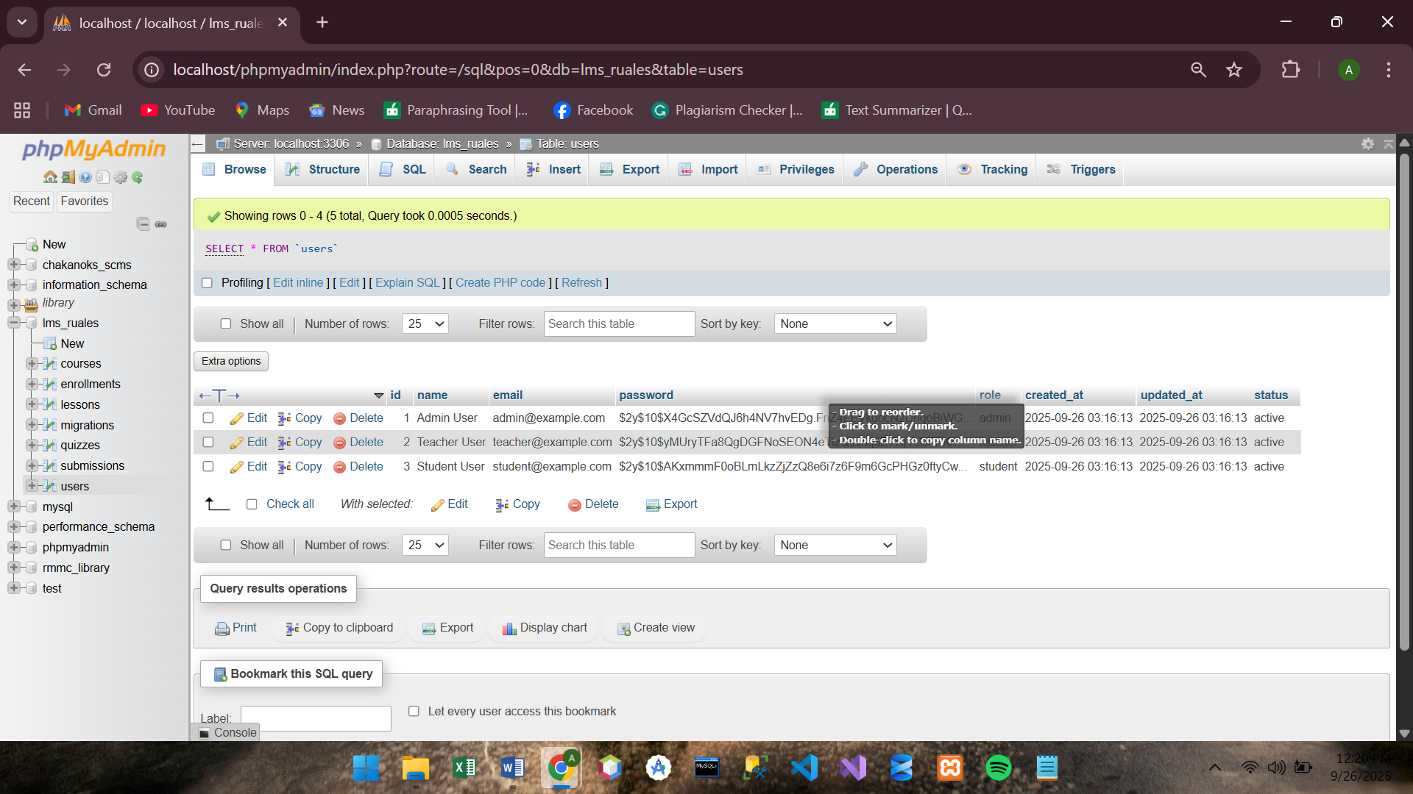

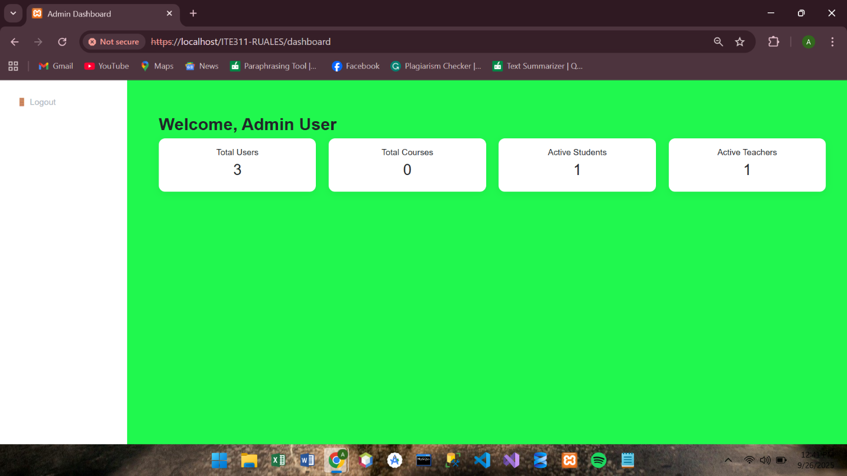**Screenshot 2**

**Screenshot 3**

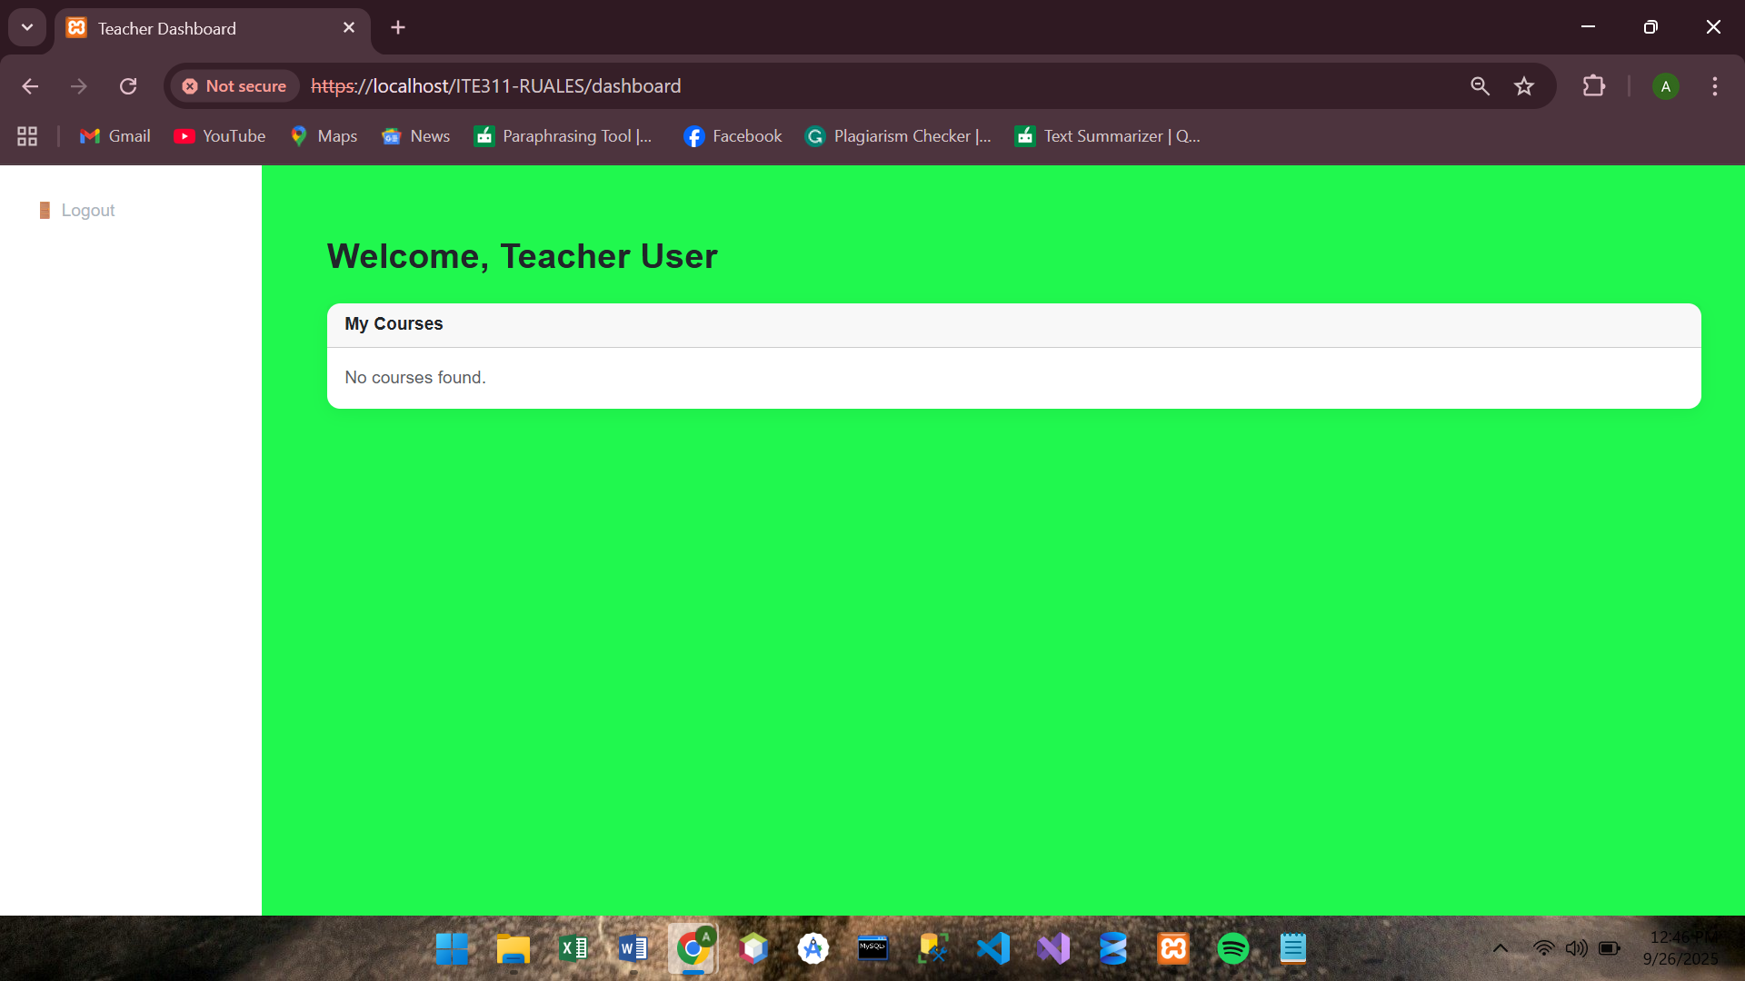

**Screenshot 4**

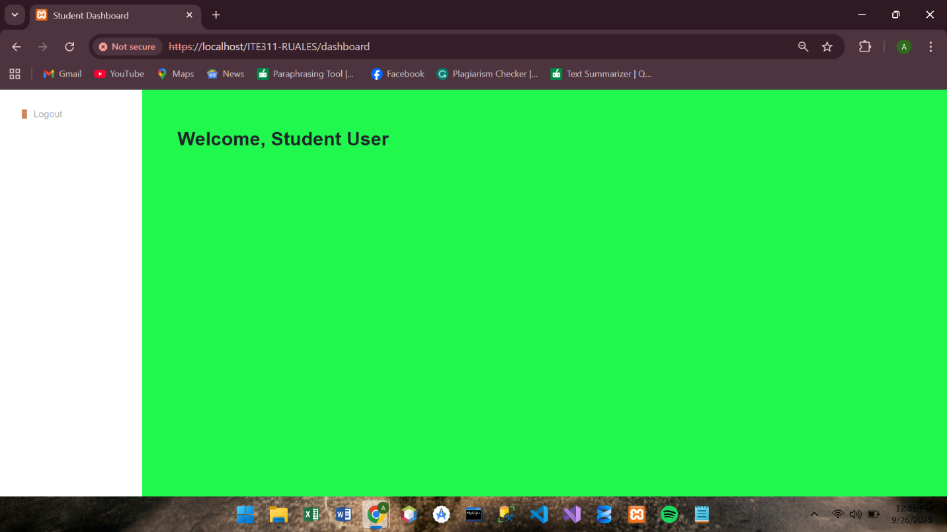

**Screenshot 6**

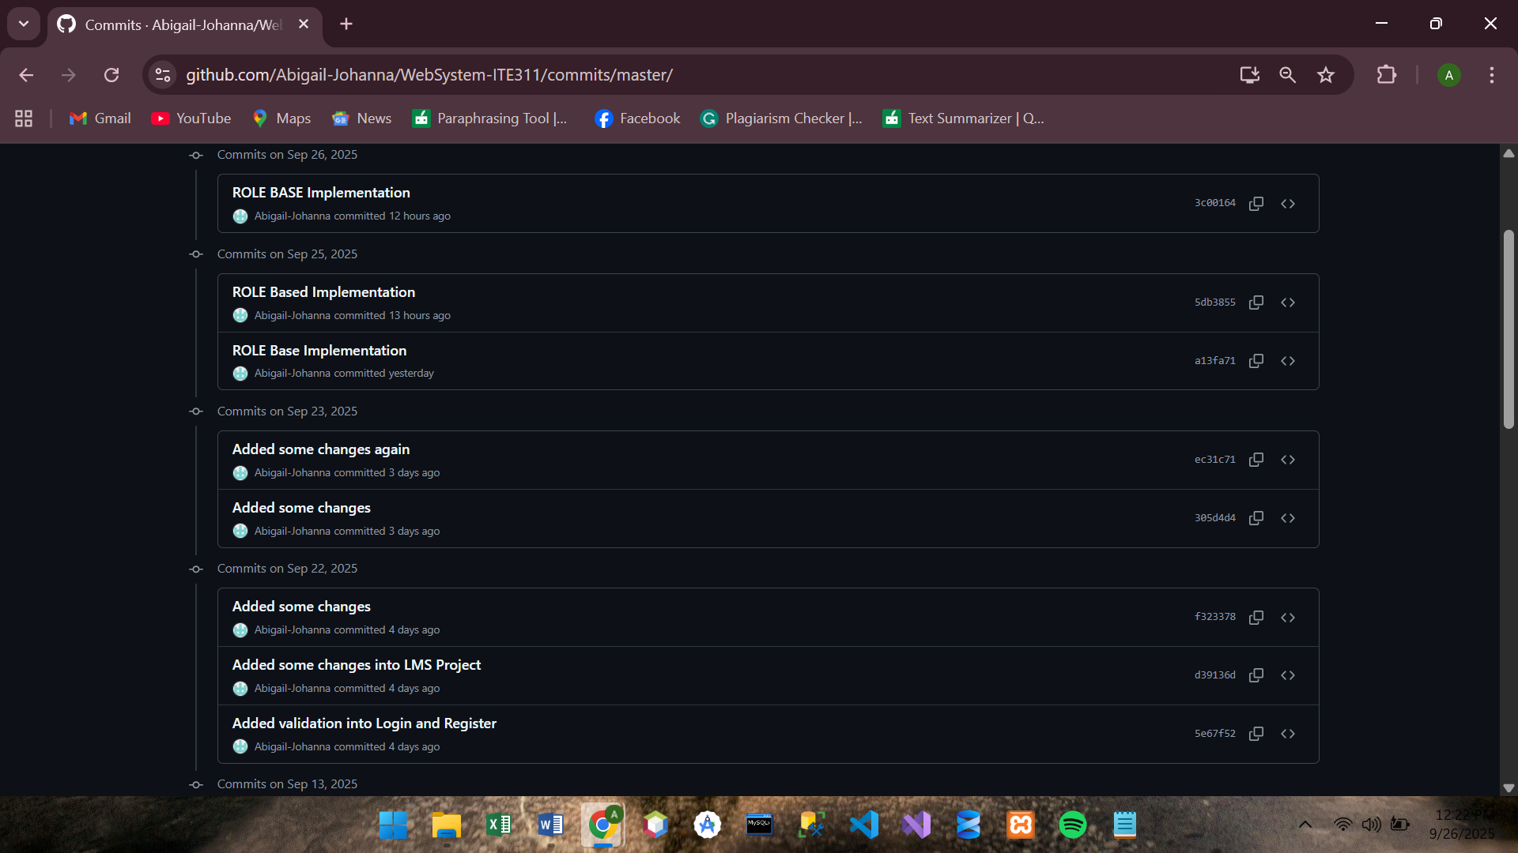



**Conclusion**

Therefore, I conclude that authentication and authorization are different but complementary security measures. Authentication confirms a user’s identity, a process completed during login, while authorization restricts their access to specific features and content based on their role. This was effectively demonstrated by using a single stored in the session. Moreover, adding new user roles to the system is a straightforward process that requires minimal, targeted changes. By updating the database, view files, and controller logic with new conditional statements, the application can easily scale to accommodate a variety of user types without requiring a complete rewrite.