# LABORATORY EXERCISE 6

# COURSE ENROLLMENT SYSTEM

**Learning Objectives**

By the end of this laboratory exercise, students should be able to:

* Design and create a new database table to manage relationships between users and courses.
* Implement server-side logic for handling course enrollments.
* Display user-specific data (enrolled courses) in a dashboard.
* Utilize jQuery and AJAX to create a dynamic, seamless user experience without page reloads.
* Understand and implement basic foreign key relationships in a web application.

**Prerequisite student experiences and knowledge**

Before starting this exercise, students should have:

* Completed Laboratory Exercise 5 (Admin and Student Dashboards).
* A solid understanding of the MVC architecture in CodeIgniter.
* Proficiency in writing database queries using CodeIgniter's Query Builder.
* Basic knowledge of SQL relationships (one-to-many).
* Familiarity with jQuery syntax and the concept of AJAX.
* Ability to create and style front-end components with Bootstrap.

**Background**

A core feature of any Learning Management System (LMS) is the ability for students to enroll in available courses. This involves creating a relationship between the **users** table (students) and the **courses** table. This relationship is typically stored in a pivot table. To enhance user experience, the enrollment process should be dynamic, allowing students to join courses without refreshing the page. This is achieved using jQuery AJAX to send a request to the server in the background, providing immediate feedback to the user.

**Materials/Resources**

* **Personal Computer with Internet Access**
* **XAMPP/WAMP/LAMP server installed**
* **CodeIgniter Framework (latest version)**
* **Visual Studio Code or any code editor**
* **Git and GitHub Account**
* **Web Browser (Chrome, Firefox, etc.)**

**Laboratory Activity**

**Step 1: Create a Database Migration for the Enrollments Table**

1. Create a new migration file for the **enrollments** table.

Run: php spark make:migration CreateEnrollmentsTable

1. Open the newly created file in app/Database/Migrations/.
2. In the up() method, define the table with the following fields:
   * id (primary key, auto-increment)
   * user_id (int, foreign key to **users** table)
   * course_id (int, foreign key to **courses** table)
   * enrollment_date (datetime)
3. In the down() method, define how to drop the table.
4. Run the migration: php spark migrate.

**Step 2: Create the Enrollment Model**

1. Navigate to app/Models/ and create a file named EnrollmentModel.php.
2. Create a model class with methods to:

* enrollUser($data): Insert a new enrollment record.
* getUserEnrollments($user_id): Fetch all courses a user is enrolled in.
* isAlreadyEnrolled($user_id, $course_id): Check if a user is already enrolled in a specific course to prevent duplicates.

**Step 3: Modify the Course Controller**

1. Open your Course.php controller (or create it if it doesn't exist).
2. Add a new method, enroll(), to handle the AJAX request.

* This method should:
* Check if the user is logged in.
* Receive the **course_id** from the POST request.
* Check if the user is already enrolled.
* If not, insert the new enrollment record with the current timestamp.
* Return a JSON response indicating success or failure.

**Step 4: Update Student Dashboard View**

1. Open/Check the student dashboard view file.
2. Create a section to **Display Enrolled Courses**. Use a Bootstrap list group or cards to iterate over and display the courses returned by **EnrollmentModel::getUserEnrollments()**.
3. Create another section for **Available Courses**. Display a list of courses with an **Enroll** button next to each.

**Step 5: Implement AJAX Enrollment**

1. In the **Available Courses** section of the dashboard, add a **data_course_id** attribute to each **Enroll** button containing the specific course ID.
2. Include the jQuery library in your view if it's not already included.
3. Write a jQuery script that:

* Listens for a click on the **Enroll** button.
* Prevents the default form submission behavior.
* Uses **$.post()** to send the **course_id** to the /course/enroll URL.
* On a successful response from the server:
* Displays a Bootstrap alert message.
* Hides or disables the **Enroll** button for that course.
* Updates the **Enrolled Courses** list dynamically without reloading the page.

**Step 6: Configure Routes**

1. Update app/Config/Routes.php to include a route for the enrollment action.

**$routes->post('/course/enroll', 'Course::enroll');**

**Step 7: Test the Application Thoroughly**

1. Log in as a student.
2. Navigate to the student dashboard.
3. Click the **Enroll** button on an available course and verify:

* The page does not reload.
* A success message appears.
* The button becomes disabled or disappears.
* The course appears in the **Enrolled Courses** list.

**Step 8: Push to GitHub**

1. Commit your changes with a descriptive message.
2. Push your changes to your GitHub repository.

**Step 9: Vulnerable Checking**

1. Test for Authorization Bypass
   * Log out of the application and attempt to directly access the enrollment endpoint via Postman or browser console by sending a POST request to /course/enroll with a course_id parameter.
   * Verify that the server returns an unauthorized error instead of processing the enrollment.
2. Test for SQL Injection
   * While logged in, use browser developer tools to modify the AJAX request and change the course_id value to 1 OR 1=1.
   * Check if the application properly validates the input and prevents SQL injection attacks.
3. Test for CSRF (Cross-Site Request Forgery)
   * Check if your enrollment form includes CSRF protection tokens.
   * Verify that CodeIgniter's CSRF protection is enabled in app/Config/Security.php.
   * Attempt to make an enrollment request without a valid CSRF token and confirm it is rejected.
4. Test for Data Tampering
   * As a student, try to enroll another user in a course by modifying the user ID in the request.
   * Verify that the server-side code uses the logged-in user's session ID rather than trusting client-supplied user IDs.
5. Test for Input Validation
   * Attempt to enroll in non-existent courses by sending invalid course_id values.
   * Verify that the application properly validates that the course exists before creating an enrollment.

Output / Results

* Screenshot of your database's **enrollments** table structure (phpMyAdmin or equivalent).
* A screenshot of the student dashboard showing the **Available** and **Enrolled Courses** sections is attached.
* A screenshot of the browser's developer tools (Network tab) shows the successful AJAX POST request and response when enrolling in a course.
* A screenshot of the GitHub repository with the latest commit for this exercise.

**QUESTIONS:**

1. What is the purpose of the **enrollments** table? Why is it necessary, instead of just adding a **course_id** column to the **users** table?

-The purpose of the enrollments table is to connect the users and courses tables. It holds user_id, the courses_id, and the enrollment date. It is necessary since this makes sure that student can sign up for as many courses as they want without messing up the data.

1. Explain the role of the **isAlreadyEnrolled()** method in the Model. What potential issue does it prevent?

-The role of the isAlreadyEnrolled() method in the Model is to make sure the data is safe, it basically checks the database to see if a student is already enrolled in a certain course. Also, it prevents duplicate in enrollments which is a potential issue. If a student click the “Enroll” button twice by mistake, the check will say “Yes, they are in the course,” and the system will not save a second copy.

1. Describe the client-side and server-side steps when students click the **Enroll** button until they receive confirmation.

-When students click the Enroll button on thr client-side, a jQuery script intercepts the action and sends an AJAX POST request which carry the course_id only to thr server. While, on the server side, the controller method takes charge, it confirms if the student’s identity matches and then uses the model to perform the duplicate check. If everything is secure and valid, the enrollment record is inserted on the database. Lastly, the server sends a JSON response back to the cient, allowing the script to immediately update the user interface which displays a success message and removing the course on the available courses while hiding the Enroll button for the certain course without forcing the page to reload.

**Output / Results**

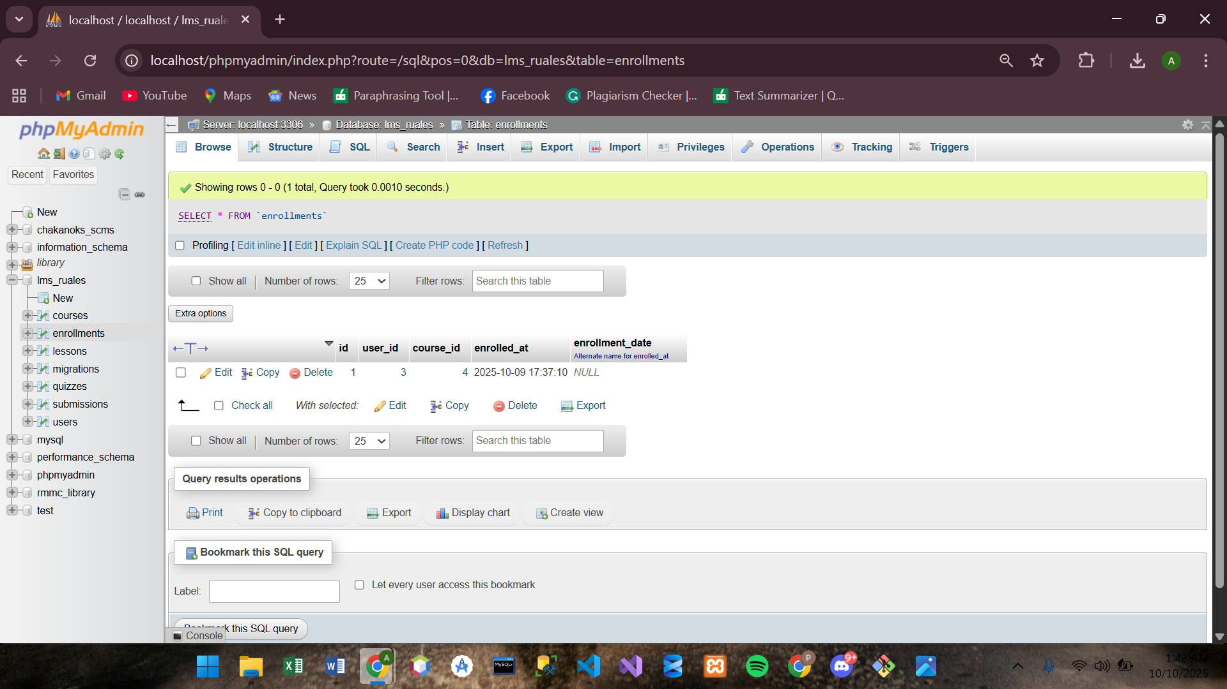

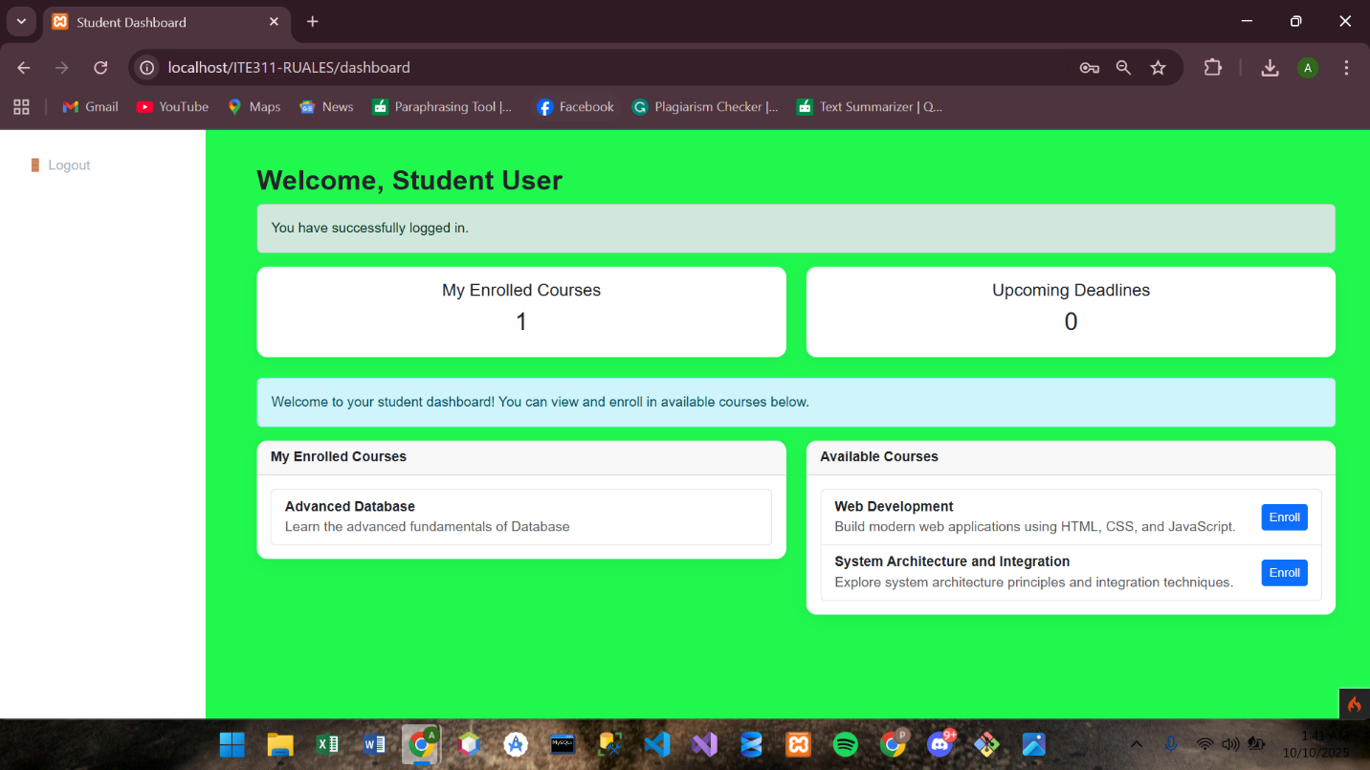

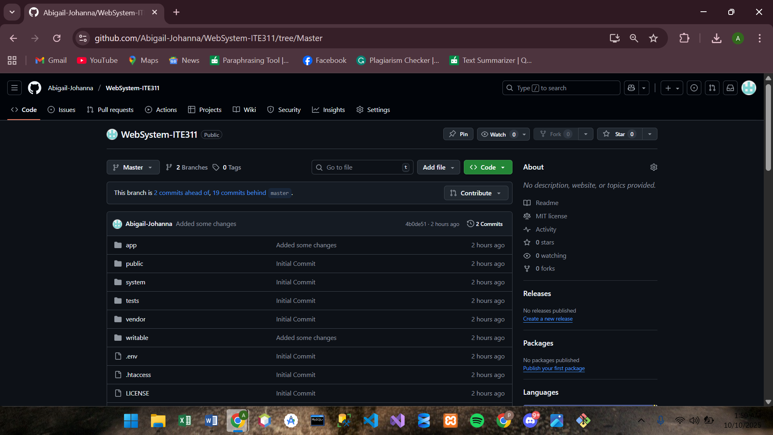

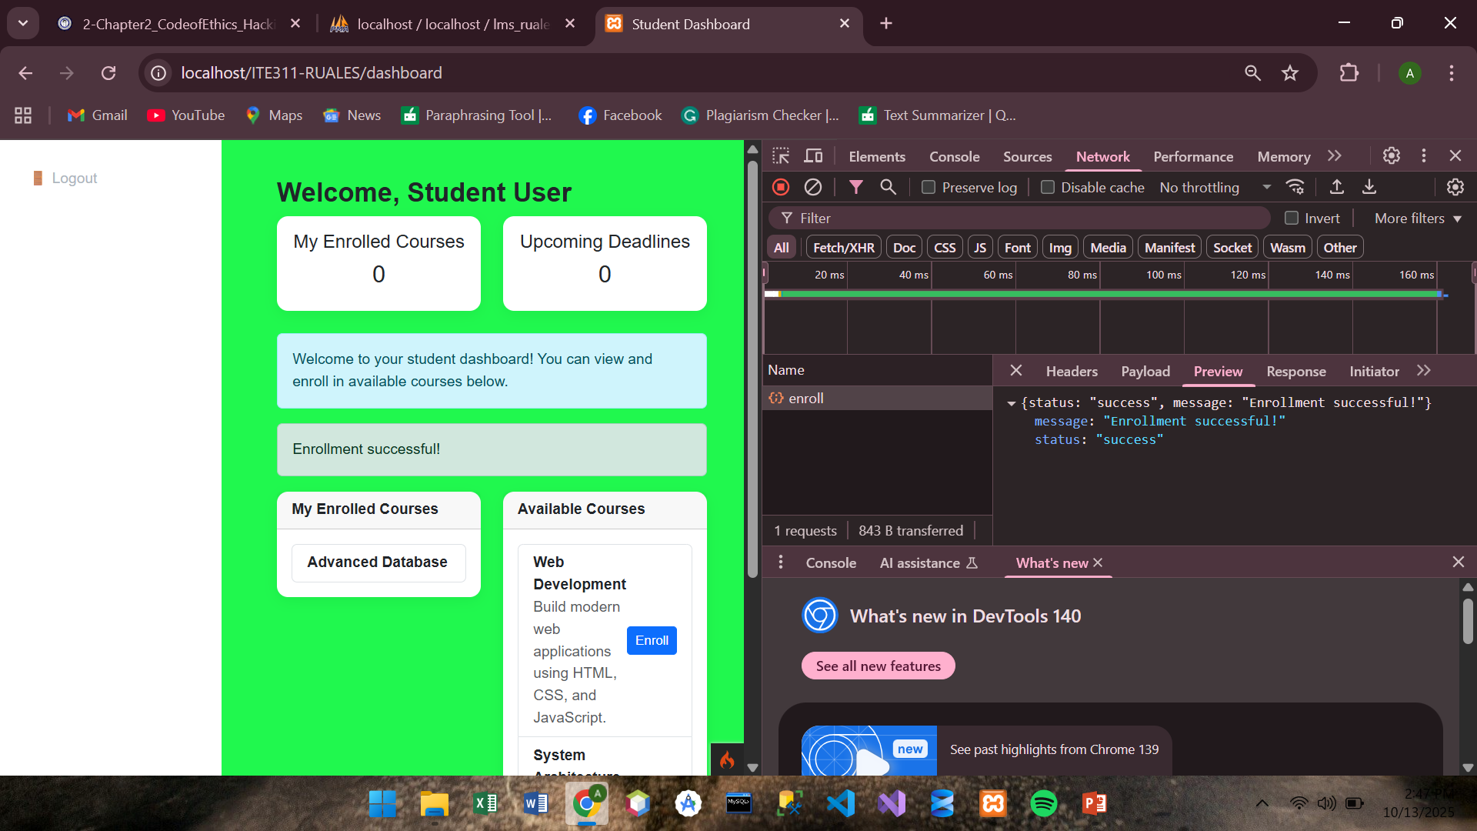

**Conclusion**

Therefore, I conclude, I successfully built the course enrollment feature that allow students to join courses directly from the dashboard. I created the enrollments table to connect users and courses, which made is possible for students to enroll in multiple courses without any data problems. I also leaerned how to use AJAX with jQuery so the enrollment process happens smoothly without realoding the page. Overall, this laboratory helped me improve my skills in database management and creating interactive web system using CodeIgniter.