Coursework Part A-Project Proposal/Plan

Date: 5/11/2021
Student number: 201918010104
Class: L5C-4

Content
1. Product Introduction 3
2. Background Research 3
3. Technologies 5
3.1 Hardware Facilities 5
3.2 Software Facilities 5
3.3Infrastructure 6
4. Project Team Requirements 8

Pet Mutual Aid APP
Product introduction
This project will develop a Pet mutual aid APP. This APP will help owners deal with pets they don't want or can't raise anymore, especially pet cats and dogs. The target users of the App are college students and postgraduate students who are about to graduate in Chengdu with house cats and dogs. This APP will allow users to provide information about these pets and push it to users who want to adopt pets for helping them give their pets to families in need of pets to avoid these pets being abandoned in university and cause some issues. The system will also improve the quality of life of people living in the area and reduce their risk of being attacked by stray animals. In addition, the ecosystem of the region will be indirectly protected. More importantly, users can also contact official managers through the specified contact information to obtain more support and help.

Background Research
With the development of science and technology and the progress of the times, social media has gradually become one of the main ways for people to communicate. The pet industry is also developing more and more rapidly. Pets have changed from a simple appreciation to a more important spiritual life partner. At present, China's pet market has great potential and huge development space. So far, China has many forums, post bars, official accounts and APPs related with pets, but there are some limitations. Mainstream pet APPs, such as pet mainland, mainly focus on mall transactions (purchase of pets and pet products), supplemented by community social networking (sharing pet life, communication between pet owners), pet health and other functions. They focus on providing a communication platform for users to allow them to share their pet rearing experience and daily life about their lovely cats or dogs, and provide systematic knowledge about pets to novices. These platforms connect users living in different places, so that people who should not have known are connected because of pets. The excessive attention to the function of the mall and social function leads to the neglect of the adoption. But pet adoption is only a small part of these platforms. There is almost no platform for pet adoption. The adoption and placement sections of these pet related platforms usually have no screening mechanism, which cannot enable users to quickly obtain the information they want. At the same time, there are a lot of advertisements on many platforms, such as the Chengdu pet zone of Baidu Post Bar and the adoption zone of goodmaoning.com. Some people try to sell some pet related products that seem easy to use but are actually fake to users, some recommend unsafe group chat to users, and some hide advertisements in their articles. Users need time to think and filter whether this information is useless advertising information, and cannot get results quickly. This will greatly waste users' time and energy and reduce efficiency. This APP will only focus on the service of adoption and placement, so as to avoid the provision of other services affecting the quality of the APP and facilitate users to quickly and accurately find the channel with the largest traffic and most suitable for them. In addition, this APP will only provide services for college students and graduate students in Chengdu, which greatly avoids the phenomenon of mixed users and facilitates real users to use the APP normally.

Technologies
- Hardware Facilities: the APP will be updated and used synchronously on the web page.
- Software Facilities: In order to run on Windows XP or later versions and ensure the persistence of the APP, MySQL database management system is required. The request to access MySQL database will be realized through SQL statement. Spring data JPA is used to develop the database layer. At the same time, the project adopts the object-oriented design method, which requires the front-end and back-end technologies of web server. Sublime Text, IntelliJ IDEA, Visual Studio Code and other compilers will be used as important development tools to realize these technologies. The core framework will refer to the representative state transfer style, which is jointly completed by Spring Boot 2 and Vue. Vue will be completed by Vue, Vuex, Vue-router and Vuetify. Front end development will use vue.js based element and vux.
- Infrastructure: the campus Pet Rescue APP system mainly includes two functional components
  - Administrator Management System
    - Management Function
The administrator can carry out management functions such as personnel management, animal management, authority management and article management through the system.
    - Maintenance Function
Through the system, the administrator can deal with the illegal members such as prohibition, review the information uploaded by users and other maintenance functions.
  - User System
    - Login Registration
Users can log in through the system and register information. The system will automatically save the corresponding user login information so that users can use the system quickly and conveniently next time.
    - Publishing Function
After being approved by the administrator, users can publish articles to provide basic information such as pet name, variety, weight, height and so on.
    - Private Message System
Through this function, users can send private information to the publisher of the article, learn more about pets, and reach a consensus with the caregiver to adopt pets.
    - Comment Function
Users can comment on the approved articles, like the comments they like, and can reply to all comments.
    - Filter View Function
Users can filter articles according to their own needs and use information such as cities and pet varieties to quickly obtain the information they want.

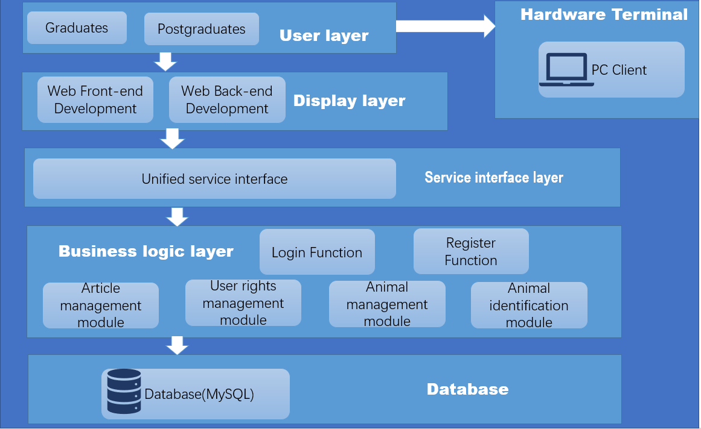
Figure 1: Pet Mutual Aid APP Facility Architecture Diagram

Project Team Requirements
Job description
- Participate in project requirement analysis and detailed design of system framework and core modules.
- Complete the design, development and programming of corresponding module software according to the development task and development progress.
- Be responsible for improving the defects in the system test and acceptance report.
- Responsible for the preparation of development documents such as software change description and function characteristic description.
Job requirements
- Have a clear understanding and design ability of software development architecture
- Rich experience in Web front-end development, proficient in front-end development languages such as HTML, CSS and JavaScript.
- Familiar with Spring Boot 2 Framework and Vue.js Framework.
- Good communication skills, teamwork and basic English communication skills.
- Strong willing and ability to learn new things.

