Specification Number: |  | G1 | Product Code: | G
Product Name: | Broadmere Pre-Cooked Chicken Breasts 198-255g (7-9 oz)
Product Description: |  | Steam Cooked Frozen Chicken Breasts 198-255g
Barcode (outer case) |  | None
Barcode (inner bag) |  | 5030466794026

Manufacturer: | George Morris & Son  Units 55-57 Livestock Market  Hall Road  Norwich  Norfolk  NR4 6EQ
Approved Plant Number: |  | UK UN-012-P
Telephone: | 01603 250615 |  | Website: | cookedchickenportions.co.uk
Fax: | 01603 259893 |  | Email: | mailbox@gmorrisandson.co.uk
Commercial Contact: | Simon Morris |  | Email: | simon@gmorrisandson.co.uk
Accounts Contact: | Sue Morris |  | Email: | sue@gmorrisandson.co.uk
Technical Contact: | Gina Blake |  | Email: | gina@gmorrisandson.co.uk

Ingredients | Country(s) of Origin
Chicken (100%) | EU
Natural Flavour Paprika | India
Caramelised Sugar Syrup | UK

Pack configuration per case: | 4 bags x 10 Breasts | Pallet Configuration: | 80 cases
Declared Minimum Net Weight per bag: | 1.985 kg | Minimum Net Weight per case: | 7.94 kg

Nutritional Information
Typical values per 100g of edible portion
Breast Portion
Energy | 171 kcal
Total Fat | 6.4g
Of Which
Saturates |  | 1.51g
Mono-unsaturates |  | 2.63g
Polyunsaturates |  | 1.89g
Carbohydrate |  | <0.1g
Of Which
Sugars |  | <0.1g
Fibre |  | 1g
Protein |  | 27.9g
Salt |  | 0.1250g

Microbiological Standards
(cfu/g)
Test | Frequency | Target | Max Acceptable
TVC | Daily | <10³ | 10⁴
E Coli | Daily | <20 | 20
Enterobacteriaceae | Daily | <10 | 10²
Staphlycoccus Aureus | Daily | <20 | 20
Salmonella (in 25g) | Daily | Not Detected | Not Detected
Listeria (in 25g) | Daily | Not Detected | Not Detected
Clostridium Perfringens | Daily | <10 | 10²
Campylobacter(in 25g) | Daily | Not Detected | Not Detected
Laboratory Used: | M S Laboratories | Accreditation: | UKAS

Allergen/Intolerance Information
Description | Free From?  Y/N
Peanuts | Yes
Nuts e.g. almonds, hazelnuts, walnuts, brazil nuts, cashews, pecans, pistachios and macadamia nuts | Yes
Sesame seeds | Yes
Eggs | Yes
Milk | Yes
Celery | Yes
Cereals containing gluten (wheat, barley, rye and oats) | Yes
Crustaceans (such as lobster and crab) | Yes
Fish | Yes
Mustard | Yes
Soybeans | Yes
Sulphur dioxide and sulphites | Yes
Lupin | Yes
Molluscs | Yes
Antioxidants | Yes
Colours | Yes
Artificial Colours | Yes
Phenylalanine | Yes
Sugar / Sweeteners | Yes
Preservatives | Yes
Artificial Preservatives | Yes
Flavourings | No
Artificial Flavourings | Yes
Benzoates | Yes
HVP / Acid HVP | Yes
Genetically Modified Ingredients | Yes
Mechanically Recovered / Separated Meat | Yes

Special Dietary Requirements
Suitable for | Yes/No
Vegetarians | No
Vegans | No
Kosher | No
Halal | Yes
Organic | No
Diabetics | Yes
Coeliacs | Yes
Additive Free | Yes

Organoleptic Standards
Appearance: | Whole chicken breast, with wing on. Dipped into a flavour dip before cooking, giving a slight brown colouring on the skin, similar to that achieved by roasting.
Aroma: | Clean cooked chicken aroma.
Flavour: | Typical fresh roast chicken flavour.
Texture: | Moist and succulent texture, even after re-heating.

Packaging
 | Material | Size | Weight
Primary | 4% EVA clear low density polythene with side welds, gauge 75µm. Flexographic 3 colour print on both sides. | 508mm long  305mm wide | 18.8g
Secondary | Corrugated cardboard 4 flap box.  150 White Kraft outer liner, 150 Waste based centre C flute, 150 Kraft inner liner.  Black print on two sides and product detail label | 395mm long  295mm wide  216mm high | 290.58g
Tertiary/Transit

Storage
Keep frozen at -18°C or colder
Once thawed keep at 4°C or colder for max 24 hours
Shelf Life
18 months from time of manufacture
Batch Coding
On outer case only
Pack Day | Julian day number
Box Number | Sequential number
Best Before Date | 550 days from pack date

Reheating Instructions
Always thaw before use: | 4-5 hours at room temperature or overnight in a refrigerator.
Deep Fry | Heat oil to 170°C/325°F and cook for approx. 8 minutes
Grill | Grill under a high heat for approx. 15 minutes, turning once.
Oven | Pre-heat oven to 220°C/425°F/Gas Mark 6  Place in a roasting dish and cook for approx. 25-30 minutes
Microwave: | Times vary according to the power of the microwave.  Based on a commercial microwave re-heat on full power for approx. 5-6 minutes, turning half way through cooking.
Always ensure product is piping hot before serving

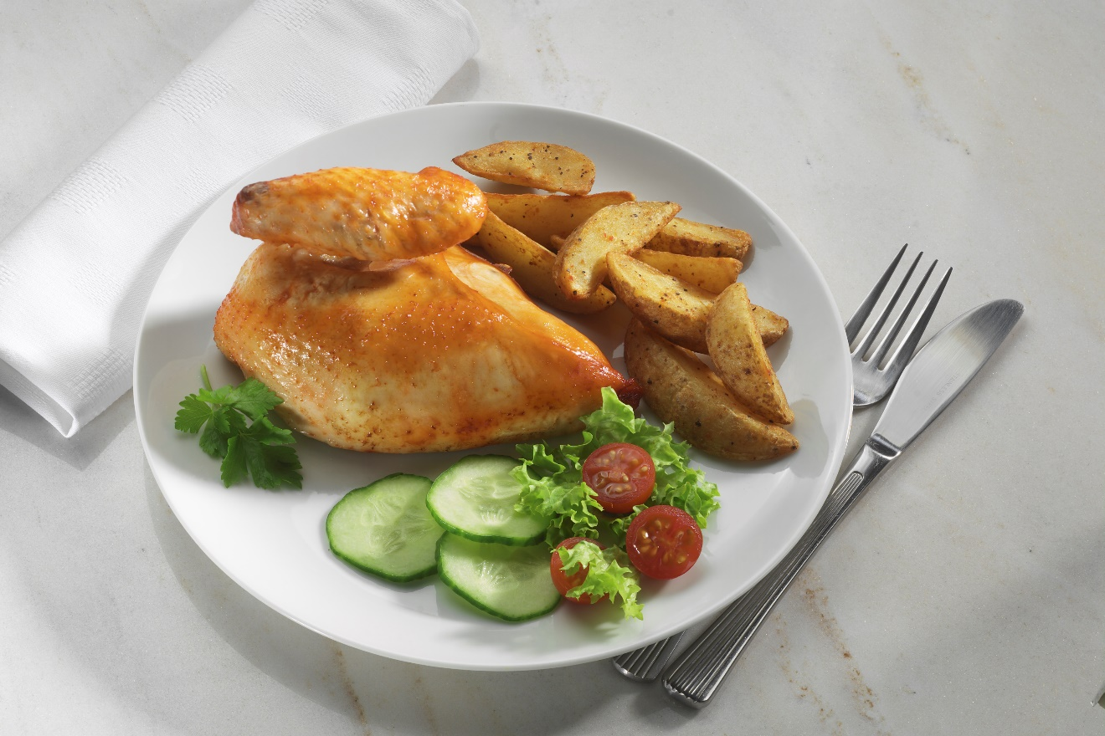

Warranty

We warrant that all foods, goods and packaging supplied by us:

- Will comply in all respects with the information detailed in this specification.
- Will be clean, sound and undamaged on delivery.
- Comply in all respects with the Food Safety Act 1990, with any regulations made there under and with all other UK and European Union legislation, regulations and quality standards relating to the supply of food, including accepted Codes of Practice.
- Will be of the nature, substance or quality described in the specification.
- Will not be presented in such a way to mislead as to its nature, substance or quality.
- Will be free from agricultural and veterinary contaminants.
- Will have packaging that complies with all legal Food Contact Material requirements where appropriate.
- Will have been subjected to such checks that ensure that the above requirements have been achieved.
- Will have been produced in premises and using such equipment/machinery as to ensure its compliance with the standards required by the Food Safety Act 1990, Food Safety and Hygiene (England) Regulations 2013.
- Will be completely covered by the Nutritional and Food Intolerance/Dietary Needs information supplied in this specification, which will be validated annually. Customers will be made aware of any deviations from the agreed specification.
- Will be free from problems likely to result in consumer dissatisfaction.

Specification Approval:

For customer:
 | Commercial | Technical
Print Name:
Signature:

Date:
For George Morris & Son:
Print Name: | Simon Morris | Gina Blake
Signature:

Position: | Partner | Partner
Date: | 9/1/19 | 9/1/19

