Review of the test_3.0.html;

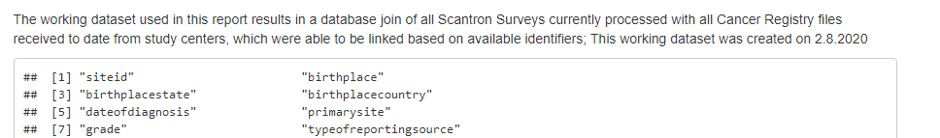

Perhaps insert above the list of ..what … 31 vars, plus the Count, something like this -edit away:

“ A selected subset of 31 Cancer Registry data items are presented in this report as a way to develop an initial data review, analysis and revising steps for RESPOND. This version is based on XXX registry records”

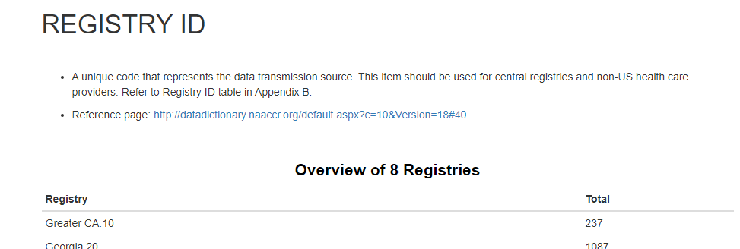

Rename this to ‘SiteID’, remove the two bullet points.

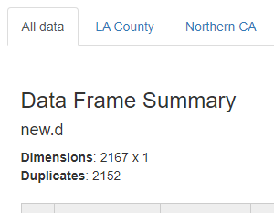 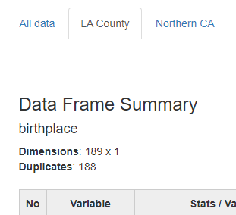

Labeling - applies to many (all?) of the tabbed sections: ‘all data’ shows ‘new.d’ - ‘la county’ shows correct label ‘birthplace’

should we revisit ‘duplicates’ labeling here ? (can/should we just suppress that label?)

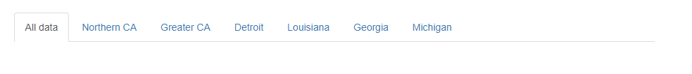

...vs:

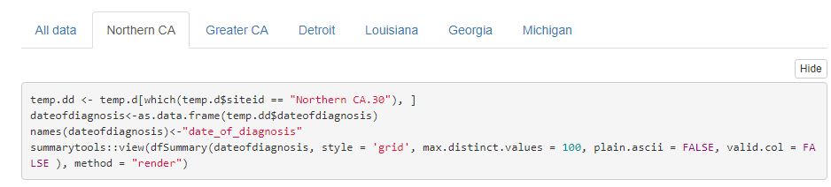

The code box seems hidden for the ‘all’, but appears for individual sites (maybe tied to above issue?)

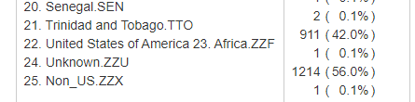

To me (chrome) these arent lining up ?? wait, i see… ‘africa.zzf’ didnt wrap properly ….

R:

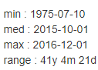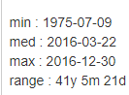

SQL:

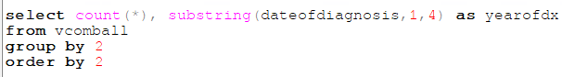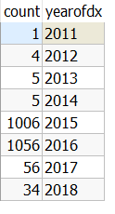

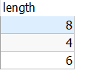

Date conversion issue? From SummaryTools, shows 1975 early years; sql differs?

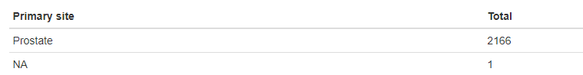



Gotta check with Georgia on this one ! C541 is endometrial ca !!

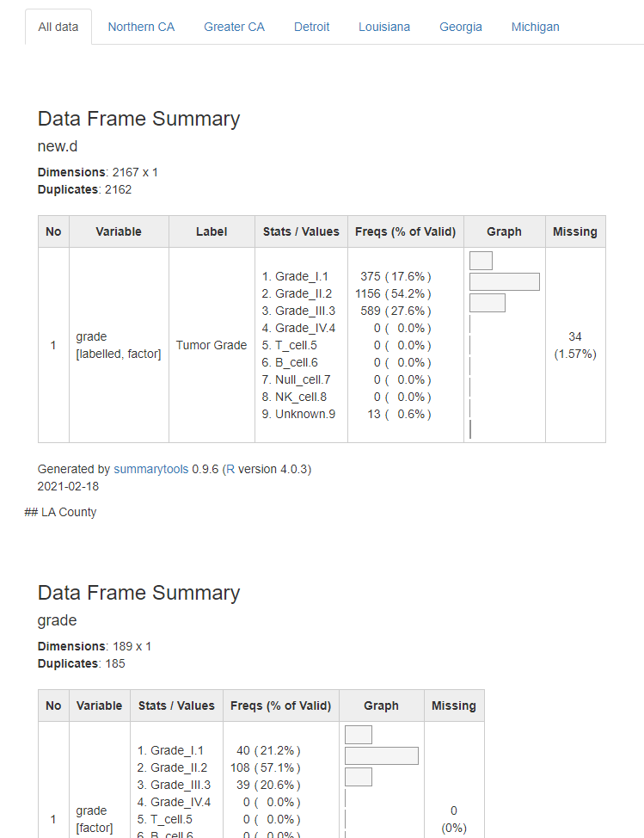

Another variation on the theme - on GRADE here, the ALL DATA seems to be sticking the LA data below, in a second graphic? [actually this now seems to happen on subsequent sections]



Vital stats issue - this doesn't concern me a WHOLE bunch, except I need to communicate with the 3 sites who report. We see this often in long running studies like this. Since these numbers are based on the MERGED data, I can think of these possible stories:

* registry death info was added to their database AFTER initial selection for study. That info could be:
  + correct linkage, when a patient died AFTER the survey was completed
  + correct linkage, patient died PRIOR to the survey date (and a family member completed survey)
  + incorrect linkage - matching wrong case
* registry death info was missed on initial selection - like second sub’bullet above, someone else filled out survey

We SHOULD request, towards end of study, a report from all sites with responded and date of death for ANY of the recruited cases - we then can compare with the survey date to resolve discrepancies.



What typically can SummaryTools squish in this section ?