**Economic Freedom Analysis**

1 INTRODUCTION

Economic freedom is the fundamental right of every human to control his or her own labor and property. We measure economic freedom based on 12 quantitative and qualitative factors. Each factor is measured with equal score.

The aim of this project is to find the economic freedom by analyzing the given data.

2 Problem Definition & Design Thinking

2.1 Empathy Map

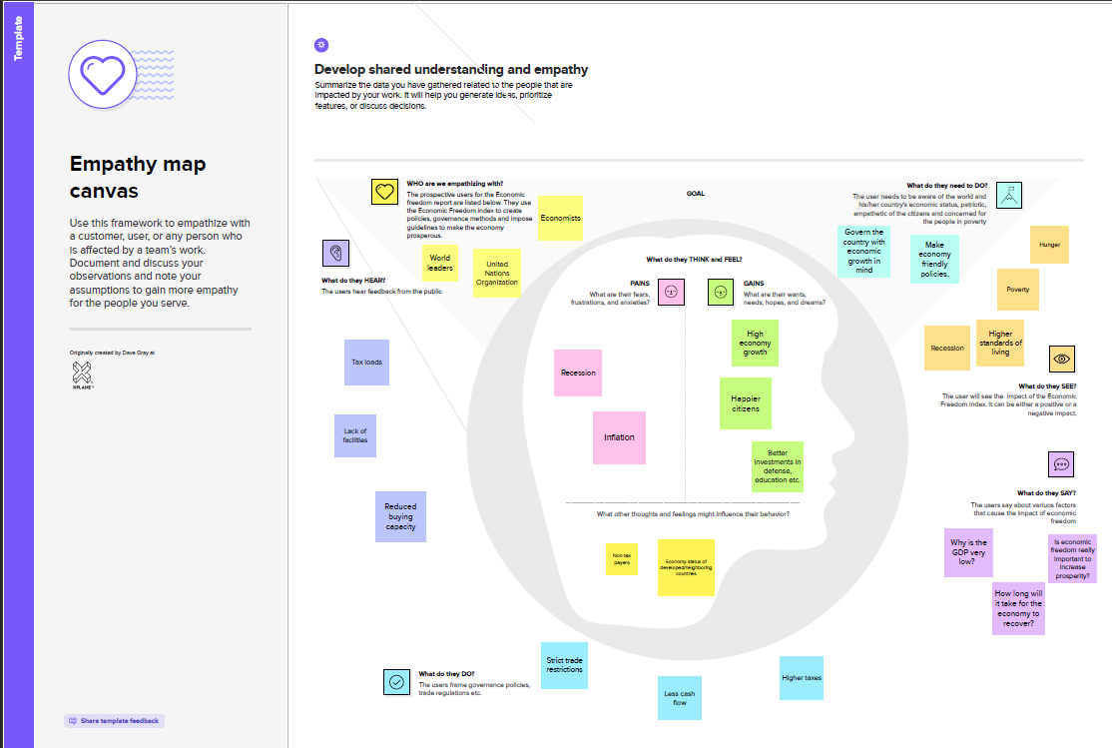2.2 Ideation & Brainstorming Map

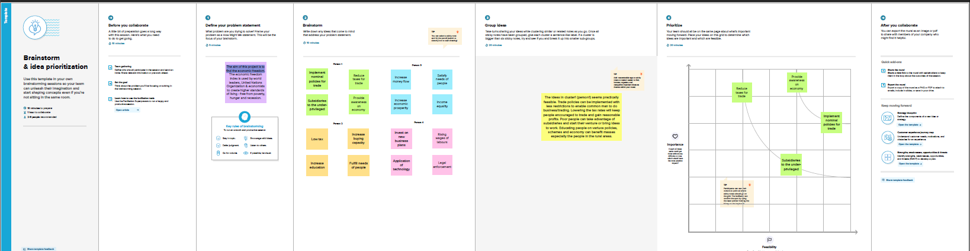

3 RESULTS

3.1 DASHBOARD

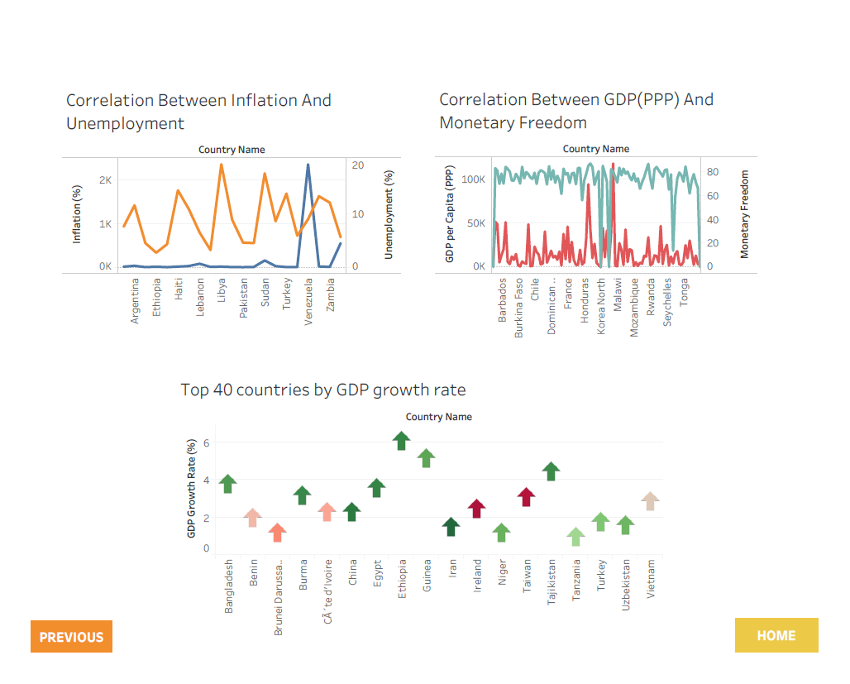

3.2 STORY

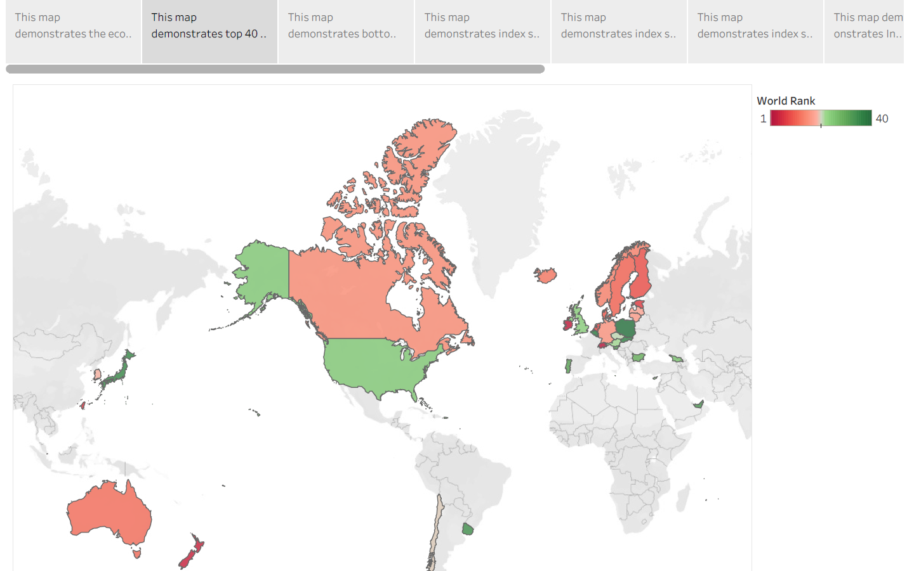

4 ADVANTAGES & DISADVANTAGES

Advantages of the solution are it can help understand the current economic freedom status of various nations.

Disadvantage is that the solution does not account for sudden changes in volatile economic factors at global level.

5 APPLICATIONS

This solution can be applied in various domains other than economic freedom analysis like global population analysis etc.

6 CONCLUSIONS

We can conclude that this project helps to visualize the economic freedom scores and its surrounding factors of various countries. We have arrived at top countries which perform well at GDP, population per capita income etc.

7 FUTURE SCOPE

We can expand this solution as a generalized one for various datasets and domains

8 APPENDIXES

A. Source Code

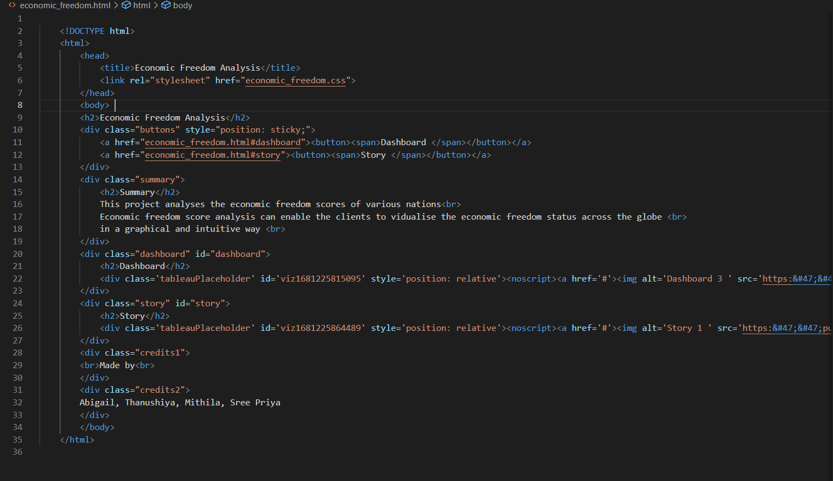

Project Report Template

