GRC102 Lab 8 — Security Governance in Practice

Simulating, Analyzing, and Remediating an Equifax-Style Breach
Student ID: C11/26/CGRCE/17260
Email : c11.cgrce2617260@icdfa.edu.ng
Date: 10 October 2026
Lab Environment: Isolated Kali Linux VM, Docker-based lab (web + database + monitoring), all data synthetic

Exective Summary
The goal of this lab was to treat security governance as something you can actually measure rather than talk about in the abstract. I built a small, deliberately vulnerable environment that mirrors the conditions behind the 2017 Equifax breach, measured its security posture with a scanner and a simulated attack path, mapped each weakness back to a governance failure, and then applied controls and re-measured to prove the posture had changed. Everything ran in an isolated VM against synthetic records, and the web service was bound to loopback so nothing was ever exposed outside the lab.
The work is organized into four parts, each committed to Git as I went:
- Building the simulated environment and taking a baseline.
- Simulating the attack path and analyzing the governance failures behind it.
- Applying remediation and verifying the result.
- An executive summary with governance recommendations.

Part 1 — Simulated Environment and Baseline Assessment
I started the lab stack with Docker Compose: an Apache Struts 2.3.30 web tier, a MySQL 5.7 database, and a monitoring container. One early snag worth noting — the image tag in the original instructions (vulhub/struts2:s2-045) no longer exists on Docker Hub, so I pinned the real vulnerable release, vulhub/struts2:2.3.30, and bound the web port to 127.0.0.1 so the vulnerable app could never be reached from outside the VM.
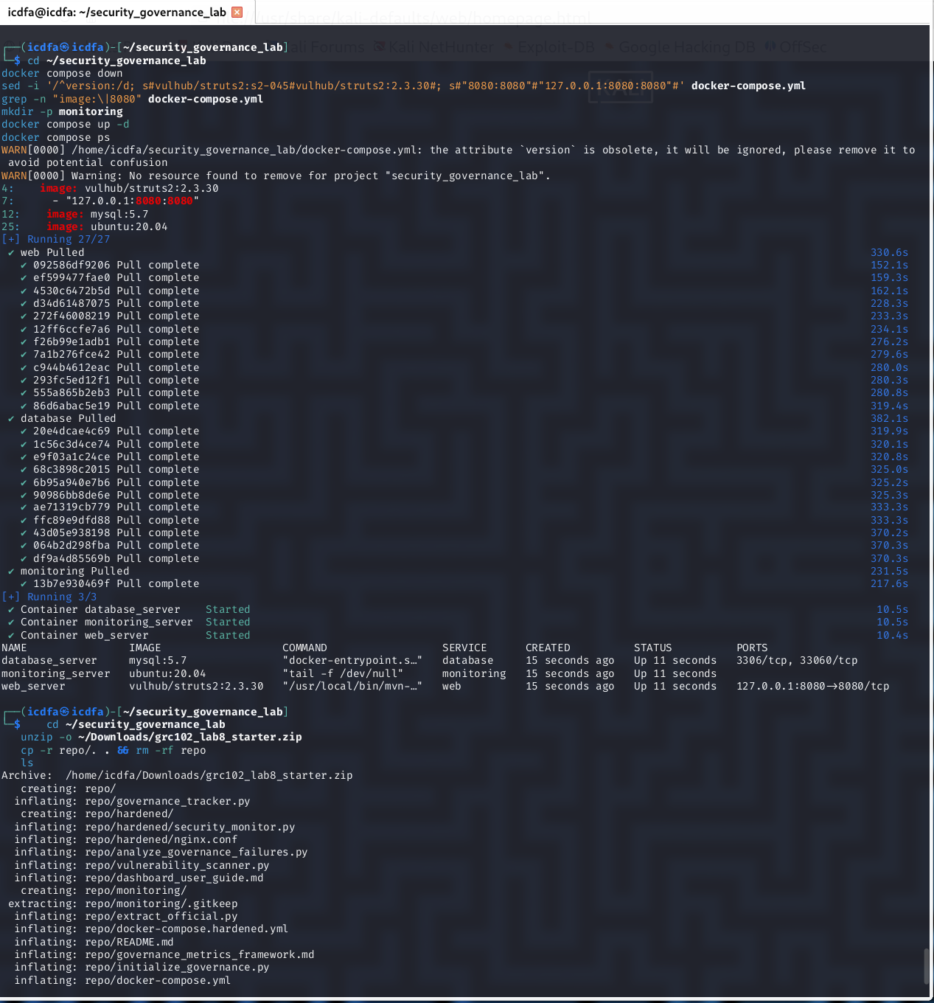
Figure 1. Lab stack running — Struts 2.3.30 web tier, MySQL 5.7 database, and monitoring container, with the web port bound to loopback (127.0.0.1:8080).
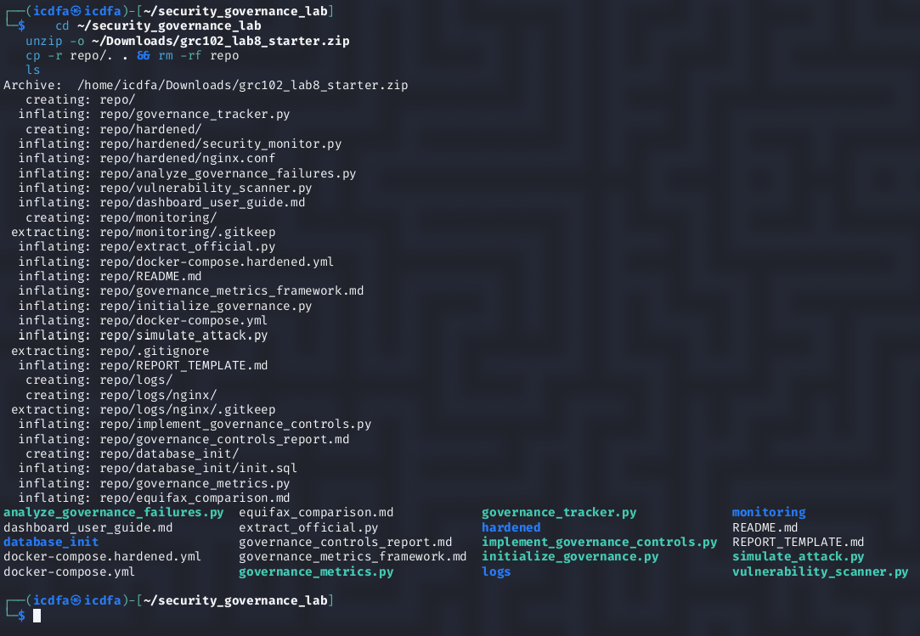
Figure 2. The governance toolkit extracted into the working directory — the scanner, attack simulator, failure analyzer, tracker, and hardened configuration.
With the environment up, I confirmed the synthetic dataset (three customer records containing SSN, date-of-birth, and credit-card fields), initialized the governance tracker, and ran the baseline vulnerability scan.
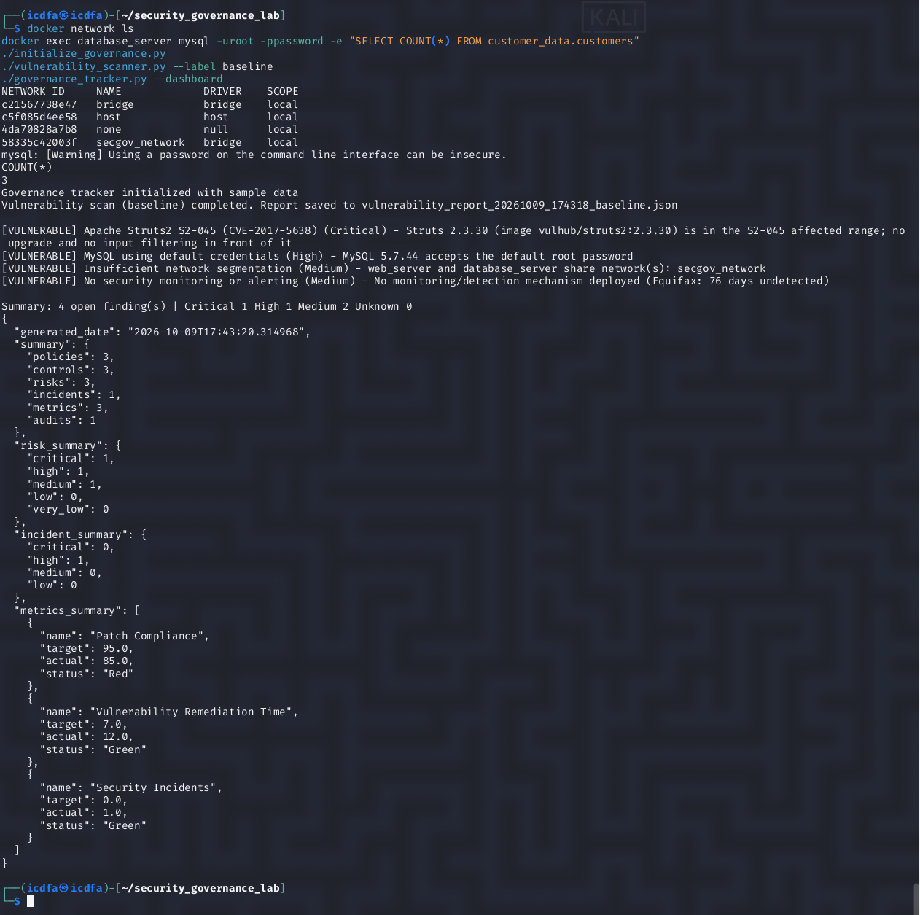
Figure 3. Network list, the three synthetic customer records, tracker initialization, and the baseline scan reporting four open findings.
The baseline scan returned four findings: one Critical, one High, and two Medium.
# | Finding | Severity | Why it matters
1 | Apache Struts S2-045 (CVE-2017-5638) | Critical | Remote code execution on an internet-facing component — the exact Equifax flaw
2 | MySQL default root credentials | High | Anyone reaching the database can read customer PII
3 | Insufficient network segmentation | Medium | Web and database tiers share one network, enabling lateral movement
4 | No security monitoring or alerting | Medium | A compromise would go unnoticed (Equifax: 76 days)
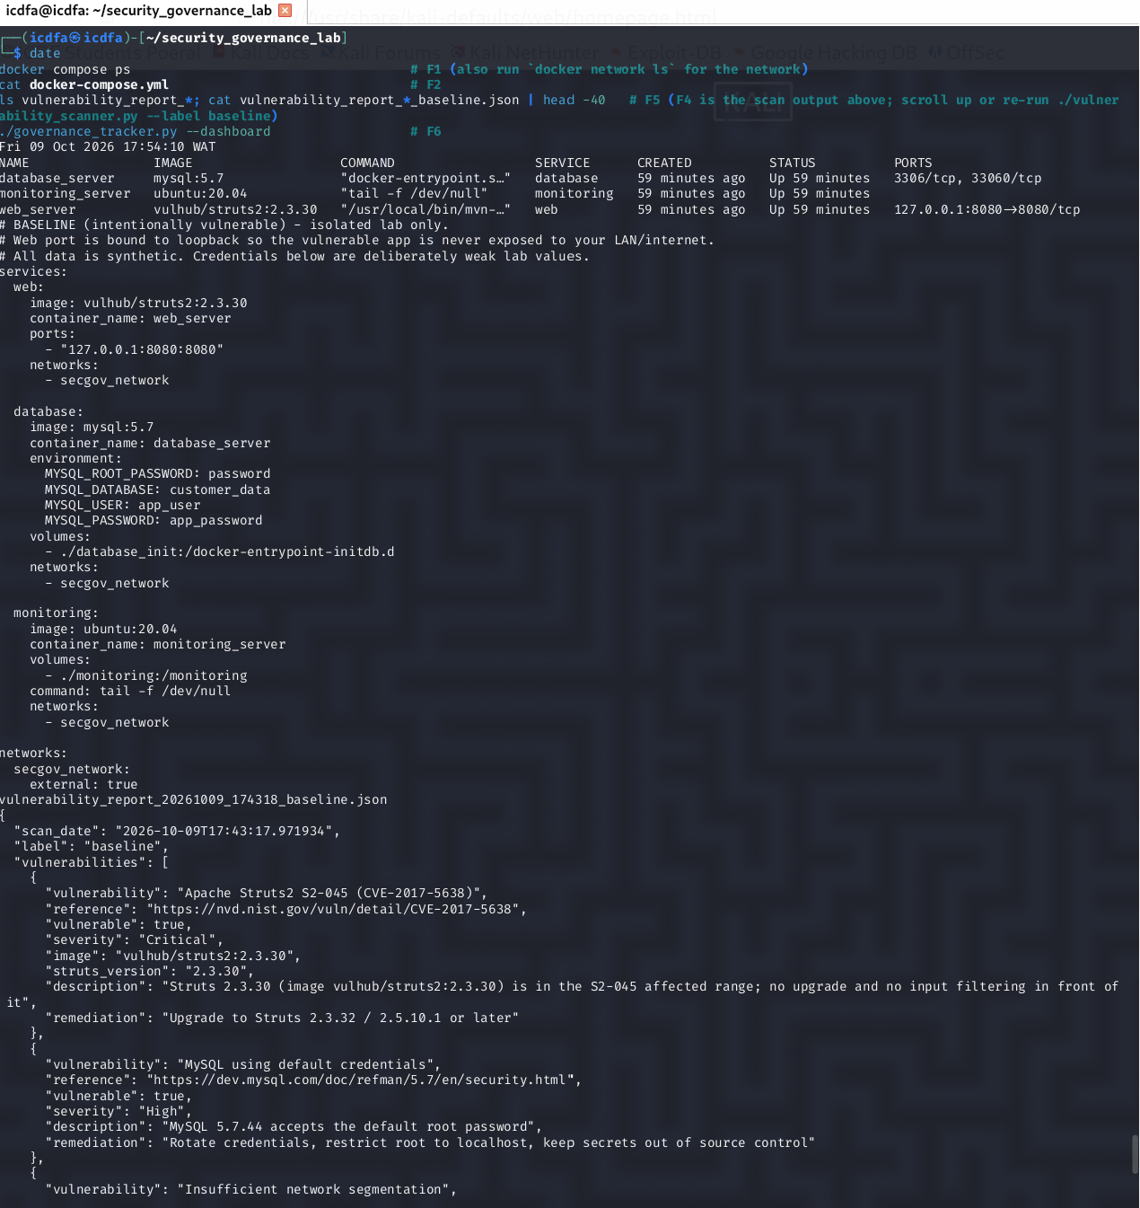
Figure 4. The environment definition (docker-compose.yml) and the saved baseline report — note the deliberately weak lab values and the loopback-bound web port.
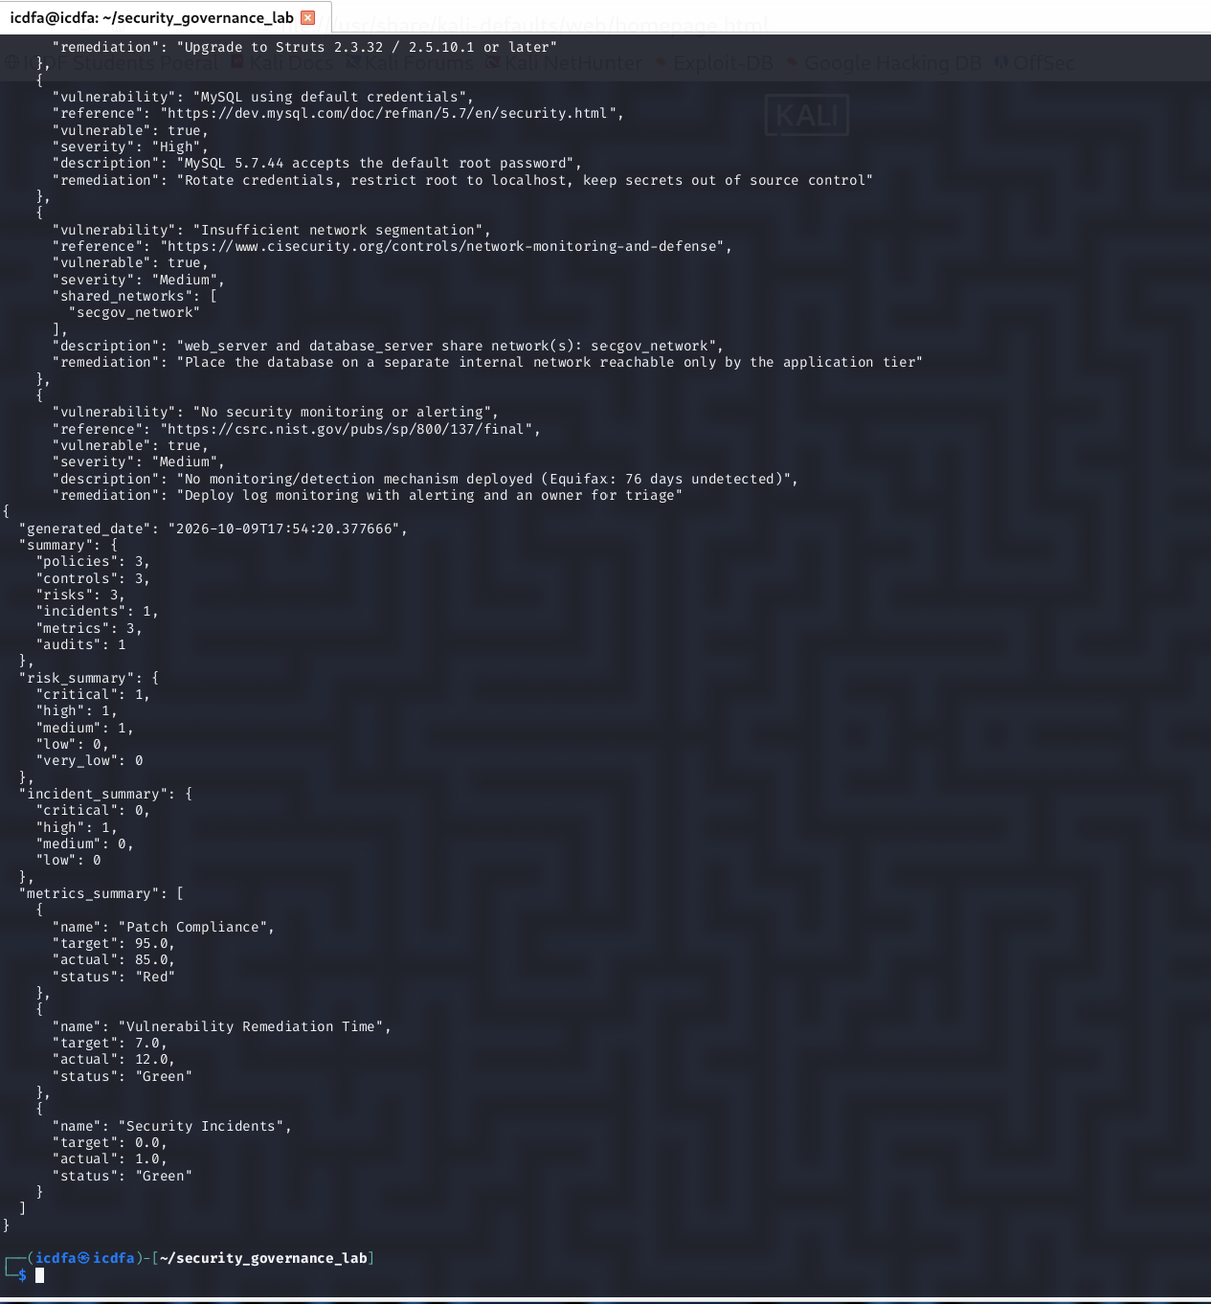
Figure 5. Baseline vulnerability report detail — each of the four findings with severity, description, and remediation guidance.
I committed this baseline so the “before” state is preserved in version history.
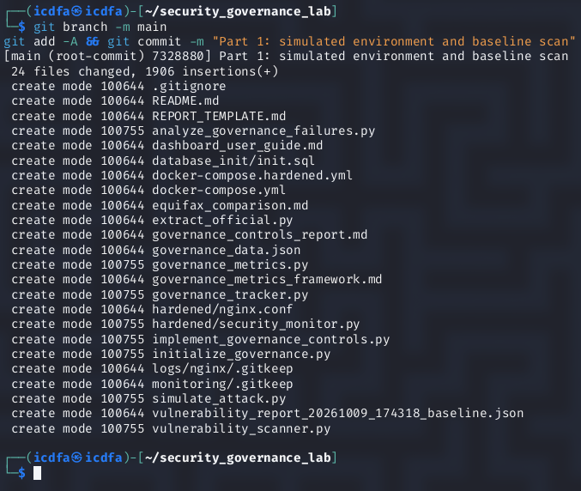
Figure 6. Part 1 committed to Git — the simulated environment and baseline scan.

Part 2 — Attack-Path Simulation and Governance-Failure Analysis
With a measured baseline, I ran the attack-path simulation. This is analysis only — it inspects the running environment and reasons about whether each stage of an Equifax-style chain is feasible; it sends no exploit traffic. At baseline, every stage was OPEN: initial access through unpatched Struts, lateral movement across the flat network, database access with default credentials, and the whole thing going undetected. The simulated compromise succeeded, all three records were exposed, and detected was False.
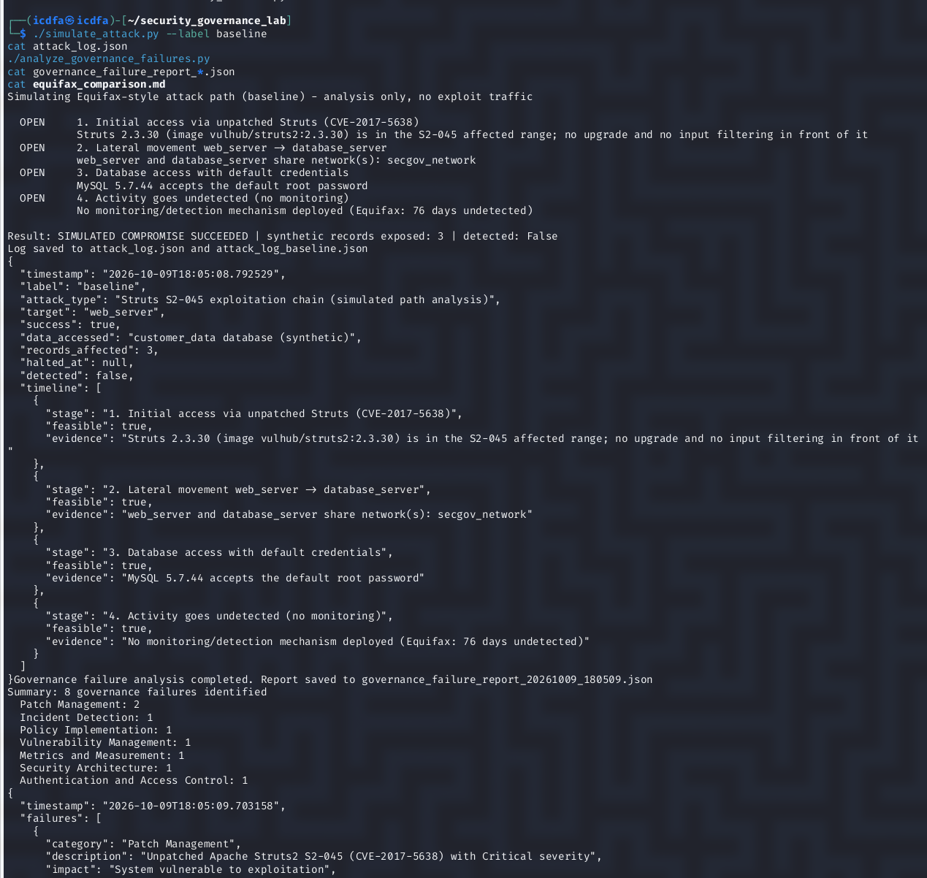
Figure 7. Baseline attack path — all four stages OPEN, simulated compromise succeeded, 3 records exposed, undetected; failure analysis run immediately after.
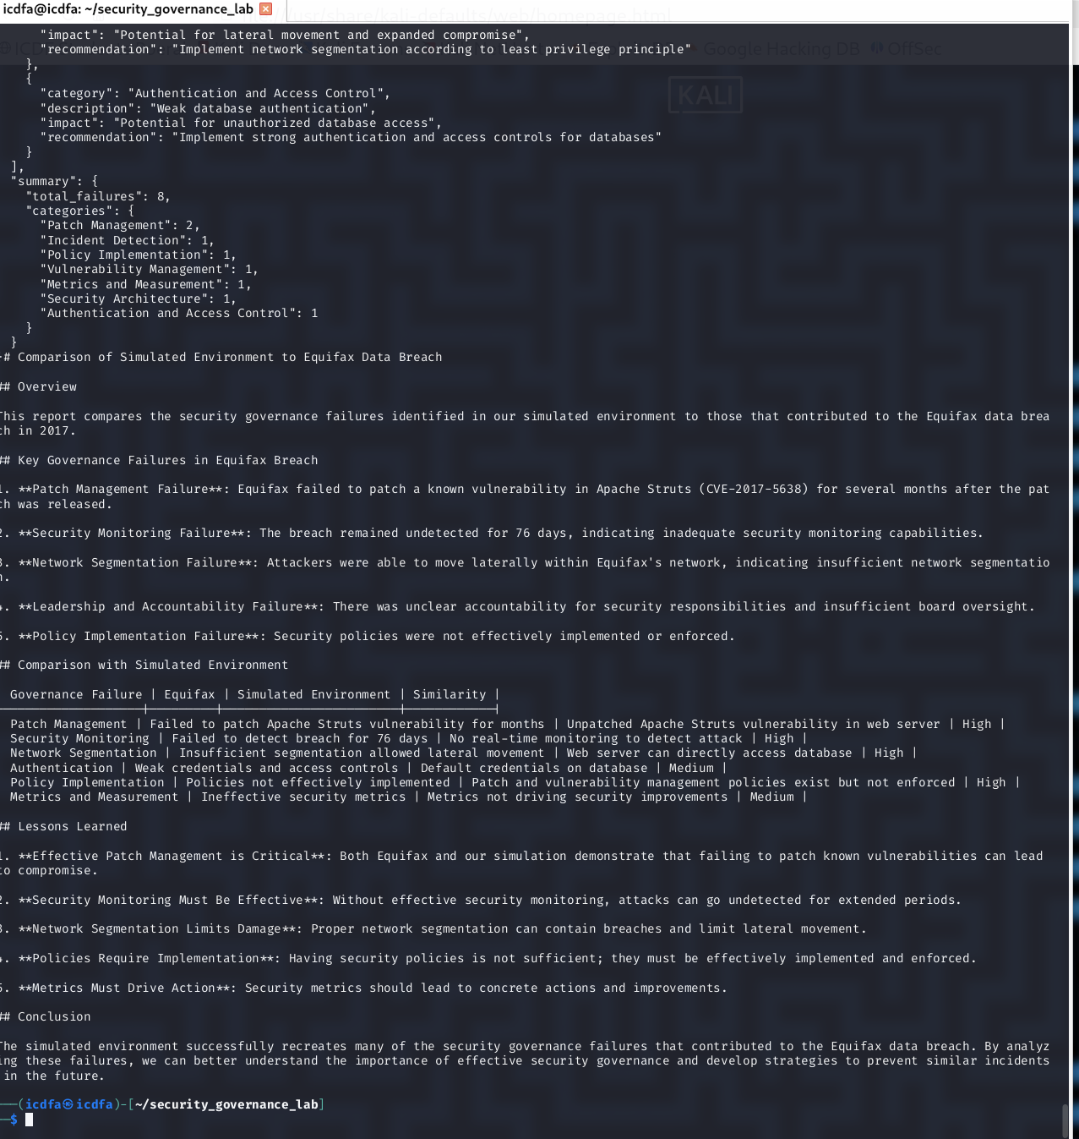
Figure 8. The governance-failure report and the Equifax comparison document generated from the baseline results.
Midway through this part the VM needed a restart (a disk-space issue I describe in the appendix), so I brought the stack back up and confirmed the three records were intact before re-running the simulation cleanly with the date visible.
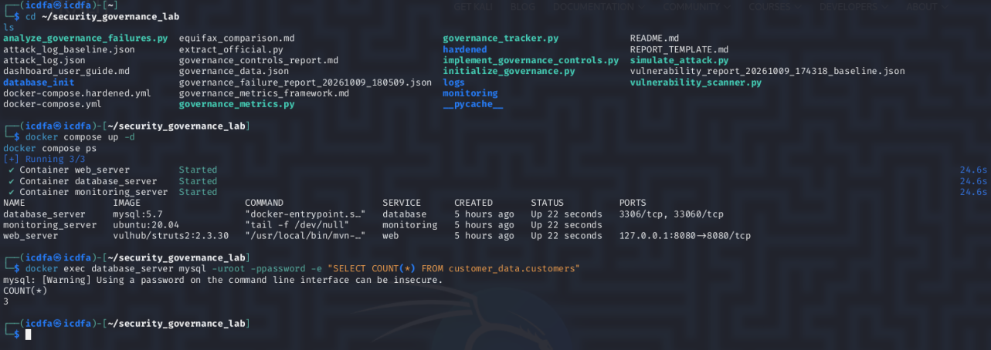
Figure 9. Environment restored after a restart — all three containers back up and the three synthetic records intact.
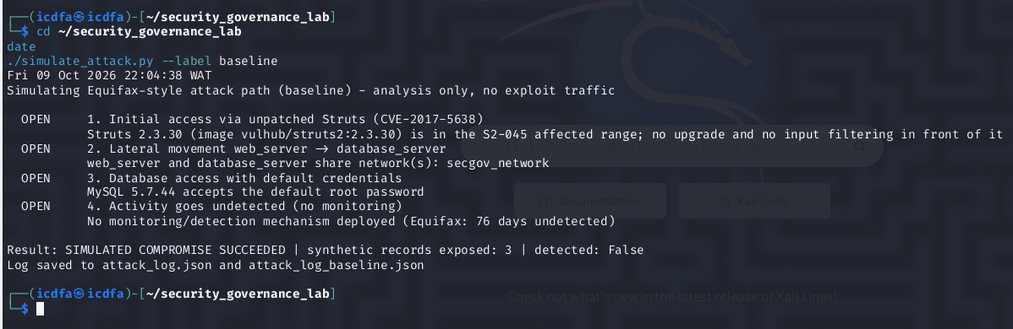
Figure 10. Baseline attack-path simulation re-run with timestamp — compromise succeeded, undetected.
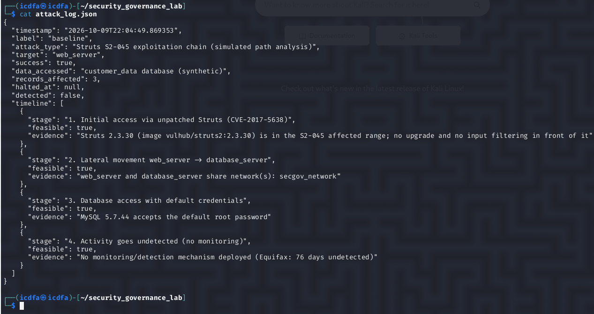
Figure 11. The full attack log (attack_log.json) showing all four stages feasible.
The failure analyzer then translated the technical findings into eight governance failures across seven categories — patch management (two), incident detection, policy implementation, vulnerability management, metrics and measurement, security architecture, and authentication and access control. This is the heart of the governance argument: the vulnerabilities are symptoms, but the failures are about ownership, process, and oversight.
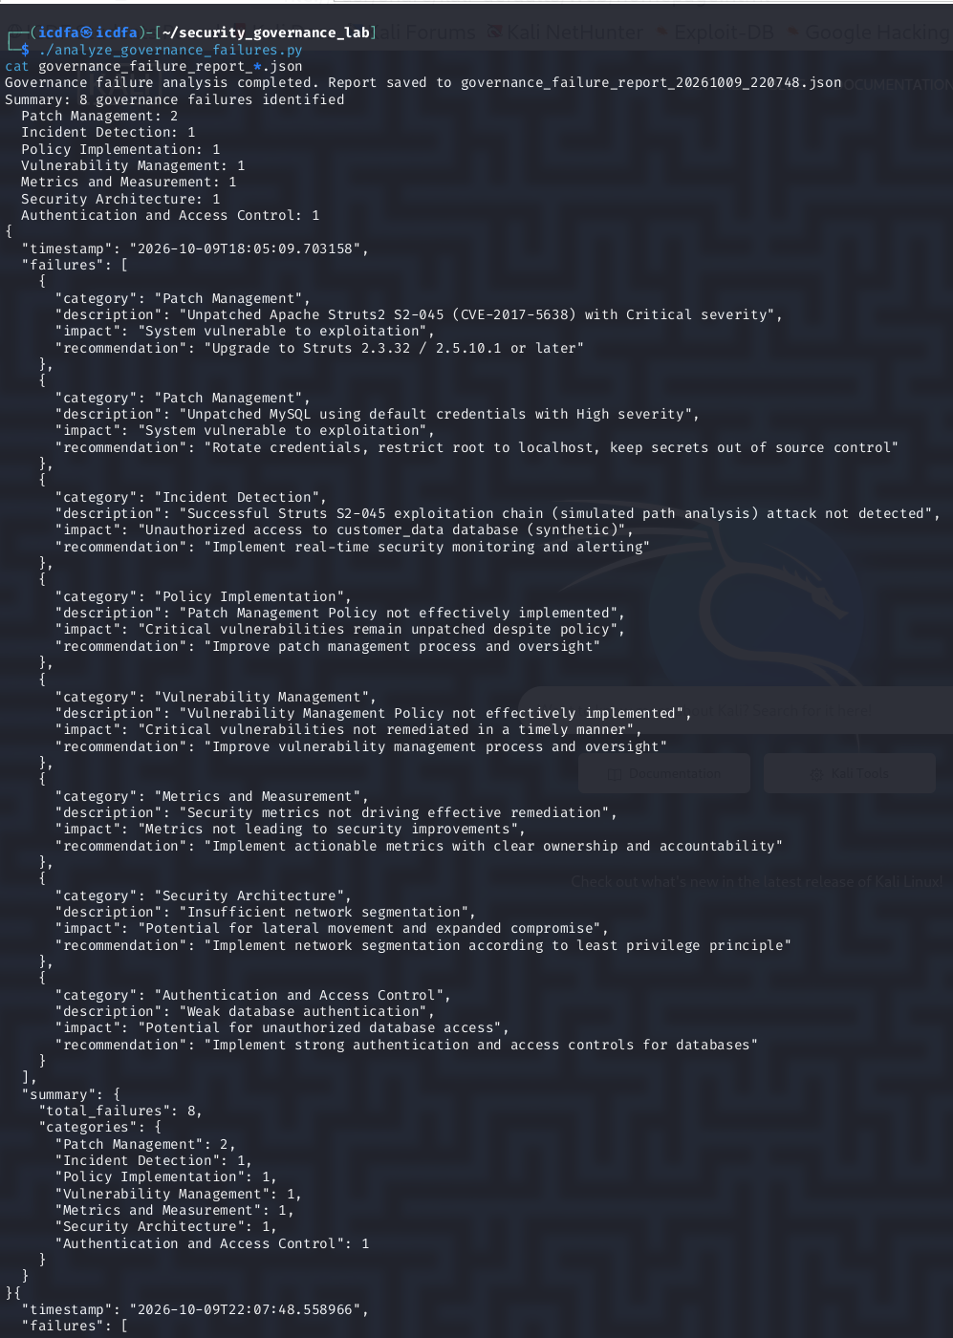
Figure 12. Governance-failure analysis — eight failures across seven categories, each with its impact and recommendation.

Mapping my lab to the Equifax breach
Governance failure | Equifax (2017) | My lab (2026)
Unpatched Struts S2-045 (CVE-2017-5638) | Patch available March 2017, never applied to the ACIS dispute portal; exploited that May | Scanner identified the exact build — Struts 2.3.30 — in the affected range, with no input filtering
No detection | Intrusion ran ~76 days undetected; an expired SSL-inspection certificate created a blind spot | No monitoring deployed at all; simulated compromise detected: False
Flat network | Attackers moved laterally and reached multiple databases (~9,000 queries) | Web and database tiers shared one network; lateral stage OPEN
Weak credentials | Plaintext credentials expanded access | MySQL accepted the default root password; database stage OPEN
Scale of exposure | ~147–148 million consumers’ PII | 3 synthetic records (same data classes, lab scale)
What stands out is that none of these were exotic. The House Oversight Committee called the Equifax breach “entirely preventable,” and the lab makes clear why: each failure had a known, ordinary fix that simply wasn’t owned by anyone accountable.
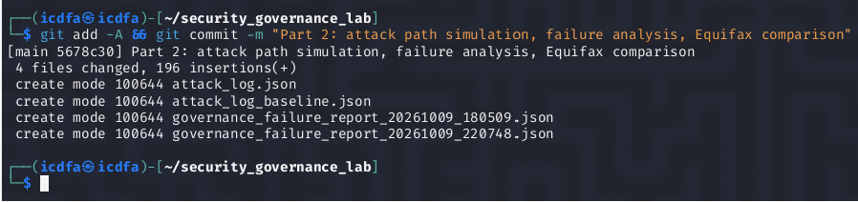
Figure 13. Part 2 committed to Git.

Part 3 — Remediation and Verification
Part 3 is where governance becomes visible. I applied the hardened configuration, which upgraded Struts to a fixed release (2.3.32) behind an edge proxy that filters hostile Content-Type headers, rotated the database credentials and rejected default access, segmented the network so the web and database tiers no longer share one, and deployed monitoring. During verification the monitor actually earned its keep — it logged and blocked a hostile request at the edge proxy.
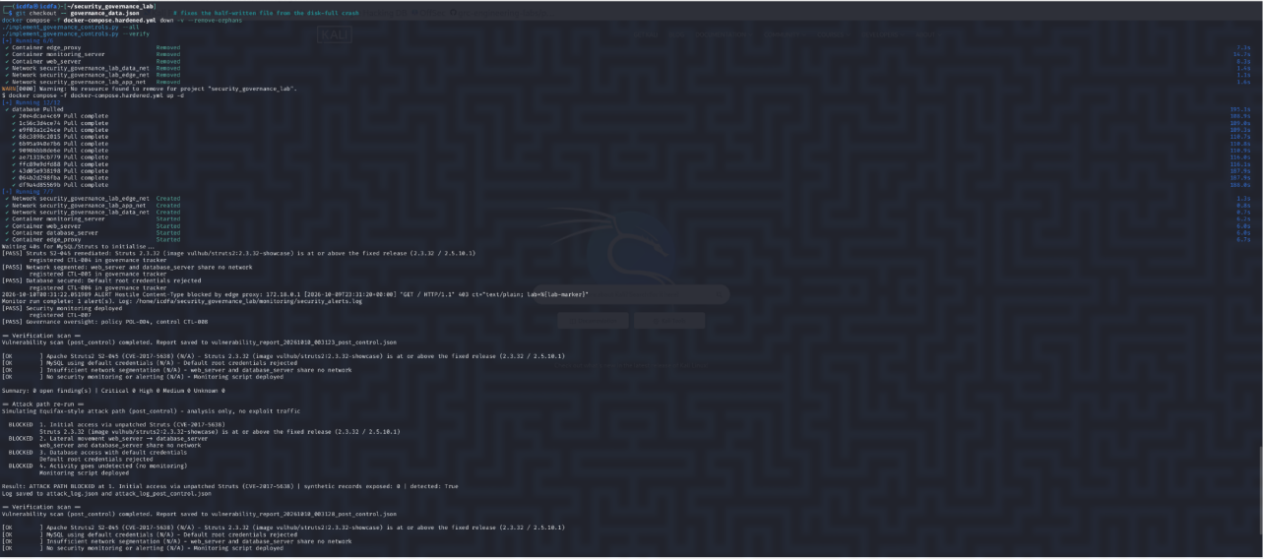
Figure 14. The full remediation run — hardened stack deployed, each control applied, followed by a verification scan and attack re-run.
Every control reported PASS, the verification scan returned zero open findings, and the re-run attack path was BLOCKED at the initial-access stage with zero records exposed and detected: True.
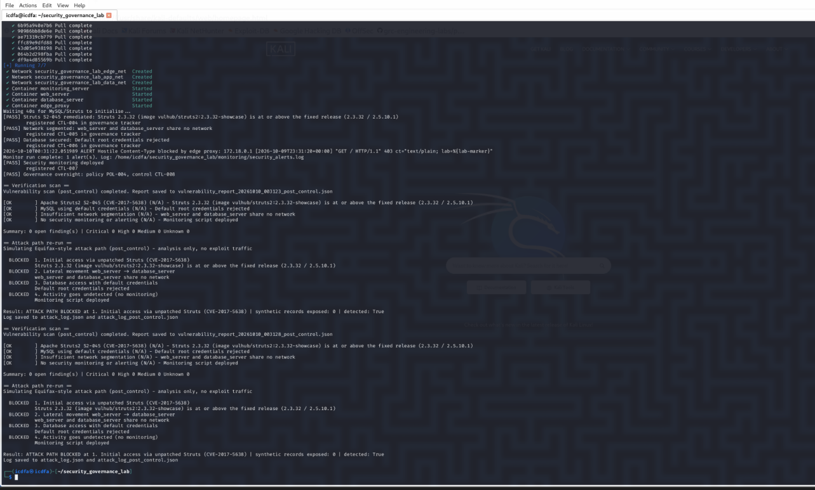
Figure 15. Remediation detail — all controls PASS, 0 open findings, attack path BLOCKED at stage 1, 0 records exposed, detected: True.

Before and after
Measure | Baseline | After remediation
Open findings | 4 (1 Critical, 1 High, 2 Medium) | 0
Attack path | Succeeded, undetected | Blocked at stage 1, detected
Records exposed | 3 (all) | 0
I refreshed the governance dashboard to reflect the new controls, then committed Part 3.
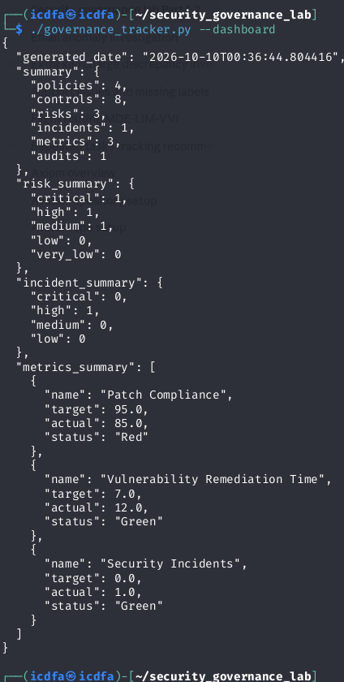
Figure 16. Post-remediation governance dashboard — policies and controls increased (4 policies, 8 controls).
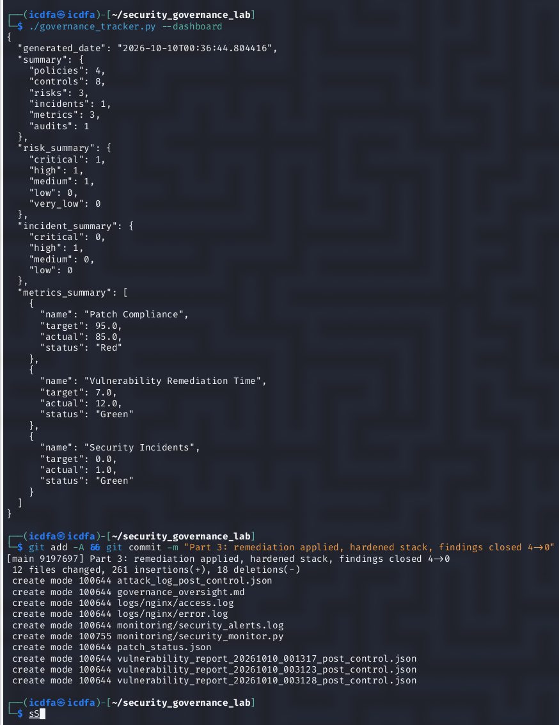
Figure 17. Post-remediation dashboard and the Part 3 commit — remediation applied, findings closed 4 → 0.

An honest observation about the dashboard
One thing I deliberately did not “fix,” because it makes a governance point on its own: even after the scan showed zero open findings, the dashboard still reported the environment as at-risk (an open Critical, High, and Medium in its risk summary) and still colored two missed targets — Vulnerability Remediation Time (12 days against a 7-day target) and Security Incidents (1 against a target of 0) — as Green. The tracker’s scoring treats every metric as higher-is-better, so lower-is-better metrics are mislabeled, and its risk register isn’t wired to the live scan results. The operational reality (fixed) had diverged from what the dashboard told a reader (still at risk, and falsely green). That gap is exactly the kind of blind spot that let Equifax believe things were fine, and it’s the clearest argument in the whole lab for why metrics have to be validated before a board relies on them.

Part 4 — Executive Summary (Board-Level)
Purpose. This assessment simulated the governance failures behind the 2017 Equifax breach in a controlled lab, measured the security posture, applied remediation, and verified the result.
Baseline posture. An automated scan identified four findings — one Critical (unpatched Apache Struts, CVE-2017-5638), one High (default database credentials), and two Medium (flat network, no monitoring). A simulated attack path succeeded end to end, exposed all synthetic customer records, and went undetected — the same chain of failures the House Oversight Committee called “entirely preventable.”
Remediation and verified result. Struts was upgraded to a fixed release behind an input-filtering edge proxy; database credentials were rotated and default access rejected; the network was segmented; and monitoring was deployed. The post-remediation scan returned zero open findings, the re-run attack path was blocked at initial access, zero records were exposed, and the activity was detected. Four findings closed; the simulated breach was prevented.
Governance recommendations.
- Ownership and accountability. Every control needs a named owner and a verification step. Equifax’s patch policy existed on paper but no one owned its execution; the same gap showed up here as 85% patch compliance that never escalated.
- Defense in depth. No single control is sufficient. Segmentation, strong authentication, and monitoring each independently broke the attack chain in the remediated environment.
- Metrics integrity — board action required. The dashboard reported stale risk and colored missed targets green even after remediation, because its metrics aren’t tied to operational reality and its scoring is directionally wrong. Leadership must not take dashboard colors at face value; metrics require independent validation before they inform decisions.
Residual risk. The web tier remains on the legacy Struts 2.3.x line; a planned migration to a currently supported release is recommended. The risk register and metrics program should be updated to reflect the remediation so the dashboard matches verified posture.

Sources
- U.S. Government Accountability Office, Data Protection: Actions Taken by Equifax and Federal Agencies in Response to the 2017 Breach, GAO-18-559, August 2018. https://www.gao.gov/assets/gao-18-559-highlights.pdf
- U.S. House Committee on Oversight and Government Reform, The Equifax Data Breach, Majority Staff Report, December 2018. https://oversight.house.gov/wp-content/uploads/2018/12/Equifax-Report.pdf
- NIST, Information Security Continuous Monitoring, SP 800-137. https://csrc.nist.gov/pubs/sp/800/137/final

Appendix — Note on reproducibility
The lab runs on a 24 GB VM, which is tight for Kali plus Docker. Pulling the hardened stack filled the disk mid-run and interrupted the remediation step once; clearing unused Docker images and caches freed enough space to complete it cleanly. For anyone reproducing this, running docker compose down between sessions and keeping a few GB free avoids the issue. All secrets used by the hardened stack are generated into a git-ignored .env, so no credentials are committed to version control.

