Hire a Tenant Edits:


Front End, Backend, Agent Bids, Counter Bids:

- Creating a Listing

Tab 1: Listing Details:

Bidding Period: (Edit Tooltip)
Agents can submit bids until the countdown timer ends. Each bid will display the Agent’s Offered Services and Broker Compensation & Agency Agreement Terms.
Traditional: (Edit Tooltip)
You may hire an Agent at any time and choose whether to show or hide bids. If shown, bids will display the Agent’s Offered Services and Broker Compensation & Agency Agreement Terms.

Bidding Period Length: (Edit Tooltip)
Agents can submit bids until the countdown ends. Each bid will display the Agent’s Offered Services and Broker Compensation & Agency Agreement Terms. Once the timer expires, you may select the Agent who best meets your needs—you are not required to choose the highest or lowest bid. Broker compensation and agency agreement terms remain private on your dashboard and are never shown to other agents or the public.

- A unique listing ID should generate for each listing on front and backend so I can search from their for future listing tracking: Listing ID should also show on listing.

- Tab 2: Property Preferences:
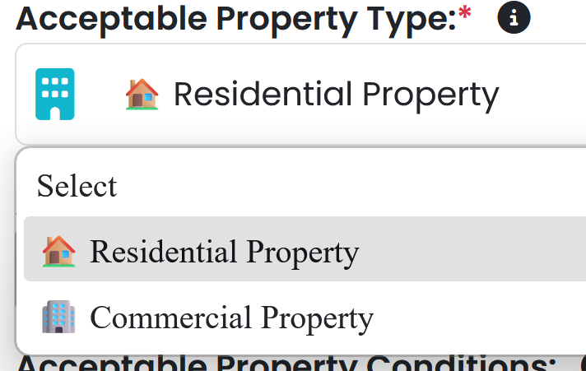

Remove the symbols next to Residential Property and Commercial Property

- Garage Parking Features Needed:
Should read as Garage/Parking Features Needed:

- Tab 5: Services:

Issue with checking the selections. The boxes will delete each other
User is not required to select one service so delete that and this requirement

🔍 Search, Alerts & Property Matching
For Both Residential and Commercial change that title to this: 🔍 Property Search, Alerts & Matching

- Search for off-market, pre-market, distressed, withdrawn, canceled, or expired properties that meet the Tenant’s rental criteria

Tab 7: Broker Compensation & Agency Agreement Terms:
The tab should read as:
Broker Compensation & Agency Agreement Terms:
instead of just Broker Compensation
(Also take these edits & apply them under Agent Bids and Counter Bids)

- Tenant’s Broker Commission Structure:

Change to

Out of Pocket Payment
To
Tenant Pays Out-of-Pocket

Change
Included in Offer
to
Requested From Landlord in the Offer

Edit Tooltip for Tenant’s Broker Commission Structure to:
Select how the Tenant’s Broker will be compensated—either paid directly by the Tenant (out-of-pocket) or requested from the Landlord as part of the offer. If the Landlord does not agree to pay, the Tenant remains responsible for the commission under the brokerage agreement.

For Residential
I selected 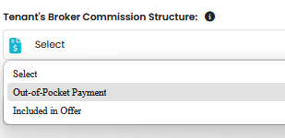
And I got this error

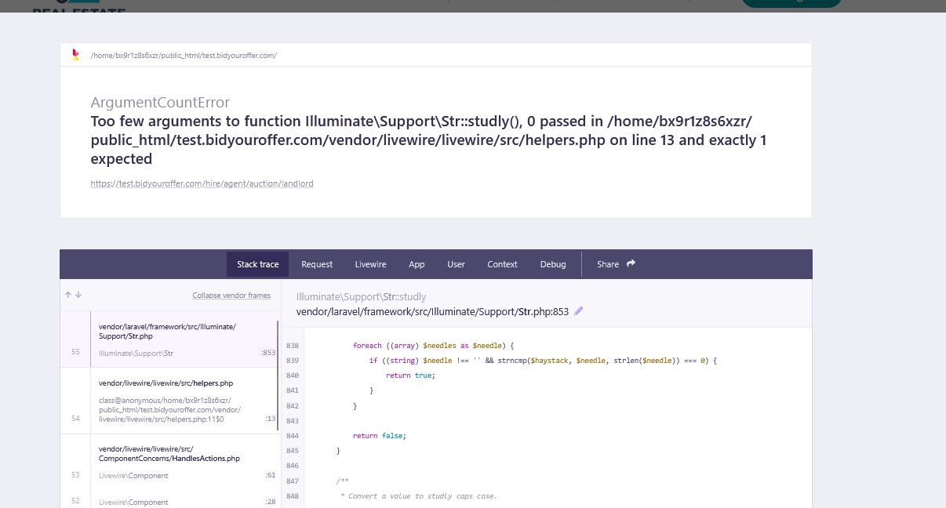

All field inputs should be cleared if user switches just like you did for landlord listings
For Both Residential & Commercial:

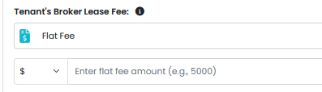
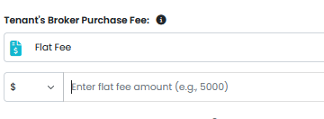
User should not be able to switch flat fee symbol it should static

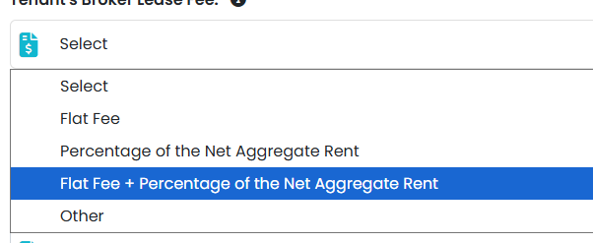
When I clicked Flat Fee + Percentage of the Net Aggregate Rent this popped up

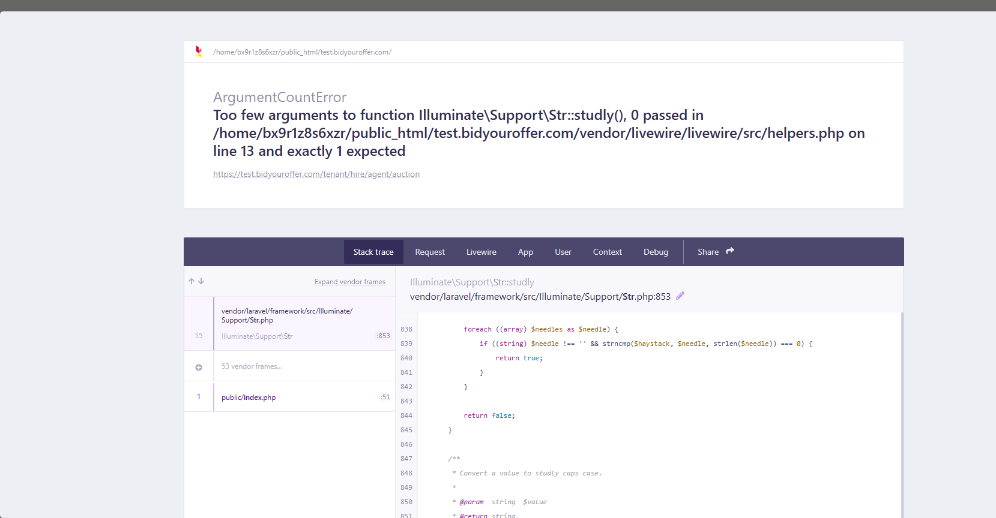

- Interested in a Lease-Option Agreement:
If user selects yes
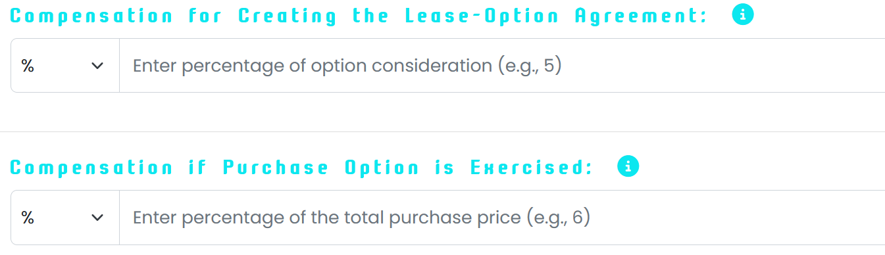

The blue text above that says “Compensation for Creating the Lease-Option Agreement” and “Compensation if Purchase Option is Exercised” needs to be added back, because right now there is no text displayed for those sections.
For Compensation for Creating the Lease-Option Agreement: the tooltip should say:
Specify how the Broker will be compensated at the time the lease-option agreement is created. This may include a flat fee or a percentage of the option consideration paid by the party granting the option. This compensation is typically paid upfront and is separate from any commission that may be owed if the purchase option is later exercised.

For Compensation if Purchase Option is Exercised: the tooltip should say

If the purchase option is exercised, the Broker may be entitled to additional compensation. Enter how the Broker will be compensated at that time, such as a flat fee or a percentage of the total purchase price. Any compensation already received under the lease-option agreement may be credited toward the final amount due, depending on the terms of the agreement.

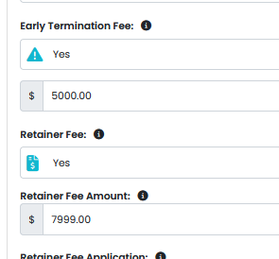
Comma format not working here

Looks like comma format is only tied to the one where user can switch between $ and % instead of just the static $

Add this After Tenant’s Broker Lease Fee:
- Payment Timing for Broker Fees:
Use same options/format/tooltips/placeholder text you have that is under Landlord one example for Residential you have
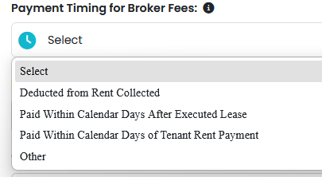

For Commercial use same options as Commercial:
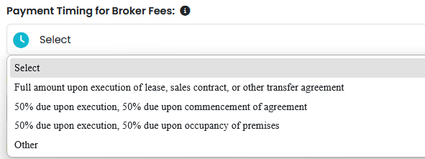

Tab 8: Tenant Information
First Name, Last Name, Phone Number, & Email
- Should be required fields so admin can view

- Phone number should have – automatically so It goes
555-555-5555 without user having to type in -

- Personal Video Upload: Delete field just going to have agent upload embedded video

- Agent Bids:
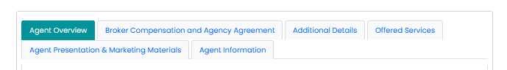

- Tab 1: Agent Overview

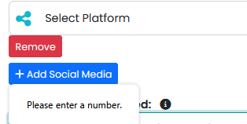

When user clicks + Add Social Media it says Please enter a number – delete that

- Required fields should have red star

Tab 2: Broker Compensation & Agency Agreement Timeframe


Should read as: Broker Compensation & Agency Agreement Timeframe

- Tenant's Broker Commission Structure: & Tenant’s Broker Lease Fee should be required fields

- Tenant’s Broker Commission Structure:
Edit tooltip to:

Edit this: 

To this
📝 Complete the compensation terms and agreement timeframe that apply.
The compensation terms previously selected by the Tenant are pre-checked below. The Agent may edit, add, or remove terms as needed to reflect what the Agent is offering.

Take the edits you did when creating a listing and apply to this as well.

- Tab 4: Offered Services
(also update this section on counter terms)
Edit this label because it’s different wording then when a tenant is creating a listing
Change that to this for Agent Bids/Agent Counter Bids

🤝 Select or review the services the Agent will provide to the Tenant throughout the leasing process. The services previously selected by the Tenant are pre-checked below. The Agent may edit, add, or remove services as needed to match what the Agent offers. Services are offered under a commission-based, full-service agreement, with the brokerage relationship type determined in accordance with state law. Your selections help outline the intended scope of services, but the signed brokerage agreement will ultimately confirm the final terms of representation and compensation.

Issue with checking the selections. The boxes will delete each other

🔍 Search, Alerts & Property Matching
For Both Residential and Commercial change that title to this: 🔍 Property Search, Alerts & Matching

- Search for off-market, pre-market, distressed, withdrawn, canceled, or expired properties that meet the Tenant’s rental criteria

- Tab 5: Agent Presentation & Promotional Materials



User should be able to upload larger file for Marketing Materials Upload

Delete: Virtual Agent Presentation (Upload):

Have embedded video in the
Virtual Agent Presentation(Link):

- Tab 6: Agent Information

- For the Phone number it should have the – input so it automatically goes 555-555-555 instead of 55555555

- The agent information should automatically fill in from when user created profile since it’s the same questions, so agents don’t have to repeat their credentials

- Actual Bids:
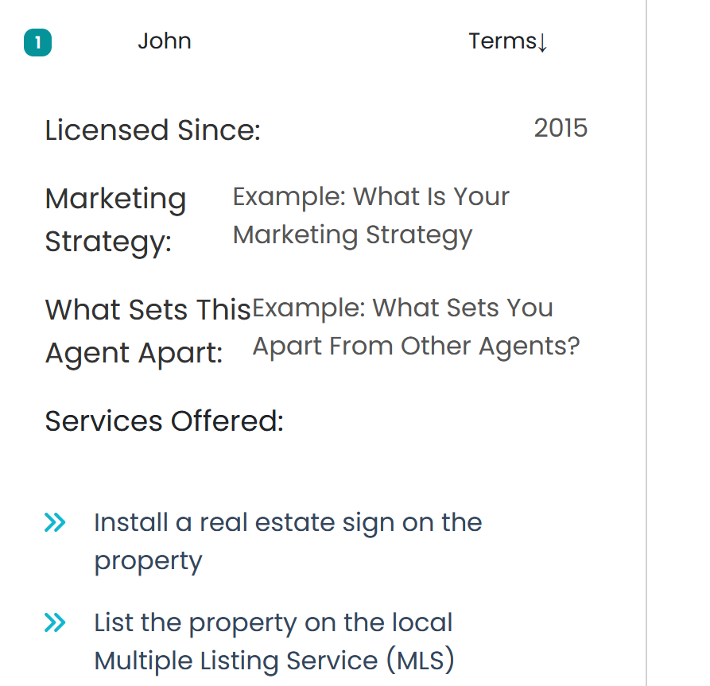

Full Bid should be visible under Private Compensation & Agency Agreement Terms right now it’s not showing the fields that are on the bid it should show the full bid in the Private Compensation & Agreement Terms missing fields Licensed Since, & Marketing Strategy, What Set’s This Agent Apart. & Services Offered,

Why Should You Be Hired should be changed to Why Hire This Agent:


Example: here is Landlord one where it shows it correctly:
Also have the : after each term like it is for Landlord such as
About Agent: instead of About Agent etc

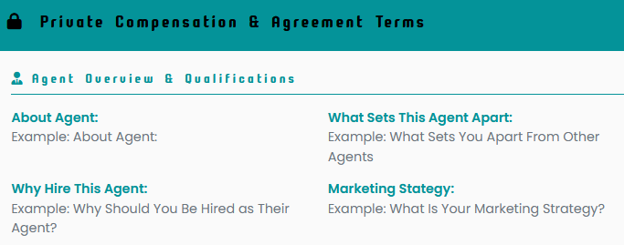

Verse Current Tenant one that is missing fields:
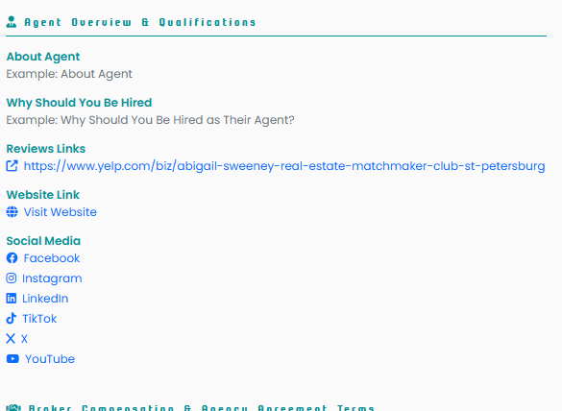

If user selects the Visit Website it goes to this error
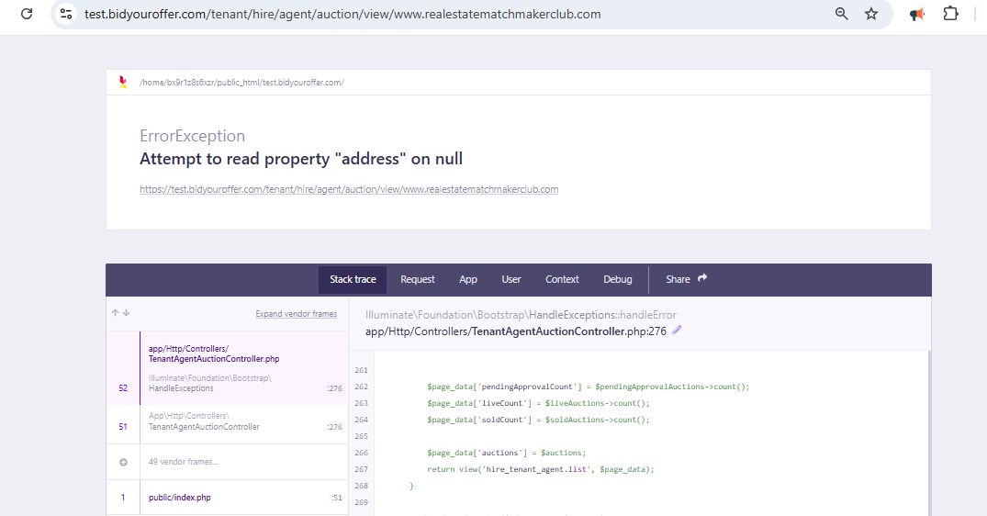


Should say Review Links: instead of Reviews Links

- Under Broker Compensation & Agency Agreement Terms
Here is how it should be formatted

Broker Compensation & Agency Agreement Terms

Tenant’s Broker Compensation:
- Tenant’s Broker Commission Structure: Included in Offer
- Tenant’s Broker Lease Fee: Flat Fee
- Flat Fee Amount: $6,000)
- Payment Timing for Broker Fees: Paid within calendar days of Tenant rent payment
- Calendar Days to Pay: 5 days

Purchase Fee Details:
- Interested in Purchasing a Property: Yes
- Purchase Fee Type: Percentage of the Total Purchase Price + Flat Fee
- Purchase Percentage: 2%
- Additional Flat Fee: $2,000

Lease-Option Details:
- Interested in a Lease-Option Agreement: Yes
• Compensation Type (When Option Is Created) Percentage
• Percentage Amount: 2%
• Compensation Type (If Purchase Option is Exercised): Flat Fee
• Flat Fee Amount: $7,000

Legal Terms:
- Protection Period Timeframe: 90 days
- Early Termination Fee: Yes
- Termination Fee Amount: $1,000
- Retainer Fee: Yes
- Retainer Fee Amount: $500
- Retainer Fee Application: Applied toward final compensation
- Tenant Agency Agreement Timeframe: 9 Months

Brokerage Relationship:
Acceptable Brokerage Relationship: Transaction Broker Representation

Additional Terms:

Additional Details:

- Services Offered

Please keep all items under one main “Services” section, but reinsert the category sub-titles inside that section (with emojis and bold text) for clarity and organization.
Use the following category titles and correct order:
Here is the Residential List:

📢 Tenant Criteria Marketing & Promotion
🔍 Property Search, Alerts & Matching
🏡 Property Showings & Virtual Tours
📝 Tenant Application Support
📃 Lease Preparation & Execution
🚚 Move-In Support & Coordination
💡 Leasing Strategy & Guidance
✍️ Additional Services

Here is Commercial list:

📢 Tenant Criteria Marketing & Promotion
🔍 Property Search, Alerts & Matching
🏡 Property Showings & Virtual Tours
📝 Tenant Application Support
📃 Lease Preparation, LOI & Execution
🚚 Move-In Support & Coordination
💡 Leasing Strategy & Guidance
✍️ Additional Services

Make sure:
- All service items stay under one scrollable “Services” section (no other services box should be under Additional Services instead)
- Each category title appears above its related checklist items.
- The order matches this list exactly.
- Keep consistent spacing, indentation, and bullet formatting.

- Under Agent Presentation & Promotional Materials:

The business card is too small to read user should be able to download.
Also there should be a display with the marketing materials link or upload and download link with the marketing materials uploaded because right now that is missing:

🔹 Agents CAN EDIT their bid if:
- Status = Active
- No counter sent
- Not accepted yet
- For Bidding Period listings → countdown still active
🔹 Agents CAN WITHDRAW their bid if:
- Status = Active
- Not accepted
- No counter received
🔹 Agents CANNOT edit OR withdraw if:
- Bid has been accepted
- There is an open counter
- Listing is in Pending or Hired status
- Bidding Period has ended (for edit only)

- Once the listing expiration date or bidding period end time is reached, the “Bid Now” button must be disabled or hidden, and any attempt to submit a bid should show an error message.

- Actual Bids Display:
Remove this notice:
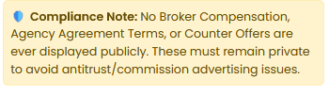
Please update the bid display so that all bids are completely anonymous. Instead of showing the Agent’s first name or username, each bid should be labeled Agent 1, Agent 2, Agent 3, etc., based on the order in which the bids are submitted.
Additionally, where it currently shows the first name of the “last bidder,” it should instead display the last Agent who placed a bid—for example: “Agent 5 was the last bidder.”

Remove the following fields from public view entirely:
• Licensed Since
• Marketing Strategy
• What Sets This Agent Apart

Publicly, each bid should display only the following:
• The bid status (Active, Accepted, Rejected, or Countered).
• The total number of Services selected. Each “Additional Service” selected should also count as one service.
• The Broker Compensation & Agency Agreement summary fields, specifically:
– Tenant’s Broker Commission Structure:
– Tenant’s Broker Lease Fee:

Below this summary, the card should display a link labeled:
View Full Services & Broker Compensation Terms
When the user clicks this link, it should show:
• All Services selected (grouped under the correct categories and sub-categories)
• The full Broker Compensation & Agency Agreement Terms (in the approved order)
- All remaining information submitted by the Agent should remain private and visible only to the creator of the listing.

- Agents should be able to edit or delete their bid after submitting it, as long as the bid has not been accepted.
Here is example of Bid:

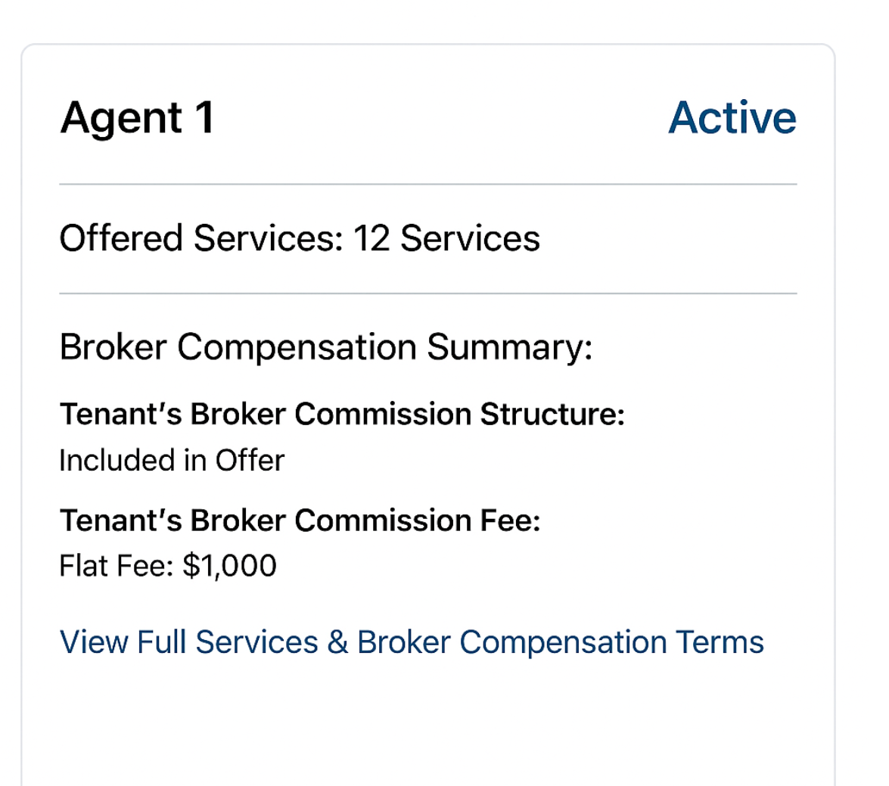

Change Tenant’s Broker Commission Fee: to
Tenant’s Broker Lease Fee:

- Counter Bids:

For counterbids, the system must show the latest version of both the Services and the Broker Compensation & Agency Agreement Terms, using the correct category structure. This information should be visible only to the Client and the Agent involved—not publicly. The bid status is the only element that changes publicly. For example, once a Landlord counters a bid, the status should update from Active to Countered. If the Landlord rejects a bid, the status should update to Rejected, etc.
The counterbid form should automatically populate with the latest terms.
For example, if a Tenant counters an Agent’s bid, the counterbid form should automatically load all of the most recent:
• Broker Compensation & Agency Agreement Terms, and
• Services
that the Agent previously selected.
The Tenant can then edit any field before submitting the counterbid.
Likewise, if the Agent counters the Tenant’s counterbid, the system should automatically populate the form with the Tenant’s latest terms, allowing the Agent to edit and resubmit.
In summary:
• Each counterbid should always pre-fill with the most recently submitted version of all compensation fields and service selections from whichever party made the last bid.
• The receiving party should only need to adjust the fields they want to change—no blank forms and no re-entering of prior data.

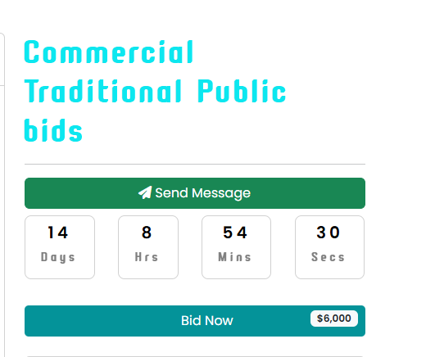

Delete the number next to Bid Nows

- Actual Listing Display:
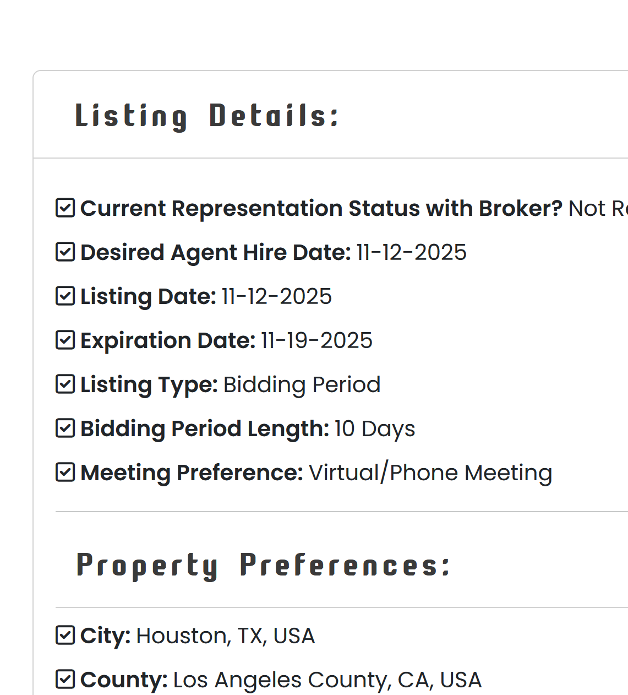

- Listing Status should show on listings

✅ Developer Instructions — Correct Formatting for Acceptable Cities, Counties, ZIP Codes, and State
Current Problem (What the UI shows now):
- Cities display as long full-address strings:
Treasure Island, FL, USA St. Petersburg, FL, USA
- Counties include redundant state/country text:
Pinellas County, FL, USA Hillsborough County, FL, USA
- ZIP codes show as full location chips:
St. Petersburg, FL 33715, USA
This creates clutter, duplicates data, and is inconsistent with the desired display format.

✅ Correct Format (What it MUST display on Listings)
• Acceptable Cities: St. Petersburg, Seminole
• Acceptable ZIP Codes: 33715, 33716
• Acceptable Counties: Pinellas
• Acceptable State: Florida

✅ Backend Output Requirements
1. Acceptable Cities
- Extract only the city name(s)
- Strip out state, ZIP, and country
- Remove duplicates
- Join multiple cities with commas
- Final Example Output:
Acceptable Cities: St. Petersburg, Seminole

2. Acceptable Counties
- Extract only the county name
- Option A: Display as just the name (“Pinellas”)
- Option B: Keep the suffix (“Pinellas County”) — choose one style and keep it consistent across platform
- Remove state and country
- Remove duplicates
- Final Example Output:
Acceptable Counties: Pinellas

3. Acceptable ZIP Codes
- Extract only the 5-digit ZIP code
- Remove associated city/state/country text
- Remove duplicates
- Join multiple ZIP codes with commas
- Final Example Output:
Acceptable ZIP Codes: 33715, 33716

4. Acceptable State
- Display only the full state name (not abbreviation)
- Final Example Output:
Acceptable State: Florida

- Residential Listing:

- Listing Details:

- Current Representation Status with Broker? Should have : instead of ?
So should read as Current Representation Status with Broker:

- Property Preferences:

The format should match listing creation:
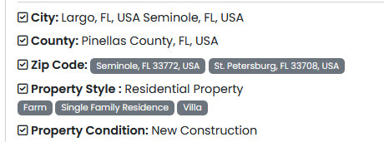

Change to:

- Acceptable Cities:
- Acceptable ZIP Codes:
- Acceptable Counties:
- Acceptable Property Type:
- Acceptable Property Styles:
- Acceptable Property Conditions:

Furnishings Needed should be before Carport Needed, then if yes Number of Carport Spaces Needed, then Garage Needed, then if yes Number of Garage Spaces Needed:

Right now Carport Needed is missing:

Fields should say
- Carport Needed: Yes or No
if Yes then
- Number of Carport Spaces Needed: 6

Right now Garage Needed is missing:

Field should say
- Garage Needed: Yes or No
If Yes then
- Number of Garage Spaces Needed:

- Pool Needed: should say Yes or No if yes then show (Private, Community)
Capitalize Private and Community. Should read as
Pool Needed: Yes (Private, Community)

- View Preference Needed: if user selects Other it should have just the answer not the word other
- Non-Negotiable Amenities and Property Features: if user selects Other it should have just the answer not the word other

- Leasing Terms:

- Offered Lease Term: Offered Lease Term: It should say Offered Lease Term instead of Offered Lease Length:
if user selects Other it should have just the answer not the word other
- Offered Lease Date: the date should display as Month, Date, then Year, right now it’s Year, Month, then Date.

- Services:

Some of the services are out of order on actual listing display compared to the order it was selected in.

Developer Note:
Please keep all items under one main “Services” section, but reinsert the category sub-titles inside that section (with emojis and bold text) for clarity and organization.
Use the following category titles and correct order:

📢 Tenant Criteria Marketing & Promotion
🔍 Property Search, Alerts & Matching
🏡 Property Showings & Virtual Tours
📝 Tenant Application Support
📃 Lease Preparation & Execution
🚚 Move-In Support & Coordination
💡 Leasing Strategy & Guidance
✍️ Additional Services

Make sure:
- All service items stay under one scrollable “Services” section (no other services box should be under Additional Services instead)
- Each category title appears above its related checklist items.
- The order matches this list exactly.
- Keep consistent spacing, indentation, and bullet formatting.

- Broker Compensation
should say Broker Compensation & Agency Agreement Terms


Make sure the $ is before the number not after

The $ should be before the 5

Also, update the format we will have sub-categories that fall under Broker Compensation & Agency Agreement Terms. These sub-categories should be smaller then main section headers.
Here is an example of how the information should be displayed:

Tenant’s Broker Compensation:
- Tenant’s Broker Commission Structure: Included in Offer
- Tenant’s Broker Lease Fee: Flat Fee
- Flat Fee Amount: $6,000)
- Payment Timing for Broker Fees: Paid within calendar days of Tenant rent payment
- Calendar Days to Pay: 5 days

Purchase Fee Details:
- Interested in Purchasing a Property: Yes
- Purchase Fee Type: Percentage of the Total Purchase Price + Flat Fee
- Purchase Percentage: 2%
- Additional Flat Fee: $2,000

Lease-Option Details:
- Interested in a Lease-Option Agreement: Yes
• Compensation Type (When Option Is Created) Percentage
• Percentage Amount: 2%
• Compensation Type (If Purchase Option is Exercised): Flat Fee
• Flat Fee Amount: $7,000

Legal Terms:
- Protection Period Timeframe: 90 days
- Early Termination Fee: Yes
- Termination Fee Amount: $1,000
- Retainer Fee: Yes
- Retainer Fee Amount: $500
- Retainer Fee Application: Applied toward final compensation
- Tenant Agency Agreement Timeframe: 9 Months

Brokerage Relationship:
Acceptable Brokerage Relationship: Transaction Broker Representation

Additional Terms:

- Actual listing: (Commercial)

- Listing Details:

- Current Representation Status with Broker? Should have : instead of ?
So should read as Current Representation Status with Broker:

- Property Preferences:

The format should match listing creation:


Change to:

- Acceptable Cities:
- Acceptable ZIP Codes:
- Acceptable Counties:
- Acceptable Property Type:
- Acceptable Property Styles:
- Acceptable Property Conditions:

- Minimum Net Leasable Sqft Needed: There shouldn’t be a $ in front of the number

- Garage/Parking Features Needed: (Missing)

- View Preference Needed: if user selects Other it should have just the answer not the word other
- Age Restricted Community: Delete this field for Commercial

- Non-Negotiable Amenities and Property Features: if user selects Other it should have just the answer not the word other

- Leasing Terms:

- Offered Lease Term: It should say Offered Lease Term instead of Offered Lease Length: if user selects Other it should have just the answer not the word other
- Offered Lease Date: the date should display as Month, Date, then Year, right now it’s Year, Month, then Date.

- Services:
Some of the services are out of order on actual listing display compared to the order it was selected in.

Developer Note:
Please keep all items under one main “Services” section, but reinsert the category sub-titles inside that section (with emojis and bold text) for clarity and organization.
Use the following category titles and correct order:

📢 Tenant Criteria Marketing & Promotion
🔍 Property Search, Alerts & Matching
🏡 Property Showings & Virtual Tours
📝 Tenant Application Support
📃 Lease Preparation, LOI & Execution
🚚 Move-In Support & Coordination
💡 Leasing Strategy & Guidance
✍️ Additional Services

Make sure:
- All service items stay under one scrollable “Services” section (no other services box should be under Additional Services instead)
- Each category title appears above its related checklist items.
- The order matches this list exactly.
- Keep consistent spacing, indentation, and bullet formatting.

- Broker Compensation
should say Broker Compensation & Agency Agreement Terms


Make sure the $ is before the number not after
The $ should be before the 5

Also, update the format we will have sub-categories that fall under Broker Compensation & Agency Agreement Terms. These sub-categories should be smaller then main section headers.
Here is an example of how the information should be displayed:

Tenant’s Broker Compensation:
- Tenant’s Broker Commission Structure: Included in Offer
- Tenant’s Broker Lease Fee: Flat Fee
- Flat Fee Amount: $6,000)
- Payment Timing for Broker Fees: Paid within calendar days of Tenant rent payment
- Calendar Days to Pay: 5 days

Purchase Fee Details:
- Interested in Purchasing a Property: Yes
- Purchase Fee Type: Percentage of the Total Purchase Price + Flat Fee
- Purchase Percentage: 2%
- Additional Flat Fee: $2,000

Lease-Option Details:
- Interested in a Lease-Option Agreement: Yes
• Compensation Type (When Option Is Created) Percentage
• Percentage Amount: 2%
• Compensation Type (If Purchase Option is Exercised): Flat Fee
• Flat Fee Amount: $7,000

Legal Terms:
- Protection Period Timeframe: 90 days
- Early Termination Fee: Yes
- Termination Fee Amount: $1,000
- Retainer Fee: Yes
- Retainer Fee Amount: $500
- Retainer Fee Application: Applied toward final compensation
- Tenant Agency Agreement Timeframe: 9 Months

Brokerage Relationship:
Acceptable Brokerage Relationship: Transaction Broker Representation

Additional Terms:

✅ Listing Logic Rules for Bidding Period vs. Traditional
1. Bidding Period Listings
If the listing is created with a Bidding Period, then:
- The listing creator cannot Accept, Counter, or Reject any bids until the countdown timer has fully expired.
- All action buttons must be disabled or hidden during the active bidding period.

2. Traditional Listings (No Bidding Period)
A. If Agent Bids Are Public (Visible to Other Agents)
- All agent bids are publicly visible to other competing agents.
- The listing should display:
  - Offered Services
  - Broker Compensation & Agency Agreement Terms

3. If Agent Bids Are Private
- No other agents can see the bid details.
- Only the listing creator can view the full details of each bid privately.

- Once an Offer Gets Accepted:
When a User accepts a bid, the platform should generate a Document Summary containing:
When a User accepts a bid, the platform should generate a Document Summary containing:
- Parties: Tenant/Agent name/contact info)
- Listing ID, Target Areas, Property Type, and Day Bid was Accepted
- All Services selected for that bid
(grouped exactly by category)
- All Broker Compensation & Agency Agreement Terms
- Any Additional Terms or Details
(provided by either the Agent or the User)

Example of what should be generated:

Accepted Bid Summary
This document summarizes the Services, Broker Compensation & Agency Agreement Terms, and related details for the bid accepted on the BidYourAgent platform. It is intended to be used as a reference and attached to the Agent’s and Client’s state-approved brokerage forms and agreements.

1. Parties
Client (Tenant):
First & Last Name: {{client_name}}
Email: {{client_email}}
Phone: {{client_phone}}
Agent:
First & Last Name: {{agent_name}}
Email: {{agent_email}}
Phone: {{agent_phone}}
Brokerage: {{agent_brokerage_name}}
Real Estate License #: {{agent_license}}
NAR Member ID: {{nar_id}}

2. Listing / Criteria Details
Listing ID: {{listing_id}}
Target Areas: {{tenant_Acceptable cities, County, zip code, state)
Property Type Sought: {{property_type}}
Date Bid Accepted: {{accepted_date}}

3. Services Selected for This Bid
The following Services were accepted as part of this bid:
(Examples shown just to show you but actual input should be based on the accepted bid, if a service was not selected do not show on the summary)

📢 Tenant Criteria Marketing & Promotion
• Create a branded flyer summarizing the Tenant’s rental criteria
• Post criteria on Craigslist under “Real Estate Wanted”
• Share criteria on Nextdoor community groups

🔍 Search, Alerts & Property Matching
• Send MLS email alerts matching Tenant criteria
• Search for off-market, pre-market, expired, and withdrawn properties

🏡 Property Showings & Virtual Tours
• Schedule and attend in-person showings
• Coordinate or conduct virtual showings

📝 Tenant Application Support
• Provide application instructions or platform links
• Gather and organize supporting documents

📃 Lease Preparation & Execution
• Review lease offers and prepare questions or change requests
• Coordinate negotiation with Landlord/Agent

🚚 Move-In Support & Coordination
• Coordinate move-in date and key handoff
• Confirm required cleaning or repairs

💡 Leasing Strategy & Guidance
• Provide Rental Market Analysis (RMA)
• Advise on lease types (annual, month-to-month, furnished, lease-option)

✍️ Additional Services
• Other – Additional services specified by the Agent or Tenant

(…continue for all selected categories and services depending on agreed services and property type…)

4. Broker Compensation & Agency Agreement Terms
The following Broker Compensation & Agreement Terms were included in the accepted bid and should be attached to the appropriate state-approved brokerage agreements.

(Examples shown just to show you but actual input should be based on the accepted bid, if a term was left blank it should not show on the summary)

Tenant’s Broker Compensation:
- Tenant’s Broker Commission Structure: Included in Offer
- Tenant’s Broker Lease Fee: Flat Fee
- Flat Fee Amount: $6,000)
- Payment Timing for Broker Fees: Paid within calendar days of Tenant rent payment
- Calendar Days to Pay: 5 days

Purchase Fee Details:
- Interested in Purchasing a Property: Yes
- Purchase Fee Type: Percentage of the Total Purchase Price + Flat Fee
- Purchase Percentage: 2%
- Additional Flat Fee: $2,000

Lease-Option Details:
- Interested in a Lease-Option Agreement: Yes
• Compensation Type (When Option Is Created) Percentage
• Percentage Amount: 2%
• Compensation Type (If Purchase Option is Exercised): Flat Fee
• Flat Fee Amount: $7,000

Legal Terms:
- Protection Period Timeframe: 90 days
- Early Termination Fee: Yes
- Termination Fee Amount: $1,000
- Retainer Fee: Yes
- Retainer Fee Amount: $500
- Retainer Fee Application: Applied toward final compensation
- Tenant Agency Agreement Timeframe: 9 Months

Brokerage Relationship:
Acceptable Brokerage Relationship: Transaction Broker Representation

Additional Terms:

5. Additional Details
{{additional_details_block}}

6. Important Notice
This Accepted Bid Summary is provided for convenience and transparency. It is not a substitute for state-approved brokerage agreements, representation agreements, leases, or purchase contracts.
The Client and Agent should incorporate these terms into their official forms and agreements as required by state law and brokerage policy.

- Additional Details on Bidding Logic not done correctly:

The timer should be linked to the Bidding Period Length input if the user selects Bidding Period for the Listing Type. There should be no timer for Traditional listings. Right now, the timer for all listings

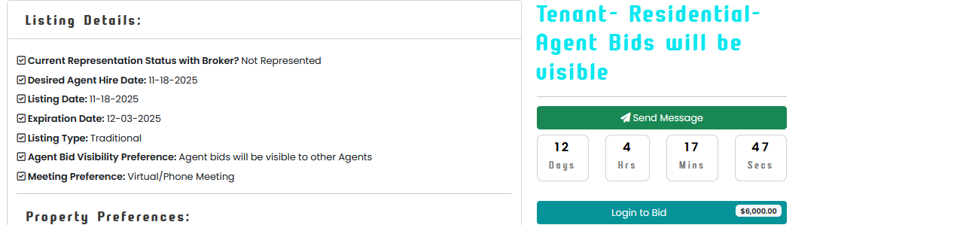

Remove timer for Listing Type: Traditional

- Dashboard

It looks like the counter, accept, and reject actions are currently tied only to the main listing view. Each bid should be individually actionable. For example, if a property has two bids, the User should be able to counter, accept, or reject each bid separately, not just counter the terms in general.
Users should be able to view each Agent’s full bid inside their dashboard and take action on it (counter, accept, or reject) in the same way they can from the actual listing page.
Example Issue:
When I attempted to send a counter, the bid status changed to Inactive, and I was unable to see where the counter went or how to respond from the Agent side.
In the Agent’s dashboard, each bid should clearly show whether it was Accepted, Rejected, or Countered.
The Agent should also be able to edit their bid until it is accepted, rejected, or countered.
Right now, the system only allows you to view the bid, and then it redirects you back to the listing. I had to click on my own name to discover that the bid was rejected. There is currently no clear indication that a bid was accepted, rejected, or countered unless you manually look for it.
Users and Agents need a clear, direct way to:
- View the full bid
- See the current status
- Counter, accept, or reject from their dashboard
- Know immediately when the status of their bid changes

Once I submit a bid the listing would not actually load if I was signed in gave me this error . This was specifically if I was signed in as the user who created the listing tenant@exp.com, if I was signed out or signed in as an agent (john@exp & johnlong@exp) I could view the listings.
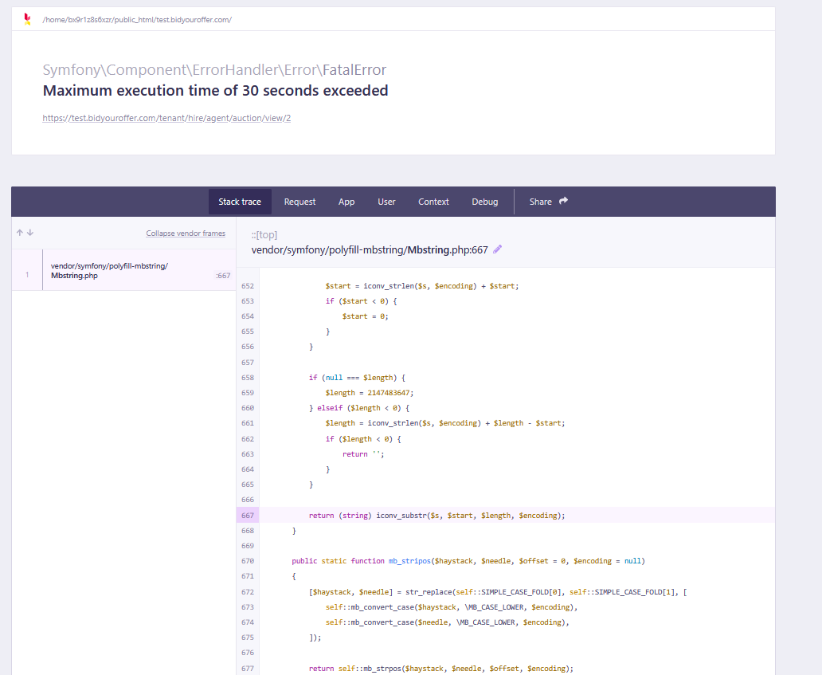

- Updated Listing Card Display Requirements (Corrected Grammar + Clear Logic)

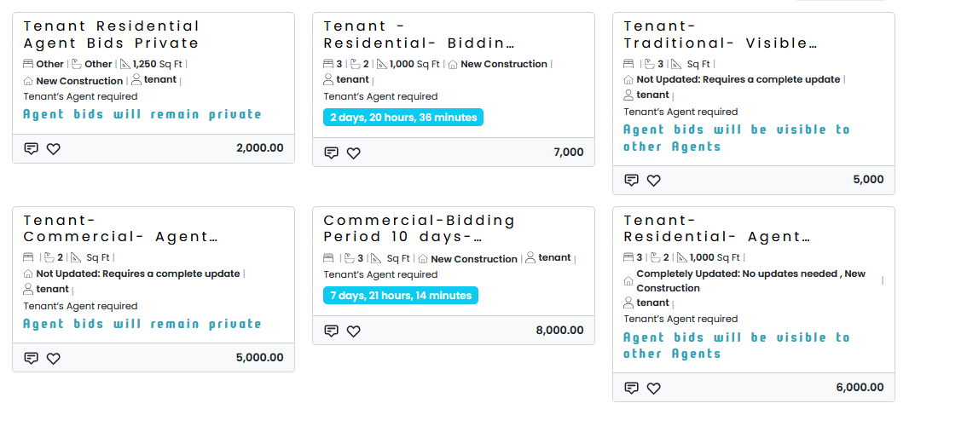

Edit the cards to display as follows:
🟦 Residential Tenant Listing Card

Tenant • Residential
🏠 Single-Family Home
🛏 3 Beds | 🛁 2 Baths | 📐 1,000 Sq Ft
📍 Pinellas County
👤 Tenant’s Agent Required
💼 Commission Structure: Included in Offer
💼 Tenant’s Broker Commission Fee: Flat Fee – $6,000

🟧 Commercial Tenant Listing Card

Tenant • Commercial
🏢 Office
📐 3,000 Sq Ft
📍 Hillsborough County
👤 Tenant’s Agent Required
💼 Commission Structure: Included in Offer
💼 Tenant’s Broker Commission Fee: 3% of Gross Rent

Here are the instructions based on what I need from what currently shows:

1. Remove bid-visibility text
Do not display the following on listing cards:
• “Agent bids will be visible to other Agents”
• “Agent bids will remain private”
These messages should only appear inside the listing details page if needed.

2. Capitalization
Change “tenant” to:
✔Tenant

4. Replace “Other” with the actual user input
When a User selects Other in ANY field, the card should display the value the User typed, not the word “Other.”
Examples:
A. Bedrooms / Bathrooms
If User selects “Other” and enters:
- “11” Bedrooms → show 11 Beds
- “7” Bathrooms → show 7 Baths
Not:
❌ “Other”
❌ “Other | Other”
Remove Bed/Bath for Commercial Property

5. Display both Property Type and Property Style
The listing card must show:
✔ Property Type (e.g., Residential, Commercial, Income, Vacant Land)
✔ Property Style (e.g., Single-Family, Condo, Warehouse, Retail, Office)

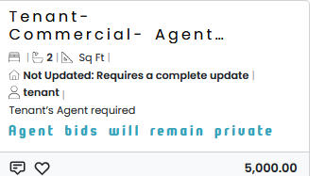

For Commercial listings the Sq Ft number should be connected to the Minimum Net Leasable Sqft Needed, right now it’s blank and remove the Bed symbol for commercial

  - Remove Property Condition from listing card not needed
  - Add County
  - Add Commission Structure & Commission Fee
Exact display is below

- Edit a listing:

- Right now I can’t edit listing or listing status. The creator should be able to edit a listing.

- Make sure listing is mobile friendly as well.

Thank you for all your hard work

