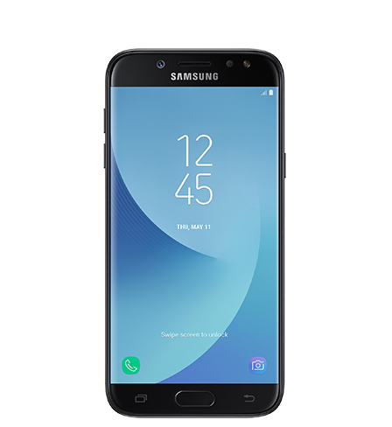

|  |
| --- |
| Clase |
| Smartphon |

|  |
| --- |
| Método |
| Llamar |
| Mensajear |
| Navegar internet |

|  |
| --- |
| Objeto |
| Galaxy |

|  |
| --- |
| Atributos |
| Samsung |
| S6 |
| Botón |