**LAB#3**

**RECURSION**

**OBJECTIVE:** To understand the complexities of the recursive functions and a way to reduce these complexities.

**LABTASKS:**

TASK#1:

1. Write a program which takes an integer value (k) as input and prints the sequence of numbers from k to 0 in descending order

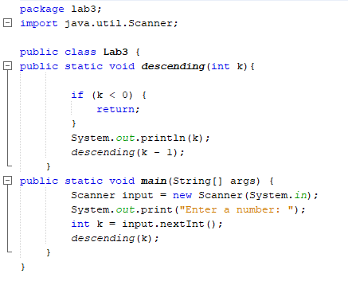

**OUTPUT:**

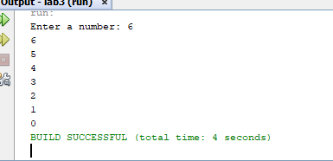

**TASK#2:**

2. Write a program to reverse your full name using Recursion.

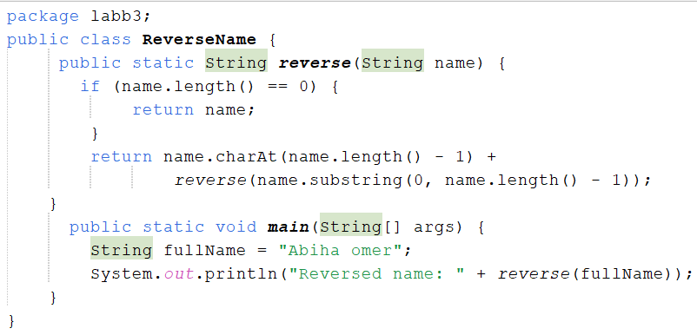

**OUTPUT:**

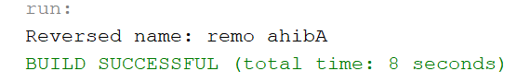

**TASK#3:**

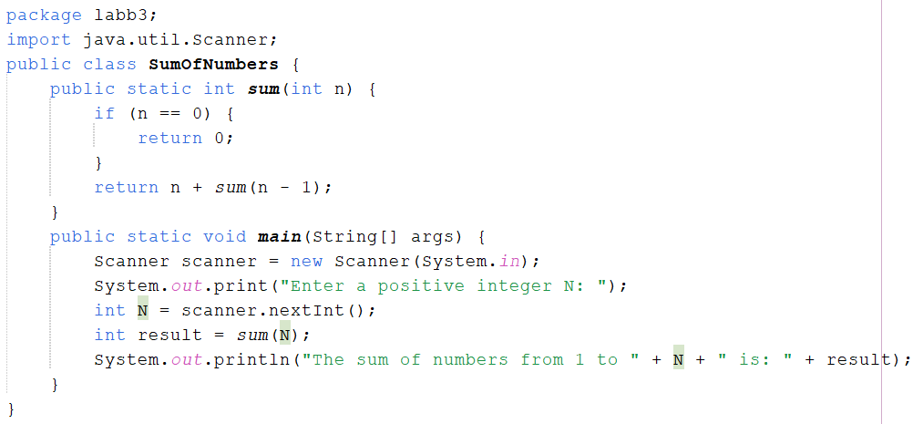3. Write a program to calculate the sum of numbers from 1 to N using recursion. N should be user input.

**Output:**

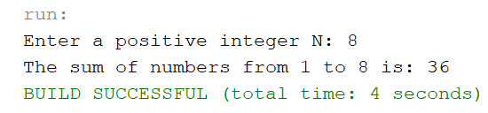

TASK#4:

4. Write a recursive program to calculate the sum of elements in an array.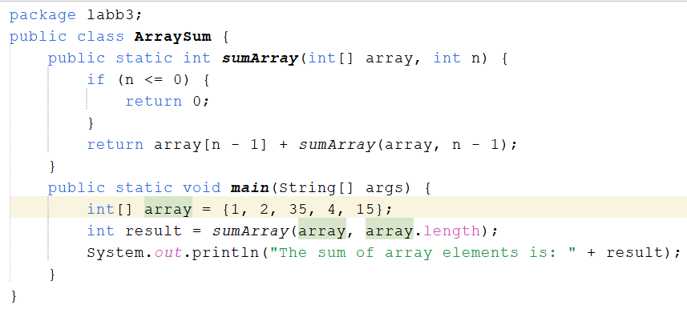

**Output:**

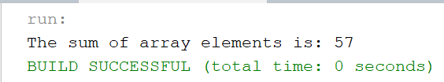

**Task#5:**

5. Write a recursive program to calculate the factorial of a given integer n

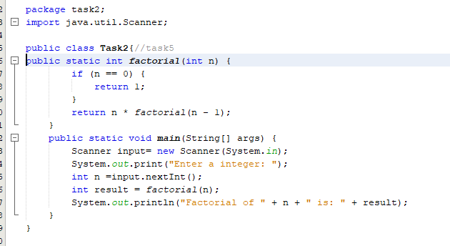

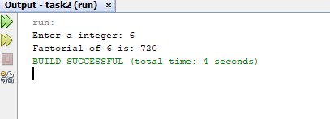

**HOME TASKS:**

**TASK#1:**

1. Write a java program to find the N-th term in the Fibonacci series using Memoization.

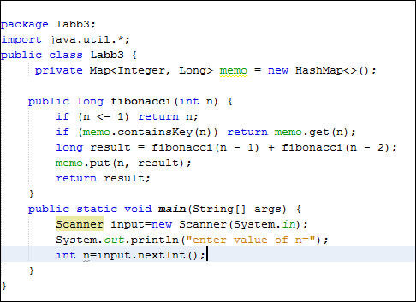

OUTPUT:

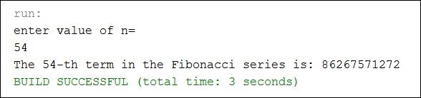

**TASK#2:**

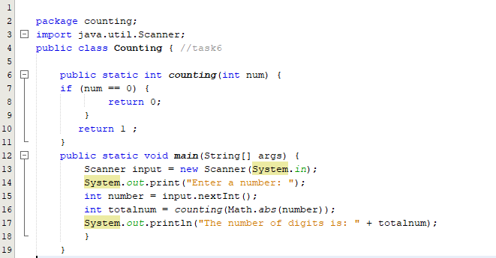2. Write a program to count the digits of a given number using recursion.

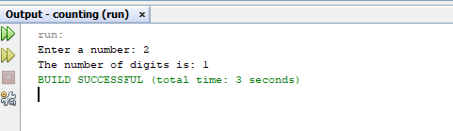

**TASK#3:**

3. Write a java program to check whether a given string is a palindrome or not. A palindrome is a string that reads the same forwards and backwards.Print "YES" if the string is a palindrome, otherwise print "NO".

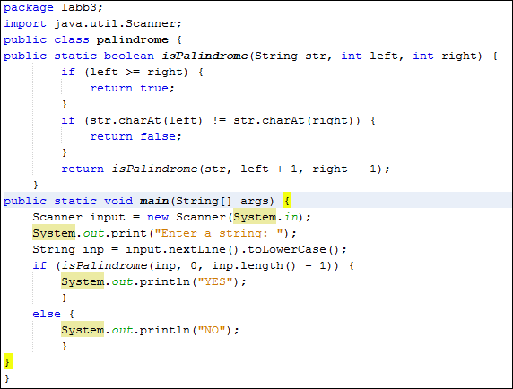

**OUTPUT:**

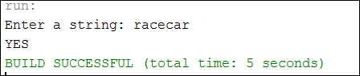

**TASK#4:**

4. Write a recursive program to find the greatest common divisor (GCD) of two numbers using Euclid's algorithm.

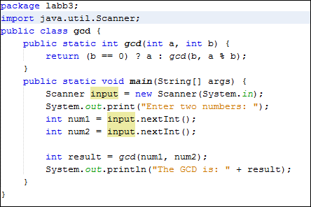

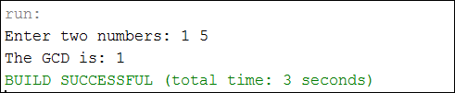**OUTPUT:**