**LAB # 04**

**ARRAYS IN JAVA**

**OBJECTIVE:** **To understand arrays and its memory allocation.**

**LAB TASKS**

1. Write a program that takes two arrays of size 4 and swap the elements of those arrays

Lab task#1:

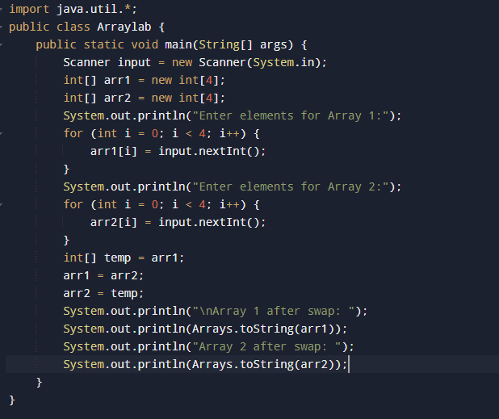

Output:

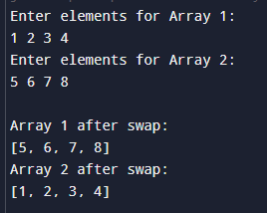

task#2:

2. Add a method in the class that takes array and merge it with the existing one.

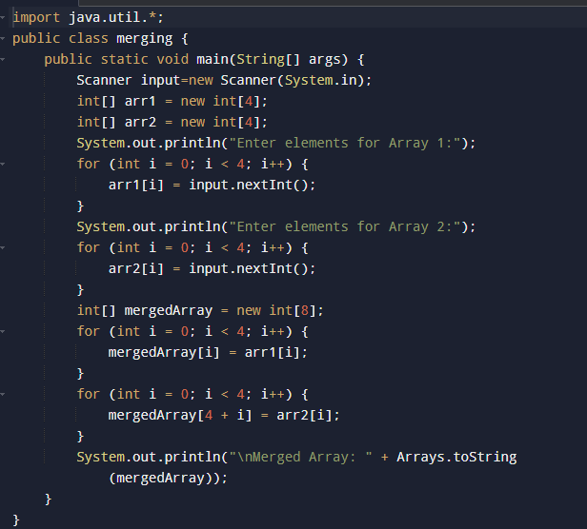

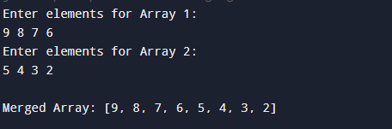Output:

Lab task#3:

3. In a JAVA program, take an array of type string and then check whether the strings are palindrome or not.

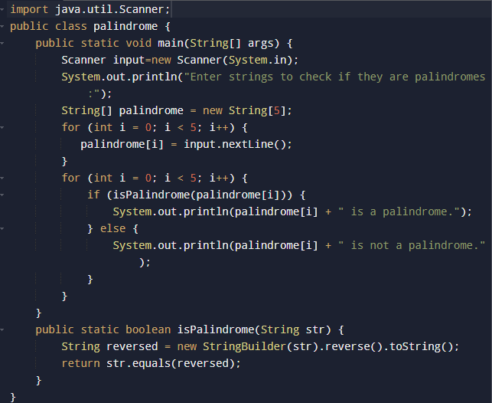

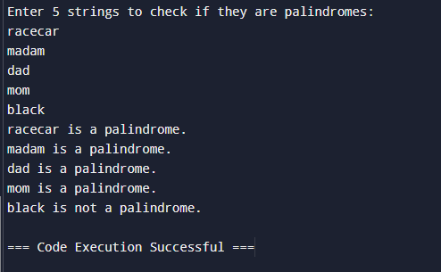Output:

Lab task#4:

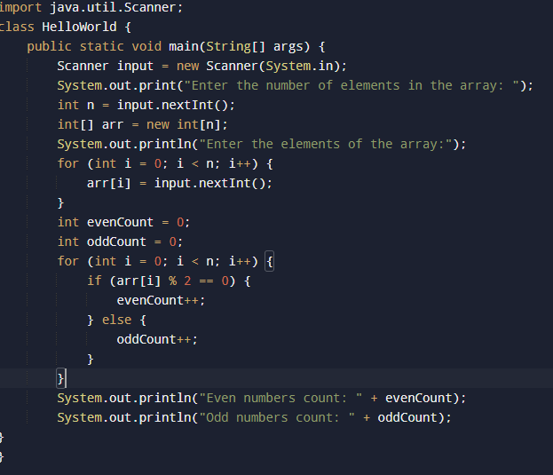4. Given an array of integers, count how many numbers are even and how many are odd.

Output:

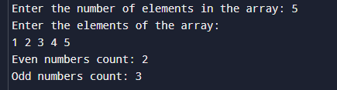

Lab task#5:

5. Given two integer arrays, merge them and remove any duplicate values from the resulting array.

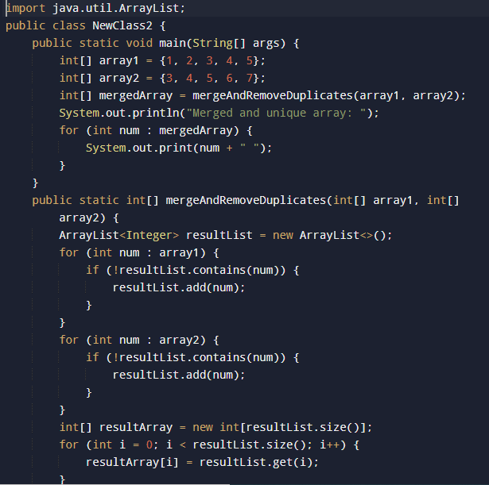

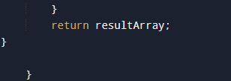

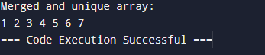Output:

**Home tasks:**

Task#1:

1. Write a program that takes an array of Real numbers having size 7 and calculate the sum and mean of all the elements. Also depict the memory management of this task.

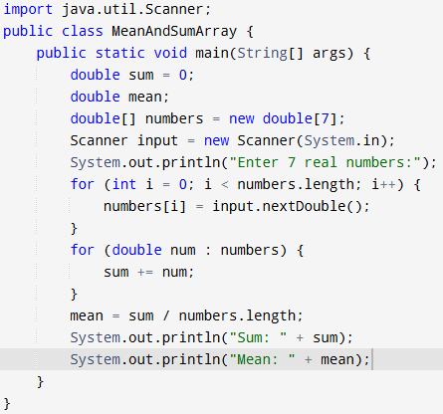

Output:

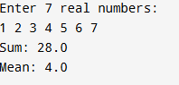

Task#2:

2. Add a method in the same class that splits the existing array into two. The method should search a key in array and if found splits the array from that index of the key

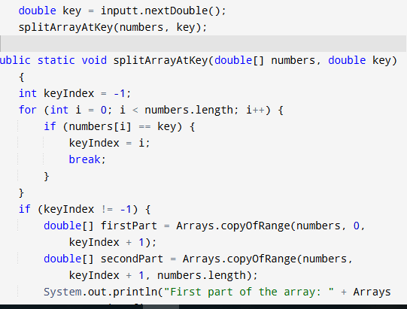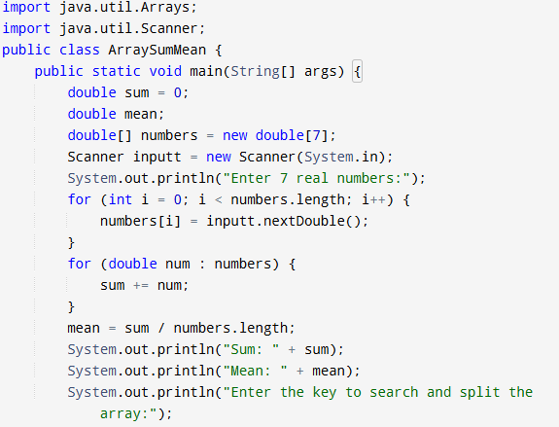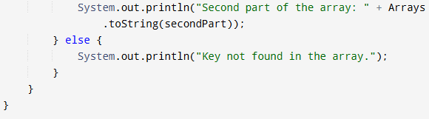

Output:

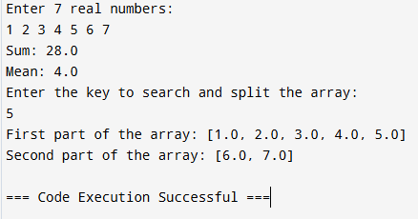

Task#3:

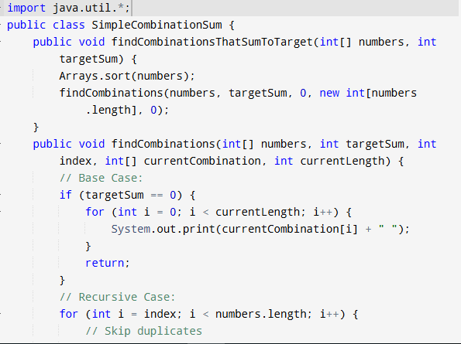3. Given an array of distinct integers and a target integer, return all unique combinations of numbers that add up to the target. Each number can be used only once in the combination.

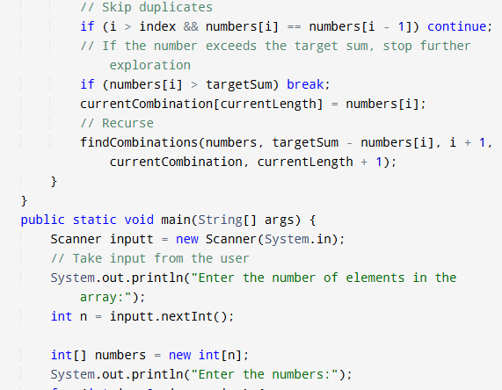

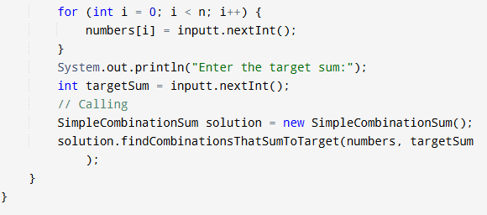

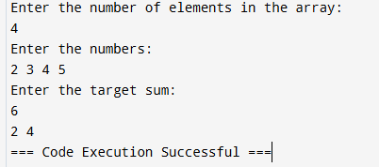Output:

Task#4:

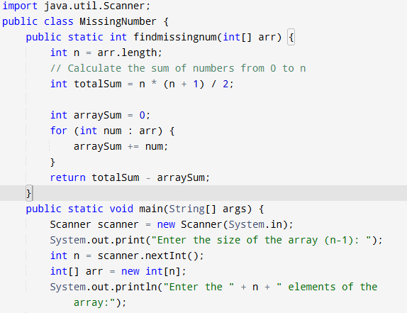4. You are given an array containing n distinct numbers taken from 0, 1, 2, ..., n. Write a program to find the one number that is missing from the array

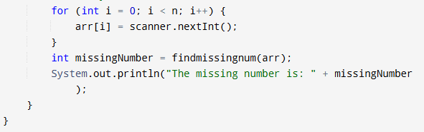

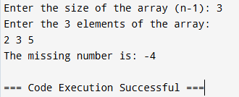output:

Task#5:

5. You are given an array of integers. Write a program to sort the array such that it follows a zigzag pattern: the first element is less than the second, the second is greater than the third, and so on.

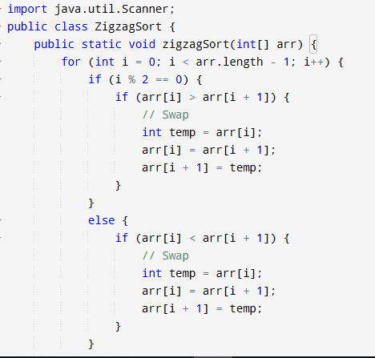

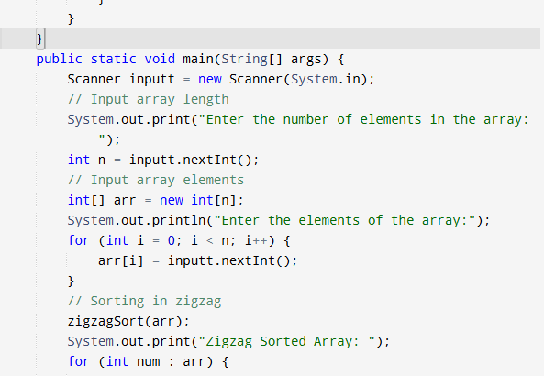

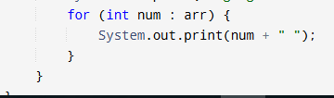

Output:

