LAB # 3
Introduction to Concurrency
OBJECTIVE
Understanding and implementing the concept of concurrency through different mechanisms of multithreading.
Lab Task:
- Implement the following program on eclipse IDE and answer the following questions:
- How many threads are running?
There are 3 user-created threads (t1, t2, t3) and 1 main thread.
Total = 4 threads.
• How many tasks are running?
Each thread runs one task (the run() method).
Total = 3 tasks.
• If more tasks are added, what will be the impact on number of threads?
More threads will be created as new tasks are added. Each new Thread object will start a new thread, increasing system load and context switching.
• Explain the flow of program:
- The main thread starts and creates three Thread objects (t1, t2, t3).
- The start() method of each object creates a new thread that calls run().
- Each thread prints “task one”.
- The three threads run concurrently, so output order may vary.
class Main extends Thread{
public void run(){
System.out.println("task one");
}
public static void main(String args[]){
Main t1=new Main();
Main t2=new Main();
Main t3=new Main();
t1.start();
t2.start();
t3.start();
}
}

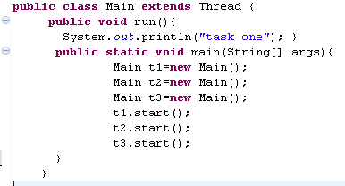
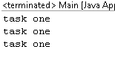
- With the help of threading print two tables concurrently, print one table number of student roll number e.g. 2019-SE-092 and second number should be date of birth e.g. 05-April.
