LAB # 4
Start, Sleep and Stop methods of multithreading
OBJECTIVE:
Understanding concurrency by implementing start, sleep and stop thread functions.
Lab Task:
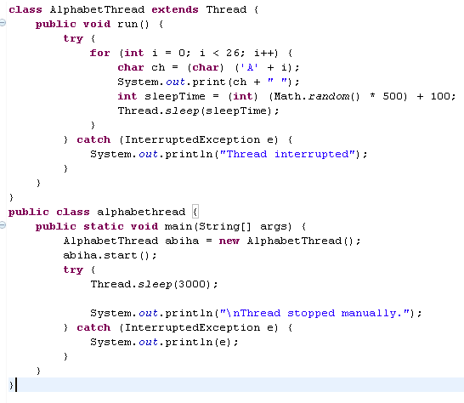
By using start, stop and sleep methods of threading, print alphabets of English from A-Z. (Hint: use math.random method for getting random numbers and then convert them into characters, print 26 characters under run method loop with fluctuating visualization through sleep method).

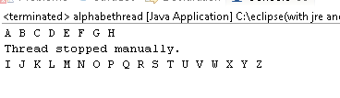
Output:

