1) Create a Database called ​ music​ .

> use music
switched to db music
>

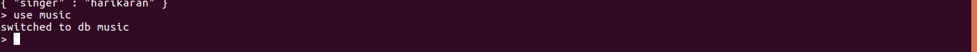

2) Create a collection called ​ songdetails​ .

> db.createCollection("mycollection")
{ "ok" : 1 }

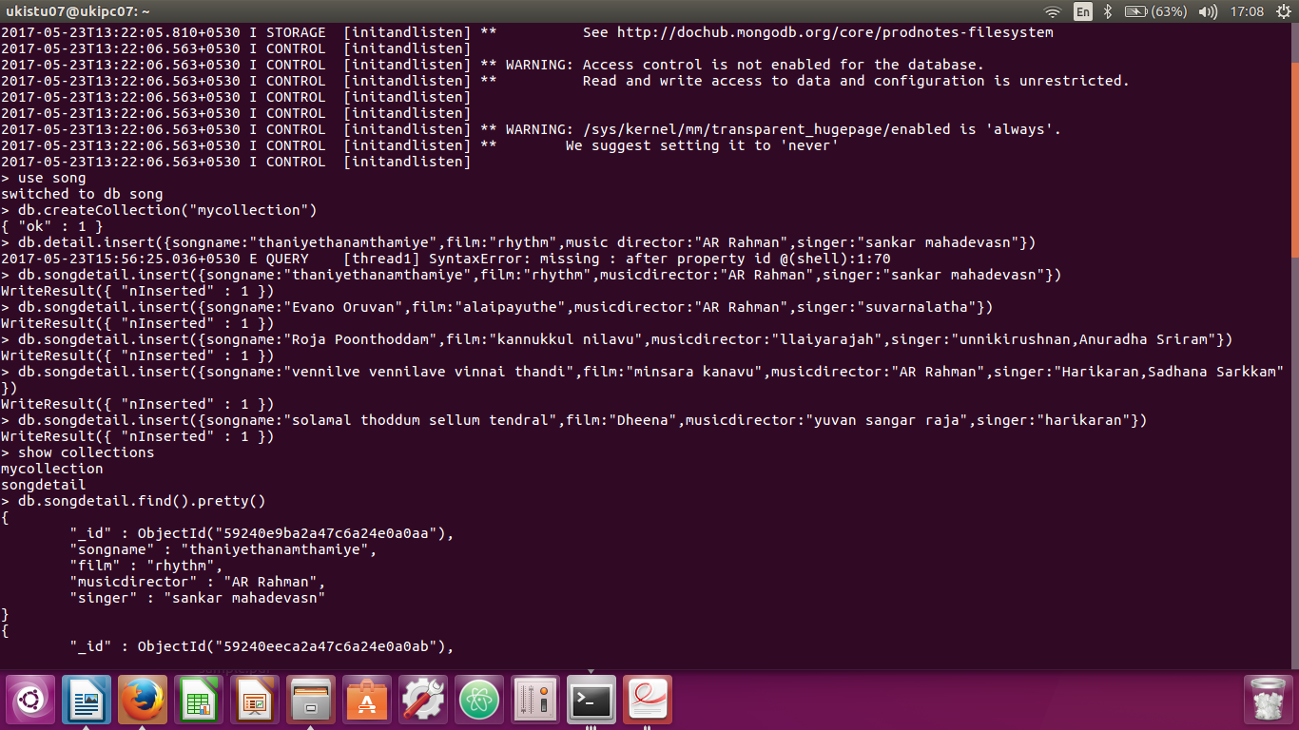

3) Create the above 5 song documents.

> db.songdetail.insert({songname:"thaniyethanamthamiye",film:"rhythm",musicdirector:"AR Rahman",singer:"sankar mahadevasn"})
WriteResult({ "nInserted" : 1 })
> db.songdetail.insert({songname:"Evano Oruvan",film:"alaipayuthe",musicdirector:"AR Rahman",singer:"suvarnalatha"})
WriteResult({ "nInserted" : 1 })
> db.songdetail.insert({songname:"Roja Poonthoddam",film:"kannukkul nilavu",musicdirector:"llaiyarajah",singer:"unnikirushnan,Anuradha Sriram"})
WriteResult({ "nInserted" : 1 })
> db.songdetail.insert({songname:"vennilve vennilave vinnai thandi",film:"minsara kanavu",musicdirector:"AR Rahman",singer:"Harikaran,Sadhana Sarkkam"})
WriteResult({ "nInserted" : 1 })
> db.songdetail.insert({songname:"solamal thoddum sellum tendral",film:"Dheena",musicdirector:"yuvan sangar raja",singer:"harikaran"})
WriteResult({ "nInserted" : 1 })

4) List all documents created.

> db.songdetail.find().pretty()
{
"_id" : ObjectId("59240e9ba2a47c6a24e0a0aa"),
"songname" : "thaniyethanamthamiye",
"film" : "rhythm",
"musicdirector" : "AR Rahman",
"singer" : "sankar mahadevasn"
}
{
"_id" : ObjectId("59240eeca2a47c6a24e0a0ab"),
"songname" : "Evano Oruvan",
"film" : "alaipayuthe",
"musicdirector" : "AR Rahman",
"singer" : "suvarnalatha"
}
{
"_id" : ObjectId("59240f9ba2a47c6a24e0a0ac"),
"songname" : "Roja Poonthoddam",
"film" : "kannukkul nilavu",
"musicdirector" : "llaiyarajah",
"singer" : "unnikirushnan,Anuradha Sriram"
}
{
"_id" : ObjectId("59241015a2a47c6a24e0a0ad"),
"songname" : "vennilve vennilave vinnai thandi",
"film" : "minsara kanavu",
"musicdirector" : "AR Rahman",
"singer" : "Harikaran,Sadhana Sarkkam"
}
{
"_id" : ObjectId("59241080a2a47c6a24e0a0ae"),
"songname" : "solamal thoddum sellum tendral",
"film" : "Dheena",
"musicdirector" : "yuvan sangar raja",
"singer" : "harikaran"
}

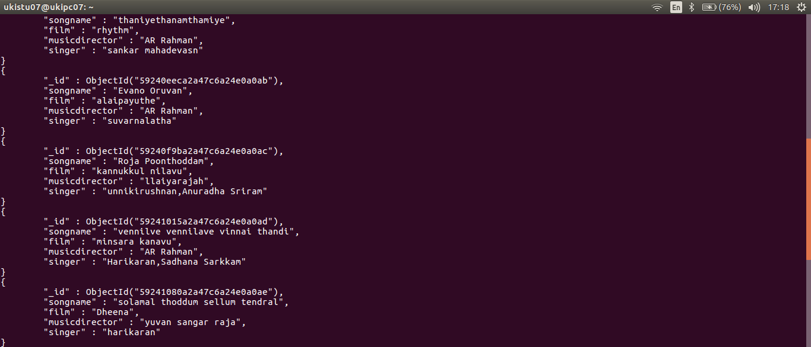

5) List A.R.Rahman’s songs.

> db.songdetails.find({songdirector:"AR Raham"},{songname:1,_id:0})
> db.songdetail.find({songdirector:"AR Rahman"},{songname:1,_id:0})
> db.songdetail.find({musicdirector:"AR Rahman"},{songname:1,_id:0})
{ "songname" : "thaniyethanamthamiye" }
{ "songname" : "Evano Oruvan" }
{ "songname" : "vennilve vennilave vinnai thandi" }

6) List A.R.Rahman’s songs sung by Unnikrishnan.

> db.songdetail.find({musicdirector:"AR Rahman",singer:"unnikirushnan"},{songname:1,_id:0})

7) Delete the song which you don’t like.

> db.songdetail.remove({songname:"Evano Oruvan",film:"alaipayuthe",musicdirector:"AR Rahman",singer:"suvarnalatha"})
WriteResult({ "nRemoved" : 1 })
> db.songdetail.find().pretty()
{
"_id" : ObjectId("59240e9ba2a47c6a24e0a0aa"),
"songname" : "thaniyethanamthamiye",
"film" : "rhythm",
"musicdirector" : "AR Rahman",
"singer" : "sankar mahadevasn"
}
{
"_id" : ObjectId("59240f9ba2a47c6a24e0a0ac"),
"songname" : "Roja Poonthoddam",
"film" : "kannukkul nilavu",
"musicdirector" : "llaiyarajah",
"singer" : "unnikirushnan,Anuradha Sriram"
}
{
"_id" : ObjectId("59241015a2a47c6a24e0a0ad"),
"songname" : "vennilve vennilave vinnai thandi",
"film" : "minsara kanavu",
"musicdirector" : "AR Rahman",
"singer" : "Harikaran,Sadhana Sarkkam"
}
{
"_id" : ObjectId("59241080a2a47c6a24e0a0ae"),
"songname" : "solamal thoddum sellum tendral",
"film" : "Dheena",
"musicdirector" : "yuvan sangar raja",
"singer" : "harikaran"
}

8) Add new song which is your favourite.

> db.songdetail.insert({songname:"sakaranilave",film:"youth",musicdirector:"yuvan sangar raja",singer:"harikaran"})
WriteResult({ "nInserted" : 1 })

9) List Songs sung by Hariharan from Minsara kanavu film.

> db.songdetail.find({musicdirector:"AR Rahman",singer:"Harikaran,Sadhana Sarkkam"},{songname:1,_id:0})
{ "songname" : "vennilve vennilave vinnai thandi" }

10)List out the singers’ names in your document.

> db.songdetail.find({},{singer:1,_id:0})
{ "singer" : "sankar mahadevasn" }
{ "singer" : "unnikirushnan,Anuradha Sriram" }
{ "singer" : "Harikaran,Sadhana Sarkkam" }
{ "singer" : "harikaran" }
{ "singer" : "harikaran" }

