Mongodb + Node.js

1) Create a Database called ​ music​ .
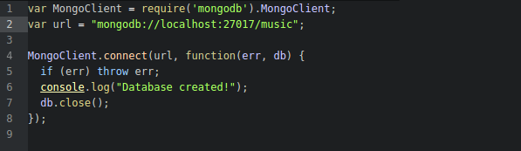
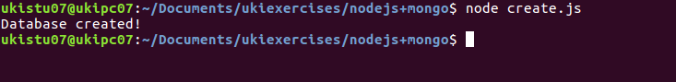

2) Create a collection called ​ songdetails​ .

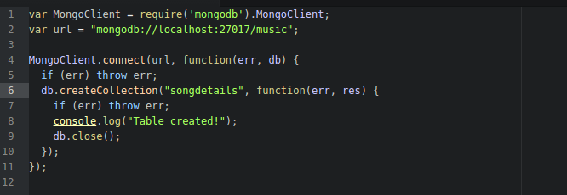

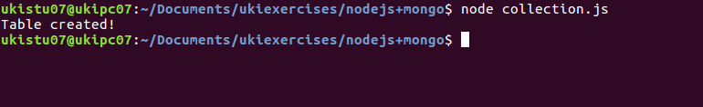

3) Create the above 5 song documents.
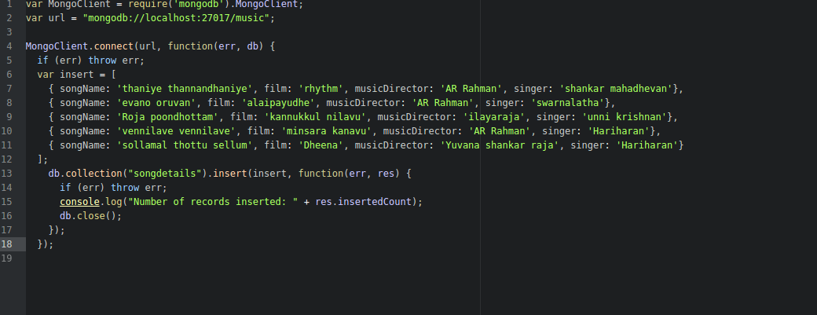

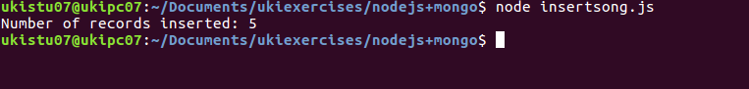

4) List all documents created.

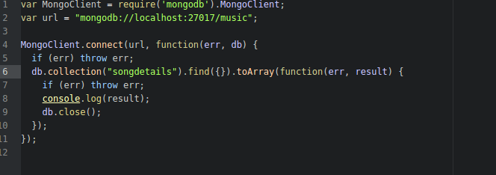
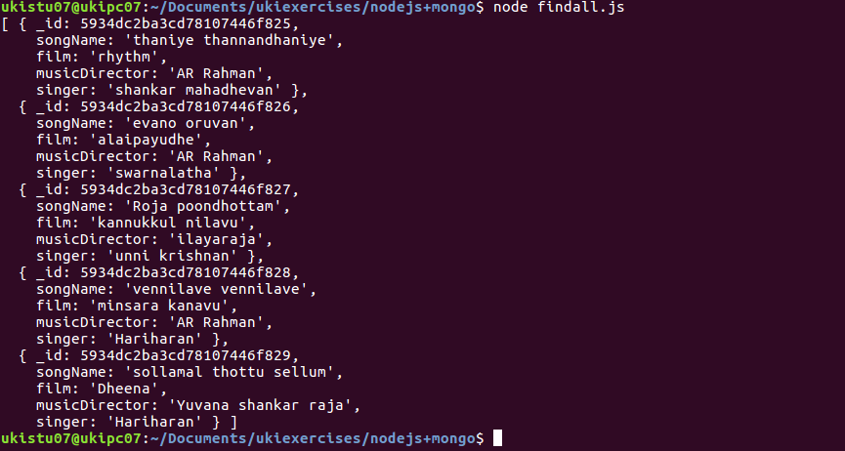
5) List A.R.Rahman’s songs.

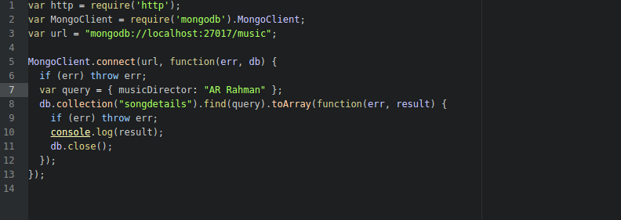
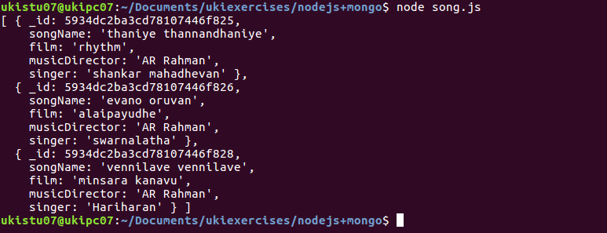
6) List A.R.Rahman’s songs sung by Unnikrishnan.

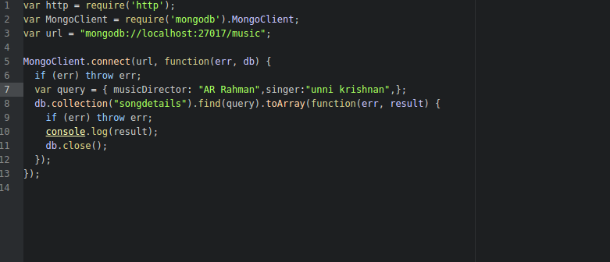

7) Delete the song which you don’t like.

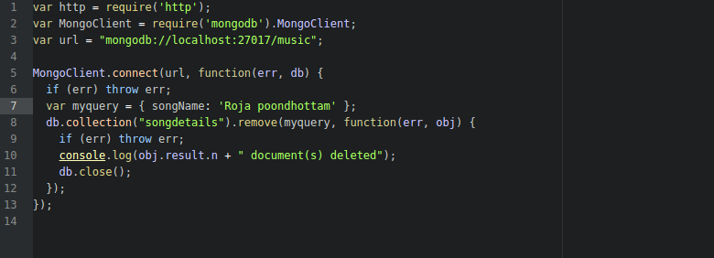
8) Add new song which is your favourite.

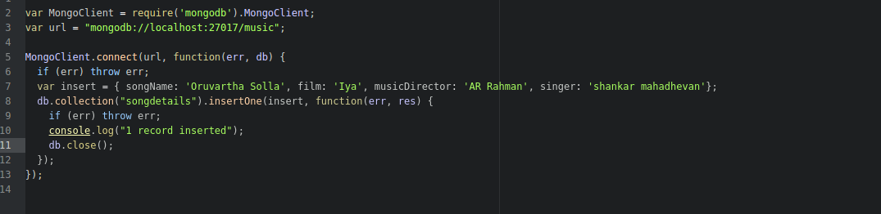

9) List Songs sung by Hariharan from Minsara kanavu film.

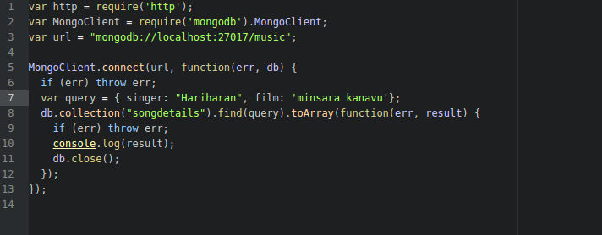
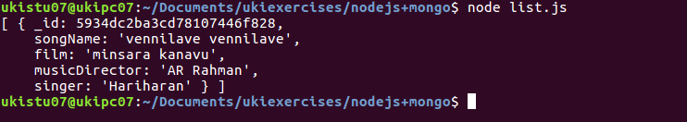
10)List out the singers’ names in your document.

Exercise 02

1) Create a Database called ​ student

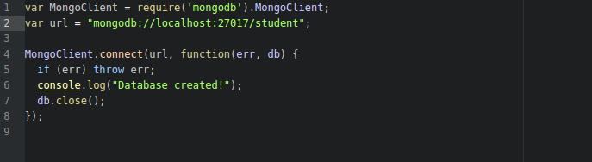
2) Create a collection called ​ studentmarks
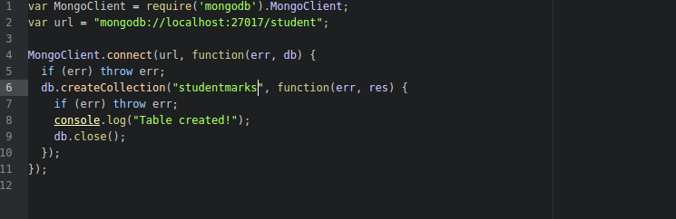

3) Create the documents listed in above table.
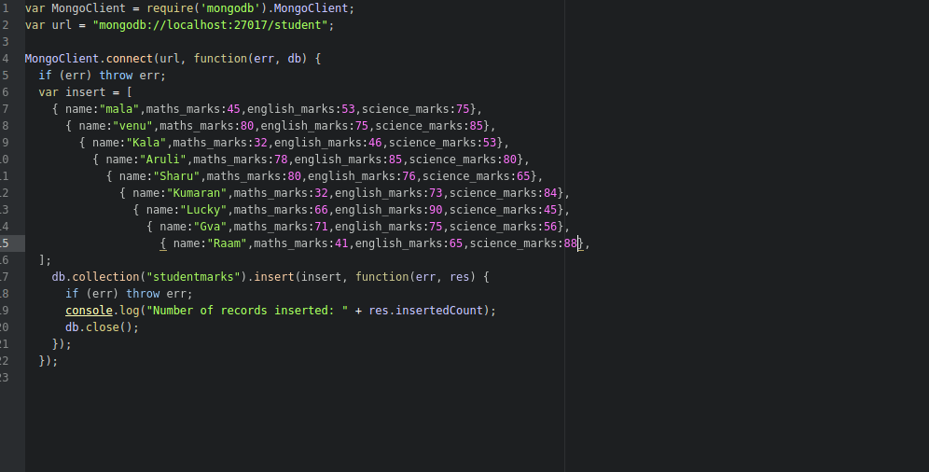

4) Increase the maths marks of Raam by 6 marks

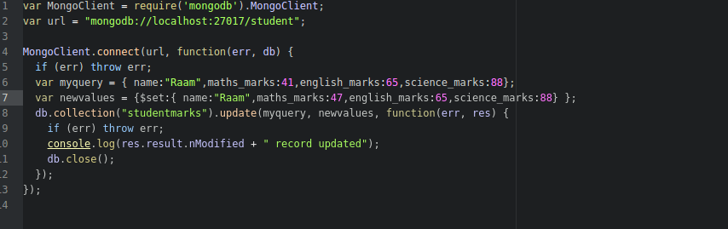

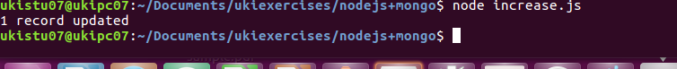
5) List the names of students who got more than 50 marks in Maths Subject.
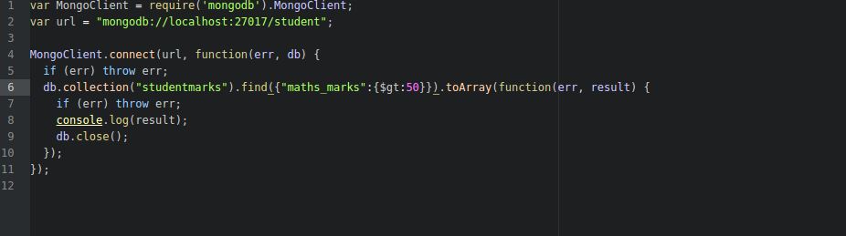

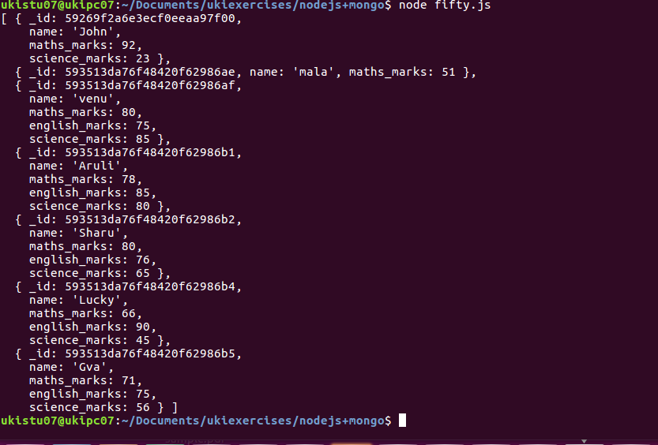
6)Add a new column(field) for Average for all students.

7) Update Marks_Science=75 to Lucky .
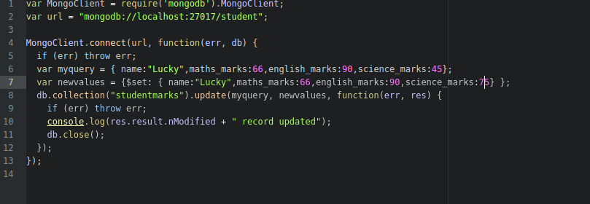

8) List the names who got more than 50 marks in all subjects.

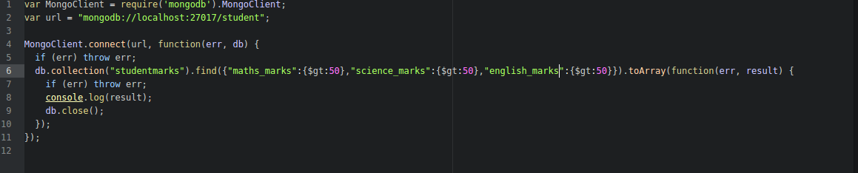
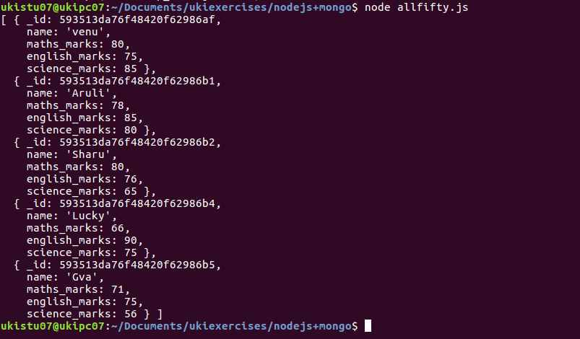

9) List the names who got less than 50 marks in Maths subject
and more than 50 marks in English

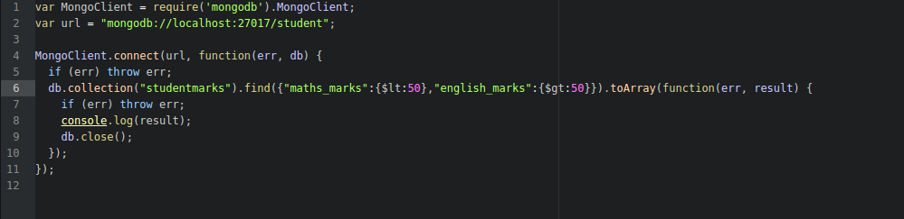

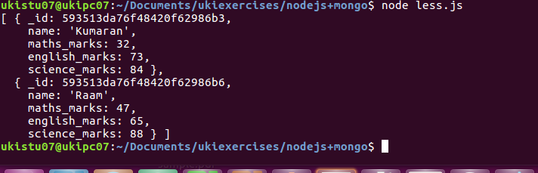
10) List the names who got less than 40 in both Maths and Science.

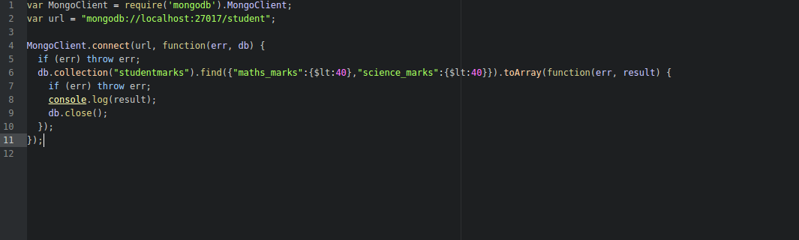
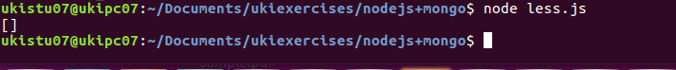
11) Remove Science column/field for Raam

12) Update John’s Math mark as 87 and English mark as 23, if john not available upsert.

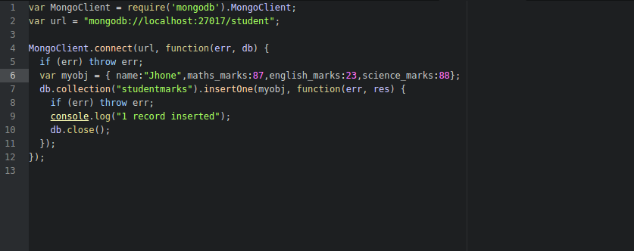
13) Rename the english_marks column/field for John to science_marks

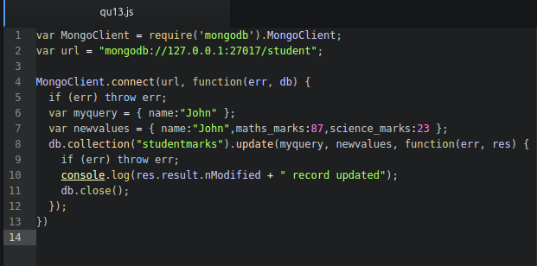

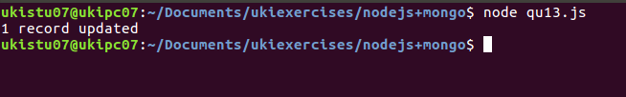

14) Remove Kumaran’s document from collection

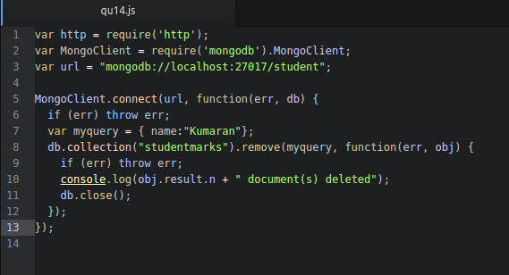

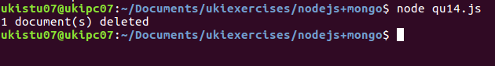

15) Find Kala’s or Aruli’s math_marks and science_marks
