GigEase
AI-Powered Parametric Income Protection for Gig Workers
India's First Parametric Insurance Platform for Delivery Partners

DevTrails 2026 — Guidewire Hackathon
Team: Abijith U | Tarun Aadarsh B | Priyadharshini | Monish M
Platform  Zomato / Swiggy / Zepto | Coverage  STFI + RSMD Combined | Payout Speed  Under 10 minutes | Premium  From Rs.25/week

1. Problem Statement — The Gig Worker Income Crisis

India has over 15 million gig economy delivery workers across Zomato, Swiggy, Zepto, Amazon, and Dunzo. These workers have no fixed salary, no paid leave, no employer-provided insurance, and no income guarantee. Every rupee depends on being able to ride their vehicle to a location and deliver an order.

A Zomato rider in Chennai earns through per-order distance pay (Rs.4.5/km), waiting time pay (Rs.1/min after 3 free minutes), a Rs.15 minimum floor per order, daily target bonuses (Rs.160-Rs.410), and weekly performance bonuses (Rs.325-Rs.575). A full-time rider working 6 days earns Rs.4,000-Rs.6,000/week normally.

During a cyclone or severe flood, that same rider earns Rs.0. They still owe rent, EMI on their bike loan, school fees, and daily household expenses. There is no buffer. There is no safety net. There is no insurance.

1.1 Why Traditional Insurance Fails Gig Workers
Problem | Traditional Insurance | GigEase Solution
Claims process | 3-8 weeks, manual adjuster | Automatic in under 10 minutes
Income documentation | Pay slips, Form 16 required | Uses verified platform earnings
Affordability | High premium, unverifiable income | Rs.25-Rs.250/week, auto-deducted
Speed of payment | Weeks after loss | Minutes after trigger fires
Claim filing | Complex forms, branch visits | Zero paperwork — fully parametric

No insurance company in India currently offers parametric income protection designed specifically for gig workers. IRDAI does not yet have a defined product category for this. GigEase is designed to be the first.

2. Mobile App — UI Design & User Experience

The GigEase mobile app is the delivery partner's primary touchpoint. The design philosophy is radical simplicity: the rider never files a claim, never calls a number, never uploads a document. The app shows their earnings, their protection status, and their payout history. Everything else is automatic.

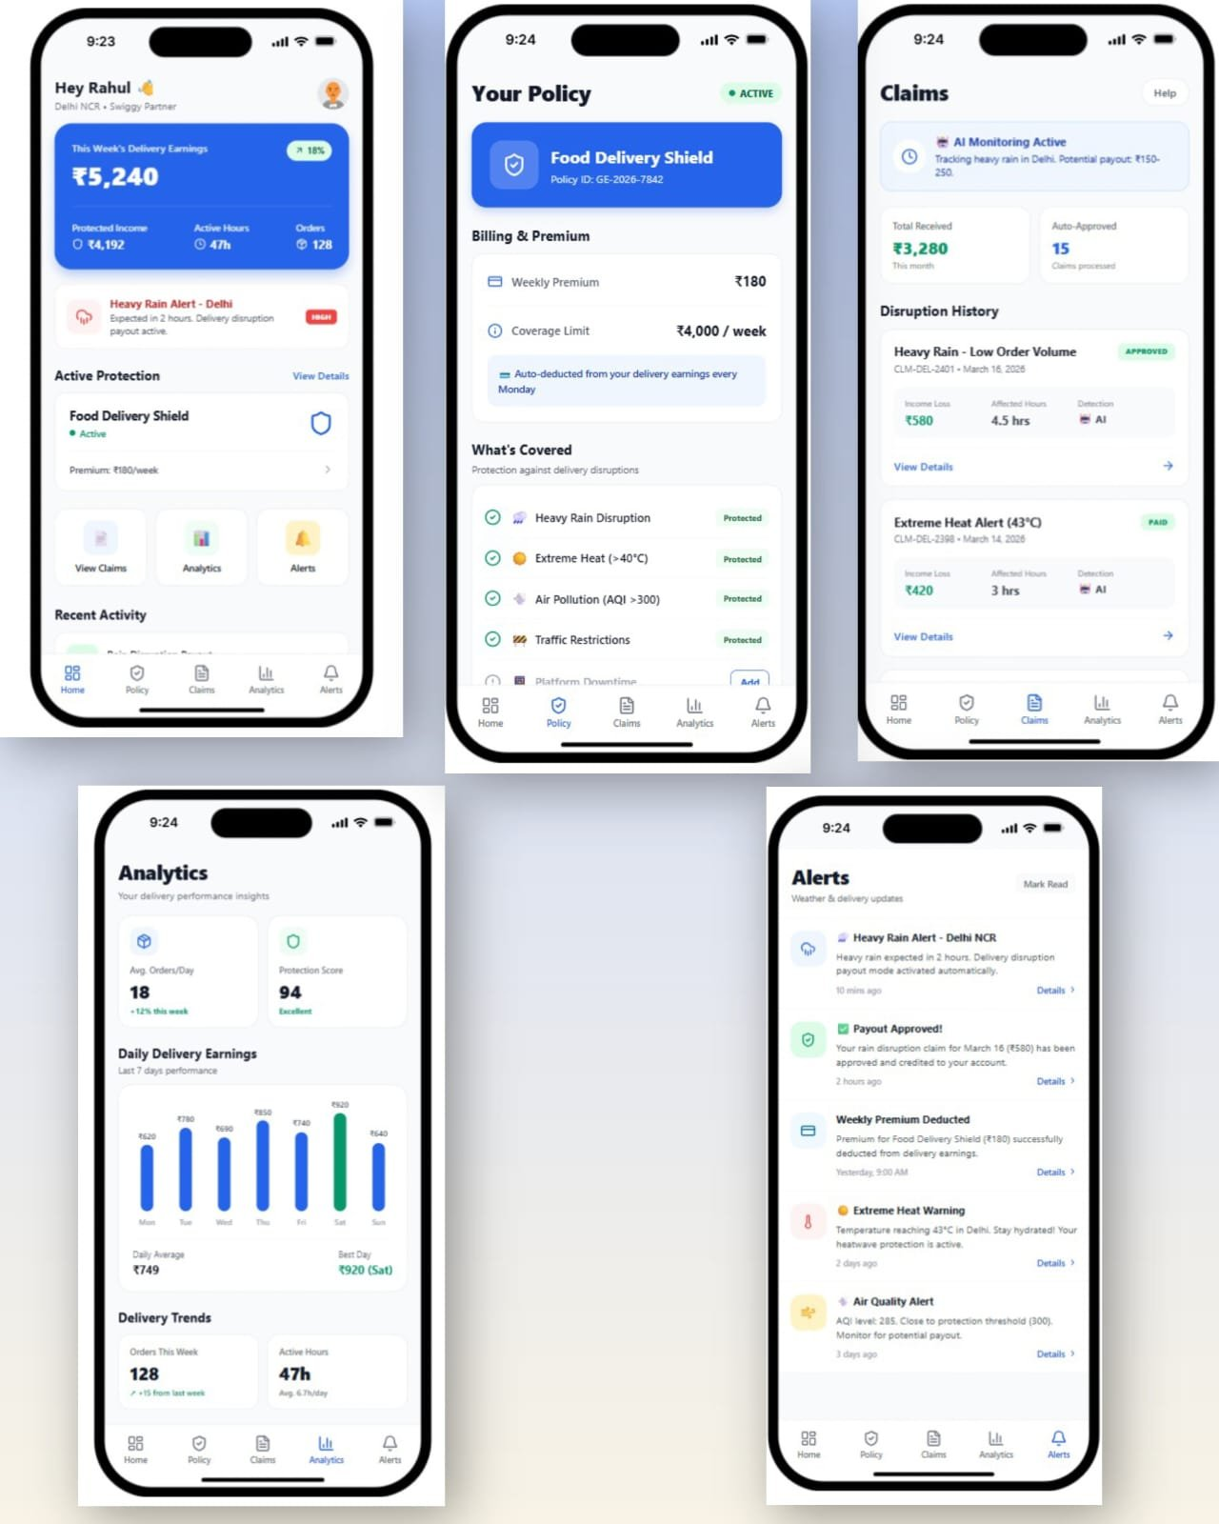
Figure 1: GigEase Mobile App — 5 core screens (Home, Policy, Claims, Analytics, Alerts)

2.1 Screen-by-Screen Breakdown
Screen | Purpose & Key UI Elements
Home Dashboard | This week's earnings (Rs.5,240 shown, +18% indicator). Protected Income / Active Hours / Orders at a glance. Heavy Rain Alert banner in red with HIGH badge. Active Protection: Food Delivery Shield, Rs.180/week premium. Quick links: View Claims, Analytics, Alerts. Recent Activity feed.
Policy Screen | Policy ID (GE-2026-7842), ACTIVE badge. Billing: Weekly Premium Rs.180, Coverage Limit Rs.4,000/week. Auto-deduction from delivery earnings every Monday. What's Covered list: Heavy Rain Disruption, Extreme Heat (>40C), Air Pollution (AQI >300), Traffic Restrictions — all marked Protected. Platform Downtime shown with Add option.
Claims Screen | AI Monitoring Active banner with rain tracking notice (Rs.150-250 potential payout). Total Received Rs.3,280 this month / 15 Auto-Approved claims. Disruption History: CLM-DEL-2401 (Heavy Rain - Low Order Volume, Rs.580 loss, 4.5hrs affected, AI detected) — APPROVED. CLM-DEL-2398 (Extreme Heat Alert 43C, Rs.420, 3hrs, AI) — PAID.
Analytics Screen | Avg Orders/Day: 18 (+12% this week). Protection Score: 94/100 (Excellent). Daily Delivery Earnings bar chart for last 7 days (Mon Rs.620 to Sun Rs.640, best Sat Rs.920 in green). Daily Average Rs.749. Delivery Trends: 128 orders this week (+15 from last), 47h active (6.7h/day avg).
Alerts Screen | Heavy Rain Alert - Delhi NCR: rain expected in 2 hours, disruption payout activated. Payout Approved: Rs.580 for March 16 rain claim credited. Weekly Premium Deducted: Rs.180 at 9AM yesterday. Extreme Heat Warning: 43C in Delhi, heatwave protection active. Air Quality Alert: AQI 285, approaching threshold 300. Each with timestamp and Details link.

2.2 Core UX Principles
- Zero manual claim filing: parametric trigger detects events automatically
- Push + WhatsApp notifications: rider never needs to check the app proactively
- Protection Score (0-100): gamifies good behavior and builds trust in the system
- Plain-English LLM explanations on every decision: no black-box rejections
- Policy ID + blockchain transaction hash: rider can independently verify on Polygonscan
- Graduated alert system: informational (air quality approaching threshold) to critical (heavy rain, payout activated)

3. Insurance Policy Design

GigEase provides a single combined policy covering both STFI (Storm, Typhoon, Flood, Inundation) and RSMD (Riots, Strikes, Malicious Damage) under one weekly premium. One enrolment. One policy. Two risk categories covered simultaneously. No separate policy per category required.

3.1 Core Policy Parameters
Parameter | Value / Formula
Policy Type | Combined STFI + RSMD Parametric Income Protection
W_avg (base income) | Rolling 12-week weighted average of verified platform earnings (decay=0.9 exponential weights)
Sum Insured | clamp(1.5 x W_avg, Rs.3,000, Rs.15,000) — floor ensures meaningful coverage, cap prevents adverse selection
Trigger Threshold | W_actual < 60% of W_expected for the disruption week AND a confirmed qualifying event in rider's zone
Payout Beta (STFI) | 0.75 — 75% of income loss paid. Below 1.0 intentionally: avoids moral hazard of 100% replacement.
Payout Beta (RSMD) | 0.65 — 65% of income loss paid. Lower because RSMD events offer more partial recovery opportunity.
Base Lambda (STFI) | 3.5% of sum insured annually — seasonal and zone-predictable, higher rate
Base Lambda (RSMD) | 1.5% of sum insured annually — completely unpredictable, lower rate
Payout Speed | Direct UPI credit within 10 minutes of trigger confirmation (normal case)
Minimum Payout | Rs.200 — claims below this threshold are not processed (administrative efficiency)
Minimum Pool Reserve | 30% of total active sum insured must remain in pool at all times before any payout executes
ICR Target | 60-70%: for every Rs.100 collected, Rs.60-70 paid out. Remaining Rs.30-40 covers operations and reinsurance.
No Claim Discount | 2% per consecutive clean week, capped at 20% (resets after any paid claim)
Claim Loading | +5% after 1 claim, +12% after 2 claims, +25% after 3+ claims in any 4-week rolling window
Co-pay Split | 70% rider (clamped Rs.25-Rs.250/week) + 30% Zomato platform CSR contribution

3.2 STFI Parametric Triggers
Event fires if ANY of these thresholds are crossed in the rider's primary zone:
Parameter | Threshold | Data Source | Notes
Rainfall | > 80 mm in 24 hours | OpenWeatherMap + IMD | Primary trigger signal
Wind Speed | > 50 km/h sustained | OpenWeatherMap | Cyclone indicator
Flood Alert | >= Level 2 on NDMA scale 0-4 | NDMA Alert Feed | Government source — 1 source sufficient for STFI
Cyclone Warning | Any active warning issued | IMD Cyclone Division | Immediate trigger on issuance
Visibility | < 50 metres | OpenWeatherMap | Storm/severe fog conditions
Heat Index | > 45C heatwave declared by IMD | IMD + OpenWeatherMap | Delhi May-Jul season
AQI | > 350 (Delhi zones only) | AQICN / CPCB | Pollution disruption equivalent

3.3 RSMD Dual-Source Confirmation
RSMD requires 2 independent source confirmations to prevent false triggers. Any 2 of these 4 sources suffice:
Source | Trigger Condition
NewsAPI / GNews | Bandh / curfew / strike keywords + city name match, 3+ articles from different outlets in 2-hour window
NDMA Alert Feed | emergency_alert = TRUE for the city/district
Google Maps Traffic | City-wide congestion index > 0.85 — gridlock indicative of shutdown
Government / Police Advisory | Section 144, curfew order, or official strike notification issued

3.4 Full Payout Formula
Step | Formula and Logic
Trigger check | REJECT if W_actual >= 0.60 x W_expected — income not below threshold
Income loss | income_loss = W_expected - W_actual (verified Zomato API — self-reported values rejected)
Raw payout | raw_payout = beta x income_loss (beta=0.75 STFI, beta=0.65 RSMD)
Fraud deduction | payout_after_fraud = raw_payout - fraud_deduction (fraud_deduction = fraudulent_GPS_distance x Rs.4.5/km)
Coverage cap | final_payout = min(payout_after_fraud, sum_insured)
Minimum check | REJECT if final_payout < Rs.200 (administrative minimum)
Pool liquidity | EXECUTE if pool_balance - final_payout > 0.30 x total_active_sum_insured; else QUEUE (paid within 72h)
UPI transfer | Razorpay Payout API -> NPCI UPI -> rider bank account (2-3 minutes transit)
Blockchain record | Web3.py writes SHA-256 hash of claim record to Polygon GigShieldLedger contract

3.5 Worked Example — Cyclone Dana, Rajan K, Velachery
Parameter | Calculation | Value | Status
W_avg (12-week rolling) | Rs.54,000 / 12 = Rs.4,500 | Rs.4,500/week
W_actual (flood week) | Mon Rs.497 + Tue Rs.475 + Wed-Fri Rs.0 + Sat Rs.67 | Rs.1,039
Trigger threshold (60%) | 0.60 x Rs.4,500 | Rs.2,700 | Rs.1,039 < Rs.2,700 TRIGGERED
Income loss | Rs.4,500 - Rs.1,039 | Rs.3,461
Raw payout (beta=0.75) | 0.75 x Rs.3,461 | Rs.2,595.75
Fraud deduction | Score 0.00 — all 17 checks clean | Rs.0 | AUTO-APPROVE
Coverage cap check | Rs.2,595 < Rs.6,750 (sum insured) | No cap needed | Pass
Pool reserve check | Rs.42,85,077 after payout > Rs.20,25,000 minimum | Execute | Pass
FINAL PAYOUT | Credited to rajan.k@upi in 10 minutes | Rs.2,595.75 | PAID

3.6 Five-Week Simulation — Income Stability Proof
Week | Event | W_actual vs W_expected | Net Income
Week 1 — Normal | No disruption | Rs.4,305 vs Rs.4,500 — not triggered | Rs.4,221 (after Rs.84 premium)
Week 2 — Slow | Light rain only | Rs.3,700 vs Rs.4,500 — not triggered | Rs.3,618 (after Rs.82, NCD 4%)
Week 3 — STFI Flood | Cyclone Dana | Rs.1,106 vs Rs.4,680 — TRIGGERED | Rs.3,708 (Rs.1,106 + Rs.2,681 payout - Rs.79)
Week 4 — Recovery | Post-flood slow | Rs.3,253 vs Rs.4,500 — not triggered | Rs.3,167 (after Rs.86, loading +5%)
Week 5 — RSMD | Chennai Bandh | Rs.1,824 vs Rs.4,500 — TRIGGERED | Rs.3,473 (Rs.1,824 + Rs.1,739 payout - Rs.90)
Result: Total premiums paid Rs.421 | Total payouts Rs.4,420 | 145% income stability improvement during disruption weeks. Without GigEase, weeks 3+5 total: Rs.2,930. With GigEase: Rs.7,181.

4. GPS Anti-Spoofing Architecture

GPS spoofing is the primary fraud vector in any location-based parametric insurance system. A fraudster uses a fake GPS application to place their device coordinates in a flood zone while physically sitting in a different area entirely. Without robust anti-spoofing defenses, a coordinated fraud ring of 500 riders with fake GPS apps could drain an entire liquidity pool in under 24 hours.

GigEase uses a multi-layer architecture combining physical hardware signals, network triangulation, sensor fusion, movement physics, and behavioral analysis. No single layer is sufficient alone. The power comes from requiring all evidence to converge before either approving or rejecting a claim.

4.1 The Core Anti-Spoofing Insight — Physics Cannot Be Faked at Software Layer
A GPS spoofing app operates entirely at the Android OS software layer. It replaces the GPS coordinates returned by the location API. However, it fundamentally cannot:
- Change which cell tower the phone is physically connected to — radio signal physics determines tower connection
- Alter the accelerometer readings — inertial sensor physics, gravity is always 9.81 m/s² on a stationary object
- Fake IP geolocation — network infrastructure determines IP geographic location
- Produce naturally degraded GPS accuracy that real monsoon rain causes (heavy cloud cover attenuates satellite signals)
- Coordinate 500 different spoofing apps to all produce varied, naturally-distributed, non-synchronized behavior

The accelerometer formula: magnitude = sqrt(accel_x^2 + accel_y^2 + accel_z^2). A stationary phone on any surface reads approximately 9.81 m/s2 (gravity only). A phone on a moving delivery bike reads higher due to road vibration and acceleration. If GPS coordinates report movement at 30 km/h but the accelerometer shows a constant 9.81 m/s2 reading — the GPS is being spoofed. This physical reality is unfakeable without hardware modification.

4.2 Module-by-Module Architecture
Module | Data Captured and Key Checks
Mobile App — Data Collection | GPS: latitude, longitude, accuracy (m), speed. Accelerometer: TYPE_ACCELEROMETER (x, y, z). Gyroscope: TYPE_GYROSCOPE. Device flags: is_mocked_location, developer mode, app integrity via Google Play Integrity API. Cell tower: LAC + Cell ID via TelephonyManager. IP address from HTTP headers. Network type (4G/WiFi/3G). Every 60 seconds.
Real-Time Data Ingestion | Apache Kafka accepts high-frequency GPS stream (1M riders = 16,667 req/s peak). Partitioned by worker_id for ordered processing. Consumer batch 1,000 records. Timestamps attached, units normalised, duplicates removed. Real-time fraud rule check on Kafka consumer side (immediate mock_location flag detection).
Location Validation Layer | GPS accuracy validation: perfect accuracy during cyclone is suspicious. Map matching to road network (Google Maps Roads API + OpenStreetMap): GPS coordinates that fall in the middle of a lake or building are invalid. Path continuity: track must follow actual road geometry. Teleport detection: >5km displacement in <3 minutes = physically impossible on a city delivery bike.
Sensor Fusion Engine | Compares GPS-reported movement against physical accelerometer data. GPS velocity > 0 + accelerometer magnitude = 9.81 m/s2 = GPS spoofing. Static detection during flood: phone physically stationary (consistent with genuine stranded rider), GPS shows home coordinates. Movement consistency: natural bike movement has characteristic vibration patterns.
Network Validation Layer | Cell tower triangulation: TelephonyManager identifies connected tower. Tower location (via Google Geolocation API / OpenCellID) must match GPS zone. A Velachery flood claimant on tower C-VLY-04 (Velachery) is consistent. A Velachery claimant on tower T-NGR-07 (T Nagar, 6.2km away) is contradictory. IP geolocation via MaxMind GeoIP cross-checked against GPS coordinates. VPN/proxy detection via ASN lookup.
Movement and Physics Engine | Speed limits: delivery bike physically cannot exceed 120 km/h between 60-second GPS pings. Haversine distance between pings divided by 60 seconds gives speed. Zone transition feasibility: can this rider have realistically traveled from their last known position to current claimed position via available roads in elapsed time? Route smoothness: genuine GPS has natural jitter and follows road curves; fake GPS from spoofing apps often produces straight-line paths or suspiciously smooth curves.
Behavior and Cluster Analyzer (DBSCAN) | Isolation Forest on 11 behavioral features. DBSCAN clusters home GPS coordinates of all claimants for the same event. Genuine city-wide flood: claims spread across many zones, varied timestamps (4+ hours spread), varied amounts. Fraud ring: tight geographic home cluster within 500m, all claims within 5-minute window, uniform payout amounts (low coefficient of variation).
Fraud Scoring Service | Weighted composite: final = 0.40xL1_hardware + 0.30xL2_behavioral + 0.15xL3_network + 0.15xL4_syndicate. Override rule: if L1>0.85 OR L2>0.90 then final = max(final, 0.75). SHAP identifies top contributing signal for human reviewers. LLM generates plain-English explanation.
Claim Decision Engine | Score <0.30: AUTO APPROVE — instant UPI credit. 0.30-0.50: SOFT FLAG — 50% now, 50% held, WhatsApp photo request. 0.50-0.70: HARD FLAG — full hold, human review within 7 days. >0.70: AUTO REJECT — appeal window 30 days, IRDAI escalation path available.

5. Adversarial Defense — Market Crash Response

Phase 1 — Market Crash: 500 delivery partners. Fake GPS. Real payouts. A coordinated fraud ring just drained a platform liquidity pool and yours is next. How do you spot the faker from the genuinely stranded worker? What data catches a fraud ring? How do you flag bad actors without punishing honest ones?

5.1 The Differentiation — Genuine Stranded Worker vs GPS Spoofer
The problem: both a genuine flood victim and a GPS spoofer can produce GPS coordinates showing them in a flooded zone. The differentiation lies entirely in every other signal converging or diverging.

5.1.1 The Physics Test — Layer 1 (Weight 0.40, Highest Priority)
A genuine rider stranded at home has a phone that is physically stationary. Accelerometer reads 9.81 m/s2 (gravity only), constant. GPS coordinates show their actual home address inside the flood zone. Cell tower C-VLY-04 confirms Velachery. GPS signal degrades to +/-120m accuracy exactly as heavy rain attenuates satellite signals. GPS accuracy is proportionally worse during heavier rainfall — a natural physical correlation. Every signal agrees with every other signal.

A fraudster in T Nagar spoofs their GPS to Velachery. Accelerometer still reads 9.81 m/s2 — because they are physically stationary at home. But GPS now claims movement through flood routes. Cell tower T-NGR-07 is physically in T Nagar, 6.2km from claimed GPS location. GPS accuracy is suspiciously perfect: +/-5m in a cyclone, because the spoofing app generates clean synthetic coordinates rather than real satellite noise. Every layer contradicts every other layer.

Signal | Genuine Rajan (Velachery) | Fraudster Suresh (T Nagar) | Score Added
is_mocked_location flag | FALSE on all 20 pings | TRUE on 14/20 pings (fake GPS app detected by Android) | +0.60
Accelerometer magnitude | 9.81 m/s2 — stationary at flood zone home | 9.81 m/s2 — stationary at T Nagar home (both stationary, inconclusive alone) | 0.00 (alone)
Accel vs GPS mismatch | GPS also stationary — consistent | GPS shows movement but accel = 9.81 static | +0.55
Cell tower vs GPS | C-VLY-04 = Velachery, matches GPS zone | T-NGR-07 = T Nagar, 6.2km from claimed GPS | +0.35
GPS accuracy in cyclone | +/-120m — degraded by rain (physically expected) | +/-5m — suspiciously perfect (synthetically generated) | +0.25
Zone-weather cross-check | GPS in Velachery + NDMA confirms Velachery flooded — all agree | Cell tower = T Nagar (dry per weather API) + GPS claims Velachery | +0.80
Pre-event order acceptance | 100% on Mon-Tue — normal work behavior | Refused 11 orders Mon-Tue before event — deliberate income suppression | +0.30
4-week work history | 91-94% acceptance rate consistently | Dropped to 40% acceptance vs 91% historical average | +0.25
Final fraud score | 0.08 - 0.05 (zone peer) - 0.04 (GPS degradation) = 0.00 | 3.05 total, capped at 1.00 | AUTO APPROVE vs REJECT

5.1.2 Why Cell Tower Is the Unbreakable Signal
GPS spoofing apps operate at the Android application layer — they replace what the GPS location API returns to other apps. Cell tower connection is a hardware radio function. The phone's baseband processor (separate from the application processor) connects to whichever physical tower has the strongest radio signal. No Android application, including root-level spoofing apps, can override which physical tower the baseband hardware connects to without being physically near that tower. This is why even a sophisticated spoofing app that defeats the is_mocked_location flag still fails: tower T-NGR-07 physically cannot be in Velachery.

5.2 The Data — Detecting a Coordinated Fraud Ring
Individual spoofing is detectable through physics. A coordinated ring of 500 fraudsters requires additional population-level analysis. These are the specific data points beyond basic GPS coordinates:

5.2.1 Temporal Synchronisation Signals
- Claim submission timestamp distribution: genuine flood claims spread naturally over 4+ hours as 47 riders discover the payout notification and check their app. A Telegram-coordinated fraud ring submits within a 5-minute window when the ring leader broadcasts the trigger event.
- Event detection to claim gap: genuine riders often notice weather before GigEase triggers — their login activity drops before the trigger. Fraud ring members are active until the exact moment the trigger fires, then all simultaneously go "offline."
- Login pattern change coordination: honest riders stop taking orders when flood water rises gradually. Fraud ring members all show zero orders from precisely the same timestamp — automated coordination.

5.2.2 Geographic Clustering via DBSCAN
- DBSCAN with eps=500m, min_samples=5 clusters home GPS coordinates of all claimants for the same event. Parameters chosen based on Chennai residential colony density.
- A legitimate city-wide flood produces claims whose home GPS coordinates are geographically distributed across many zones — matching actual delivery partner distribution across the city.
- A fraud ring recruited via one WhatsApp group in one residential colony produces a dense geographic home cluster: 50+ riders with home locations within 500m of each other, all claiming to be in a flood zone 6-10km away.
- Additional confirmation: shared device IDs or shared registration IP within the same DBSCAN cluster confirms coordinated enrollment — multiple "different" workers enrolled from the same physical device.

5.2.3 Behavioral Divergence via Isolation Forest (11 Features)
- order_acceptance_rate: normal range 80-95%. Fraudsters planning fake income loss stop accepting orders 1-2 days before the event to artificially suppress W_actual below the 60% trigger threshold. Isolation Forest flags this cliff to near-zero acceptance before the flood even starts as a behavioral outlier.
- orders_before_vs_during_event ratio: genuine rider shows gradual income decline as weather worsens. Fraud ring shows perfect zero from the exact moment the event starts — an unnaturally clean transition.
- peer_income_ratio: worker income divided by zone average income for the same week. Genuine city-wide flood: all 47 zone riders earn below 40% of baseline — ratio is near 1.0 (rider is normal relative to disrupted peers). Fraud ring member in a non-affected zone: their income drops but zone peers are earning normally — ratio is 0.2, flagged as anomaly.
- idle_time_ratio: logged in and appeared online but accepting zero orders for extended periods before the event — manufactured inactivity to build a paper trail of "being active but unable to earn."
- earnings_per_order_deviation: some sophisticated fraud involves taking short, low-value orders at home to appear active while keeping total earnings below the trigger threshold — per-order earnings are anomalously low.

5.2.4 Network and Device Fingerprinting
- IP geolocation clustering: multiple claimants submitting from the same IP subnet at claim time — they are in the same building or using the same mobile hotspot, not stranded in a flood zone.
- UPI account clustering: multiple claimants all linked to accounts at the same bank branch or registered from the same IP — suggests organized enrollment by a ring coordinator.
- Device ID cross-reference: one device used to enroll multiple workers is an immediate hard flag. Fraud rings sometimes enroll workers using a shared coordinator device.
- Uniform payout amounts: the coefficient of variation (standard deviation / mean) of payout amounts across a suspected cluster that is suspiciously low indicates all members fabricated similar income loss — genuine disruptions produce varied payout amounts because every rider has a different W_expected.

5.2.5 Real-Time Circuit Breaker — Pool Protection
When zone claim spike threshold crosses 3x historical average, the circuit breaker activates automatically:
- All new claims from that zone are queued — not rejected — pending cluster analysis completion.
- DBSCAN analysis runs on queued batch within 5 minutes (Celery async task).
- Claims belonging to geographically distributed genuine workers are released — payment within 2 hours of circuit breaker activation.
- Claims forming tight geographic home clusters are hard-flagged — full hold, human review.
- Admin dashboard receives cluster map, timestamp synchronization chart, and LLM-generated syndicate assessment.
- Honest riders receive a push notification: "Your claim is temporarily under verification due to high claim volume. You will receive your payment within 2 hours."

5.3 The UX Balance — Fair Treatment of Honest Riders
This is the most critical design principle in the entire fraud detection system: genuine flood victims are the ones most likely to have degraded GPS signals, network outages, and unusual activity patterns — because floods cause exactly those conditions. A naive fraud detection system would penalize honest workers for being in a real disaster.

5.3.1 The GPS Degradation Inversion Rule
Standard fraud logic would say "poor GPS signal = suspicious." GigEase inverts this completely for verified disaster events:
GPS Signal Condition During Verified STFI Event | Fraud Score Treatment
GPS accuracy +/-120m during cyclone | Expected — score contribution: 0.00. Rain attenuates satellite signals. This is physically normal.
GPS gaps of 30-60 minutes during peak rainfall | Expected — mobile network towers in flood zones get congested or go offline. Score: 0.00. Filled with last known zone location, marked data_gap_verified.
GPS accuracy +/-5m during cyclone | Suspicious — too perfect. Score addition: +0.25. Synthetic coordinates, not real satellite data.
GPS accuracy +/-5m when NDMA confirms zone flooded | Very suspicious — perfect accuracy while the zone is proven to be under active cyclone. Override to score +0.35.

5.3.2 Network Outage Protection
During severe floods, mobile network infrastructure in affected zones degrades. A genuine rider may lose all GPS and data connectivity for 2-4 hours. The network_outage_flag checks whether cell tower congestion data for the rider's zone shows network degradation during the GPS gap period. If confirmed: gap is marked data_gap_verified (treated as genuine), not data_gap_suspicious. This prevents the flood itself from causing false fraud rejections for riders in the hardest-hit areas.

5.3.3 The Graduated Response — Default to Trust
GigEase's core operating principle: trust the rider first, investigate second. Pay before fully resolving any ambiguity. The fraud score thresholds are deliberately designed to give honest riders their money quickly and handle edge cases without creating panic:
Score Range | Rider Experience
< 0.30 — Auto-Approve | 100% payout credited within 10 minutes via UPI. Zero interaction required. The overwhelming majority of genuine claims (>90%) land here. Rider gets a "Payout Approved" notification and bank SMS.
0.30-0.50 — Soft Flag | 50% credited immediately — rider has money in under 10 minutes. WhatsApp message sent: "Your claim is under review. Reply with a photo of your current location to receive the remaining amount." System reads EXIF GPS metadata from photo for location verification. 85% of legitimate soft-flags resolve within 2 hours. Remaining 50% credited upon verification.
0.50-0.70 — Hard Flag | Full payout held. Clear WhatsApp + app notification with appeal link and specific reason (e.g., "GPS and cell tower locations disagreed — please submit location evidence"). Human reviewer examines within 7 days. If upheld: full payout + no additional claim loading. Rider can submit photos, news screenshots, or any evidence.
> 0.70 — Reject | Claim rejected. Rider receives a plain-English LLM-generated explanation of the specific signals that triggered rejection. Appeal window: 30 days. If appeal upheld: payout processed with no loading. Escalation path to Insurance Ombudsman (IRDAI) available. First-time flag: no blacklist.

5.3.4 Fairness Protections Built Into Architecture
- First-offence protection: no rider is blacklisted after their first fraud flag. Only 3+ confirmed fraud strikes leads to policy cancellation. False positives are treated as data collection, not punishment.
- Human override: every AI fraud decision can be overridden by a human reviewer with documented reasoning. The system explicitly acknowledges its own fallibility.
- SHAP transparency: every rejection includes the specific feature that drove it (not "our AI rejected you" but "your cell tower location was 6.2km from your GPS location"). Riders can contest specific claims.
- No punishment for genuine network issues: GPS gap during confirmed network outage = data_gap_verified, not fraud signal. Flood victims in worst-hit areas are most protected, not most penalized.
- Blockchain immutability: every approved or rejected claim is permanently recorded on Polygon. No GigEase employee can retroactively change a payout amount or approval status. Riders have an independent audit trail.
- Cluster analysis protects honest riders in fraud-heavy zones: a genuine rider who happens to be in the same zone as a fraud ring is protected because their individual profile is analyzed separately — the ring's cluster flag does not contaminate individual clean claims.

6. End-to-End STFI Use Case — Cyclone Dana, Velachery

This section documents the complete claim lifecycle for Rider Rajan K (W001, Velachery, Chennai) during Cyclone Dana on 5 November 2025. From first API ping to UPI credit: 10 minutes, 4 AI agents, 22 verification checks, 7 external API calls, 5 database writes, 1 UPI transfer.

6.1 Scenario Setup
Parameter | Value
Rider | Rajan K — Worker W001 — Velachery, Chennai — 18 months experience — Rating 4.3/5.0
Event | Cyclone Dana — Category 2 — Landfall 02:30 AM, 5 Nov 2025 near Mahabalipuram, Tamil Nadu
Zone flood risk score | 0.82 / 1.00 (critical historical flood zone — poor drainage, low elevation)
Policy | POL-2025-W001 — Active since Sep 1 2025 — Coverage Rs.6,750 — Premium Rs.84/week
W_avg | Rs.4,500/week (12-week rolling average from Zomato API)
W_actual (flood week) | Mon Rs.497 + Tue Rs.475 + Wed Rs.0 (flood) + Thu Rs.0 + Fri Rs.0 + Sat Rs.67 = Rs.1,039
Trigger check | Rs.1,039 < Rs.2,700 (60% of Rs.4,500) — TRIGGERED
Fraud history | fraud_history_flag = FALSE — 1 prior claim (genuine, paid) in 18 months

6.2 Environmental API Response — 06:00 AM
API | Key Response Data | Threshold | Result
OpenWeatherMap | rainfall_mm=187.4, wind_speed=78 km/h, visibility=45m, cyclone_warning=TRUE, storm_alert=TRUE | >80mm / >50km/h / <50m | ALL EXCEEDED
NDMA Alert Feed | flood_alert_level=4, cyclone_category=2, Velachery in affected_zones, emergency_alert=TRUE | Level >= 2 | CRITICAL EXCEEDED
IMD Cyclone Division | cyclone_name=Dana, landfall=Mahabalipuram, max_wind=95 km/h, storm_surge=1.2m, warning_issued=TRUE | Any active warning | FLAGGED
Google Maps Traffic | congestion_index=0.97, road_closure_flag=TRUE, travel_time_index=8.4, avg_speed=3.2 km/h | >0.85 gridlock | EXCEEDED
Event record written: EVT-STFI-20251105-Z001. 47 riders in Velachery, Tambaram, Pallikaranai identified as policyholders in affected zones.

6.3 Four-Agent Pipeline
Agent | Checks Performed and Outcome
Agent 1: Work History (2 min) | GPS: all 8 checks clean. is_mocked_location=FALSE all pings. Max speed 40 km/h (Mon-Tue delivery). No location jumps. Accelerometer stationary on flood days matches GPS stationary. Cell tower C-VLY-04 = Velachery confirms home location. GPS accuracy +/-120m during cyclone = genuine indicator (not suspicious). Behavioral: 100% acceptance rate Mon-Tue (no pre-event manipulation). 4-week baseline 91-94% consistent. All 47 zone riders similarly affected (zone peer signal -0.05). Result: score 0.04 — PASS.
Agent 2: KYC/Finance (parallel, 2 min) | DigiLocker: aadhaar_hash matched, name=Rajan K, address district=Chennai, active=TRUE, no duplicate. Policy: status=ACTIVE, started Sep 1 2025, ends Aug 2026, coverage=STFI+RSMD, premium Rs.84 deducted Nov 3, claim_cooldown=NULL, suspended_flag=FALSE. UPI: rajan.k@upi validated via NPCI, account_holder=Rajan K, SBI account active, can_receive=TRUE. Result: financial_eligibility_score=1.00 — PASS.
Agent 3: Fraud Detection (<1 min) | All 17 fraud checks run via XGBoost model. F01-F16: all 0.00 (clean). F11 zone peer: -0.05 (positive signal, 47 riders all affected). F17 GPS degradation: -0.04 (genuine cyclone signal). Base 0.08 - 0.05 - 0.04 = 0.00. Cluster analysis: 47 claims spread over 4 hours, varied amounts (not uniform), different zones — not syndicate. Cluster fraud flag: NOT raised. Result: final_fraud_score=0.00 — AUTO APPROVE.
Agent 4: Decision and Payout (<30 sec) | Calculation: W_avg=Rs.4,500, W_actual=Rs.1,039, loss=Rs.3,461, raw_payout=0.75xRs.3,461=Rs.2,595.75. Fraud deduction: Rs.0. Coverage cap: Rs.2,595 < Rs.6,750. Minimum: Rs.2,595 > Rs.200. Pool: Rs.42,87,500 - Rs.2,595 = Rs.42,84,905 > Rs.20,25,000 reserve. Execute. Razorpay call: pout_QrBxY8K92mnLp4. 5 DB writes atomic. Blockchain hash written. WhatsApp notification sent. Total time: 10 minutes from trigger fire to UPI credit.

6.4 Contrast — Fraudster Suresh M Rejected in Same Event
Suresh M lives in T Nagar (not a flood zone). Saw news on Telegram. Used a fake GPS app to claim Velachery location. Fraud score: 3.05 capped at 1.00. Decisive signals: is_mocked_location TRUE on 14/20 pings (+0.60), accelerometer stationary but GPS claiming movement (+0.55), cell tower T-NGR-07 = T Nagar 6.2km from claimed location (+0.35), GPS accuracy perfect during cyclone (+0.25), zone-weather cross-check override (+0.80), pre-event order refusal (+0.30), work history anomaly (+0.25). Total: 3.10 capped at 1.00. Result: AUTO REJECT. Worker notified with plain-English reason. Appeal link provided. Strike count: 1.

6.5 Complete 10-Minute Timeline
Time | System Event
02:30 AM | Cyclone Dana makes landfall near Mahabalipuram. IMD pushes alert — ingested by GigEase within 1 minute.
06:00 AM | OpenWeatherMap: 187.4mm, 78 km/h wind. NDMA: flood level 4. Google Maps: congestion 0.97, roads closed. All thresholds exceeded.
06:01 AM | Trigger engine fires EVT-STFI-20251105-Z001 (<30 seconds). 47 riders in affected zones identified (<5 seconds). W_actual=Rs.1,039 fetched from Zomato API (<3 seconds). Claim evaluation initiated for all 47 riders.
06:02 AM | Agent 1 (Work History) starts. GPS logs, activity logs, behavioural analysis initiated.
06:04 AM | Agent 2 (KYC/Finance) starts in parallel. DigiLocker, policy table, NPCI UPI validation all run simultaneously.
06:04 AM | Agent 1 completes. Score: 0.04 — PASS. Passed to Fraud Agent.
06:06 AM | Agent 2 completes. Score: 1.00 — PASS. Fraud Agent fires immediately with both agent outputs.
06:06 AM | Agent 3: all 17 fraud checks completed in under 60 seconds. DBSCAN cluster analysis: genuine event. Final score: 0.00 — AUTO APPROVE.
06:07 AM | Agent 4: payout Rs.2,595.75 calculated. Pool reserve check passed. Razorpay API call issued (pout_QrBxY8K92mnLp4). Time elapsed: <2 seconds for API call.
06:09 AM | NPCI processes UPI transfer. UTR: RZNP2025110500000142. Funds in transit to rajan.k@upi (SBI account).
06:11 AM | Rs.2,595.75 credited to Rajan's SBI account. 5 DB tables updated atomically: claims, insurance_policies, workers, pool_financials, fraud_detection_log. Polygon blockchain hash written. WhatsApp + in-app notification sent.
TOTAL | 10 minutes. Zero paperwork. Zero phone calls. Zero claim forms filed. Pure parametric. Rajan woke up to flood waters and money in his account before the roads cleared.

7. Database Architecture — Three-Layer Data Strategy

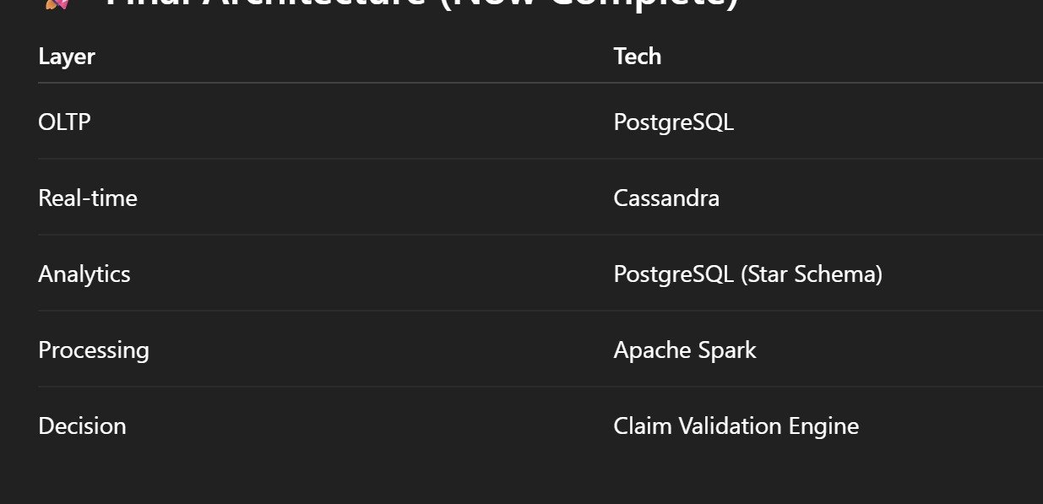
Figure 2: Three-layer database architecture — OLTP (PostgreSQL), Real-time (Cassandra), Analytics (Star Schema)
GigEase uses three purpose-built database layers. Each layer is optimized for its specific access pattern and throughput requirement. Apache Spark handles ETL between layers nightly.

7.1 Layer 1 — PostgreSQL OLTP (Transactional Core, 19 Tables)
Full ACID compliance for financial transactions. Row-level security (GPS data access restricted to fraud service DB role only). PgBouncer connection pooling: 1,000 concurrent app workers share 50 actual DB connections. TimescaleDB extension: GPS data partitioned by week — queries hit only 1 partition rather than full table.

Table | Key Fields | Purpose
workers | partner_id, aadhaar_hash (SHA-256), upi_id (AES-256-GCM), fraud_score, fraud_history_flag | Identity, KYC status, fraud history — primary partner record
policy | policy_id, coverage_amount, premium_amount, risk_score, payout_beta, status enum | Active policy management — updated weekly by premium engine
claims | claim_id, fraud_score, claim_status enum, razorpay_transfer_id, blockchain_tx_hash, llm_explanation | Complete claim lifecycle — durable financial record
earnings | gross_earnings, incentives, penalties, net_earnings, source_type | Daily verified earnings from Zomato API — income model training data
orders | distance_km, waiting_time_min, base_pay, incentive_pay, total_pay, order_status | Individual order records — fraud distance inflation detection
order_tracking | actual_distance, expected_distance, deviation_flag, pickup_lat/lng, drop_lat/lng | GPS vs platform distance cross-check — fraud km inflation detector
fraud_events | event_type, risk_score, reference_id, detected_at | Durable fraud audit log — persists permanently
partner_kyc | aadhaar_hash, pan_hash, kyc_status, verified_at | DigiLocker verification records
wallet + ledger_transactions | balance, idempotency_key, txn_type, source, reference_id, status | Financial ledger with idempotency — prevents double-payment on timeout
payout | payout_amount, bank_id, claim_id, status, processed_at | Razorpay transfer execution records
gps_logs | lat, lng (AES-256-GCM), accuracy, speed, device_id, ip_address (encrypted), is_mocked_location | Raw GPS audit trail — purged after 90 days per DPDP Act 2023
partner_device | device_type, os_version, app_version, is_trusted | Device fingerprinting — detects device swaps mid-shift
weather_events | event_type, severity, start_time, end_time | Confirmed STFI/RSMD events — trigger engine source of truth
login_activity | login_time, logout_time, total_hours | Platform activity baseline for income model
audit_logs | entity, action, old_value, new_value (jsonb) | Full immutable audit trail for IRDAI compliance

7.2 Layer 2 — Apache Cassandra (Real-Time Fraud Signals, 7 Tables)
7 denormalized tables. No joins — ever. Each table is keyed for exactly one access pattern. GPS stream: 1M riders x 1 ping/60s = 16,667 req/s peak. Kafka buffers the stream; Cassandra consumer batch-inserts 1,000 records at a time.
Table | Partition Key / Access Pattern / Purpose
gps_logs_by_partner | PK: partner_id | CK: recorded_at DESC | Stores: lat, lng, speed, accuracy, ip, device_id. Optimized for "show me this rider's GPS track for the past 6 hours" — the fraud agent's primary read.
latest_location | PK: partner_id (single row per partner, always overwritten) | Real-time fraud engine reads this for immediate zone validation at claim initiation. Sub-millisecond read.
device_activity_by_partner | PK: partner_id | CK: device_id | Detects device changes mid-shift: last_used, ip_address, is_trusted. A new device_id mid-shift = +0.40 fraud score.
fraud_events_by_partner | PK: partner_id | CK: event_time DESC | Per-rider fraud history lookup. How many prior fraud events? What was the last risk score? Read at claim initiation for instant pre-screening.
fraud_events_by_time | PK: event_date | CK: event_time, partner_id | Answers "how many fraud events in Velachery zone today vs historical average?" — the zone spike detector query.
gps_summary_by_window | PK: partner_id | CK: date DESC | Stores: total_distance, avg_speed, anomaly_count. Weekly fraud batch reads 7-day summary for behavioral baseline — avoids scanning all raw GPS logs.
recent_fraud_summary | PK: partner_id | Stores: last_fraud_time, fraud_count, avg_risk_score. Instant risk pre-check before running full 17-signal pipeline. High fraud_count = escalate to hard scrutiny immediately.

Key design insight: fraud_events_by_partner and fraud_events_by_time are the same logical data written to two different tables. This is deliberate Cassandra denormalization — each table serves a different query pattern without joins, maintaining sub-millisecond read times even at millions of records.

7.3 Layer 3 — PostgreSQL Analytics (Star Schema)
Dimensional model for ICR monitoring, fraud trend analysis, and zone risk reporting. Apache Spark ETL loads nightly from OLTP. Cassandra fraud aggregates feed avg_fraud_score in fact_partner_risk. Two fact tables + four dimensions.
Table | Type and Key Fields
fact_claims | FACT | claim_amount, approved_amount, fraud_score, is_approved, processing_time_minutes — linked to all 4 dimensions via foreign keys. Primary ICR calculation table.
fact_partner_risk | FACT | avg_fraud_score, claim_count, rejection_rate — weekly rollup per partner. Dashboard analytics for at-risk rider identification.
dim_partner | DIMENSION | city, rating, join_date, status — SCD Type 2 for historical tracking of partner status changes.
dim_date | DIMENSION | date, day, month, year, week, quarter, is_weekend — enables monsoon season vs off-season ICR comparison.
dim_policy | DIMENSION | coverage_amount, premium_amount, risk_category — policy characteristics for segmented analytics.
dim_weather | DIMENSION | event_type, severity, city — STFI vs RSMD classification for payout analysis by event type.

8. Machine Learning System — Three Models

8.1 Model 1 — Risk Prediction (XGBoost + Facebook Prophet Ensemble)
Purpose: predict zone disruption probability every Sunday night. Output drives premium loading for all riders in that zone for the coming week. 35 input features, 200 zones, runs in under 2 minutes.

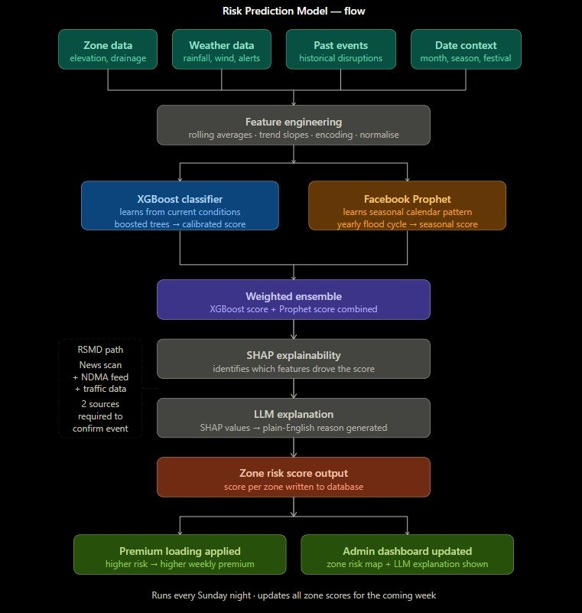
Figure 3: Risk Prediction Model flow — XGBoost classifier + Facebook Prophet ensemble with SHAP explainability

Component | Technical Detail
XGBoost Classifier | n_estimators=300, max_depth=6, learning_rate=0.05, subsample=0.8, eval_metric=AUC-ROC. 300 sequential trees where each corrects errors of all previous (gradient boosting). max_depth=6: captures complex zone x weather interactions without overfitting. Platt Scaling post-processing converts raw logits to calibrated probabilities (critical: without calibration, score 0.7 does not mean 70% disruption probability).
Facebook Prophet | Decomposes weekly disruption frequency into trend + yearly seasonality + weekly seasonality + external regressors. changepoint_prior_scale=0.05 (conservative — prevents 2-week rainfall spike from permanently shifting long-term prediction). Captures Chennai Oct-Jan flood cycle and Delhi May-Jul heatwave season — calendar patterns XGBoost cannot learn from limited training data alone.
Ensemble Formula | final_risk_score = 0.65 x XGBoost + 0.35 x Prophet. XGBoost weighted higher because current conditions are most informative in the short term. Prophet provides seasonal floor — ensures the model is not surprised by predictable October floods even with a dry preceding week.
SHAP Explainability | TreeExplainer produces per-zone feature contributions after every weekly run. Example: "Velachery risk=0.72. Top drivers: flood_risk_score +0.28, avg_rainfall_7d +0.19, is_cyclone_season +0.15, elevation -0.04." LangChain formats for OpenAI GPT-4o which writes admin plain-English explanation. Stored in zones.shap_top_features.
Loading Factor Map | 0.00-0.20: 0% | 0.20-0.35: +10% | 0.35-0.50: +20% | 0.50-0.65: +35% | 0.65-0.80: +50% | 0.80+: +65%. Velachery November: risk=0.72 = +50% loading.
Label Definition | A (zone_id, week_start_date) pair labeled 1 if average gross income in that zone fell below 60% of prior 4-week zone rolling average. Labels mirror exact trigger condition the model is trained to predict — no label leakage.
Training Schedule | Full retrain quarterly on 3 years historical data. Incremental fortnightly. Drift alert if AUC drops below 0.75.

8.2 Model 2 — Income Prediction (Weighted Moving Average to LightGBM)
Purpose: predict W_expected — each rider's individual expected income as the counterfactual baseline. This single number determines whether a claim triggers and how large the payout is. The most critical calculation in the entire system.

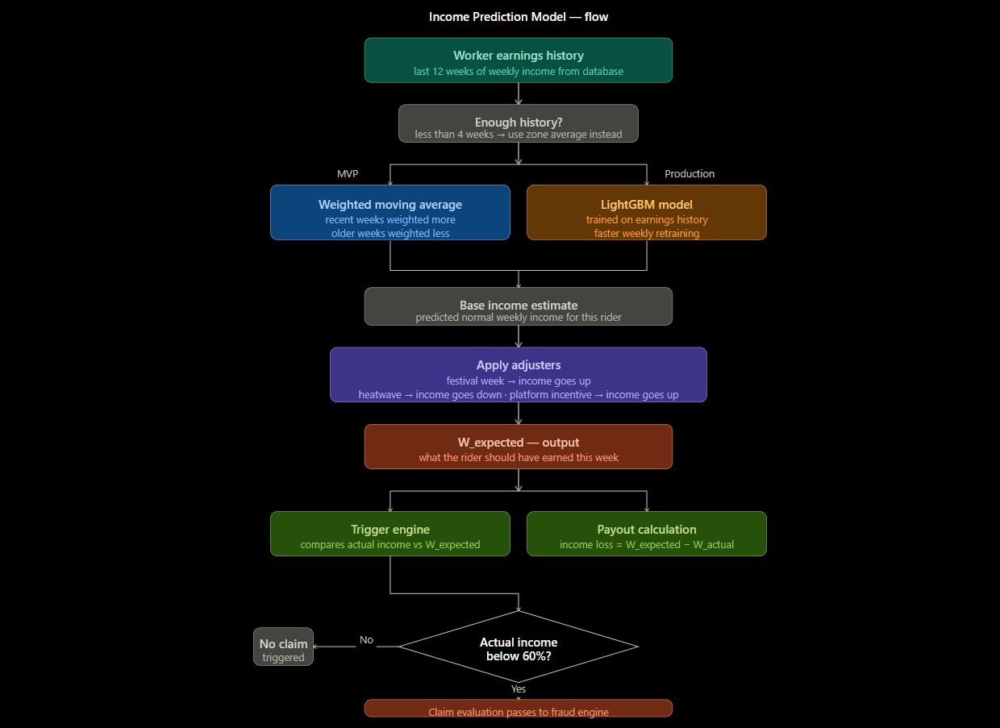
Figure 4: Income Prediction Model — MVP weighted moving average path and Production LightGBM path

Component | Technical Detail
MVP: Weighted Moving Average | weights=[0.05, 0.05, 0.05, 0.05, 0.07, 0.07, 0.08, 0.08, 0.10, 0.10, 0.13, 0.17] (decay=0.9, 12 weeks). NumPy dot product. Newest week gets weight 0.17, oldest 0.05. Runs in milliseconds. Suitable for demo and early deployment.
Production: LightGBM | Histogram-based leaf-wise tree growth. 3-5x faster than XGBoost for the same depth. Critical when weekly retraining 10,000+ individual worker models on Sunday night. Each rider gets their own personalised income model trained on their specific 12-week history.
Applied Adjusters | festival_flag=TRUE: x1.20 (Diwali, Pongal — demand spikes 20%). heatwave_flag=TRUE: x0.85 (extreme heat reduces rider hours by ~15%). platform_incentive_active=TRUE: x1.10 (bonus campaigns increase deliveries 10%). These adjusters are sourced from date_context and weather APIs, not historical earnings alone.
Cold Start Handling | Riders with <4 weeks history use zone average income as W_expected. Deliberately conservative: zone average tends higher than new rider actual income, making trigger harder to hit in first 4 weeks. Personalised model activates at week 5.
Why Personalisation Matters | A flat zone average over-compensates high earners and under-compensates low earners. A rider earning Rs.6,000/week has a completely different baseline than one earning Rs.2,000/week. Per-rider model ensures every payout reflects that specific rider's actual income loss, not a generic zone estimate.
Retrain Schedule | Full retrain monthly. Incremental weekly. Alert if RMSE drift >15% vs established baseline.

8.3 Model 3 — Fraud Detection (4-Layer Weighted Pipeline)
Purpose: score every claim 0-1 for fraud probability. Runs in under 60 seconds per claim. Four independent layers run in parallel — each examining a different physical reality.

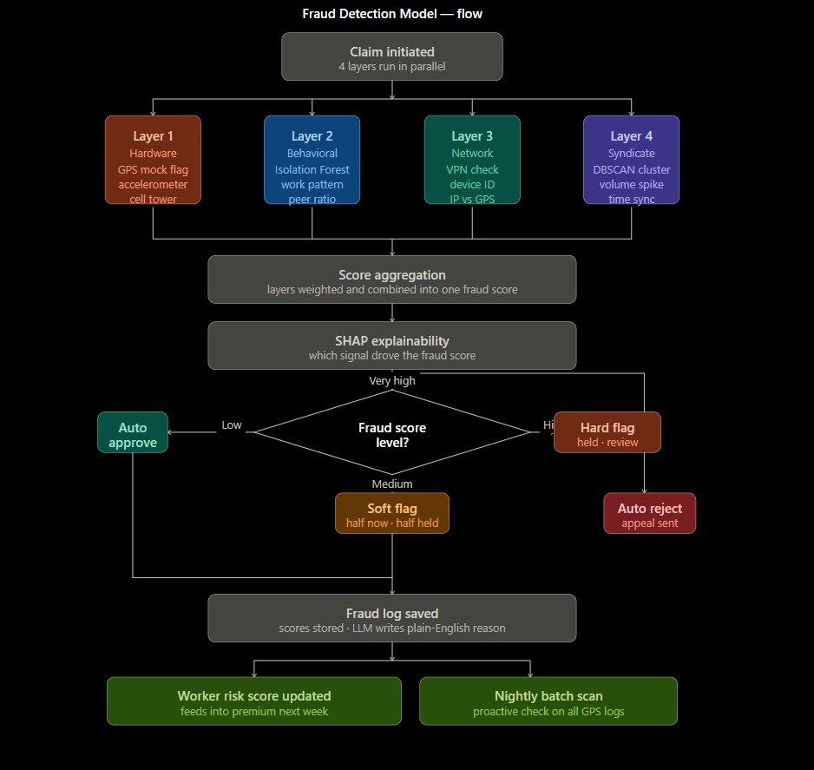
Figure 5: Fraud Detection Model — 4 parallel layers (Hardware, Behavioral, Network, Syndicate) with SHAP explainability and action gate

Layer | Algorithm, Weight, and Key Signals
L1 — Hardware (weight 0.40) | Rule-based physics checks. Highest weight because these signals cannot be faked at software layer. Mock GPS flag: is_mocked_location>50% of pings (+0.60). Impossible speed: >120 km/h between 60-second pings (+0.45). Location jump: >5km in <3 minutes (+0.40). Accelerometer vs GPS mismatch: GPS moving + accel=9.81 m/s2 (+0.55). Cell tower vs GPS >2km gap (+0.35). Perfect GPS during cyclone: <5m accuracy when rain should degrade it (+0.25). Override: if L1>0.85 then final = max(final, 0.75).
L2 — Behavioral Isolation Forest (weight 0.30) | Unsupervised anomaly detection. contamination=0.05. No fraud labels needed at launch — learns what normal looks like from honest majority. 11 features: order_acceptance_rate, orders_before_vs_during, peer_income_ratio, claim_freq_30d, idle_time_ratio, active_hours_during_event, earnings_per_order_deviation, login_hour_pattern, acceptance_rate_event_vs_normal, zone_income_vs_peers, denial_rate_event_week. SHAP identifies top anomalous feature. Override: if L2>0.90 then final = max(final, 0.75).
L3 — Network/Device (weight 0.15) | Rule-based checks. VPN detected via ASN lookup (+0.30). IP geolocation vs GPS >5km (+0.25). Device ID changed during active session (+0.40). Simultaneous login from two locations >1km apart (+0.70). Multiple workers on same device (+0.50).
L4 — Syndicate/DBSCAN (weight 0.15) | DBSCAN (eps=500m, min_samples=5) clusters home GPS coordinates. Why DBSCAN: does not require pre-specifying number of clusters. Syndicate signals: volume spike >3x historical (0.30 within layer), temporal sync all claims <5min window (0.25), geographic home cluster (0.20), shared device IDs (0.15), uniform payout amounts low CV (0.10). Final layer score is weighted combination of syndicate signals.
Score Formula | final = 0.40xL1 + 0.30xL2 + 0.15xL3 + 0.15xL4. Floored if L1>0.85 or L2>0.90: max(final, 0.75). Actions: <0.30 Auto-Approve, 0.30-0.50 Soft Flag, 0.50-0.70 Hard Flag, >0.70 Reject.
GPS Distance Fraud Deduction | For GPS km inflation fraud: fraud_deduction = (GPS_distance - cell_tower_distance) x Rs.4.5/km. Applied only when GPS_distance > cell_tower_distance x 1.30 (30% inflation threshold). Recovers exact inflated earnings from payout.
Post-Decision Actions | Fraud log saved with all 17 check results. Worker risk score updated (rolling weighted average) — feeds next week's premium. Nightly batch proactively re-scans all GPS logs for patterns missed in real-time. SHAP explanation to LLM for plain-English reason generation.

9. Complete System Architecture

9.1 End-to-End Pipeline
Layer | Technology and Role
Mobile App | React Native / Flutter. GPS via FusedLocationProviderClient. Accelerometer + Gyroscope via SensorManager. Device integrity via Google Play Integrity API. Cell tower via TelephonyManager. Certificate pinning on GPS endpoint. HMAC-SHA256 request signing with per-device secret key.
API Gateway | Kong API Gateway. Rate limiting: GPS endpoint max 2 req/60s per worker_id, Auth endpoint max 5 failures/15min per IP. JWT RS256 verification. HMAC request signing with 90-second timestamp window (replay attack prevention). Cloudflare WAF for DDoS and injection filtering.
Application Services | FastAPI (Python 3.11+, async). Worker Service (identity, auth). Policy Service (premium calc, NACH). Risk Engine (Sunday batch). AI Engine (XGBoost, Prophet, LightGBM, Isolation Forest, DBSCAN). Trigger Engine (every 15 min). Claims Engine (4-agent validation). Payment Service (Razorpay, blockchain).
Message Queue | Apache Kafka. GPS topic partitioned by worker_id for ordered per-rider processing. 16,667 req/s peak buffered. Consumer batch 1,000 records. Real-time fraud rule check (mock_location flag, impossible speed) runs on consumer side for immediate detection before DB write.
Cache Layer | Redis. JWT tokens (24h TTL, 64-byte refresh tokens 7-day TTL). OTPs. Rate limit counters. Sub-millisecond reads. Device fingerprint store for JWT validation.
ML Execution | Sunday night: XGBoost+Prophet for 200 zones (<2 min). Income model retrain for all workers via Celery (50 workers x 20,000 models each, <2 hours). Nightly: fraud score rolling update. Per-claim real-time: Isolation Forest + DBSCAN + rule checks (<60 sec). joblib serialization: 50ms model load vs 5-min retrain.
Payments | Razorpay UPI Instant Payout API. NACH mandates for weekly premium auto-deduction (NACH mandate signed at onboarding, debited every Monday). Webhook HMAC-SHA256 verification (prevents fake payment confirmations). Idempotency keys: claim_id for payouts, week_start_date+worker_id for premium deductions.
Blockchain | Polygon network (65,000 TPS, Rs.0.01/tx). GigShieldLedger Solidity smart contract. Web3.py Python connector from FastAPI. SHA-256 hash of claim data written on-chain. worker_id hashed (SHA-256) for privacy. Riders verify on Polygonscan. Hardhat local testnet for hackathon demo (identical contract, zero cost, works offline).
Security Infrastructure | TLS 1.3 + ECDHE (Perfect Forward Secrecy). AES-256-GCM field encryption (phone, UPI, GPS, IP). HashiCorp Vault (all secrets, dynamic 1-hour DB credentials). AWS KMS (encryption key management — never in code). AWS GuardDuty (intrusion detection, bulk API anomaly monitoring).
Data Infrastructure | PostgreSQL + TimescaleDB + PgBouncer (OLTP). Apache Cassandra (real-time GPS/fraud stream). Apache Spark (nightly ETL OLTP to analytics warehouse). PostgreSQL star schema (analytics). Redis (cache). Kafka (GPS stream buffer).

9.2 External API Integrations
API | Data Fields Used | Frequency | Role in System
OpenWeatherMap | rainfall_mm, wind_kmph, storm_alert, cyclone_warning, visibility_m, heatwave_flag | Every 15 min per zone | Primary STFI trigger + Risk Model features + Income Model adjusters
NDMA Alert Feed | flood_alert_level, cyclone_category, affected_zones, emergency_alert | Every 15 min RSS poll | Government authoritative STFI confirmation. 1 source sufficient for STFI trigger.
AQICN / CPCB | AQI, PM2.5, pollution_category | Every 15 min | Delhi pollution trigger (AQI>350). Risk Model feature. Income adjuster.
Google Maps Traffic | congestion_index, road_closure_flag, travel_time_index, avg_speed_kmph | Every 15 min | RSMD bandh detection (congestion>0.85). Income Model (travel time -> orders per hour).
NewsAPI / GNews | RSMD keywords x city names scan | Every 15 min | RSMD primary detection source. 3+ articles in 2-hour window = severity signal.
DigiLocker | aadhaar_hash verification, name_match, dob_match, address_district | At claim (KYC Agent) | Identity verification. SHA-256 hash only stored. Raw Aadhaar never retained.
NPCI UPI API | VPA validation, account_holder, bank, can_receive, daily_limit | Before every payout | Confirms UPI account active and reachable before Razorpay transfer initiated.
Razorpay | UPI payout API, NACH mandate debit, webhook HMAC | Per payout + weekly debit | Payment execution. PCI DSS Level 1. Idempotency prevents double payment.
IMD Cyclone Division | cyclone_name, landfall_time, max_wind, storm_surge, warning_issued | Every 15 min | Cyclone tracking for STFI trigger. High-confidence government source.
Polygon / Web3.py | Blockchain write (Solidity contract) | Per payout | Immutable audit record. Rider verification on Polygonscan.

10. Financial Model

10.1 7-Step Premium Calculation Engine
Step | Formula and Rationale
1: W_avg | weights=decay(0.9, 12 weeks). W_avg=sum(income[i] x weights[i]). Newest week: 0.17, oldest: 0.05. NumPy dot product. Fallback for new riders: declared income. Recalculated every Sunday night.
2: Sum insured | clamp(1.5 x W_avg, Rs.3,000, Rs.15,000). Rs.3,000 floor: meaningful coverage even for lowest earners. Rs.15,000 cap: prevents adverse selection from very high earners distorting pool math.
3: Base premium | P_base_monthly = 5% x sum_insured. P_base_weekly = monthly / 4. (STFI lambda=3.5%: seasonal, predictable, higher rate. RSMD lambda=1.5%: unpredictable, low frequency, lower rate.)
4: Risk adjustment | risk_adj = (0.50 x zone_risk_score) + (0.30 x seasonal_loading_factor) + (0.20 x worker_risk_score). P_risk_adjusted = P_base x (1 + risk_adj). Velachery November: 0.531 = +53.1% loading.
5: NCD discount | NCD = min(20%, consecutive_clean_weeks x 2%). P_after_NCD = P_risk_adj x (1 - NCD). Maximum discount at 10 consecutive clean weeks. Resets to 0% after any paid claim.
6: Claim loading | 0 claims: 0% | 1 claim in 4 weeks: +5% | 2 claims: +12% | 3+: +25%. Resets to 0% after 8 consecutive claim-free weeks. Prevents serial claimants from draining pool.
7: Co-pay split | rider_share = clamp(total_premium x 70%, Rs.25, Rs.250/week). platform_share = total_premium x 30% (Zomato CSR). Rs.25 floor ensures no rider is priced out. Rs.250 cap prevents excessive burden.

Worked example — Rajan, Velachery, November: W_avg Rs.4,623 -> sum_insured Rs.6,934 -> P_base_weekly Rs.86.68 -> risk_adj 0.531 (+53.1%) -> Rs.132.72 -> NCD -4% -> Rs.127.41 -> loading +5% -> Rs.133.78 -> rider share 70% = Rs.93.65/week.

10.2 ICR Management and Pool Sustainability
ICR Range | Automatic System Response
> 80% (CRITICAL) | lambda += 0.5%, fraud score thresholds tightened by 0.05, admin CRITICAL alert, new enrolments paused, reinsurance drawdown evaluated
70-80% (WARNING) | lambda += 0.2%, admin WARNING alert, fraud review frequency increased to daily manual sampling
50-70% (HEALTHY) | No action. Target operating zone. Pool is financially sustainable.
< 40% (OVER-PROFITABLE) | lambda -= 0.3%, NCD rate increases from 2% to 3%/week — reward riders for pool health, improve retention

Pool reserve rule: 30% of total active sum insured must be maintained at all times. Payouts that would breach the reserve are queued (never rejected) and settled after the following Monday's premium collection. Workers receive a push notification explaining the brief delay. Maximum queue duration: 7 days before emergency reinsurance layer is drawn down.

11. Security Architecture and Blockchain

11.1 Security Stack
Component | Implementation Detail
TLS 1.3 + Certificate Pinning | All data in transit uses ECDHE key exchange — a new encryption key per session. Even if server private key is later compromised, past sessions cannot be decrypted (Perfect Forward Secrecy). GPS endpoint: SHA-256 of server TLS certificate hardcoded in mobile app. MITM attack with fraudulent certificate causes immediate connection termination.
AES-256-GCM Field Encryption | PII encrypted before every DB write: phone, upi_id, GPS coordinates, IP address, NACH mandate ID. GCM provides both encryption AND authentication — detects any ciphertext tampering. Encryption keys in AWS KMS — never in code, config files, or database. FastAPI backend fetches key from KMS at startup, holds in memory only.
RS256 JWT Authentication | RSA 2048-bit asymmetric signing. Private key in HashiCorp Vault. Public key verifies all incoming tokens. 24-hour expiry. Refresh tokens: 64-byte random hex in Redis (7-day TTL). Device fingerprint mismatch between JWT and request = immediate token revocation.
HashiCorp Vault | All secrets: API keys, DB passwords, JWT keys, Razorpay credentials. Dynamic database credentials with 1-hour TTL — stolen credentials become useless within minutes. Application never holds credentials longer than needed.
Kong API Gateway + HMAC Signing | Rate limiting (GPS: 2 req/60s per worker_id). Per-device HMAC-SHA256 signature on all mobile app requests. Timestamps older than 90 seconds rejected (prevents replay attacks where attacker captures and resubmits valid requests).
DPDP Act 2023 Compliance | GPS coordinates purged after 90 days, replaced with zone-level aggregates. Aadhaar stored as SHA-256 hash only with salt in Vault — raw Aadhaar never retained anywhere. PostgreSQL row-level security: only fraud detection service DB role can SELECT from gps_logs table. Right to erasure: coordinate-level data gone after 90 days by design.
AWS GuardDuty + Cloudflare WAF | GuardDuty monitors CloudTrail: alerts on bulk payout API calls from one IP, DB volume spikes, admin dashboard access outside 08:00-22:00 IST. Cloudflare: blocks SQL injection patterns, XSS, known malicious IPs, overseas routing claiming to be Indian mobile IPs.

11.2 Polygon Blockchain Audit Trail
Every GigEase payout is permanently recorded on the Polygon blockchain via the GigShieldLedger smart contract. This solves the internal corruption problem: no employee can modify a past payout. Riders can independently verify their payment on Polygonscan using their transaction hash — without trusting GigEase at all.

Aspect | Detail
Why Polygon not Ethereum | Ethereum gas: Rs.1,500-3,000/transaction. 10,000 monthly payouts = Rs.1.5-3 crore/month in gas alone. Polygon: Rs.0.01/transaction. 10,000 payouts = Rs.100/month total. Same Solidity language, same Web3.py connector, same Etherscan-style explorer (Polygonscan). 65,000 TPS.
On-chain data per payout | claim_id, SHA-256(worker_id) for privacy, event_id, trigger_type, payout_amount_inr, fraud_score, fraud_action, razorpay_transfer_id, Unix timestamp, SHA-256(llm_explanation_text). Worker identity is hashed — no PII on public blockchain.
Smart contract access | onlyOwner modifier: only GigEase backend wallet can write. Anyone (rider, regulator, journalist, auditor) can read. verifyPayout(claim_id) returns full record. getPayoutHash(claim_id) for integrity check.
Demo implementation | Hardhat local testnet for hackathon presentation. Identical Solidity contract, zero gas cost, works completely offline. Production deployment: Polygon mainnet, Web3.py, real MATIC gas.

12. Complete Technology Stack

Category | Technology | Notes | Why Chosen
Backend | FastAPI Python 3.11+ | Async, Pydantic | Native async critical for GPS ingestion. 5-10x Flask performance. Auto OpenAPI docs.
OLTP Database | PostgreSQL + TimescaleDB | PgBouncer pooling | ACID for financial tx. TimescaleDB: GPS weekly partitioning. PgBouncer: 1000 app workers -> 50 DB connections.
Real-time Layer | Apache Cassandra | 7 fraud signal tables | No joins, sub-ms reads, optimised for time-series. GPS stream at 16,667 req/s.
Stream Buffer | Apache Kafka | Partitioned by worker_id | Absorbs GPS peak traffic. No data loss on consumer restart. Real-time fraud check on consumer side.
Cache | Redis | JWT, OTP, rate limits | Sub-millisecond reads. JWT expiry management. Refresh token store.
ML: Risk | XGBoost + Prophet | scikit-learn + joblib | XGBoost: best tabular data performance + SHAP-compatible. Prophet: yearly seasonality for monsoon cycles.
ML: Income | LightGBM | Weekly retraining | 3-5x faster than XGBoost. Retraining 10K+ worker models weekly is feasible.
ML: Fraud | Isolation Forest + DBSCAN | scikit-learn | Isolation Forest: unsupervised, no fraud labels needed. DBSCAN: discovers ring clusters without pre-specifying k.
Explainability | SHAP + LangChain + OpenAI | GPT-4o / Llama3 fallback | SHAP: IRDAI requires traceable decisions. LangChain: prompt templates. LLM: plain-English output for riders and regulators.
Payments | Razorpay | UPI + NACH + idempotency | India-native. UPI payouts + NACH auto-debit. RBI compliance. Idempotency: money moves exactly once.
Blockchain | Polygon + Web3.py + Solidity | Hardhat testnet demo | Rs.0.01/tx vs Ethereum Rs.3000/tx. 65K TPS. Same EVM tooling. Polygonscan for rider verification.
Security | Vault + KMS + Kong + Cloudflare | TLS 1.3, AES-256-GCM | Zero secrets in code. Dynamic credentials. Certificate pinning. DDoS protection.
Infrastructure | Docker + AWS ECS + Celery | Cloud-agnostic | Portable containers. Managed scaling. Celery for Sunday ML batch jobs.
Monitoring | AWS CloudWatch + GuardDuty | Intrusion detection | Log analytics + behavioral anomaly detection for admin dashboard and security alerts.

13. Impact, Future Scope, and Team

13.1 Demonstrated Impact
Metric | Value
Market size (today) | 15 million gig workers in India — virtually zero parametric income protection available
Market size (projected) | 50 million as gig economy expands. Zomato alone: 250,000+ active delivery partners.
Payout speed improvement | 10 minutes vs 3-8 weeks traditional insurance. Approximately 2,000x faster.
5-week simulation result | Premiums paid Rs.421 | Payouts Rs.4,420 | 145% income stability improvement during disruption weeks
Fraud rejection accuracy | Physics-based L1 layer: unfakeable without hardware modification. Suresh M case: 1.00 fraud score from 7 independent signals in under 60 seconds.
Pool sustainability demo | Cyclone Dana event: 47 claims, ICR 128.7% (stress event), but pool Rs.42.87L vs Rs.20.25L minimum — absorbed. Seasonal loading pre-built the buffer.
Blockchain cost | Polygon: Rs.100 total for 10,000 monthly payouts vs Rs.1.5-3 crore on Ethereum mainnet
Privacy by design | GPS coordinates purged 90 days. Aadhaar: hash only, never raw. AES-256-GCM on all PII. DPDP Act 2023 compliant by architecture.

13.2 Future Roadmap
- Zomato / Swiggy / Zepto platform API data sharing agreements for real-time earnings and auto-enrollment at onboarding
- Sentinel-1 SAR satellite flood detection: 10-metre resolution, penetrates monsoon cloud cover — eliminates basis risk for flood zone mapping entirely
- Cross-platform risk pooling: 1M riders across all platforms = significantly more actuarially stable pool
- Federated learning for privacy: Isolation Forest trained locally on rider device, only gradients sent to central server — eliminates GPS retention requirement
- Bundled income + health microinsurance using GigEase GPS activity data for health risk modelling
- IRDAI Regulatory Sandbox registration: formal parametric insurance product licensing under IRDAI 2019 Sandbox framework
- Google Earth Engine SAR-based one-time zone flood risk mapping before each monsoon season

13.3 Team
Member | Role
Abijith U | Team member — DevTrails2026
Tarun Aadarsh B | Team member — DevTrails2026
Priyadharshini | Team member — DevTrails2026
Monish M | Team member — DevTrails2026

GigEase — Protecting Every Delivery, Every Day
India's First Parametric Income Protection for Gig Workers
#DevTrails2026 | Guidewire Hackathon | March 2026
4 Agents | 22 Checks | 7 API Calls | 5 DB Writes | 1 UPI Transfer | 10 Minutes

