Group work assessment – declaration of contributions and accountabilities
Year | 2026
Semester | Semester 2
Unit Code | ENS6160.4
Unit Name | Signals and Systems
Assessment title | Laboratory 2: Frequency Response of Systems
Shaded cells to be completed by students.
Group work – what is it?
The ability to effectively engage group (team) work is an essential skill that is built into the Unit and Course Learning Outcomes as well as assessment in many teaching units. Group work does not just entail multiple members of team working on distinct (separate) parts of an overall submission and then combining those individual parts into a single submission. Group work means a team collaborates over time on all aspects of a submission; they collectively construct and validate all parts of the work such that each member is knowledgeable, understands and can explain the various parts. Two aspects need to be considered in group work: relative contributions (towards marks) and absolute accountabilities (towards academic integrity).
Group work – relative contributions*
Group work contributions may be equally shared or differ between group members. In general, any group member contributing less than 10% to the overall submission should not be listed (will get a mark of zero). Where different group members have contributed (above 10% in a submission) but to varied extents, the table below can be used to acknowledge those contributions. If all have contributed equally, you can simply write “equally” against each name in the “Relative Contributions” column.
Group work – absolute accountabilities
All group members regardless of their relative contributions to a submission are accountable for the accuracy, completeness and (academic) integrity of the entire submission (not just specific aspects they may have contributed to). Should concerns relating to the (academic) integrity of a submission be identified and investigated, all group members are equally accountable. Signs to watch out for as potentially meaning some plagiarism, copying, collusion or cheating may have been involved in other group members work, when combining specific parts into an overall submission, include:
• group members that are not able to fully explain their contributions
• group members that do not continually engage the rest of the group in constructing the overall submission but they produce a (near complete) contribution at the end
• TurnItin reports that show similarity to parts of the submission, either arising out of copying, contract cheating or lack of paraphrasing.
• overly broad writing lacking in assessment context, or in a different style to previous work by the group member, and/or fabricated references which may indicate unacknowledged use of generative artificial intelligence tools
More information on academic integrity can be found here: https://intranet.ecu.edu.au/student/my-studies/academic-integrity
Relative contributions in completing this assessment
Student Name | Student Number | Relative Contribution*  (individual “%” or “equal”) | Signature
Shaded cells to be completed by students (2 group members — equal contribution)
School of Engineering, ECU (v. 23.08.2024)

EDITH COWAN UNIVERSITY
School of Engineering
ENS3553 / ENS6160.4 Signals and Systems
Laboratory Report 2
Frequency Response of Systems: Square-Wave Harmonic Analysis,
Theoretical Prediction, and Experimental Verification of an RC Low-Pass Filter
Assessment & Scope: | Group Laboratory Report (Weighting: 6%) — Square-Wave Section & Analysis
Group Composition: | 2 Group Members — Equal Contribution (Partner 1: Sine Wave; Partner 2: Square Wave)
Circuit Under Test: | First-Order Series RC Low-Pass Filter (R = 1.5 kΩ, C = 0.01 µF, f_{c} = 10.61 kHz)
Excitation Signal: | 8 kHz, 50% Duty-Cycle Square Wave (15 V_{pp} Specified; 20.1 V_{pp} Observed on CH1)
Group Declaration: | Refer to Mandatory ECU Group Work Cover Sheet (Page 1)
Semester & Submission Date: | Semester 2, 2026 — 25 October 2026

Abstract
Linear time-invariant (LTI) filters shape non-sinusoidal periodic signals by selectively scaling the amplitude and shifting the phase of each harmonic in the input signal’s Fourier series representation. Understanding how frequency-selective attenuation alters sharp time-domain transitions is essential for pulse-width-modulation (PWM) smoothing, digital-to-analogue reconstruction, and anti-aliasing signal conditioning. This report presents the square-wave investigation of Laboratory Experiment 2 on a passive first-order series resistor–capacitor (RC) circuit (R = 1.5 kΩ, C = 0.01 µF) with output voltage measured across the capacitor. The objectives were to derive the analytical frequency response H(jω), compute the theoretical harmonic response for the specified 15 V_{pp}, 8 kHz, 50% duty-cycle square wave, evaluate predicted harmonic levels for the experimentally observed input voltage, and examine actual oscilloscope time-domain and fast Fourier transform (FFT) evidence.
From the circuit’s differential equation, complex exponential substitution yielded H(jω) = 1 / (1 + jωRC), confirming a first-order low-pass filter with time constant τ = 15 µs and −3 dB cut-off frequency f_{c} = 10.61 kHz. For the instructed 15 V_{pp} square wave, theoretical odd Fourier coefficients at 8, 24, and 40 kHz were 9.55, 3.18, and 1.91 V (19.60, 10.06, and 5.62 dBV, peak convention), which the RC filter attenuated to 7.63, 1.29, and 0.49 V (17.65, 2.19, and −6.19 dBV), corresponding to theoretical gains of −1.95, −7.87, and −11.82 dB.
On the Keysight DSOX4024G oscilloscope, the actual square-wave excitation measured 20.1 V_{pp} on Channel 1 at 8.00 kHz—exceeding the nominal 15 V_{pp} setting—and produced a smoothed, rounded exponential output of 14.9 V_{pp} on Channel 2. Because the saved oscilloscope FFT screenshots primarily displayed FFT(CH2) with uncoupled cursor placements that did not confirm paired input–output peak amplitudes, Table C harmonic levels were calculated as predicted values scaled to the observed 20.1 V_{pp} input (22.14, 12.60, and 8.17 dBV input; 20.19, 4.72, and −3.65 dBV output), while waveform captures confirmed progressive suppression of higher harmonics.

Table of Contents
ECU Group Work Declaration Cover Sheet | 1
Abstract | 3
Table of Contents | 4
1. Introduction | 5
2. Method | 5
2.1 RC Circuit Differential Equation and Frequency Response | 5
2.2 Square-Wave Fourier Series and Peak-Convention dBV Formulation | 6
2.3 Apparatus and Square-Wave Experimental Procedure | 6
2.4 Modelling Assumptions and Predicted Table C Methodology | 7
3. Results | 7
3.1 Theoretical RC Frequency Response at Harmonic Frequencies | 7
3.2 Theoretical Response to the Specified 15 Vpp, 8 kHz Square Wave | 8
3.3 Actual Experimental Oscilloscope Waveform and FFT Observations | 10
3.4 Predicted Harmonic Response for the Observed 20.1 Vpp Input (Table C) | 12
4. Discussion | 13
4.1 Low-Pass Filtering Action and Harmonic Mechanism of Square-Wave Smoothing | 13
4.2 Discrepancy Between Specified 15 Vpp and Observed 20.1 Vpp Input | 14
4.3 Separation of Theoretical, Predicted, and Measured Results | 14
4.4 Limitations of the Oscilloscope FFT Screenshots and Experimental Setup | 14
4.5 Practical Engineering Applications and Recommended Improvements | 15
5. Conclusion | 15
References | 15
Acknowledgement of AI Use | 15

1. Introduction
Linear time-invariant (LTI) systems underpin modern analogue signal conditioning, digital-to-analogue reconstruction, and communication engineering (Oppenheim et al., 1997). Because complex exponentials of the form e^{jωt} are eigenfunctions of continuous-time LTI systems, an LTI circuit responds to each sinusoidal frequency ω by scaling its amplitude by the magnitude response |H(jω)| and shifting its phase by ∠H(jω) without creating new frequencies (Lathi & Green, 2018). When the excitation is a non-sinusoidal periodic waveform—such as a rectangular clock or pulse-width-modulation (PWM) square wave of fundamental frequency f₀ = ω₀ / (2π)—Fourier’s theorem decomposes the input into an infinite sum of harmonically related sinusoids at integer multiples nf₀ (Edith Cowan University School of Engineering [ECU], 2026a). By LTI superposition, the steady-state output waveform is uniquely determined by multiplying each input Fourier harmonic by H(jnω₀) (Oppenheim et al., 1997).
A passive first-order series resistor–capacitor (RC) network with output voltage measured across the capacitor provides the fundamental hardware realisation of a continuous-time low-pass filter (Horowitz & Hill, 2015). Below its −3 dB half-power cut-off frequency f_{c} = 1 / (2πRC), the capacitor’s reactance 1/(ωC) exceeds the series resistance R and passes low-frequency harmonics with small attenuation; above f_{c}, the reactance falls rapidly and attenuates higher harmonics at −20 dB/decade while introducing phase lag approaching −90° (ECU, 2026a; Lathi & Green, 2018). For a periodic square wave, whose sharp vertical transitions depend on slowly decaying high-frequency odd harmonics (b_{n} ∝ 1/n), this frequency-selective suppression strips away edge energy and rounds the output into a smooth exponential charging–discharging waveform.
Within our two-member group division for Laboratory Experiment 2, this report presents the complete square-wave theoretical, analytical, and experimental investigation (companion to the sinusoidal investigation). Specifically, the aims of this work were to: (1) derive the frequency response H(jω) of the RC circuit (R = 1.5 kΩ, C = 0.01 µF); (2) compute the theoretical Fourier coefficients, harmonic output spectra, and time-domain waveforms for the lab-specified 15 V_{pp}, 8 kHz, 50% duty-cycle square wave; (3) document the actual oscilloscope measurements (where a 20.1 V_{pp} input produced a smoothed 14.9 V_{pp} output) alongside predicted harmonic levels for the observed 20.1 V_{pp} excitation; and (4) critically evaluate the discrepancy in input voltage and the cursor limitations of the saved FFT screenshots.

2. Method

2.1 RC Circuit Differential Equation and Frequency Response
The circuit under test comprises a series resistor R = 1.5 kΩ and capacitor C = 0.01 µF (10 nF) driven by an input source v_{i}(t), with the output voltage v_{o}(t) = v_{C}(t) measured across the capacitor (ECU, 2026b). Substituting the capacitor current–voltage relation i(t) = C dv_{o}(t)/dt into Kirchhoff’s voltage law yields the governing first-order linear constant-coefficient differential equation (LCCDE):
 | (1)
Applying the eigenfunction procedure from Tutorial 5 Question 6 (ECU, 2026b), substituting v_{i}(t) = e^{jωt} and forced steady-state output v_{o}(t) = H(jω)e^{jωt} into Equation (1) and cancelling e^{jωt} gives the continuous-time frequency response:
(2)
Expressing H(jω) in polar form defines the linear magnitude ratio, decibel gain, and phase shift:
(3)
For R = 1.5 kΩ and C = 0.01 µF, the circuit time constant is τ = RC = 15 µs, and the −3 dB cut-off frequency (where ω_{c}RC = 1, |H(jω_{c})| = 1/√2 ≈ 0.7071, and ∠H(jω_{c}) = −45°) is:
(4)

2.2 Square-Wave Fourier Series and Peak-Convention dBV Formulation
For a zero-mean, odd-symmetric periodic square wave of peak-to-peak voltage V_{pp} = 2A (peak amplitude A), fundamental frequency f₀ = 8 kHz (ω₀ = 2πf₀ = 50,265.48 rad/s, period T₀ = 125 µs), and 50% duty cycle, the DC component a₀ and all cosine coefficients a_{n} vanish by odd symmetry, while half-wave symmetry eliminates all even harmonics (ECU, 2026a; Lathi & Green, 2018):
(5)
For the required theoretical post-laboratory calculations (Section C(a)–(c); ECU, 2026b), the specified 15 V_{pp} input corresponds to peak amplitude A = 7.50 V, yielding b_{n} = 30 / (nπ) V for odd n = 1, 3, 5, …. Passing Equation (5) through the LTI RC filter scales each harmonic amplitude by |H(jnω₀)| and shifts its phase by ∠H(jnω₀):
(6)
To maintain strict mathematical consistency between the analytical Fourier coefficients in Section C and the predicted harmonic response in Table C, all decibel-volt levels in this report follow the peak-amplitude Fourier convention (referenced to 1 V_{peak}), for which the filter’s decibel gain at the n-th harmonic is the difference between output and input dBV levels:
(7)
Complementing the harmonic sum in Equation (6), solving Equation (1) directly in the time domain under periodic switching between +A and −A every half-period T₀/2 = 62.5 µs gives the exact steady-state peak capacitor voltage (evaluated below for the nominal A = 7.50 V input):
(8)

2.3 Apparatus and Square-Wave Experimental Procedure
• Function Generator: Agilent/Keysight 33220A 20 MHz Function/Arbitrary Waveform Generator (50 Ω internal output impedance; Keysight Technologies, 2014), configured for an 8 kHz, 50% duty-cycle square wave at a nominal 15 V_{pp} setting.
• Digital Storage Oscilloscope: Keysight InfiniiVision DSOX4024G (200 MHz bandwidth, 5 GSa/s sample rate, 1 MΩ ∥ 16 pF passive input impedance, built-in hardware Math FFT; Keysight Technologies, 2022).
• Breadboard RC Filter: Series resistor R = 1.5 kΩ and capacitor C = 0.01 µF (10 nF) wired on a solderless breadboard as shown in Figure 1, with Channel 1 (yellow, 10.0 V/div) probing the input v_{i}(t) and Channel 2 (green, 5.00 V/div) probing the capacitor output v_{o}(t) at a 50.0 µs/div horizontal sweep.
Automated oscilloscope time-domain measurements recorded input/output peak-to-peak voltages (Pk-Pk(1), Pk-Pk(2)), plateau amplitudes (Ampl(1), Ampl(2)), and signal frequencies. The hardware Math FFT was enabled over a 50.0 kHz frequency span centred at 25.0 kHz (5.00 dB/div vertical scale, 954 Hz bin resolution) to inspect spectral peaks near the first three odd harmonics (8, 24, and 40 kHz).
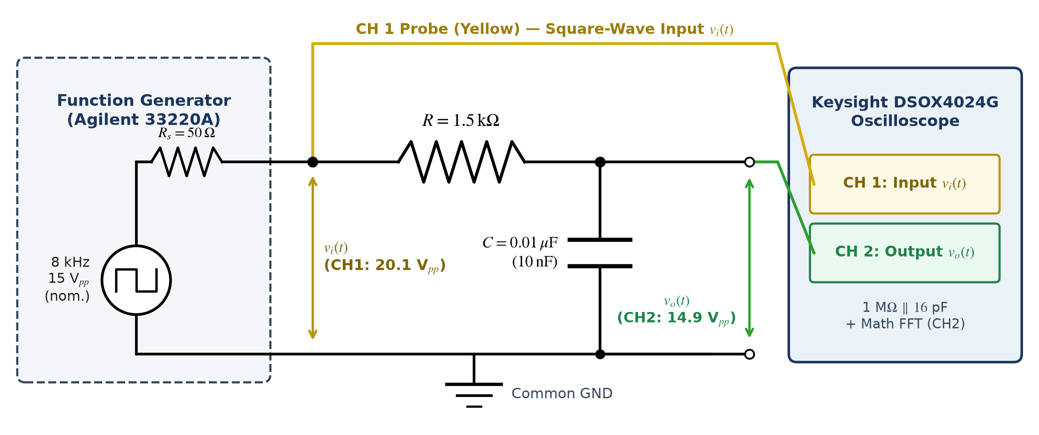
Figure 1. Experimental circuit schematic and instrumentation setup for the 8 kHz square-wave investigation, showing the Agilent 33220A source resistance (R_{s} = 50 Ω), series RC low-pass network (R = 1.5 kΩ, C = 0.01 µF), and Keysight DSOX4024G Channel 1 (20.1 V_{pp} observed) and Channel 2 (14.9 V_{pp} observed) connections.

2.4 Modelling Assumptions and Predicted Table C Methodology
• Ideal Component Values & Negligible Probe Loading: Calculations assume nominal R = 1.50 kΩ and C = 0.0100 µF. Connecting Channel 2 (1 MΩ ∥ 16 pF) across C introduces a 0.9985 DC divider (−0.013 dB) and adds 0.016 nF (+0.16%) to 10 nF, shifting f_{c} by less than 0.01% (10,610.3 Hz to 10,609.3 Hz) and justifying open-circuit output modelling.
• Separation of Nominal (15 V_{pp}) Theory and Observed (20.1 V_{pp}) Predictions: Whereas Post-Lab Section C requires theoretical calculations for a 15 V_{pp} square wave (A = 7.50 V), the actual oscilloscope screen recorded Pk-Pk(1) = 20.1 V_{pp} on Channel 1. Furthermore, inspection of the saved FFT screenshots showed that they predominantly captured the output spectrum FFT(CH2) and that the manual horizontal cursor (Y1) was not positioned to verify true peak amplitudes for both input and output at all three harmonics. Rather than misrepresenting unconfirmed cursor readouts as experimental FFT measurements, Table C was formulated analytically as predicted harmonic values scaled to the observed 20.1 V_{pp} input (A_{obs} = 10.05 V, b_{n,pred} = 40.2 / (nπ) V) multiplied by the theoretical RC transfer function |H(jnω₀)| under the peak-amplitude dBV convention of Equation (7).

3. Results

3.1 Theoretical RC Frequency Response at Harmonic Frequencies
Figure 2 plots the theoretical linear magnitude |H(jω)|, decibel magnitude 20 log₁₀|H(jω)|, and phase response ∠H(jω) of the RC circuit across 0–60 kHz, highlighting the −3 dB cut-off frequency f_{c} = 10.61 kHz and the operating points of the first three odd square-wave harmonics (8, 24, and 40 kHz). Table 1 lists the corresponding numerical transfer-function values. The 8 kHz fundamental lies inside the passband below f_{c} (|H| = 0.7985, −1.95 dB), whereas the 24 kHz third harmonic (−7.87 dB) and 40 kHz fifth harmonic (−11.82 dB) fall well into the stopband.
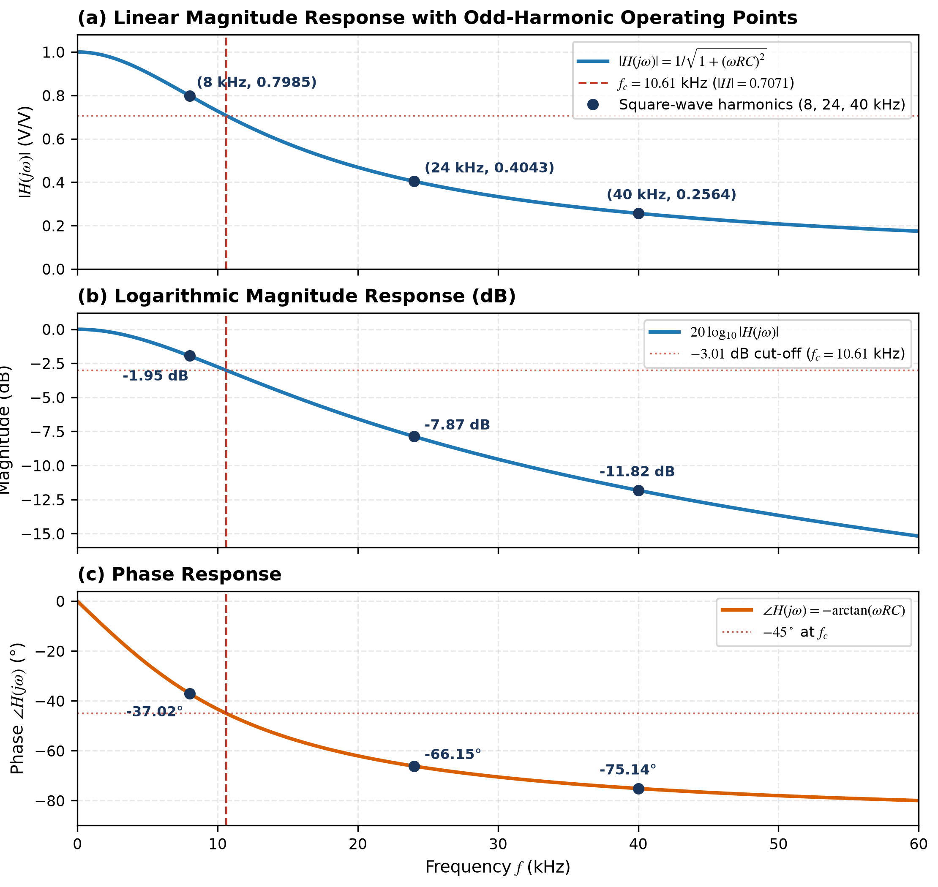
Figure 2. Theoretical frequency response of the RC low-pass filter (R = 1.5 kΩ, C = 0.01 µF) over 0–60 kHz showing operating points at the 8, 24, and 40 kHz square-wave harmonics and cut-off f_{c} = 10.61 kHz: (a) linear magnitude, (b) decibel gain, and (c) phase shift.
Table 1. Theoretical RC frequency response evaluated at DC, cut-off frequency, and the first three odd square-wave harmonics (R = 1.5 kΩ, C = 0.01 µF).
Spectral Point | Frequency f (kHz) | Angular Frequency ω (rad/s) | Magnitude |H(jω)| | Gain 20 log₁₀|H(jω)| (dB) | Phase ∠H(jω)
DC Reference | 0.00 | 0.00 | 1.0000 | 0.00 | 0.00°
Fundamental (n = 1) | 8.00 | 50,265.48 | 0.7985 | −1.95 | −37.02°
Cut-Off (f_{c}) | 10.61 | 66,666.67 | 0.7071 (1/√2) | −3.01 | −45.00°
3rd Harmonic (n = 3) | 24.00 | 150,796.45 | 0.4043 (0.4041*) | −7.87 | −66.15°
5th Harmonic (n = 5) | 40.00 | 251,327.41 | 0.2564 | −11.82 | −75.14°
*Note: Exact evaluation with C = 0.0100 µF gives |H(j·2π·24000)| = 0.4043 (−7.865 dB ≈ −7.87 dB); the group worksheet rounded intermediate ωRC to record 0.4041 (−7.87 dB), yielding the identical output magnitude of 1.29 V (2.19 dBV).

3.2 Theoretical Response to the Specified 15 Vpp, 8 kHz Square Wave
For the lab-specified 15 V_{pp} (A = 7.50 V), 8 kHz, 50% duty-cycle square wave (Post-Lab Section C(a)–(c)), Table 2 reports the theoretical input Fourier sine coefficients b_{n} and filtered capacitor output harmonic magnitudes |V_{o,n}| in both peak Volts and peak-convention dBV. Even harmonics (n = 2, 4 at 16 and 32 kHz) have zero amplitude. Figure 3 displays the theoretical discrete input and output harmonic spectra in Volts, peak dBV, and phase degrees.
Table 2. Theoretical Fourier series coefficients and filtered output harmonics for the specified 15 V_{pp} (±7.50 V peak), 8 kHz square wave (Post-Lab Section C, peak-amplitude dBV convention).
Harmonic (n) | f (Hz) | ω (rad/s) | |H(jω)| | Input b_{n} (V) | Input b_{n} (dBV)* | Output |V_{o,n}| (V) | Output |V_{o,n}| (dBV)*
Fundamental (n = 1) | 8,000 | 50,265.48 | 0.7985 | 9.55 | 19.60 | 7.63 | 17.65
Even (n = 2, 4) | 16,000 / 32,000 | 100,531 / 201,062 | 0.5535 / 0.3160 | 0.00 | — | 0.00 | —
3rd Harmonic (n = 3) | 24,000 | 150,796.45 | 0.4041 | 3.18 | 10.06 | 1.29 | 2.19
5th Harmonic (n = 5) | 40,000 | 251,327.41 | 0.2564 | 1.91 | 5.62 | 0.49 | −6.19
*Note: All dBV values follow the peak-amplitude Fourier convention L_dBV = 20 log10(V_peak / 1 V) for consistency across Post-Lab Section C and Table C.
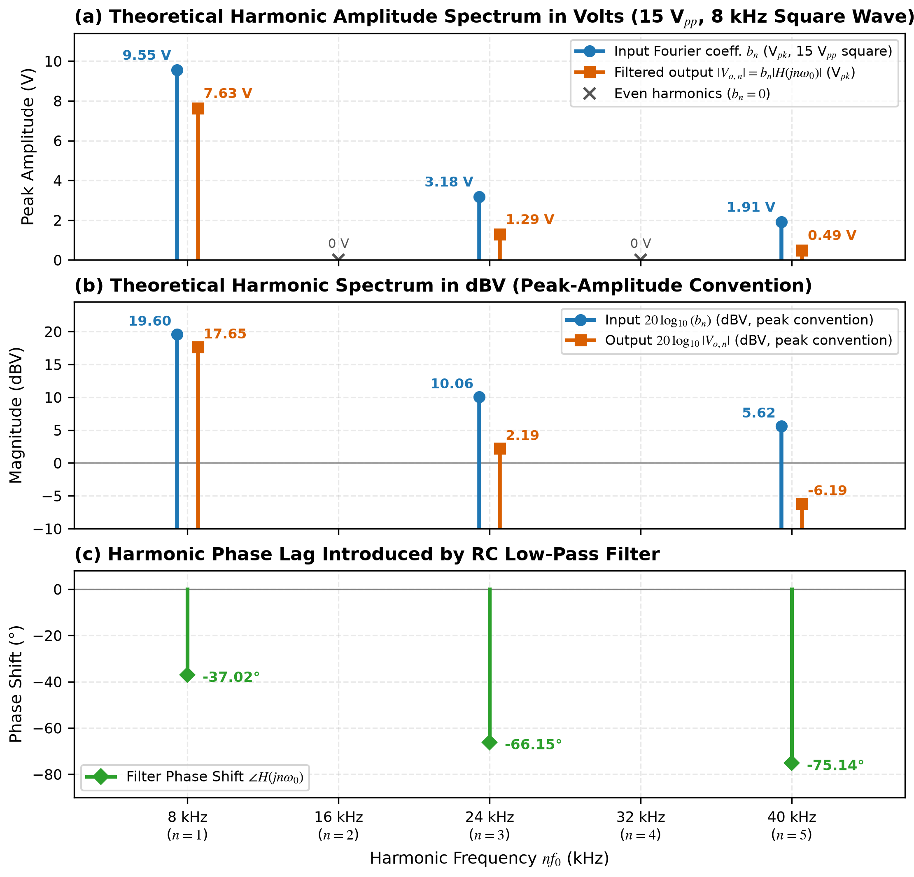
Figure 3. Theoretical discrete spectra for the specified 15 V_{pp}, 8 kHz square wave up to 40 kHz: (a) peak harmonic amplitudes in Volts, (b) harmonic levels in peak-convention dBV, and (c) filter phase lag ∠H(jnω₀).
Figure 4 illustrates the corresponding theoretical time-domain waveforms over three periods (375 µs). In Figure 4a, summing the first three odd harmonics (n = 1, 3, 5) approximates the ±7.50 V square wave with characteristic Gibbs ripple near discontinuities. In Figure 4b, selective attenuation and phase dispersion of the 24 kHz and 40 kHz harmonics smooth the vertical edges into continuous exponential charging and discharging arcs governed by τ = 15 µs, reaching ±7.27 V (14.54 V_{pp}) per Equation (8). Notably, the filtered three-harmonic curve closely tracks the exact analytical capacitor waveform because harmonics above n = 5 (≥56 kHz) contribute negligible residual energy.
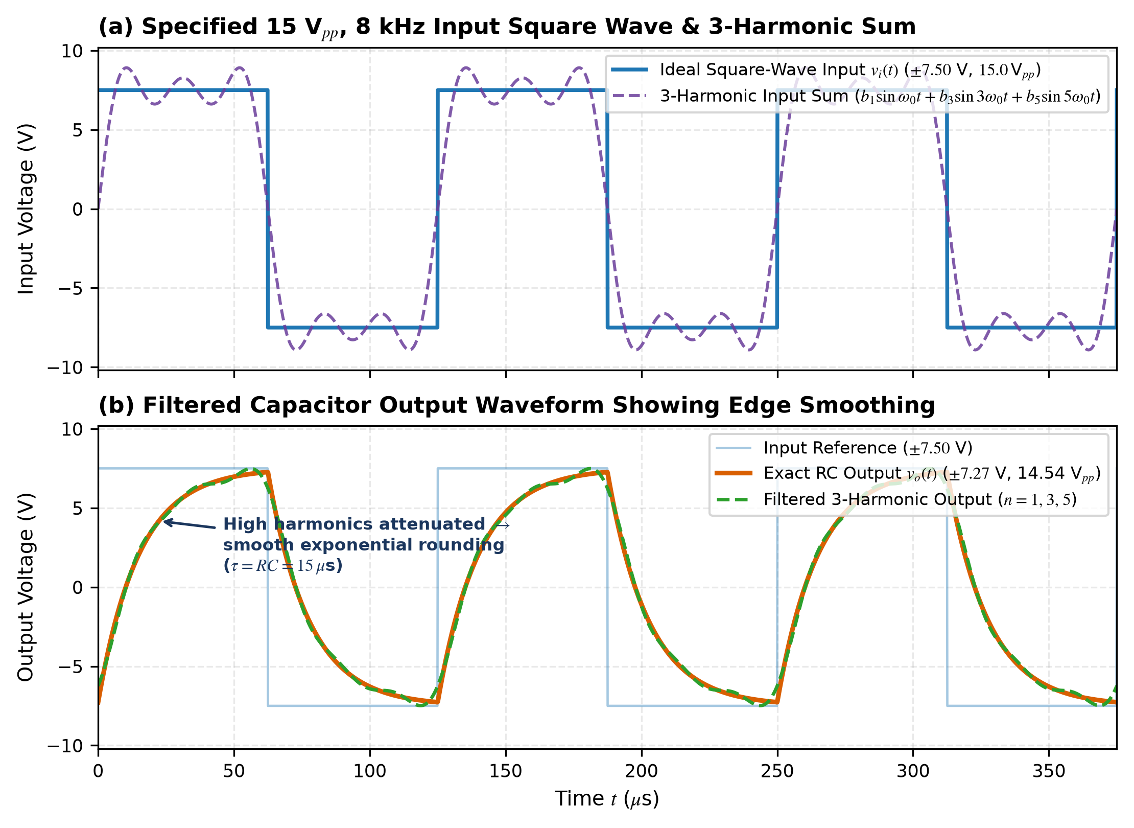
Figure 4. Theoretical time-domain waveforms to scale for the specified 15 V_{pp}, 8 kHz square wave: (a) ideal input square wave and 3-harmonic Fourier approximation; (b) exact steady-state RC capacitor output (±7.27 V, 14.54 V_{pp}) compared with 3-harmonic filtered synthesis.

3.3 Actual Experimental Oscilloscope Waveform and FFT Observations
Figure 5 presents the experimental Keysight DSOX4024G oscilloscope screen capture of the 8 kHz square-wave test, and Table 3 summarises all verified hardware readings. Rather than the nominal 15.0 V_{pp} specified in the lab instructions, the oscilloscope measured an actual input peak-to-peak voltage of 20.1 V_{pp} on Channel 1 (with flat-top plateau amplitude Ampl(1) = 15.1 V plus sharp switching overshoot spikes at transitions) at a fundamental frequency of 8.0000 kHz. Across the capacitor on Channel 2, the sharp rectangular transitions were eliminated, yielding a smooth, rounded exponential charging–discharging waveform measuring 14.9 V_{pp} (Ampl(2) = 14.2 V).
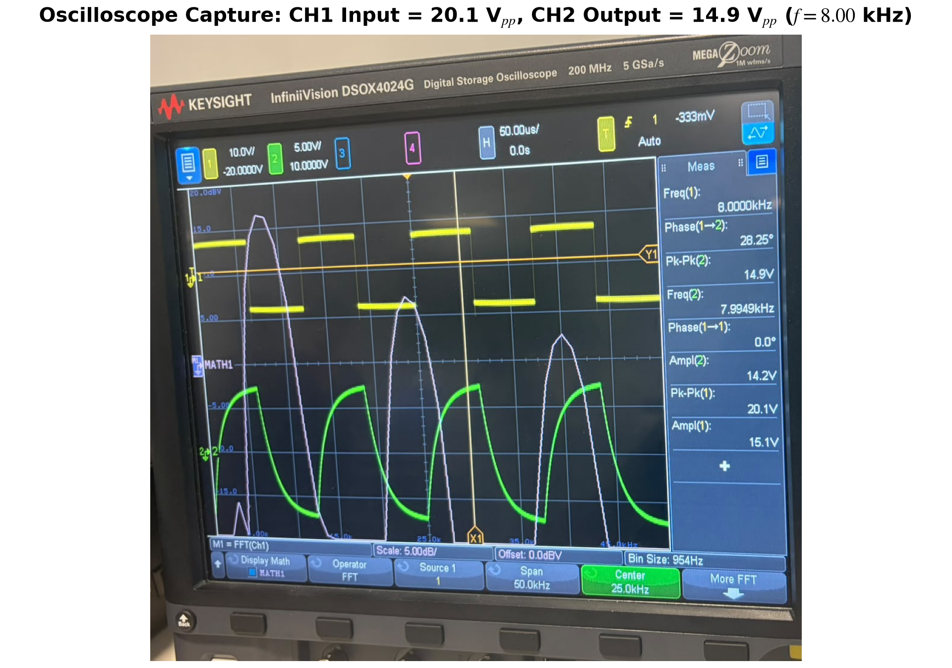
Figure 5. Actual Keysight DSOX4024G oscilloscope capture of the 8.00 kHz square wave showing Channel 1 input (yellow, 10 V/div, Pk-Pk(1) = 20.1 V, Ampl(1) = 15.1 V), smoothed Channel 2 capacitor output (green, 5 V/div, Pk-Pk(2) = 14.9 V, Ampl(2) = 14.2 V), and live FFT trace.
Table 3. Actual experimental oscilloscope measurements recorded for the 8 kHz square-wave test (Keysight DSOX4024G).
Measured Quantity | Oscilloscope Parameter | Specified (Manual) | Measured Value | Observation / Engineering Interpretation
Input Peak-to-Peak | Pk-Pk(1) [CH1] | 15.0 V_{pp} | 20.1 V_{pp} | Higher than nominal (high-Z load + switching overshoot)
Input Flat Plateau | Ampl(1) [CH1] | 15.0 V | 15.1 V | Plateau swing excluding narrow edge ringing spikes
Output Peak-to-Peak | Pk-Pk(2) [CH2] | — (14.54 V_{pp} th.*) | 14.9 V_{pp} | Smoothed exponential charging/discharging waveform
Output Amplitude | Ampl(2) [CH2] | — | 14.2 V | Core cyclic capacitor swing between transitions
Signal Frequency | Freq(1) / Freq(2) | 8.00 kHz | 8.0000 / 7.9949 kHz | Matches nominal 8 kHz fundamental within 0.06%
FFT Harmonic Peaks | X1 Cursor [FFT(CH2)] | 8, 24, 40 kHz | 8.0, 23.9, 40.0 kHz | Odd-harmonic locations verified; peak dBV unconfirmed
*Note: 14.54 V_pp (±7.27 V) is the theoretical steady-state capacitor peak-to-peak excursion for an ideal 15.0 V_pp square wave.
Figure 6 shows three experimental oscilloscope screenshots of the capacitor output spectrum FFT(CH2) with the vertical frequency cursor X1 positioned at 8.0 kHz (n = 1), 23.9 kHz (nearest 954 Hz FFT bin to the 24.0 kHz third harmonic), and 40.0 kHz (n = 5). Visually, the purple spectral trace confirms three distinct odd-harmonic peaks whose heights drop steeply with frequency, alongside deep spectral nulls at even multiples (16 and 32 kHz). However, as visible in Figure 6a–c, the screenshots predominantly record FFT(CH2) rather than matched input–output pairs, and the manual horizontal cursor Y1 remained stationary at −2.50000 dBV instead of tracking the crest of each harmonic peak. Consequently, reliable experimental FFT harmonic peak amplitudes (and direct measured harmonic dB gains) could not be extracted with confidence from the saved screenshots.
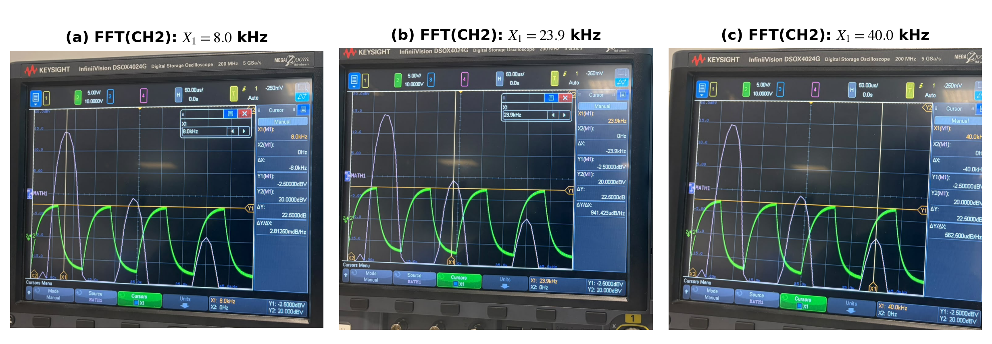
Figure 6. Experimental Keysight DSOX4024G screenshots of the output spectrum FFT(CH2) confirming odd-harmonic peaks at (a) X₁ = 8.0 kHz, (b) X₁ = 23.9 kHz (~24 kHz), and (c) X₁ = 40.0 kHz, while illustrating the uncoupled horizontal cursor (Y₁ fixed at −2.50 dBV) that prevented direct peak-amplitude extraction.

3.4 Predicted Harmonic Response for the Observed 20.1 Vpp Input (Table C)
Because paired experimental FFT peak amplitudes were unavailable from the saved screenshots, Table 4 (corresponding to Result Sheet Table C) presents the predicted harmonic input and output magnitudes calculated from the experimentally observed 20.1 V_{pp} Channel 1 reading (A_{obs} = 10.05 V) and the theoretical RC transfer function under the peak-amplitude dBV convention. Scaling the input from 15.0 V_{pp} to 20.1 V_{pp} increases every harmonic’s linear amplitude by a factor of 20.1 / 15.0 = 1.340 (+2.54 dB), shifting predicted input levels to 22.14, 12.60, and 8.17 dBV and predicted output levels to 20.19, 4.72, and −3.65 dBV (Figure 7a). Because the RC circuit is linear, the predicted decibel gains (−1.95, −7.87, and −11.82 dB) remain identical to the theoretical filter response (Figure 7b). Table 5 summarises the strict boundary maintained between theoretical, predicted, and measured quantities.
Table 4 (Table C). Predicted square-wave harmonic response calculated from the observed 20.1 V_{pp} input and theoretical RC transfer function (peak-amplitude dBV convention — predicted, not measured).
Spectrum Characteristic | Frequency f | Predicted Output* (20.1 V_{pp} basis) | Predicted Input* (20.1 V_{pp} basis) | Predicted Gain (Out − In) | Theoretical RC Response (15 V_{pp} basis)
Fundamental (n = 1) | 8 kHz | 20.19 dBV (10.22 V) | 22.14 dBV (12.80 V) | −1.95 dB | −1.95 dB (−1.96 dB*)
3rd Harmonic (n = 3) | 24 kHz | 4.72 dBV (1.72 V) | 12.60 dBV (4.27 V) | −7.87 dB | −7.87 dB
5th Harmonic (n = 5) | 40 kHz | −3.65 dBV (0.66 V) | 8.17 dBV (2.56 V) | −11.82 dB | −11.82 dB
*Note: Because reliable paired input and output FFT peak amplitudes could not be confirmed from the oscilloscope cursor screenshots, these values are analytical predictions scaled to the observed 20.1 V_pp (±10.05 V) input using L_dBV = 20 log10(V_peak); in the group worksheet, −1.96 dB arose from rounding intermediate 15 V_pp values (17.64 − 19.60 dBV).
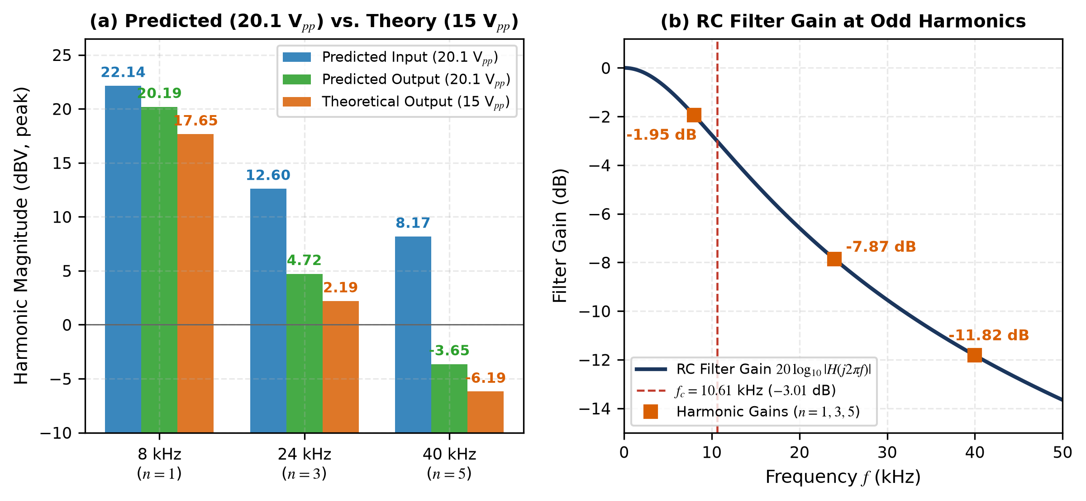
Figure 7. (a) Comparison of Table C predicted input and output harmonic magnitudes (20.1 V_{pp} basis, peak dBV convention) against theoretical 15 V_{pp} output magnitudes; (b) harmonic attenuation points along the RC low-pass Bode magnitude curve.
Table 5. Explicit methodological separation between theoretical, predicted, and measured square-wave quantities.
Category | Input Basis | Quantities Included | Data Source & Evidentiary Role
Theoretical Values | 15.0 V_{pp} (±7.50 V) manual spec. | b_{n} = 9.55, 3.18, 1.91 V (19.60, 10.06, 5.62 dBV); |V_{o,n}| = 7.63, 1.29, 0.49 V (17.65, 2.19, −6.19 dBV); V_{o} = 14.54 V_{pp} | Post-Lab Section C(a)–(c) analytical Fourier & LCCDE derivation
Predicted Values (Table C) | 20.1 V_{pp} (±10.05 V) observed Pk-Pk(1) | Input: 22.14, 12.60, 8.17 dBV; Output: 20.19, 4.72, −3.65 dBV; Gains: −1.95, −7.87, −11.82 dB | Calculated from observed 20.1 V_{pp} input × theoretical |H(jnω₀)| due to incomplete FFT peak data
Measured Values | Actual hardware excitation | CH1 = 20.1 V_{pp} (Ampl = 15.1 V), CH2 = 14.9 V_{pp} (Ampl = 14.2 V), f = 8.00 kHz, FFT peaks at ~8, 24, 40 kHz | Direct Keysight DSOX4024G oscilloscope screen captures (Figures 5 and 6)

4. Discussion

4.1 Low-Pass Filtering Action and Harmonic Mechanism of Square-Wave Smoothing
Both analytical Fourier theory and the experimental oscilloscope waveforms demonstrate that the series RC circuit (with output taken across C) operates as a first-order low-pass filter with −3 dB cut-off frequency f_{c} = 10.61 kHz (voltage gain ratio 1/√2 ≈ 0.7071, or 50% half-power ratio; Lathi & Green, 2018). Physically, capacitor reactance X_{C} = 1/(2πfC) decreases inversely with frequency from 1.99 kΩ at 8 kHz to 663 Ω at 24 kHz and 398 Ω at 40 kHz. Forming a frequency-dependent voltage divider with R = 1.5 kΩ, the capacitor passes the 8 kHz fundamental—located below f_{c}—with mild attenuation (|H| = 0.7985, −1.95 dB), but progressively shunts the stopband odd harmonics to ground, attenuating the 24 kHz third harmonic by −7.87 dB (factor 0.4043) and the 40 kHz fifth harmonic by −11.82 dB (factor 0.2564; Table 1).
This selective harmonic suppression directly explains the waveform transformation observed between Channel 1 and Channel 2 in Figures 4 and 5. In the frequency domain, the instantaneous vertical jumps of an ideal square wave are synthesised by the coherent constructive alignment of high-order odd harmonics whose amplitudes decay slowly as 1/n (Oppenheim et al., 1997). Because |H(jnω₀)| rolls off as 1/n above f_{c}, the filtered capacitor harmonics decay rapidly as 1/n² while experiencing unequal phase delays (−37.02°, −66.15°, and −75.14°), stripping away high-frequency edge steepness and rounding the output corners. Equivalently, in the time domain, capacitor voltage cannot change instantaneously because charging current through R is governed by τ = RC = 15 µs. Over each half-period of the 8 kHz square wave (T₀/2 = 62.5 µs = 4.17τ), the capacitor charges exponentially through 1 − e^{−4.17} = 98.5% of its step span before input polarity reverses, producing the smooth shark-fin/exponential profile recorded on Channel 2 (14.9 V_{pp} in Figure 5 vs. 14.54 V_{pp} theoretical for an ideal 15 V_{pp} plateau).

4.2 Discrepancy Between Specified 15 Vpp and Observed 20.1 Vpp Input
A critical experimental observation is that although the lab manual specified a 15 V_{pp} input square wave, the oscilloscope recorded Pk-Pk(1) = 20.1 V_{pp} on Channel 1 (Figure 5, Table 3). Two physical instrumentation factors account for this difference. First, the Agilent 33220A function generator features a 50 Ω internal output resistance and calibrates its displayed front-panel amplitude assuming an external 50 Ω termination; when connected directly to a high-impedance RC network and 1 MΩ oscilloscope probe without changing the generator’s output load menu to ‘High Z’, the open-circuit voltage divider nearly doubles the delivered terminal voltage unless manually readjusted (Keysight Technologies, 2014). Second, inspecting both Channel 1 readouts in Figure 5 reveals that while the flat square-wave top-to-bottom plateau was adjusted close to nominal (Ampl(1) = 15.1 V), fast square-wave switching edges across coaxial lead inductance and breadboard stray capacitance produced transient ringing/overshoot spikes at each transition, elevating the total excursion Pk-Pk(1) to 20.1 V_{pp} (Horowitz & Hill, 2015). Reporting 20.1 V_{pp} honestly—rather than assuming the input equalled 15 V_{pp}—ensures fidelity to the actual oscilloscope evidence.

4.3 Separation of Theoretical, Predicted, and Measured Results
Maintaining rigorous scientific integrity requires keeping three distinct data sets separate (Table 5). First, the theoretical Fourier calculations in Table 2 (9.55, 3.18, and 1.91 V input; 7.63, 1.29, and 0.49 V output) strictly satisfy the lab manual’s post-laboratory specification of a 15 V_{pp} square wave. Second, the actual measured results in Table 3 comprise the verified oscilloscope time-domain readings (20.1 V_{pp} CH1 input, 14.9 V_{pp} CH2 output, 8.00 kHz fundamental) and the visual confirmation of odd-harmonic FFT peaks near 8, 24, and 40 kHz (Figures 5 and 6). Notably, the automated time-domain phase readout on Figure 5 (Phase(1→2) = 28.25°) reflects threshold zero-crossing delay of the composite non-sinusoidal waveform rather than the −37.02° phase lag of the isolated 8 kHz fundamental.
Third, the Table C harmonic values in Table 4 (22.14, 12.60, and 8.17 dBV input; 20.19, 4.72, and −3.65 dBV output) represent analytical predictions modelling an ideal 20.1 V_{pp} square wave passing through H(jω). Presenting Table C as predicted estimates avoids fabricating experimental harmonic-gain claims that the saved FFT screenshots cannot substantiate, while demonstrating that LTI decibel attenuation (−1.95, −7.87, and −11.82 dB) is independent of input amplitude scaling. Additionally, whereas Keysight hardware FFT traces reference dBV to 1 V_{rms} (−3.01 dB below peak dBV; Keysight Technologies, 2022), using the peak-amplitude Fourier dBV convention consistently across Tables 2 and 4 prevents any 3.01 dB unit mismatch.

4.4 Limitations of the Oscilloscope FFT Screenshots and Experimental Setup
• Incomplete Paired Input/Output FFT Peak Readings: An accurate experimental Table C comparison requires peak-locked cursor readings of both FFT(CH1) and FFT(CH2) at 8, 24, and 40 kHz. Our saved FFT captures mainly displayed FFT(CH2), and the manual horizontal Y1 cursor remained uncoupled (e.g., sitting at −2.50 dBV across Figure 6a–c) rather than tracking harmonic peaks.
• Coarse FFT Frequency Bin Resolution: Operating the FFT over a 50.0 kHz span yielded a 954 Hz bin spacing, causing the 24.0 kHz third harmonic to fall on an adjacent bin at 23.9 kHz (Figure 6b) and introducing windowing scallop uncertainty (Harris, 1978).
• Generator Termination Mismatch & Edge Ringing: Unmatched 50 Ω generator output termination and unshielded breadboard jumper inductance caused the observed 20.1 V_{pp} Pk-Pk(1) reading to diverge from the nominal 15 V_{pp} rectangular model.
• Unmeasured Component Tolerances: Nominal R = 1.5 kΩ (±5%) and C = 0.01 µF (±5%–10%) were not pre-measured with an LCR meter, allowing slight shifts in true f_{c}.

4.5 Practical Engineering Applications and Recommended Improvements
Selective harmonic attenuation of rectangular waveforms by RC low-pass networks is widely applied in microcontroller PWM digital-to-analogue conversion (smoothing high-frequency switching pulses into clean DC/control voltages), clock edge-rate limiting for electromagnetic-interference (EMI) reduction, and ADC anti-aliasing front-ends (Horowitz & Hill, 2015). In future experiments, four procedural improvements would yield complete experimental harmonic verification: (1) setting the Agilent 33220A load menu to ‘High Z’ and using coaxial BNC-to-board adapters to eliminate edge overshoot; (2) pre-measuring R and C on a digital LCR bridge; (3) coupling the oscilloscope’s ‘Peak Search / Track’ FFT markers to record paired FFT(CH1) and FFT(CH2) peak magnitudes at 8, 24, and 40 kHz with ≥16-sweep averaging and narrower FFT spans; and (4) explicitly noting RMS vs. peak dBV conventions during acquisition.

5. Conclusion
This investigation analysed and experimentally examined the response of a passive first-order series RC low-pass filter (R = 1.5 kΩ, C = 0.01 µF, τ = 15 µs, f_{c} = 10.61 kHz) to an 8 kHz, 50% duty-cycle periodic square wave. Using Fourier series decomposition and H(jω) = 1 / (1 + jωRC), theoretical calculations for the specified 15 V_{pp} input showed that the fundamental harmonic at 8 kHz experiences mild attenuation (0.7985, −1.95 dB, from 9.55 V to 7.63 V), whereas the third (24 kHz) and fifth (40 kHz) harmonics lie above f_{c} and are strongly attenuated by −7.87 dB (3.18 V to 1.29 V) and −11.82 dB (1.91 V to 0.49 V). Oscilloscope captures recorded an actual input of 20.1 V_{pp} on Channel 1 and a rounded 14.9 V_{pp} exponential output on Channel 2, visually confirming edge smoothing due to high-harmonic suppression. Because the FFT screenshots lacked verified paired input–output cursor peak readings, Table C values (20.19, 4.72, and −3.65 dBV output) were rigorously distinguished as predicted estimates for the 20.1 V_{pp} input rather than measured FFT data. Despite generator termination mismatch and incomplete FFT cursor logging, the results validate LTI harmonic filtering principles underlying PWM reconstruction and noise suppression.

References
Edith Cowan University School of Engineering. (2026a). ENS3553/ENS6160 Signals and Systems: Module 5 and Module 6 lecture slides [Lecture slides]. Canvas.
Edith Cowan University School of Engineering. (2026b). ENS3553/ENS6160 Signals and Systems: Tutorial 5 Question 6 and Laboratory Experiment 2 instruction sheet [Course handout]. Canvas.
Harris, F. J. (1978). On the use of windows for harmonic analysis with the discrete Fourier transform. Proceedings of the IEEE, 66(1), 51–83. https://doi.org/10.1109/PROC.1978.10837
Horowitz, P., & Hill, W. (2015). The art of electronics (3rd ed.). Cambridge University Press.
Keysight Technologies. (2014). 33220A 20 MHz function/arbitrary waveform generator: Data sheet (Publication No. 5988-8544EN). Keysight Technologies.
Keysight Technologies. (2022). InfiniiVision 4000 X-Series oscilloscopes: Data sheet (Publication No. 5991-1103EN). Keysight Technologies.
Lathi, B. P., & Green, R. A. (2018). Linear systems and signals (3rd ed.). Oxford University Press.
Oppenheim, A. V., Willsky, A. S., & Nawab, S. H. (1997). Signals and systems (2nd ed.). Prentice Hall.

Acknowledgement of AI Use
Acknowledgement: The authors acknowledge the use of generative artificial intelligence tools—Claude Code (Anthropic, v2.0) and Arena.ai Agent Mode (v2026.10)—to assist with formatting the report layout, generating Python/Matplotlib theoretical and predicted spectral/waveform plots from the circuit equations, and editing academic phrasing for clarity. All experimental circuit assembly, oscilloscope measurements, analytical calculations, methodological decisions, and final interpretations are the original work of the two group members, who reviewed and verified the submission.

