Edith Cowan University
School of Engineering

ENS3553 / ENS6160 Signals and Systems
Laboratory Report 2
Frequency Response of Systems: Analysis and Measurement of a First-Order RC Low-Pass Filter

Group members: [Name 1 – Student ID] [Name 2 – Student ID] [Name 3 – Student ID]
Laboratory supervisor: [Name] Laboratory date: [dd Month 2026]
Date of submission: 25 October 2026

Abstract
Linear time-invariant (LTI) systems act on a signal by scaling and shifting each of its sinusoidal components, so the frequency response of a system fully describes how it filters a signal. This laboratory investigated that principle using a first-order RC circuit (R = 1.5 kΩ, C = 0.01 µF) with the capacitor voltage taken as the output. The aim was to derive the frequency response of the circuit, use it to predict the output for sinusoidal and square-wave inputs, and verify the predictions experimentally in both the time and frequency domains.
From the governing differential equation, the frequency response was derived as H(jω) = 1/(1 + jωRC), giving a low-pass characteristic with a theoretical cut-off frequency of 10.6 kHz. The predicted gains at 1, 10 and 40 kHz were 0.9956, 0.7277 and 0.2564 (−0.04, −2.76 and −11.82 dB). A function generator supplied a 15 V peak-to-peak sinusoid at these frequencies and a 15 V peak-to-peak, 8 kHz, 50% duty-cycle square wave. A digital storage oscilloscope was used to measure the output amplitude and phase in the time domain and the magnitude of the input and output spectra using the FFT function.
Measured amplitudes agreed with theory to within about 10% (15.20, 11.50 and 4.22 V peak-to-peak against 14.93, 10.92 and 3.85 V) and measured phases to within about 1.3° (−6.65°, −42.30° and −73.71° against −5.39°, −43.30° and −75.14°). FFT-based gains at 1, 10 and 40 kHz were −0.23, −2.81 and −11.35 dB, and for the 8 kHz square wave the fundamental, third and fifth harmonics were attenuated by −1.95, −7.87 and −11.82 dB, in close agreement with theory. The attenuation of the higher harmonics rounded the square wave into the exponential charging and discharging waveform predicted by the time constant RC = 15 µs. The results confirm that the frequency response accurately predicts the behaviour of the circuit and that the circuit behaves as a first-order low-pass filter.

Table of Contents
Right-click and choose "Update Field" to build the table of contents.

1. Introduction
Many engineering systems, including amplifiers, audio equipment, sensors and communication links, are well modelled as linear time-invariant (LTI) systems. A defining property of an LTI system is that an everlasting complex exponential e^{st} applied at its input emerges at the output as the same exponential multiplied by a complex number H(s) (Oppenheim, Willsky & Nawab, 1997). For s = jω the quantity H(jω) is the frequency response of the system: its magnitude gives the gain applied to a sinusoid of angular frequency ω and its angle gives the phase shift (Lathi & Green, 2018). Because a periodic signal can be written as a Fourier series, a sum of harmonically related sinusoids, the output of an LTI system for any periodic input is found by scaling and phase-shifting each harmonic individually. An LTI system therefore cannot create new frequencies; it can only change the relative amplitude and phase of those already present, which is the basis of filtering.
The simplest practical filter is a first-order RC circuit. With the output taken across the capacitor, it passes low frequencies and attenuates high frequencies. The boundary between the passband and the stopband is the cut-off frequency, at which the amplitude gain falls to 1/√2 (≈ 0.707, or −3 dB). Predicting the response of such a circuit to sinusoidal and square-wave inputs from H(jω) and then confirming the predictions by measurement links the mathematical description of a system with its observable behaviour in both the time and frequency domains. Measuring spectra with the oscilloscope FFT, as in the first laboratory experiment, also provides a direct view of how the filter reshapes the spectrum of an input signal.
The aim of this experiment was to derive the frequency response of an RC filter, use it to predict the filter output for sinusoidal and square-wave inputs, and to measure the frequency response in the time and frequency domains in order to compare it with theory and to relate the time-response and frequency-response characteristics of the system.

2. Method

2.1 Theory and pre-laboratory calculations
The circuit comprised a resistor R = 1.5 kΩ in series with a capacitor C = 0.01 µF. The input is the source voltage v_i(t) and the output v_o(t) is the capacitor voltage. Applying Kirchhoff’s voltage law gives the linear constant-coefficient differential equation
RC · dv_o(t)/dt + v_o(t) = v_i(t).
Following the approach of Tutorial 5 Question 6, the input was set to v_i(t) = e^{jωt}. For an LTI system the output is then v_o(t) = H(jω)e^{jωt}. Substituting into the differential equation gives jωRC·H(jω)e^{jωt} + H(jω)e^{jωt} = e^{jωt}, so
H(jω) = 1 / (1 + jωRC), |H(jω)| = 1 / √(1 + (ωRC)²), ∠H(jω) = −arctan(ωRC).
With RC = (1500)(0.01 × 10⁻⁶) = 15 µs, the time constant of the circuit is τ = 15 µs and the cut-off frequency, at which ωRC = 1, is
f_c = 1 / (2πRC) = 1 / (2π × 15 × 10⁻⁶) ≈ 10.61 kHz.
The gain and phase were evaluated at 1, 10 and 40 kHz, and the amplitude and phase responses were plotted from 0 to 60 kHz using Python (the equivalent of the sample MATLAB code provided in Module 6). Gain in decibels was computed as 20·log₁₀|H(jω)|.
For a sinusoidal input v_i(t) = A cos(ωt) the steady-state output is v_o(t) = A|H(jω)| cos(ωt + ∠H(jω)) (Module 5). The inputs were 15 V peak-to-peak (A = 7.5 V) with 0° phase.
For the periodic square wave, the input of 15 V peak-to-peak (h = 7.5 V), frequency f₀ = 8 kHz and 50% duty cycle has a Fourier series containing only odd harmonics. The sine-series coefficients are
b_n = 4h / (nπ) for odd n, b_n = 0 for even n,
at frequencies nf₀. The output harmonics were found by multiplying each coefficient by |H(jnω₀)| (and adding ∠H(jnω₀) to its phase). The first three non-zero harmonics (n = 1, 3, 5, at 8, 24 and 40 kHz) were used.

2.2 Equipment and circuit
- Function generator (Agilent/Keysight 33220A)
- Digital storage oscilloscope (Keysight InfiniiVision DSOX4024G, 200 MHz, 5 GSa/s) with two probes
- Breadboard, one 1.5 kΩ resistor and one 0.01 µF capacitor
The RC circuit was assembled on the breadboard and the function generator was connected across its input. Oscilloscope channel 1 was connected across the generator (input) and channel 2 across the capacitor (output), with a common ground.

2.3 Experimental procedure
Experiment 1: time-domain verification. The generator was set to a 15 V peak-to-peak sine wave and the frequency set in turn to 1, 10 and 40 kHz. At each frequency the two waveforms were displayed with suitable time and voltage scales, and the oscilloscope measurement function was used to record the output peak-to-peak amplitude and the phase difference between channels 1 and 2. The behaviour of the output with increasing frequency was observed to identify the type of filtering.
Experiment 2: frequency-domain verification. For each of the three frequencies the oscilloscope FFT function was used to display the spectrum of the input and output signals. Cursors were placed on the spectral peak at the signal frequency and its magnitude was recorded in dBV. The measured gain was calculated as the output magnitude minus the input magnitude in dB and compared with the theoretical value.
Experiment 3: square-wave response. The generator was set to a 15 V peak-to-peak, 8 kHz, 50% duty-cycle square wave. The FFT of the input and output was displayed and the magnitudes of the fundamental and the third and fifth harmonics (8, 24 and 40 kHz) were recorded with cursors. The input and output time-domain waveforms were also observed.

2.4 Assumptions
- The resistor and capacitor have their nominal values (component tolerances were not measured).
- The generator output impedance and the oscilloscope probe loading are neglected in the theoretical model.
- The circuit is operated in steady state, so that the output is the forced response to the input only.
- Oscilloscope FFT readings at spectral peaks are taken as the magnitude of the corresponding harmonic.

3. Results

3.1 Theoretical frequency response
Figure 1 shows the theoretical amplitude and phase responses of the circuit between 0 and 60 kHz. The gain decreases monotonically with frequency and the phase decreases from 0° towards −90°. The dashed line marks the cut-off frequency f_c = 10.61 kHz, where |H| = 0.707 (−3 dB) and ∠H = −45°. The values at the three test frequencies are given in Table 1.
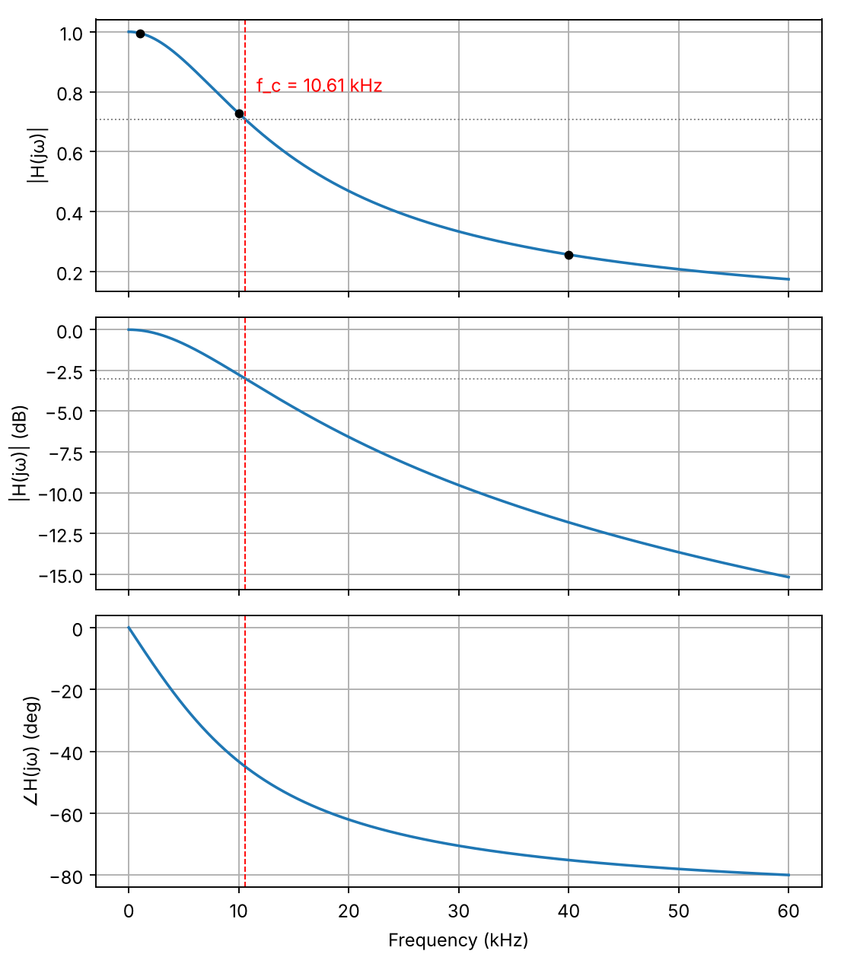
Figure 1. Theoretical amplitude (linear and dB) and phase response of the RC circuit (R = 1.5 kΩ, C = 0.01 µF). Dots mark 1, 10 and 40 kHz; the dashed line is the cut-off frequency.
Table 1. Theoretical frequency response at the test frequencies.
f | ω (rad/s) | |H(jω)| | |H(jω)| (dB) | ∠H(jω)
1 kHz | 6283.19 | 0.9956 | −0.0384 | −5.38°
10 kHz | 62831.85 | 0.7277 | −2.76 | −43.30°
40 kHz | 251327.41 | 0.2564 | −11.82 | −75.14°

3.2 Predicted output for sinusoidal inputs
For a 15 V peak-to-peak (7.5 V peak) input, the predicted output amplitudes and phases are given in Table 2, and the corresponding magnitude and phase spectra are shown in Figure 2.
Table 2. Theoretical output of the RC circuit for a 15 V peak-to-peak sinusoidal input.
f | |Vi| (V pk) | |Vo| (V pk) | |Vo| (V pk-pk) | ∠Vo
1 kHz | 7.5 | 7.467 | 14.93 | −5.38°
10 kHz | 7.5 | 5.458 | 10.92 | −43.30°
40 kHz | 7.5 | 1.923 | 3.85 | −75.14°

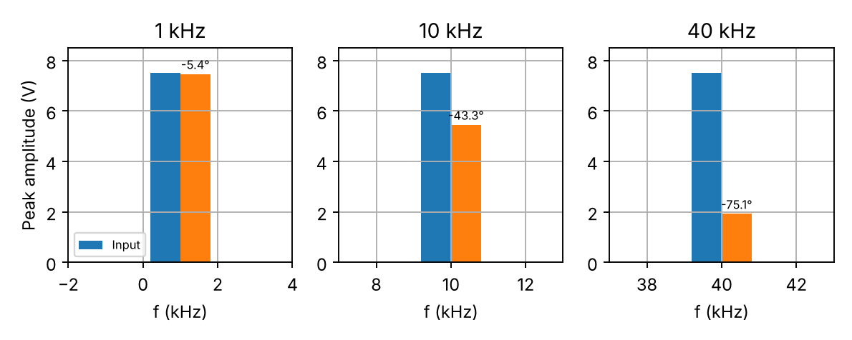
Figure 2. Single-sided amplitude spectra of the input (blue) and predicted output (orange) at 1, 10 and 40 kHz. The label above each output bar is its phase.

3.3 Predicted response to a square wave
For the 8 kHz square wave, the Fourier coefficients, filter gains and predicted output harmonic magnitudes are in Table 3 and Figure 3. Figure 4 shows the input and the output synthesised from the harmonics.
Table 3. Theoretical Fourier coefficients and output harmonics for the 15 V peak-to-peak 8 kHz square wave.
Harmonic | f (kHz) | Input b_n (V) | Input (dBV) | |H(jω)| | Output (V) | Output (dBV)
Fundamental | 8 | 9.55 | 19.60 | 0.7985 | 7.63 | 17.65
3rd | 24 | 3.18 | 10.06 | 0.4041 | 1.29 | 2.19
5th | 40 | 1.91 | 5.62 | 0.2564 | 0.49 | −6.19

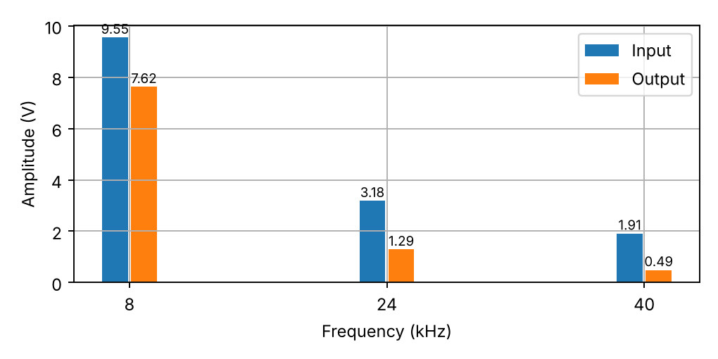
Figure 3. Theoretical input and output amplitude spectra of the 8 kHz square wave (first three non-zero harmonics).
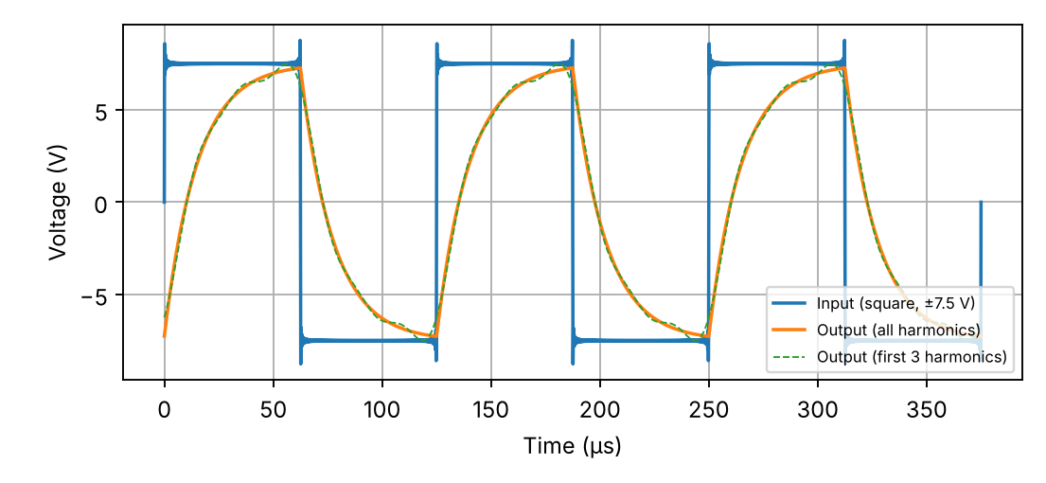
Figure 4. Theoretical input and output waveforms for the 8 kHz square wave, to scale. The dashed curve uses only the first three harmonics.

3.4 Time-domain measurements
Table 4 compares the measured and theoretical output amplitude and phase. Figures 5 and 6 are oscilloscope captures at 1 kHz and 10 kHz showing the input (yellow) and output (green). At 1 kHz the two sinusoids are almost identical in amplitude and nearly in phase; at 10 kHz the output is visibly smaller and delayed; at 40 kHz the output amplitude is about a quarter of the input.
Table 4. Theoretical and measured time-domain frequency response (15 V peak-to-peak sinusoidal input).
f | Magnitude, theory (V pk-pk) | Magnitude, measured (V pk-pk) | Phase, theory | Phase, measured
1 kHz | 14.93 | 15.20 | −5.39° | −6.65°
10 kHz | 10.92 | 11.50 | −43.30° | −42.30°
40 kHz | 3.85 | 4.22 | −75.14° | −73.71°

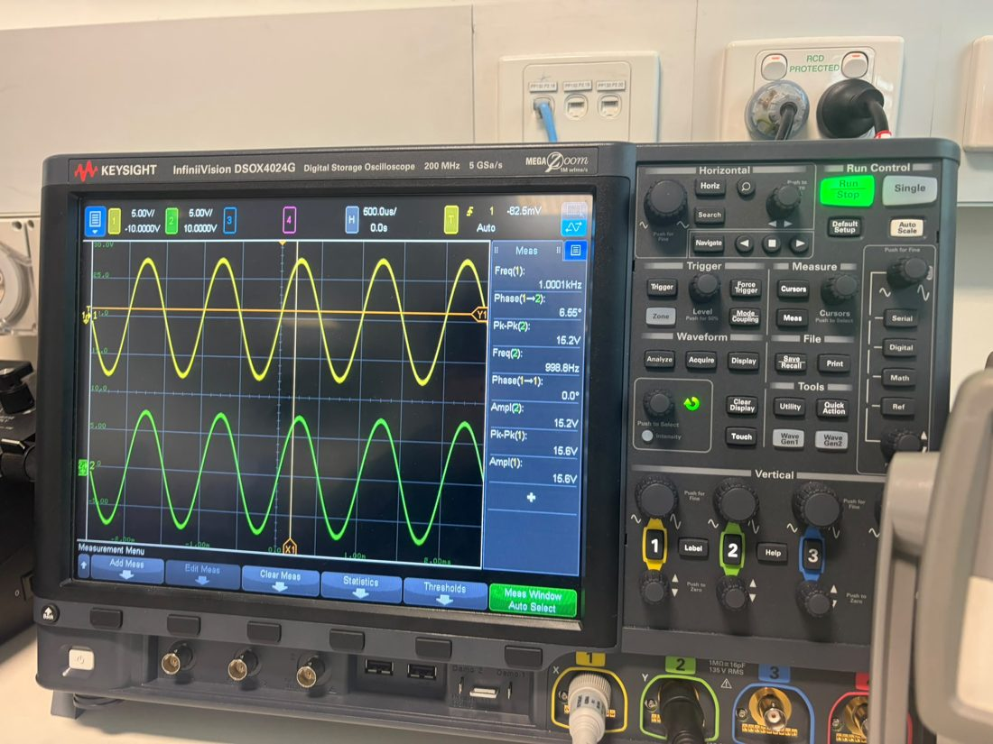
Figure 5. Oscilloscope capture, 1 kHz sinusoidal input (channel 1) and capacitor output (channel 2).
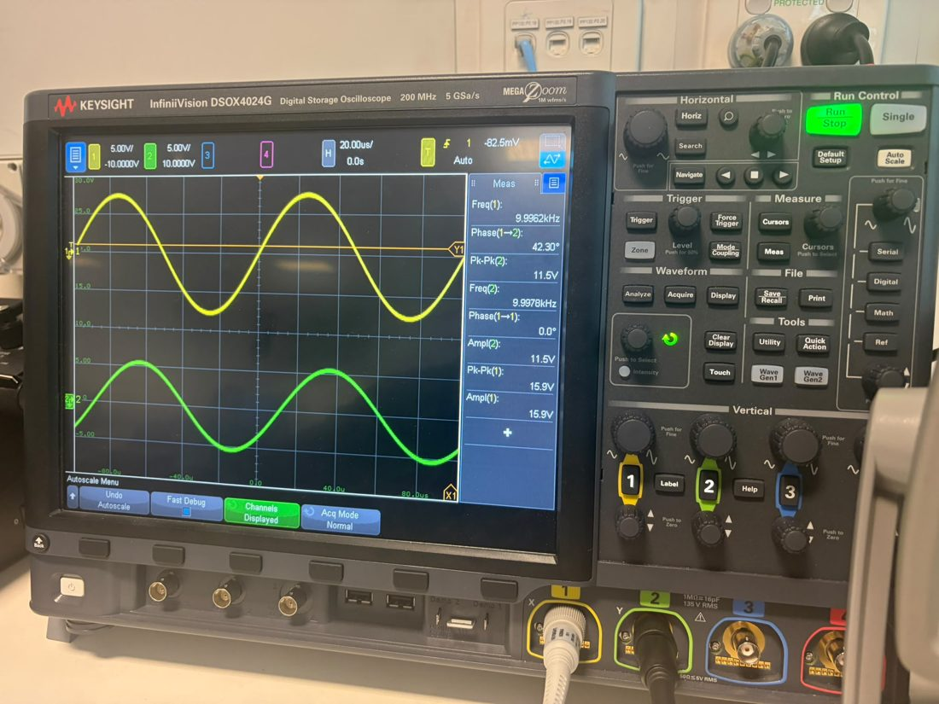
Figure 6. Oscilloscope capture, 10 kHz sinusoidal input and output, showing the reduced amplitude and phase lag of the output.

3.5 Frequency-domain measurements: sinusoids
Table 5. FFT magnitudes and gain for sinusoidal inputs.
f | Output (dBV) | Input (dBV) | Measured gain (dB) | Theoretical gain (dB)
1 kHz | 14.61 | 14.83 | −0.23 | −0.0384
10 kHz | 12.18 | 14.99 | −2.81 | −2.7606
40 kHz | 3.47 | 14.83 | −11.35 | −11.821

3.6 Frequency-domain measurements: square wave
Table 6. FFT magnitudes and gain at the first three harmonics of the 8 kHz square wave.
Harmonic | Output (dBV) | Input (dBV) | Measured response (dB) | Theoretical response (dB)
Fundamental (8 kHz) | 20.19 | 22.14 | −1.95 | −1.96
3rd (24 kHz) | 4.72 | 12.60 | −7.87 | −7.87
5th (40 kHz) | −3.65 | 8.17 | −11.82 | −11.82

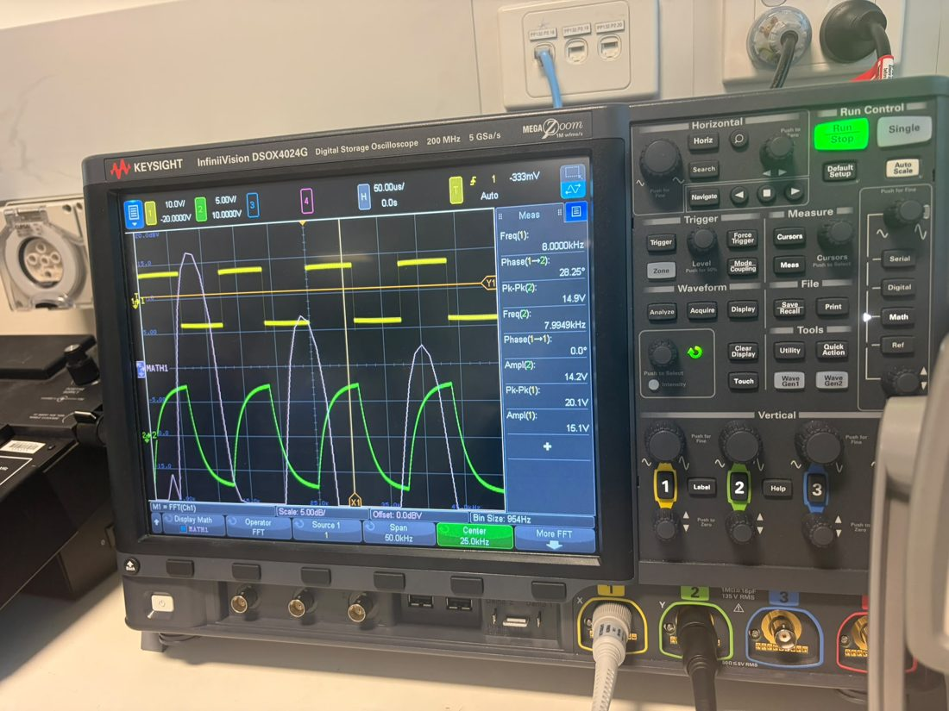
Figure 7. Oscilloscope capture for the 8 kHz square wave: input (yellow), capacitor output (green) and the FFT of the input (white).
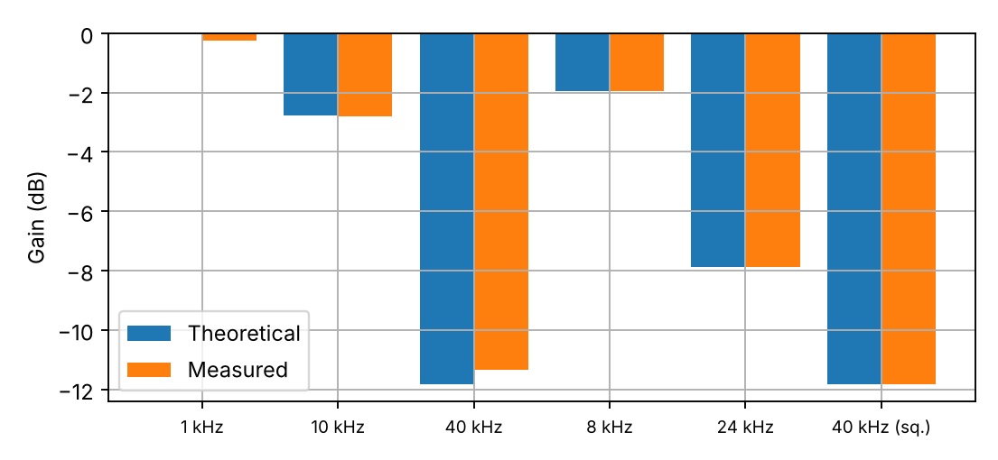
Figure 8. Theoretical and measured gain (dB) for all measurements in Tables 5 and 6.
[Insert here: the cropped oscilloscope spectra for the 1, 10 and 40 kHz sinusoids and the 8 kHz square wave, from the photographs in lab2_frequency_response/oscilloscope_photos, together with the hand sketches required by the laboratory sheet.]

4. Discussion

4.1 Type of filtering and cut-off frequency
The derived frequency response, H(jω) = 1/(1 + jωRC), has unity gain at ω = 0 and tends to zero as ω → ∞ (Figure 1), so the circuit is a first-order low-pass filter. The measurements confirm this: the output amplitude fell from 15.20 V at 1 kHz to 11.50 V at 10 kHz and 4.22 V at 40 kHz (Table 4), and the FFT gain fell from −0.23 dB to −2.81 dB and −11.35 dB (Table 5). The output therefore decreases with frequency, as expected of a low-pass filter.
A gain of −3 dB corresponds to a voltage ratio of 10^(−3/20) = 0.708, or 1/√2 (half the power). The cut-off frequency read from Figure 1 at this level is 10.6 kHz, and it follows directly from the circuit parameters as f_c = 1/(2πRC), where RC is the time constant of the circuit. The measurements support this value: at 10 kHz, just below the theoretical cut-off, the measured gain was −2.81 dB (close to −3 dB) and the phase −42.3° (close to −45°). Because the −3 dB point was bracketed by interpolating between the 1, 10 and 40 kHz measurements, rather than found by sweeping the frequency finely, the measured cut-off is only known to be close to 10–11 kHz; a frequency sweep would give a more precise value.

4.2 Frequency-domain and time-domain behaviour
In the frequency domain the circuit passes components below f_c with little change, attenuates those above f_c at about 20 dB per decade and introduces an increasing phase lag (to −90° at high frequency). In the time domain, the same circuit cannot change its output instantaneously because the capacitor must charge and discharge through R. The output is therefore a smoothed, delayed version of the input, with the delay and attenuation growing with frequency. The time constant τ = RC = 15 µs and the cut-off frequency are linked by f_c = 1/(2πτ): a small time constant gives a wide passband and a fast response, and a large time constant gives a narrow passband and a slow response. This duality is also reflected in Module 6, where narrowing a system’s bandwidth corresponds to broadening its time response.

4.3 Comparison of theory and measurement
Sinusoidal inputs (time domain). Measured amplitudes were between 2% and 10% higher than theory (15.20 against 14.93 V, 11.50 against 10.92 V and 4.22 against 3.85 V peak-to-peak) and the measured phases differed by about 1° (+1.3° at 1 kHz, +1.0° at 10 kHz and +1.4° at 40 kHz). The trend of the measurements and the theoretical values is identical, and the differences are consistent with the resolution of the oscilloscope measurements of small amplitudes and phase angles. Small differences between the nominal and actual component values, the output impedance of the function generator (nominally 50 Ω, which adds in series with R and would lower the cut-off frequency slightly) and the loading of the circuit by the oscilloscope probe may also contribute.
Sinusoidal inputs (frequency domain). The gains from the FFT agree with theory to within 0.2 dB at 1 kHz, 0.05 dB at 10 kHz and about 0.5 dB at 40 kHz. The slightly larger differences at the extremes are explained by the limited dynamic range and the bin size of the oscilloscope FFT (954 Hz in the 8 kHz capture) and by the amplitude and phase readings being taken with manual cursors. Because gains are computed from the difference of two readings made on the same instrument, systematic scaling errors cancel, and the FFT gains were in fact closer to theory than the absolute levels.
Square wave. The measured gains at the fundamental, third and fifth harmonics (−1.95, −7.87 and −11.82 dB) agree with the predicted values (−1.96, −7.87 and −11.82 dB) to within 0.01 dB. The absolute dBV levels differ from those in Table 3 because the oscilloscope FFT reports levels relative to 1 V rms and because the square-wave input was measured at about 20.1 V peak-to-peak (Figure 7), larger than the nominal 15 V; since the gain is a ratio, it is unaffected. The measured phase shown by the oscilloscope for the square wave (28.25° at 8 kHz) differs from the −37.0° predicted for the fundamental, which is not surprising since the automatic phase measurement on a non-sinusoidal waveform is based on edge timing and is not a measurement of the phase of the fundamental alone.

4.4 Effect of the filter on the square wave
The square wave contains odd harmonics with magnitudes falling as 1/n. The filter attenuates the fundamental by only 1.96 dB but the fifth harmonic by 11.82 dB, so the higher harmonics, which are responsible for the sharp edges and flat tops, are suppressed relative to the fundamental. The harmonics are also phase-shifted by different amounts. The output (Figures 4 and 7) is therefore a rounded waveform in which each half-cycle rises and falls exponentially with the time constant RC = 15 µs, which is about 0.24 of a half-period (62.5 µs) – the capacitor does not have time to charge fully before the input changes sign, so the edges are smoothed and the output swing is reduced. Three harmonics are sufficient to reproduce the shape of the output closely (dashed line in Figure 4) because the higher harmonics are already small at the input and strongly attenuated by the filter.

4.5 Limitations and possible improvements
- Only three frequencies were measured for the sinusoidal input; a frequency sweep around 10 kHz would locate the −3 dB point directly and allow a full measured Bode plot.
- Cursor-based readings of amplitude and phase from the oscilloscope screen have limited resolution; averaging and the use of measurement statistics would reduce this uncertainty.
- The FFT bin size limits frequency resolution and the choice of window affects the measured magnitude of the peaks.
- The generator output impedance, probe loading and component tolerances were not included in the model and could be measured or modelled in a refinement.

5. Conclusion
The frequency response of a first-order RC circuit (R = 1.5 kΩ, C = 0.01 µF) was derived as H(jω) = 1/(1 + jωRC), identifying a low-pass filter with a cut-off frequency of 10.6 kHz and a time constant of 15 µs. The response was then measured with a function generator and an oscilloscope using sinusoids of 1, 10 and 40 kHz and an 8 kHz square wave. The measured amplitudes and phases were within about 10% and 1.5° of the theoretical values, the FFT gains agreed with theory to within about 0.5 dB for the sinusoids and 0.01 dB for the square-wave harmonics, and the output decreased with increasing frequency as expected of a low-pass filter. The attenuation of the higher harmonics of the square wave produced a rounded output with exponential charging and discharging, consistent with the time constant of the circuit. The experiment confirms that the frequency response can be used to predict the response of an LTI system to sinusoidal and periodic inputs and that the time-domain and frequency-domain views are consistent. The main limitations were the small number of test frequencies, the resolution of cursor measurements and neglected non-ideal effects. A fine frequency sweep would give a direct measurement of the cut-off frequency, and it would allow the filter to be applied to practical tasks such as removing high-frequency noise from sensor signals.

References
Lathi, B. P., & Green, R. A. (2018). Linear systems and signals (3rd ed.). Oxford University Press.
Oppenheim, A. V., Willsky, A. S., & Nawab, S. H. (1997). Signals and systems (2nd ed.). Prentice Hall.
Edith Cowan University School of Engineering. (2026). ENS3553/ENS6160 Signals and Systems: Module 5 and Module 6 lecture slides [Lecture slides]. Canvas.
Edith Cowan University School of Engineering. (2026). ENS3553/ENS6160 Laboratory experiment 2: Frequency response of systems [Laboratory instruction sheet]. Canvas.

Acknowledgement of AI use
[Edit before submitting – the declaration on Canvas requires this statement.] Anthropic’s Claude (Claude Code, [state model/version used]) was used to draft the text of this report, to generate Figures 1–4 and to calculate the theoretical values from the circuit equations, using the group’s own measured data from the laboratory session. The group reviewed, verified and edited all content.

