EDITH COWAN UNIVERSITY
School of Engineering
ENS5230.5 — Electrical Machines and Power Systems
Laboratory Report 2
Operating Characteristics of the
Separately-Excited DC Motor
Laboratory Group 2B
Author | [INSERT YOUR FULL NAME]
Student number | [INSERT YOUR STUDENT ID]
Laboratory group members | [INSERT FULL NAME, STUDENT ID]  [INSERT FULL NAME, STUDENT ID]  [INSERT FULL NAME, STUDENT ID]
Date of experiment | 2 September 2026
Date of submission | 27 September 2026
Unit coordinator | [INSERT UNIT COORDINATOR NAME]

This report is submitted individually. All laboratory measurements presented were recorded during the Laboratory 2B session on 2 September 2026.

Table of Contents
[Right-click here and choose “Update Field”, or press Ctrl+A then F9, to generate this list.]

List of Figures
[Right-click here and choose “Update Field”, or press Ctrl+A then F9, to generate this list.]

List of Tables
[Right-click here and choose “Update Field”, or press Ctrl+A then F9, to generate this list.]

1.0 Aim of Experiment
The purpose of this laboratory exercise was to establish, by direct measurement, the steady-state operating characteristics of a separately-excited direct-current motor and to test how faithfully those characteristics are described by the simplified equivalent circuit model presented in the unit material.
The specific objectives were:
- To determine the armature resistance Rₐ of the Lab-Volt 8211 DC Motor/Generator using the direct-current volt-ampere method, and to explain why an ordinary ohmmeter cannot be used for this measurement.
- To measure the no-load relationship between armature voltage Eₐ and rotational speed n, and to evaluate the voltage-to-speed constant K₁ from the resulting characteristic.
- To measure the relationship between armature current Iₐ and developed torque T at a fixed armature voltage, and to evaluate the current-to-torque constant K₂.
- To establish the limit of linearity of the current-to-torque characteristic and to quantify the departure from linearity caused by armature reaction.
- To predict the speed droop of the machine under load using the measured Rₐ and K₁, and to compare that prediction against the measured loaded performance.

2.0 Theoretical Background

2.1 Operating principle
A direct-current motor develops continuous rotation from the interaction of two magnetic fields: a stationary field produced by the stator and a field produced by current in the rotor (armature) windings. The commutator and brush assembly reverses the direction of current in each armature coil as the rotor turns, so that the magnetic poles created in the rotor do not rotate with it but instead oscillate about a fixed position. Because the rotor poles remain approximately stationary in space, the attractive force between rotor and stator poles always acts in the same direction and the shaft turns continuously. Increasing the number of commutator segments reduces the angle through which the rotor poles swing between successive commutations and therefore smooths the developed torque [2].
When the stator field winding is supplied from a source that is electrically independent of the armature supply, the machine is described as separately excited. This arrangement allows the field flux and the armature voltage to be controlled independently, which is what makes the machine convenient for studying the voltage-speed and current-torque relationships in isolation [1].

2.2 Equivalent circuit and governing relationships
The steady-state electrical behaviour of the armature circuit is represented by the simplified equivalent circuit of Figure 1. The applied armature voltage Eₐ drives a current Iₐ through the armature resistance Rₐ, producing an ohmic drop Eᴿᴬ, and against the speed-dependent induced voltage Eᴄᴇᴍᶠ.
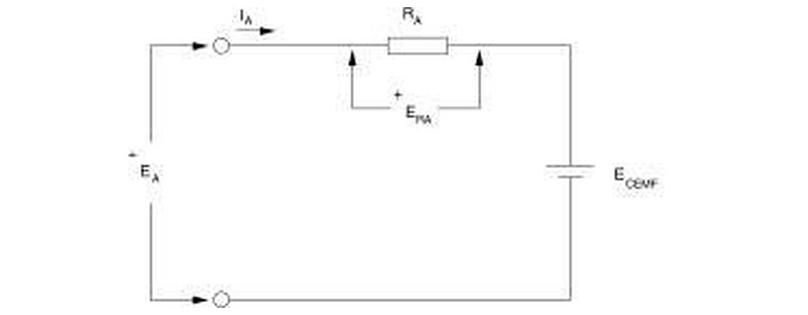
Figure 1: Simplified equivalent circuit of the armature of a DC motor (redrawn from the Laboratory 2 manual, Figure 7 [2]).
Applying Kirchhoff's voltage law around the armature loop gives:
Eₐ = Eᴄᴇᴍᶠ + Eᴿᴬ = Eᴄᴇᴍᶠ + Iₐ Rₐ (1)
The induced voltage is proportional to the speed, and the developed torque is proportional to the armature current, provided the field flux is held constant:
n = K₁ · Eᴄᴇᴍᶠ (2)
T = K₂ · Iₐ (3)
where K₁ is expressed in r/min/V and K₂ in N·m/A. Combining equations (1) and (2) gives the loaded speed of the machine directly in terms of quantities that can be measured at its terminals:
n = K₁ (Eₐ − Iₐ Rₐ) (4)

2.3 Speed droop under mechanical load
Equation (4) predicts the behaviour of the machine when the armature voltage is held constant and the mechanical load is increased. A larger load demands a larger torque, and by equation (3) a larger armature current. The ohmic drop IₐRₐ therefore rises, less of the applied voltage remains available as back-EMF, and the speed falls. This progressive reduction of speed with load is referred to as speed droop, and it is quantified by the speed regulation:
%SR = (n_no-load − n_full-load) / n_full-load × 100 % (5)
For an ideal machine with constant Rₐ the droop is linear in Iₐ, with a gradient of −K₁Rₐ r/min per ampere.

2.4 Why the armature resistance cannot be measured with an ohmmeter
The resistance presented by the armature circuit includes the contact resistance of the carbon brushes, which is strongly non-linear: the voltage dropped across a brush contact is closer to a fixed value than to a quantity proportional to current. An ohmmeter injects a very small test current, so the fixed brush drop dominates the measurement and the resistance is grossly over-read [2]. The accepted alternative is the direct-current volt-ampere method, in which the field winding is left unexcited so that no flux and therefore no back-EMF is produced, the rotor is prevented from turning, and the armature voltage required to circulate the rated armature current is measured. Under those conditions Eᴄᴇᴍᶠ = 0 and equation (1) reduces to:
Rₐ = Eₐ / Iₐ (6)
The validity of this method rests on the test being carried out at, or close to, the rated armature current. This point is returned to in Section 7.4, because it proved to be the dominant source of error in the present work.

3.0 Equipment and Circuit Configuration

3.1 Equipment
Model | Description | Qty
8134 | EMS Workstation | 1
8211 | DC Motor / Generator | 1
8311 | Resistive Load | 1
8942 | Timing Belt | 1
8960 | Prime Mover and Dynamometer Module | 1
8821 | Power Supply | 1
8951 | Connection Leads | as required
9063 | Data Acquisition Interface (DAI) | 1
— | LVDAM-EMS software (Metering, Data Table and Graph windows) | 1
Table 1: Equipment used in the Laboratory 2 exercise.

The data acquisition interface was configured with a scale of 800 V / 6 A on a 50 Hz network, as shown in the status bar of every recorded screen capture in Appendix A.

3.2 Circuit configuration
The armature of the DC Motor/Generator was supplied from the variable DC output of the 8821 Power Supply through current input I1 of the data acquisition interface, with voltage input E1 connected across the armature terminals. The shunt field winding was supplied from the fixed DC output through current input I2, in series with the DC motor rheostat, so that the field current could be trimmed independently of the armature voltage. The machine was mechanically coupled to the 8960 dynamometer through a timing belt, with the dynamometer configured as a brake so that the shaft torque and speed could be measured directly.
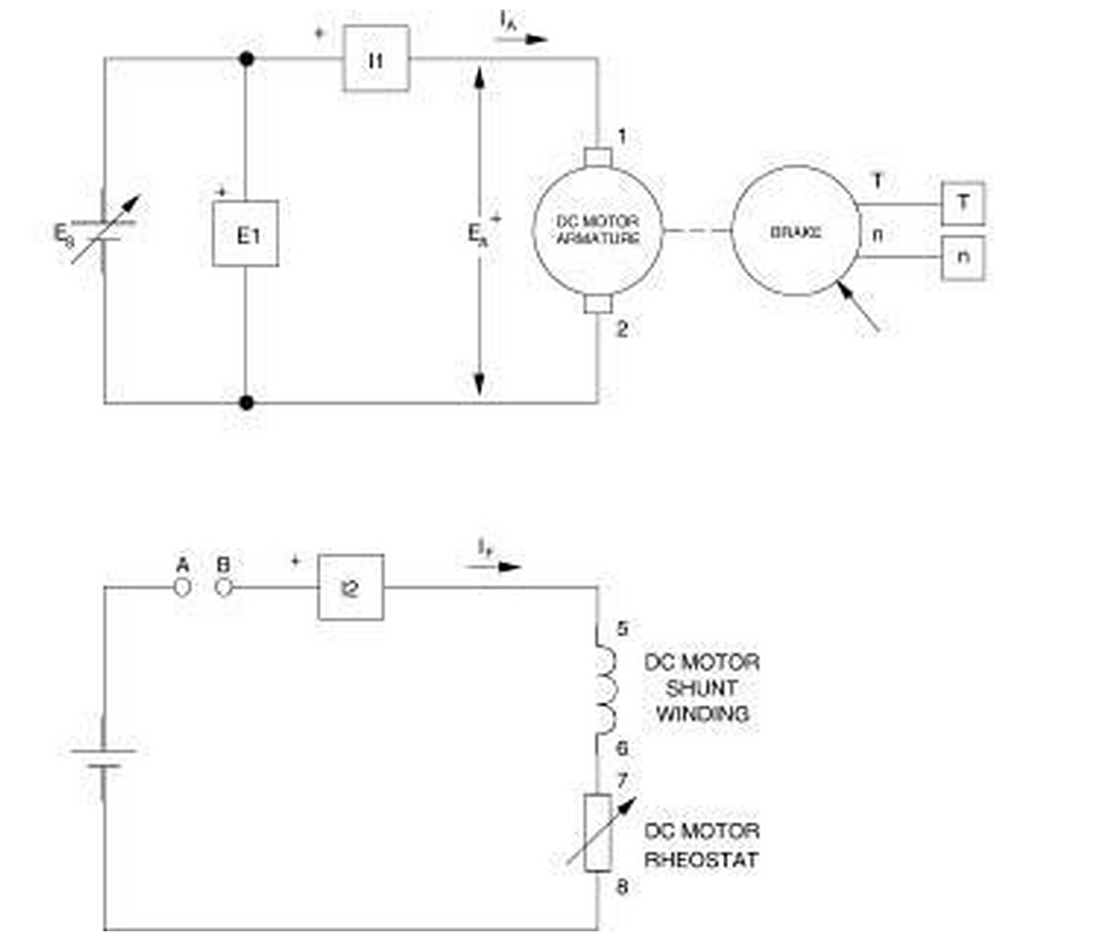
Figure 2: Separately-excited DC motor coupled to a brake (redrawn from the Laboratory 2 manual, Figure 13 [2]). Points A and B were left open for the armature resistance test and interconnected for all subsequent measurements.

4.0 Method
The procedure of the Laboratory 2 manual was followed. The principal steps are summarised below; every quantitative result reported in Section 5 is supported by the corresponding screen capture reproduced in Appendix A.
- Brush neutral alignment. Before any measurement, an AC source was connected to the armature and the brush adjustment lever was set so that the voltage induced in the shunt winding, displayed by meter E1, was a minimum. This places the brushes on the magnetic neutral axis and minimises sparking and induced circulating currents.
- Armature resistance (step 7). With the circuit open at points A and B, so that the field winding carried no current, the armature voltage was raised until the armature current reached the test value. The armature voltage and current were then recorded.
- Speed versus armature voltage (steps 9–13). Points A and B were interconnected, the brake torque was set to minimum and the field rheostat was adjusted to give a field current of 210 mA. The armature voltage was then raised in nominal 5 % increments from zero to 100 % of the supply range, allowing the speed to settle at each step before recording. The data were stored as data table DT211 and plotted as graph G211.
- Torque versus armature current (steps 14–18). The data table was cleared, the field current was re-checked, and the armature voltage was set to give a no-load speed of 1500 r/min. That armature voltage was then held constant while the brake torque was increased in nominal 0.1 N·m increments, the armature voltage being re-trimmed after each increment. The data were stored as data table DT212 and plotted as graph G212.
- Speed droop (steps 19–21). The measured armature resistance and voltage-to-speed constant were used to predict the speed at three specified armature currents. The recorded DT212 data were then re-plotted as speed against armature current (G212-1) and speed against torque (G212-2) for comparison with the prediction.

5.0 Results

5.1 Armature resistance
With the field winding de-energised the meter readings reproduced in Figure 3 were obtained. The field current of 0.001 A confirms that the stator was unexcited.
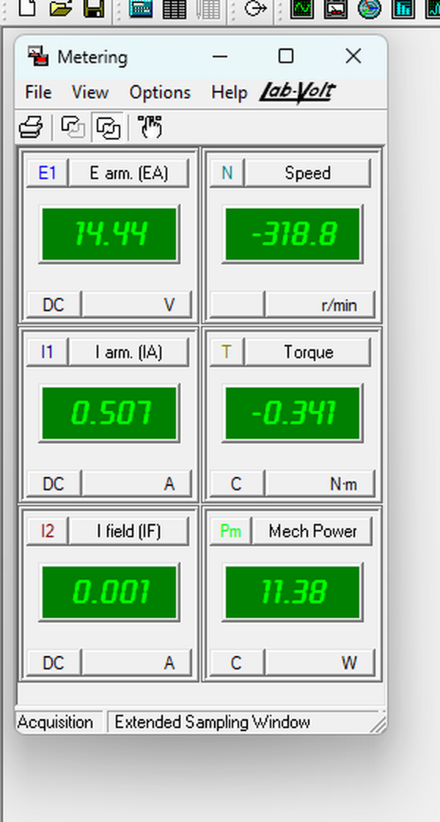
Figure 3: Metering window during the armature resistance test (step 7), recorded at 08:58 on 2 September 2026.
Quantity | Meter | Reading
Armature voltage Eₐ | E arm. (EA) | 14.44 V
Armature current Iₐ | I arm. (IA) | 0.507 A
Field current IＦ | I field (IF) | 0.001 A
Shaft speed n | Speed | −318.8 r/min
Shaft torque T | Torque | −0.341 N·m
Table 2: Meter readings recorded during the armature resistance measurement.

Applying equation (6):
Rₐ = Eₐ / Iₐ = 14.44 / 0.507 = 28.48 Ω (7)
The armature resistance is therefore reported as 28.48 Ω. Two features of this measurement require comment and are examined in Section 7.4: the test current of 0.507 A, and the fact that the speed meter indicated −318.8 r/min rather than zero.

5.2 Motor speed versus armature voltage (DT211 and G211)
The no-load data recorded in data table DT211 are reproduced in Table 3. The field current held steady at 0.20–0.21 A throughout, and the armature current remained below 0.3 A, confirming that the machine was effectively unloaded.
# | Eₐ (V) | Iₐ (A) | IＦ (A) | P_IN (W) | T (N·m) | n (r/min)
0 | 0.43 | 0.01 | 0.21 | 0.01 | 0.00 | 0.08
1 | 26.03 | 0.18 | 0.20 | 4.64 | 0.21 | 126.00
2 | 53.17 | 0.20 | 0.20 | 10.58 | 0.23 | 285.97
3 | 82.58 | 0.22 | 0.20 | 18.55 | 0.25 | 459.05
4 | 108.93 | 0.24 | 0.20 | 26.46 | 0.26 | 614.33
5 | 136.59 | 0.26 | 0.20 | 35.54 | 0.28 | 779.98
6 | 160.82 | 0.27 | 0.20 | 43.20 | 0.29 | 922.85
7 | 187.72 | 0.27 | 0.20 | 52.12 | 0.30 | 1083.56
8 | 213.66 | 0.28 | 0.20 | 61.09 | 0.31 | 1240.19
9 | 239.94 | 0.29 | 0.20 | 70.42 | 0.32 | 1394.89
10 | 271.14 | 0.29 | 0.20 | 80.62 | 0.33 | 1581.36
Table 3: Data table DT211 — motor speed as a function of armature voltage at no load (IＦ = 210 mA).

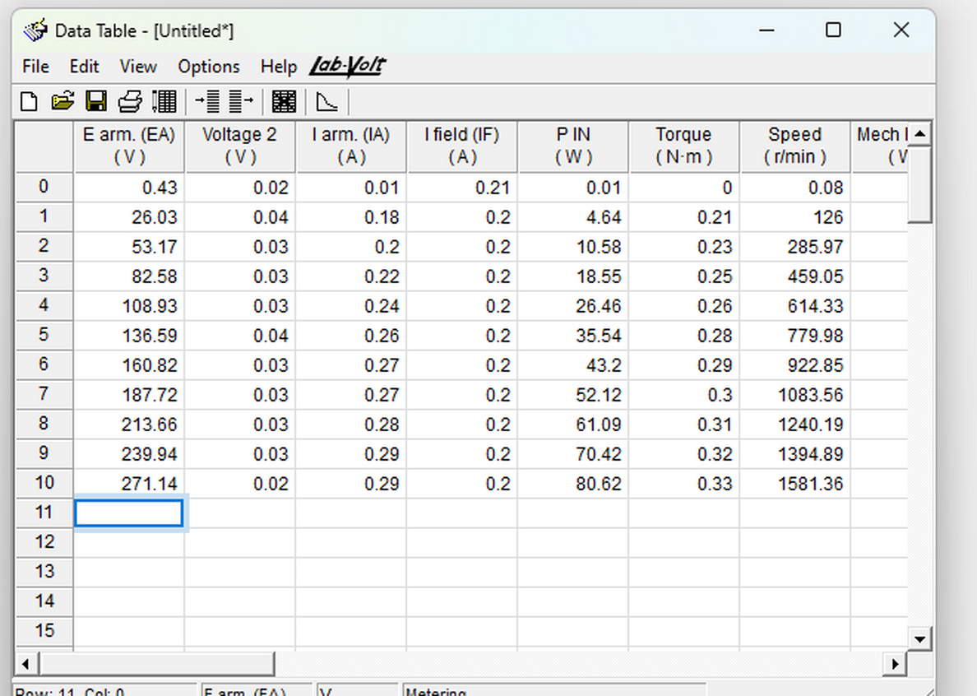
Figure 4: Data table DT211 as recorded in LVDAM-EMS at 09:11 on 2 September 2026.
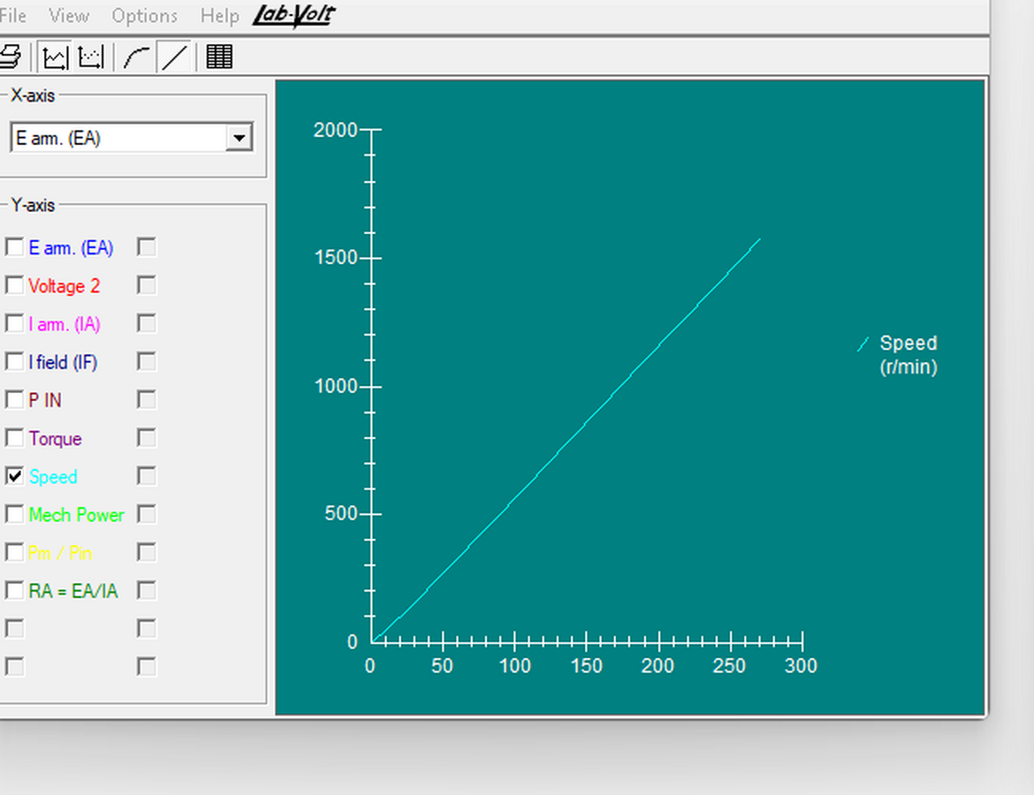
Figure 5: Graph G211 — DC motor speed as a function of armature voltage, plotted in LVDAM-EMS.
The characteristic is a straight line passing close to the origin. Using the two end points of the data table as directed in step 13:
K₁ = Δn / ΔEₐ = (1581.36 − 0.08) / (271.14 − 0.43) = 5.841 r/min/V (8)
A least-squares regression through all eleven points gives a gradient of 5.893 r/min/V with a coefficient of determination of R² = 0.9998, confirming that the relationship is linear to within the resolution of the instrumentation. The value K₁ = 5.841 r/min/V obtained by the two-point method is used in all subsequent calculations, as required by the laboratory procedure.

5.3 Motor torque versus armature current (DT212 and G212)
The armature voltage required to produce a no-load speed of 1500 r/min was recorded in step 14 as:
Eₐ = 255.73 V at n = 1500 r/min (9)
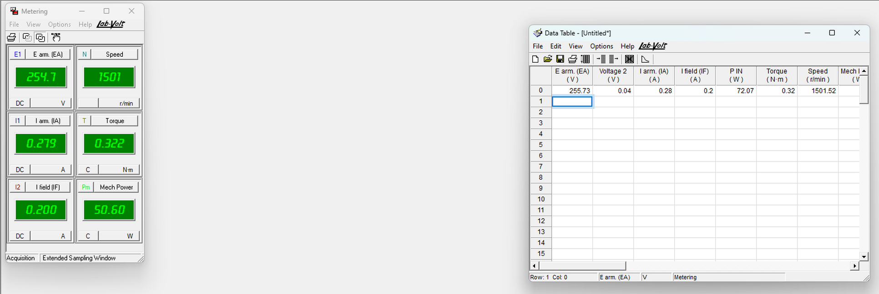
Figure 6: Metering and data table windows at step 14, showing the armature voltage of 255.73 V corresponding to a no-load speed of 1501.52 r/min (09:23 on 2 September 2026).
The brake torque was then increased in increments while the armature voltage was held at this value. Forty operating points were recorded, reproduced in Table 4.
# | Eₐ (V) | Iₐ (A) | IＦ (A) | P_IN (W) | T (N·m) | n (r/min) | Pₘ (W) | η (%)
0 | 255.73 | 0.28 | 0.20 | 72.07 | 0.32 | 1501.52 | 50.63 | 70.24
1 | 252.74 | 0.28 | 0.20 | 72.46 | 0.35 | 1499.06 | 54.47 | 75.18
2 | 252.88 | 0.32 | 0.20 | 82.10 | 0.40 | 1492.44 | 62.75 | 76.43
3 | 252.91 | 0.36 | 0.20 | 92.74 | 0.46 | 1477.29 | 70.70 | 76.24
4 | 252.82 | 0.40 | 0.20 | 103.38 | 0.52 | 1462.26 | 78.88 | 76.30
5 | 252.64 | 0.43 | 0.20 | 110.49 | 0.56 | 1462.12 | 84.98 | 76.91
6 | 252.50 | 0.47 | 0.20 | 119.75 | 0.61 | 1461.53 | 92.62 | 77.35
7 | 252.44 | 0.50 | 0.20 | 128.67 | 0.66 | 1453.14 | 100.11 | 77.80
8 | 252.28 | 0.56 | 0.20 | 142.74 | 0.73 | 1443.73 | 109.92 | 77.01
9 | 252.37 | 0.60 | 0.20 | 152.52 | 0.78 | 1453.51 | 118.97 | 78.00
10 | 251.95 | 0.65 | 0.20 | 164.77 | 0.84 | 1438.24 | 127.22 | 77.21
11 | 251.71 | 0.69 | 0.20 | 174.33 | 0.89 | 1441.41 | 134.81 | 77.33
12 | 251.65 | 0.73 | 0.20 | 185.93 | 0.95 | 1439.30 | 142.64 | 76.72
13 | 251.17 | 0.77 | 0.20 | 195.62 | 0.99 | 1432.59 | 149.13 | 76.23
14 | 251.27 | 0.84 | 0.20 | 211.36 | 1.07 | 1427.05 | 160.62 | 75.99
15 | 251.19 | 0.88 | 0.20 | 223.62 | 1.14 | 1433.82 | 170.65 | 76.31
16 | 250.96 | 0.93 | 0.20 | 234.92 | 1.19 | 1422.61 | 176.57 | 75.16
17 | 250.80 | 0.97 | 0.20 | 244.95 | 1.23 | 1425.06 | 183.92 | 75.08
18 | 250.97 | 1.02 | 0.20 | 256.36 | 1.28 | 1425.09 | 191.56 | 74.72
19 | 250.70 | 1.16 | 0.20 | 293.23 | 1.44 | 1417.57 | 214.18 | 73.04
20 | 250.31 | 1.27 | 0.20 | 319.21 | 1.54 | 1418.89 | 228.91 | 71.71
21 | 250.32 | 1.33 | 0.20 | 335.22 | 1.60 | 1415.50 | 237.08 | 70.72
22 | 250.11 | 1.38 | 0.20 | 346.00 | 1.64 | 1419.54 | 243.54 | 70.39
23 | 249.97 | 1.46 | 0.20 | 365.99 | 1.71 | 1409.04 | 251.80 | 68.80
24 | 249.83 | 1.50 | 0.20 | 376.53 | 1.75 | 1412.45 | 258.13 | 68.56
25 | 249.51 | 1.59 | 0.20 | 399.02 | 1.81 | 1405.96 | 266.49 | 66.79
26 | 249.35 | 1.63 | 0.20 | 409.19 | 1.85 | 1411.35 | 273.04 | 66.73
27 | 249.11 | 1.68 | 0.20 | 419.81 | 1.88 | 1410.48 | 278.37 | 66.31
28 | 248.88 | 1.76 | 0.20 | 438.85 | 1.93 | 1393.70 | 281.89 | 64.23
29 | 248.85 | 1.82 | 0.20 | 454.61 | 1.98 | 1409.10 | 292.67 | 64.38
30 | 248.41 | 1.90 | 0.20 | 474.41 | 2.04 | 1399.07 | 298.61 | 62.94
31 | 248.35 | 1.98 | 0.20 | 493.69 | 2.08 | 1396.34 | 303.93 | 61.56
32 | 248.15 | 2.07 | 0.20 | 516.25 | 2.14 | 1396.23 | 313.18 | 60.66
33 | 247.78 | 2.26 | 0.19 | 561.79 | 2.24 | 1358.41 | 318.99 | 56.78
34 | 247.34 | 2.42 | 0.20 | 600.14 | 2.34 | 1347.34 | 330.37 | 55.05
35 | 246.97 | 2.58 | 0.19 | 638.68 | 2.43 | 1317.12 | 334.89 | 52.43
36 | 246.54 | 2.77 | 0.19 | 684.38 | 2.52 | 1284.36 | 338.83 | 49.51
37 | 245.75 | 3.05 | 0.19 | 752.96 | 2.57 | 1133.84 | 305.09 | 40.52
38 | 244.39 | 3.59 | 0.19 | 880.53 | 2.87 | 1147.08 | 344.38 | 39.11
39 | 243.25 | 3.95 | 0.19 | 965.66 | 2.96 | 1079.88 | 334.94 | 34.68
Table 4: Data table DT212 — torque, speed and power as a function of armature current at a nominally constant armature voltage of 255.73 V.

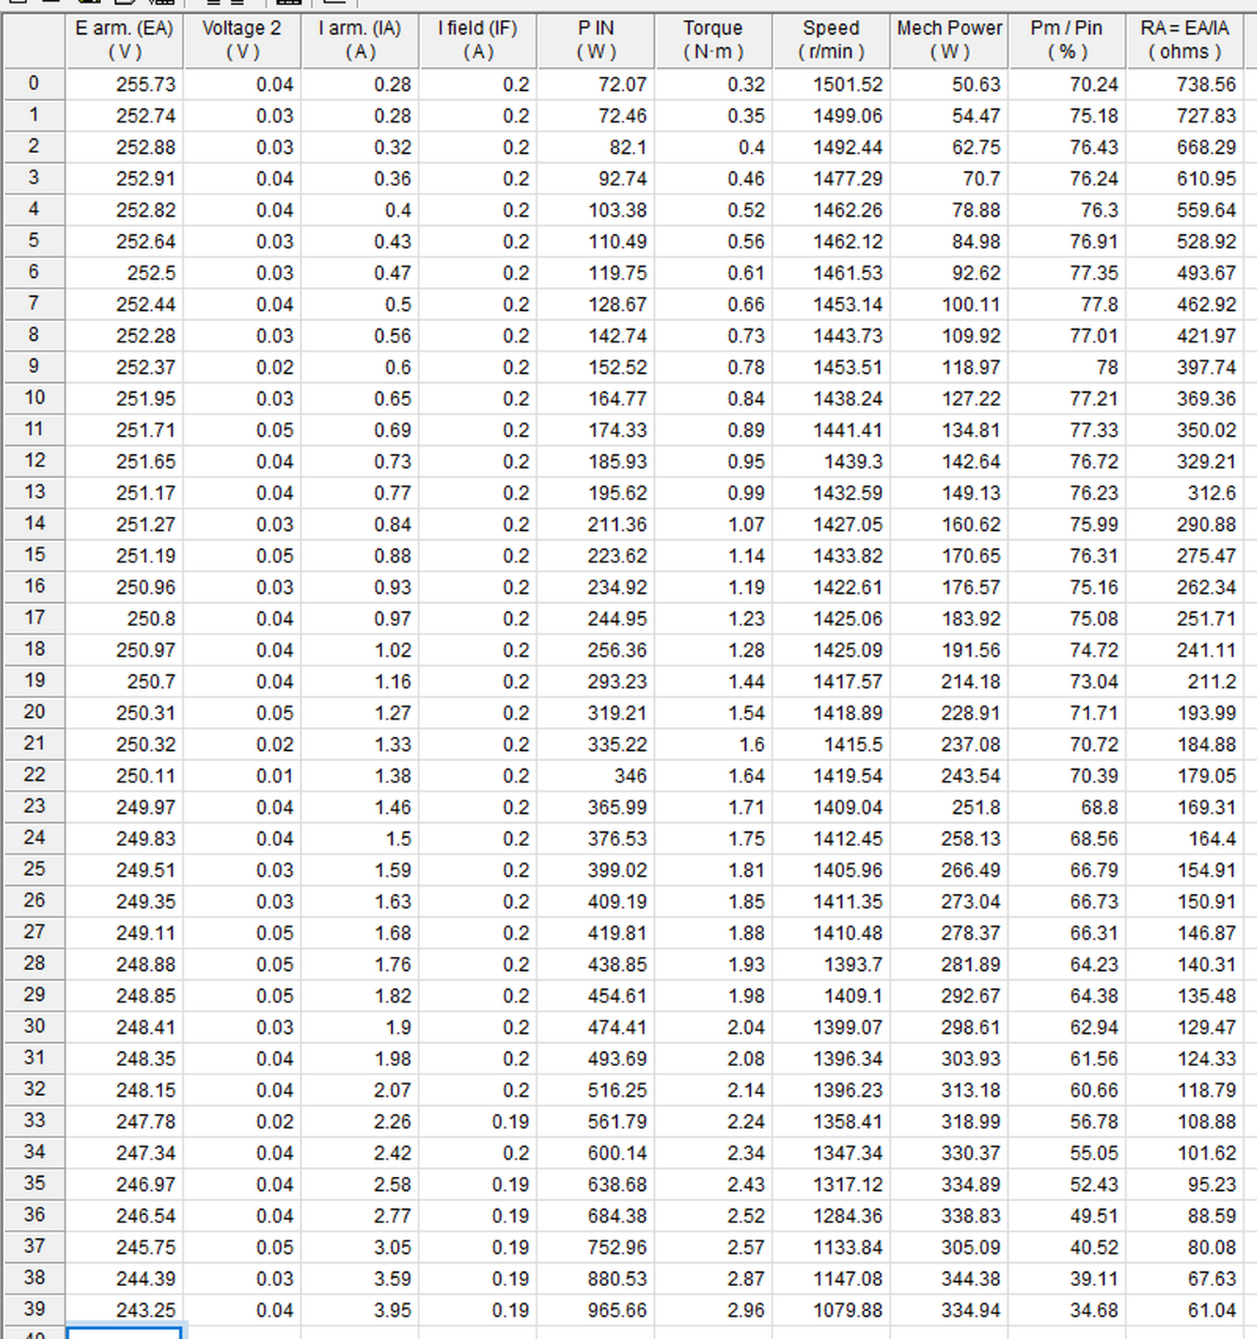
Figure 7: Data table DT212 as recorded in LVDAM-EMS at 09:31 on 2 September 2026 (all forty operating points).
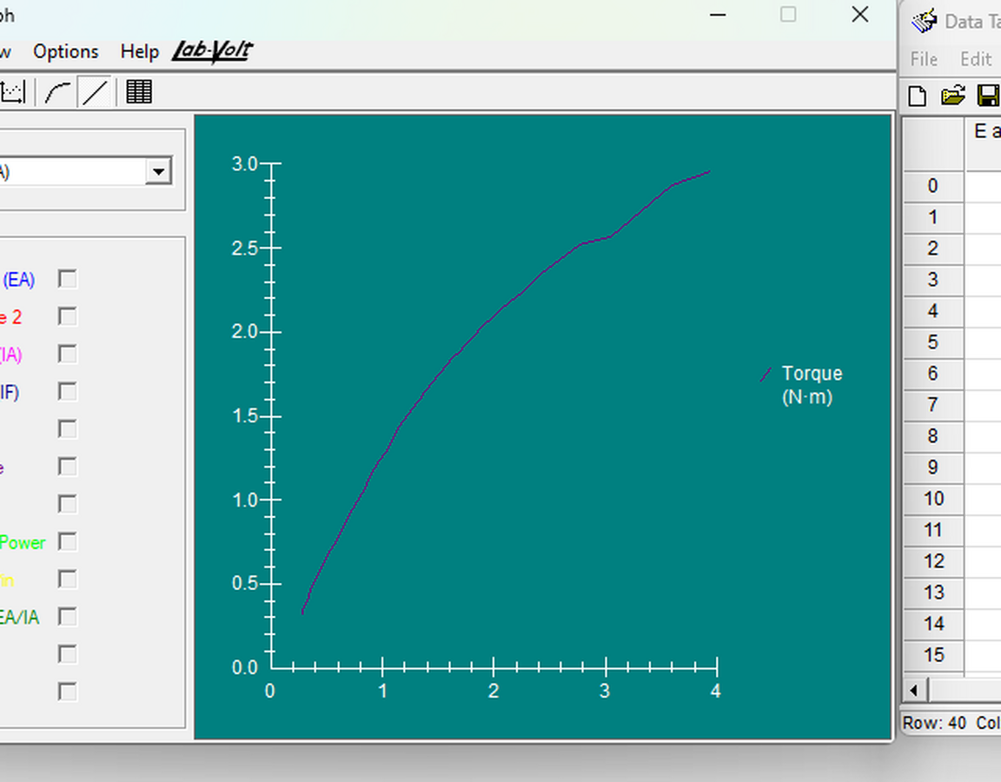
Figure 8: Graph G212 — DC motor torque as a function of armature current, plotted in LVDAM-EMS.
The characteristic is linear at low current but bends progressively away from the straight line as the current rises. Taking the two end points of the linear portion, which extends to approximately 1.5 A:
K₂ = ΔT / ΔIₐ = (1.75 − 0.32) / (1.50 − 0.28) = 1.172 N·m/A (10)
The sensitivity of this constant to the range chosen for the fit is summarised in Table 5.
Fit range | Points | K₂ (N·m/A) | R²
Iₐ ≤ 1.00 A | 18 | 1.295 | 0.9980
Iₐ ≤ 1.50 A | 25 | 1.164 | 0.9943
Iₐ ≤ 2.00 A | 32 | 1.049 | 0.9881
All 40 points | 40 | 0.780 | 0.9438
Table 5: Least-squares current-to-torque constant for different fit ranges, showing the loss of linearity as the upper limit is extended.

5.4 Speed as a function of armature current and torque (G212-1 and G212-2)
Graph G212-2, speed against torque, was plotted in LVDAM-EMS and is reproduced in Figure 9. Graph G212-1, speed against armature current, was not captured during the laboratory session; it has therefore been re-plotted in Figure 10 directly from the forty recorded points of data table DT212, which are listed in full in Table 4 and evidenced by the screen capture in Figure 7.
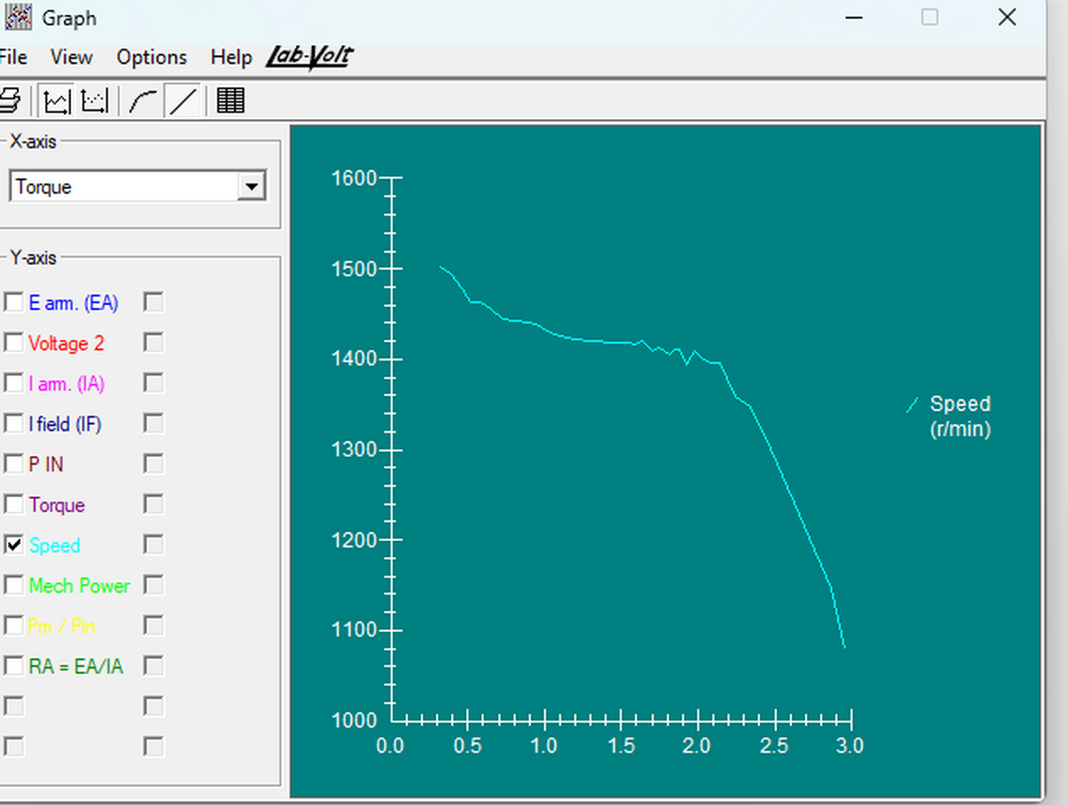
Figure 9: Graph G212-2 — DC motor speed as a function of developed torque, plotted in LVDAM-EMS at 09:48 on 2 September 2026.
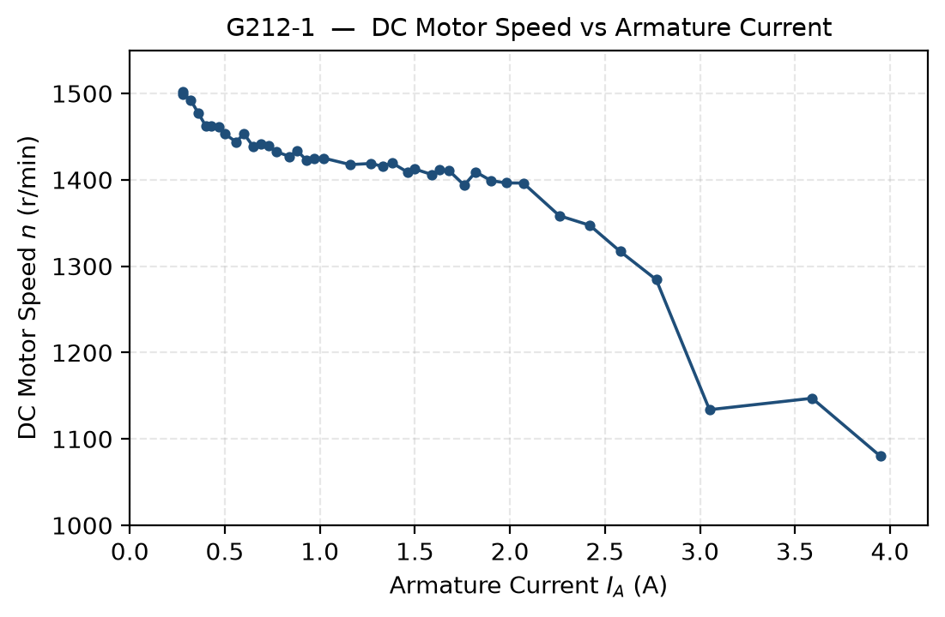
Figure 10: Graph G212-1 — DC motor speed as a function of armature current, re-plotted from the recorded DT212 data.
Both characteristics fall monotonically: the speed decreases steadily as either the armature current or the developed torque increases, in the manner anticipated by equation (4).

5.5 Predicted speed droop (step 19)
Using the measured armature resistance Rₐ = 28.48 Ω, the voltage-to-speed constant K₁ = 5.841 r/min/V and the armature voltage Eₐ = 255.73 V recorded in step 14, the speed was predicted at the three specified armature currents from Eᴿᴬ = IₐRₐ, Eᴄᴇᴍᶠ = Eₐ − Eᴿᴬ and n = K₁Eᴄᴇᴍᶠ.
Local AC network | 240 Vᴀᴄ | 240 Vᴀᴄ | 240 Vᴀᴄ
Armature current Iₐ (A) | 0.5 | 1.0 | 1.5
Eᴿᴬ (V) | 14.24 | 28.48 | 42.72
Eᴄᴇᴍᶠ (V) | 241.49 | 227.25 | 213.01
n (r/min) | 1410.6 | 1327.4 | 1244.2
Table 6: Table 1 of the laboratory manual — predicted armature circuit voltages and motor speed at three armature currents.

6.0 Answers to Review Questions
The Laboratory 2 manual poses two distinct sets of questions: those embedded in the procedure itself, which are answered from the data recorded at that point in the exercise, and the five multiple-choice review questions printed at the end of the exercise. Both sets are answered below.

6.1 Questions embedded in the experimental procedure

6.1.1 Step 12 — relationship between armature voltage and speed
Graph G211 shows that the motor speed is directly proportional to the armature voltage. The characteristic is a straight line through, or very close to, the origin: a least-squares fit over the full range from 0.43 V to 271.14 V returns R² = 0.9998 with an intercept of only -21.8 r/min, which is less than 1.4 % of the maximum speed recorded.
The graph does confirm that, under no-load conditions and with the field current held constant, the separately-excited DC motor behaves as a linear voltage-to-speed converter: a higher armature voltage produces a proportionally higher speed, with a conversion gain of K₁ = 5.841 r/min/V. Physically this follows from equations (1) and (2): at no load the armature current is small, so the ohmic drop IₐRₐ is negligible, Eᴄᴇᴍᶠ is very nearly equal to Eₐ, and the speed is therefore proportional to the applied armature voltage.

6.1.2 Step 17 — relationship between armature current and torque
Provided the armature current does not exceed the nominal value, the developed torque is directly proportional to the armature current. Over the range up to 1.5 A a least-squares fit returns a gradient of 1.164 N·m/A with R² = 0.9943, and the two-point calculation required by step 18 gives K₂ = 1.172 N·m/A. Within this range the machine is therefore confirmed to act as a linear current-to-torque converter, with a larger armature current producing a proportionally larger torque.
Beyond approximately 1.5 A the measured torque falls increasingly short of the value the linear model predicts, as Figure 8 and Figure 11 both show. At the highest current recorded, 3.95 A, the measured torque of 2.96 N·m is 36 % below the linear extrapolation. This departure is the expected consequence of armature reaction, which is discussed in Section 7.2.

6.1.3 Step 19 — predicted variation of back-EMF and speed with armature current
The calculations summarised in Table 6 show that both the back-EMF and the speed should fall linearly as the armature current increases. The armature voltage is fixed, so every additional ampere of armature current adds IₐRₐ to the ohmic drop and removes the same amount from the back-EMF: with Rₐ = 28.48 Ω the back-EMF is predicted to fall by 28.48 V per ampere. Because the speed is proportional to the back-EMF through K₁, the predicted speed falls by K₁Rₐ = 166 r/min per ampere. Over the range tabulated, the back-EMF is predicted to fall from 241.49 V to 213.01 V and the speed from 1410.6 r/min to 1244.2 r/min.

6.1.4 Step 20 — comparison with measurement and physical explanation
Graph G212-1 (Figure 10) confirms the direction of the prediction. The measured speed decreases monotonically as the armature current increases, from 1501.52 r/min at 0.28 A to 1079.88 r/min at 3.95 A, so the qualitative prediction made in step 19 is supported by the measurements.
The magnitude of the droop, however, is considerably smaller than predicted. At an armature current of 1.5 A the model predicts 1244.2 r/min whereas 1412.45 r/min was measured. Comparing gradients rather than individual points, the model over-predicts the rate of speed loss by a factor of 2.6. This discrepancy is analysed in Section 7.3, where it is attributed to the armature resistance measurement rather than to any failure of the model itself.
The physical cause of the speed reduction is the ohmic voltage drop across the armature resistance. When the brake torque is increased the motor must develop more torque, and by equation (3) it draws a proportionally larger armature current. Since the armature supply voltage is held constant, the increased drop IₐRₐ across the armature resistance leaves a smaller voltage available as back-EMF. The back-EMF is the quantity that sets the speed, so the machine settles at a lower speed. Equilibrium is reached when the speed has fallen far enough for the back-EMF to allow exactly the armature current needed to balance the applied load torque.

6.2 End-of-exercise review questions
The five multiple-choice review questions printed at the end of the exercise are reproduced below with the selected answer and the reasoning behind it. Where the question relates to a quantity measured in this exercise, the supporting measurement is cited. Table 7 summarises the selected answers.
Q | Answer | Basis
1 | (a) A linear relationship | G211 is a straight line; R² = 0.9998
2 | (a) A linear relationship | G212 is linear below nominal current; R² = 0.9943
3 | (c) The armature resistance | The volt-ampere method of step 7
4 | (b) It decreases | Measured droop 1501.52 → 1079.88 r/min
5 | (b) 995 r/min and 875 r/min | n = K₁(Eₐ − IₐRₐ) evaluated at 2 A and 50 A
Table 7: Summary of answers to the end-of-exercise review questions.

6.2.1 Question 1 — speed and armature voltage
What kind of relationship exists between the speed and armature voltage of a separately-excited dc motor? (a) A linear relationship. (b) A parabolic relationship. (c) An exponential relationship. (d) The speed of the motor is independent of the applied voltage.
Answer: (a) A linear relationship.
With the field current held constant the flux is constant, so the induced voltage is proportional to speed through n = K₁Eᴄᴇᴍᶠ. At no load the armature current is small and the ohmic drop IₐRₐ is negligible, so Eᴄᴇᴍᶠ ≈ Eₐ and the speed is therefore proportional to the armature voltage. This was confirmed directly by the measurements of Section 5.2: graph G211 (Figure 5) is a straight line and a least-squares fit through all eleven points returns R² = 0.9998, with no measurable curvature that would indicate a parabolic or exponential law. Option (d) is contradicted by the data, in which the speed rose from 0.08 r/min to 1581.36 r/min as the armature voltage was raised.

6.2.2 Question 2 — torque and armature current
What kind of relationship exists between the torque and armature current of a separately-excited dc motor as long as the armature current does not exceed the nominal value? (a) A linear relationship. (b) A parabolic relationship. (c) An exponential relationship. (d) The motor torque is independent of the current.
Answer: (a) A linear relationship.
The developed torque is proportional to the product of the flux and the armature current. While the field current is held constant the flux is constant, so T = K₂Iₐ with K₂ fixed. Section 5.3 confirms this: over the range up to 1.5 A a least-squares fit returns R² = 0.9943 with K₂ = 1.164 N·m/A.
The qualification in the question is essential. Once the armature current exceeds the nominal value the relationship ceases to be linear, because armature reaction reduces the net flux per pole. That is exactly what the measurements show: at 3.95 A the developed torque falls 36 % short of the linear extrapolation. The linear answer is therefore correct only within the stated restriction, and Section 7.2 examines the departure beyond it.

6.2.3 Question 3 — determination of the armature resistance
Connecting a dc source to the armature of a dc motor that operates without field current and measuring the voltage that produces nominal current flow in the armature allows which parameter of the dc motor to be determined? (a) The nominal armature current. (b) The nominal armature voltage. (c) The armature resistance. (d) The resistance of the field winding.
Answer: (c) The armature resistance.
Removing the field current removes the flux, so no back-EMF can be generated and Eᴄᴇᴍᶠ = 0. The armature loop equation Eₐ = Eᴄᴇᴍᶠ + IₐRₐ then reduces to Eₐ = IₐRₐ, and the ratio of the measured voltage to the measured current is the armature resistance. Option (d) is wrong because the field winding is deliberately not energised and carries no current, so nothing can be inferred about it. Options (a) and (b) are wrong because the nominal current and voltage are ratings of the machine that are set by its design and read from its nameplate, not results of this measurement — indeed the nominal current is an input to the test rather than an output of it.
This is precisely the method applied in Section 5.1, which returned Rₐ = 28.48 Ω. The question also highlights the condition that was not properly satisfied in this exercise: the test must be performed at the nominal armature current. Because it was carried out at 0.507 A, the result is inflated by the non-linear brush contact drop, as analysed in Section 7.4.

6.2.4 Question 4 — effect of armature current on speed
Does the speed of a separately-excited dc motor increase or decrease when the armature current increases? (a) It increases. (b) It decreases. (c) It stays the same because speed is independent of motor current. (d) The speed will oscillate around the previous value.
Answer: (b) It decreases.
At a fixed armature voltage, an increase in armature current increases the ohmic drop IₐRₐ across the armature resistance. Since Eᴄᴇᴍᶠ = Eₐ − IₐRₐ, the back-EMF must fall, and because the speed is proportional to the back-EMF the speed falls with it. The measurements of Section 5.4 confirm this without ambiguity: the speed decreased monotonically from 1501.52 r/min at 0.28 A to 1079.88 r/min at 3.95 A, a reduction of 28 %. Option (c) is contradicted by that measurement, and option (d) describes an instability that was not observed — the speed settled at a new steady value after each load increment.

6.2.5 Question 5 — numerical calculation of no-load and full-load speed
The armature resistance Rₐ and constant K₁ of a dc motor are 0.5 Ω and 5 r/min/V, respectively. A voltage of 200 V is applied to this motor. The no-load armature current is 2 A. At full load, the armature current increases to 50 A. What are the no-load and full-load speeds of the motor? (a) n_{NO LOAD} = 1005 r/min, n_{FULL LOAD} = 880 r/min. (b) n_{NO LOAD} = 995 r/min, n_{FULL LOAD} = 875 r/min. (c) n_{NO LOAD} = 1000 r/min, n_{FULL LOAD} = 875 r/min. (d) The speeds cannot be calculated without constant K₂.
Answer: (b) n_{NO LOAD} = 995 r/min, n_{FULL LOAD} = 875 r/min.
Applying equations (1) and (2) at each load condition. At no load, with Iₐ = 2 A:
Eᴿᴬ = IₐRₐ = 2 × 0.5 = 1 V (11)
Eᴄᴇᴍᶠ = Eₐ − Eᴿᴬ = 200 − 1 = 199 V (12)
n = K₁Eᴄᴇᴍᶠ = 5 × 199 = 995 r/min (13)
At full load, with Iₐ = 50 A:
Eᴿᴬ = 50 × 0.5 = 25 V (14)
Eᴄᴇᴍᶠ = 200 − 25 = 175 V (15)
n = 5 × 175 = 875 r/min (16)
Option (c) is the trap for anyone who neglects the no-load ohmic drop: taking Eᴄᴇᴍᶠ = Eₐ = 200 V gives 5 × 200 = 1000 r/min, which ignores the 1 V lost across the armature resistance even at light load. Option (d) is wrong because K₂ relates torque to current and plays no part in the speed calculation; the armature currents are given directly, so the torque constant is not required.
The speed regulation of this hypothetical machine is (995 − 875) / 875 × 100 = 13.7 %, which is markedly worse than the 6.3 % measured for the laboratory machine at 1.5 A. The comparison is instructive: the example motor drops 25 V across its armature resistance at full load out of a 200 V supply, whereas the laboratory machine at 1.5 A drops only about 8 V out of 250 V.

7.0 Analysis and Discussion

7.1 Validity of the linear voltage-to-speed model
The no-load characteristic is the cleanest result obtained in the exercise. With R² = 0.9998 across a range spanning nearly three decades of speed, there is no measurable curvature in the data, which supports the assumption that the field flux remained constant throughout. That assumption is independently corroborated by the recorded field current, which held at 0.20–0.21 A across all eleven points.
The small negative intercept of -21.8 r/min returned by the regression is physically meaningful rather than an artefact. A real machine must overcome bearing friction, brush friction and windage before it will turn at all, so a small armature voltage produces no rotation. This is visible in the data: at 0.43 V the recorded speed was 0.08 r/min, essentially stationary. The intercept is therefore an estimate of the armature voltage consumed by no-load losses, and its presence explains why the two-point value of K₁ (5.841 r/min/V) is marginally lower than the regression gradient (5.893 r/min/V). The difference of just under 1 % is immaterial to the conclusions drawn below.

7.2 Current-to-torque linearity and the onset of armature reaction
The torque characteristic is linear only over the lower part of the range tested. Table 5 shows the least-squares gradient falling steadily as the upper limit of the fit is extended, from 1.295 N·m/A below 1.0 A to 0.780 N·m/A over the full range, while the coefficient of determination degrades from 0.998 to 0.944. A gradient that depends on the range over which it is measured is the signature of a non-linear characteristic.
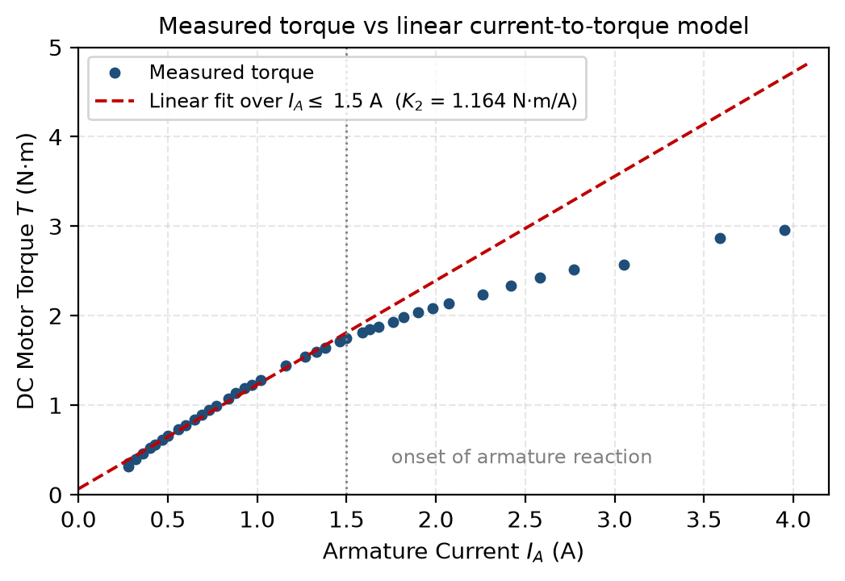
Figure 11: Measured torque compared with the linear current-to-torque model fitted below 1.5 A. The measured points fall progressively below the model as the armature current increases.
Table 8 quantifies the departure. Up to about 1.5 A the measured torque is within 3.5 % of the linear model, which is comparable with the resolution of the torque meter. Beyond that the shortfall grows rapidly and reaches 36 % at the highest current recorded.
Iₐ (A) | T measured (N·m) | T linear model (N·m) | Shortfall
1.50 | 1.75 | 1.81 | 3.4 %
1.63 | 1.85 | 1.96 | 5.7 %
1.76 | 1.93 | 2.11 | 8.7 %
1.90 | 2.04 | 2.28 | 10.4 %
2.07 | 2.14 | 2.47 | 13.5 %
2.42 | 2.34 | 2.88 | 18.8 %
2.77 | 2.52 | 3.29 | 23.4 %
3.59 | 2.87 | 4.24 | 32.4 %
Table 8: Departure of the measured torque from the linear current-to-torque model (alternate points shown).

The accepted explanation is armature reaction [1], [2]. The current flowing in the armature conductors creates a magneto-motive force of its own, which is oriented across the main field axis. Vectorially adding this cross-field to the main field distorts the resultant flux distribution, strengthening the flux at one pole tip and weakening it at the other. Because the iron near the strengthened tip is already close to magnetic saturation it cannot accept as much additional flux as is removed from the weakened tip, so the net flux per pole falls. Since the developed torque is proportional to the product of flux and armature current, a reduction of flux at high current means that torque no longer keeps pace with current, exactly as observed. The distortion also shifts the magnetic neutral axis away from the position to which the brushes were aligned at the start of the session, which degrades commutation and contributes a further small loss.
The practical significance is that the value quoted for K₂ is only meaningful if the current range over which it was determined is quoted with it. On that basis K₂ = 1.172 N·m/A is reported for Iₐ ≤ 1.5 A.

7.3 Predicted against measured speed droop
The comparison between the step 19 prediction and the corresponding measured points is the least satisfactory result of the exercise and merits careful examination.
Iₐ (A) | n predicted (r/min) | n measured (r/min) | at Iₐ (A) | Error
0.5 | 1410.6 | 1453.14 | 0.50 | -2.9 %
1.0 | 1327.4 | 1425.09 | 1.02 | -6.9 %
1.5 | 1244.2 | 1412.45 | 1.50 | -11.9 %
Table 9: Predicted speed from Table 6 compared with the nearest measured operating point in data table DT212.

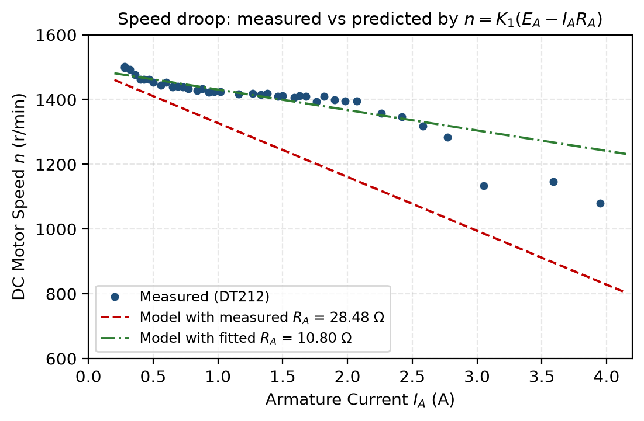
Figure 12: Measured speed droop compared with the model of equation (4), evaluated using the measured armature resistance and using a resistance fitted to the droop.
The model reproduces the shape of the characteristic but substantially exaggerates its gradient. A least-squares line fitted to the measured speed against armature current over the linear region below 1.5 A has a gradient of 63.1 r/min per ampere, whereas equation (4) with Rₐ = 28.48 Ω predicts K₁Rₐ = 166 r/min per ampere. The model is therefore a factor of 2.6 too steep.
Because equation (4) contains only two measured constants, the discrepancy must lie in one of them. K₁ is established to better than 1 % in Section 7.1, so the armature resistance is the suspect term. Treating equation (4) as a straight line in Iₐ allows an effective armature resistance to be recovered from the machine's own loaded behaviour, since the gradient of that line is −K₁Rₐ and its intercept is K₁Eₐ:
Rₐ(effective) = − (dn / dIₐ) / K₁ (17)
Applied to the 25 points below 1.5 A this returns Rₐ(effective) = 10.80 Ω, roughly 38 % of the 28.48 Ω obtained in step 7. The same regression provides a useful check on its own validity: its intercept of 1493.3 r/min corresponds to an armature voltage of 255.65 V, which agrees with the 255.73 V actually measured in step 14 to within 0.08 V. The fit therefore recovers the one parameter that is independently known, which gives confidence that the resistance it returns is also meaningful. Figure 12 shows the consequence directly: the measured points lie close to the curve computed with the smaller resistance and well above the curve computed with the step 7 value.
The scatter about this fit (R² = 0.81) is considerably larger than for the no-load characteristic. That is expected: the speed readings fluctuate by several r/min at fixed load, the armature supply voltage drifted during the run, and the field current was not perfectly constant. These effects are examined in Section 7.6. None of them is large enough to account for a factor of 2.6.

7.4 Validity of the armature resistance measurement
Two defects in the step 7 measurement account for the discrepancy identified above.
The first, and by far the more important, is the current at which the test was performed. The manual is explicit that the volt-ampere method must be carried out at the rated armature current, precisely because the brush contact drop is not proportional to current. A carbon brush contact behaves approximately as a fixed voltage drop of the order of one to two volts per brush rather than as a fixed resistance, so the apparent resistance Eₐ/Iₐ is inflated at low current and falls towards the true winding resistance as the current rises. The test was carried out at 0.507 A, whereas the torque characteristic of Section 7.2 indicates that the nominal armature current of this machine is closer to 1.5 A. The measurement was therefore made at roughly one third of the current at which it should have been made, in exactly the regime the manual warns against, and it over-reads for exactly the reason the manual gives. This is consistent in both sign and approximate magnitude with the effective resistance derived in Section 7.3.
The second defect is that the rotor was not stationary. The speed meter indicated −318.8 r/min and the torque meter −0.341 N·m, corresponding to 11.38 W of mechanical power, so the shaft was turning slowly in reverse rather than being held locked as the method requires. With the field current at 0.001 A the flux was residual only, so the back-EMF generated was small and this is a second-order effect beside the brush drop; nevertheless it means the condition Eᴄᴇᴍᶠ = 0 assumed in equation (6) was not exactly satisfied.
It should also be noted that the column headed RA = EA/IA in data table DT212 does not represent the armature resistance. That column simply divides the terminal voltage by the armature current while the machine is running and generating a back-EMF, which is why it returns values from 738 Ω down to 61 Ω. It is meaningful only under the locked-rotor, zero-flux conditions of step 7, and it has not been used anywhere in this report.
Were the exercise to be repeated, the armature resistance test should be performed at the machine's rated armature current with the rotor positively locked, and ideally repeated at several currents so that the fixed brush drop could be separated from the true ohmic resistance by extrapolation.

7.5 Energy conversion efficiency
The data acquisition software computed the ratio of mechanical output power to electrical input power for every operating point, plotted in Figure 13.
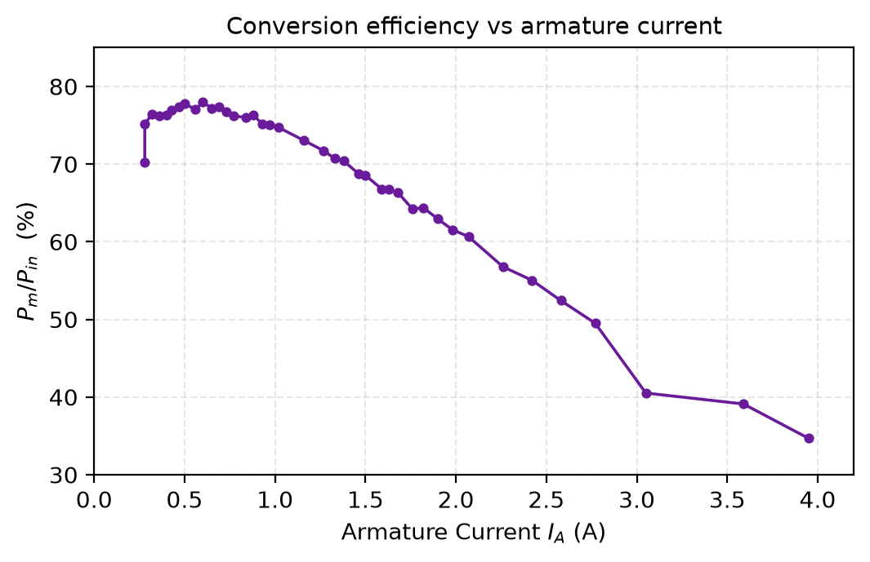
Figure 13: Ratio of mechanical output power to electrical input power as a function of armature current, computed by LVDAM-EMS from the DT212 data.
Efficiency rises steeply from 70.2 % at the lightest load, peaks at 78.0 % at an armature current of 0.60 A, and then declines steadily to 34.7 % at 3.95 A. The shape is characteristic of any electrical machine. At light load the fixed losses — friction, windage and the power dissipated in the field winding — represent a large fraction of a small input, so efficiency is poor. As load increases these fixed losses are spread over a larger output and efficiency improves. Beyond the peak the armature copper loss, which rises with the square of the armature current, comes to dominate and efficiency falls away. The peak occurs where the current-dependent losses have grown to equal the fixed losses, which for this machine is at well under half the maximum current tested.
The efficiency peak provides independent support for the conclusion of Section 7.4 that the machine was operated well beyond its rating at the top of the range. Operating at 3.95 A converted barely a third of the input power into mechanical work, the remainder being dissipated as heat, which is neither a sustainable nor a representative operating condition.

7.6 Sources of error and experimental limitations
- Armature resistance test current. Discussed in Section 7.4; this is the dominant error and propagates directly into every prediction made from equation (4).
- Drift of the armature supply voltage. Step 15 requires the armature voltage to be re-trimmed to its original value after each torque increment. In practice the recorded voltage fell steadily from 255.73 V to 243.25 V across the run, a reduction of 4.9 %. Part of the observed speed reduction is therefore attributable to falling supply voltage rather than to load. The regression used in Section 7.3 absorbs this into its intercept, which is why the armature voltage it implies (255.65 V) sits fractionally below the value set at the start of the run.
- Thermal drift. The manual advises completing the torque measurements within five minutes because the armature current exceeds its rated value. Copper resistivity rises by approximately 0.4 % per kelvin, so progressive heating of the windings during the run increases the true armature resistance as the sweep proceeds, meaning the machine did not have a single fixed Rₐ throughout.
- Field current variation. The recorded field current fell from 0.20 A to 0.19 A at the highest loads. Since both K₁ and K₂ depend on flux, this weakens the field slightly and contributes a small additional speed rise that partially masks the true droop.
- Instrument resolution. Armature current and torque were recorded to two decimal places. At the lowest torque of 0.32 N·m the quantisation alone represents about 3 % of the reading, which is why the lightest-load points scatter most about the fitted lines.
- Brush neutral alignment. The brushes were aligned at the start of the session under unloaded conditions. Armature reaction shifts the magnetic neutral axis as load increases, so the alignment is not optimal at high current and commutation degrades.
- Single measurement set. Each operating point was recorded once, so random error could not be estimated statistically. Repeating the sweep two or three times and averaging would allow uncertainty bounds to be placed on K₁ and K₂.

8.0 Conclusion
The operating characteristics of a separately-excited DC motor were measured and compared against the simplified equivalent circuit model. The principal quantitative outcomes are summarised in Table 10.
Quantity | Symbol | Result | Basis
Armature resistance | Rₐ | 28.48 Ω | Volt-ampere method at 0.507 A
Effective armature resistance | Rₐ(eff) | 10.80 Ω | Fitted to the measured speed droop
Voltage-to-speed constant | K₁ | 5.841 r/min/V | DT211 end points, R² = 0.9998
Current-to-torque constant | K₂ | 1.172 N·m/A | DT212 linear portion, Iₐ ≤ 1.5 A
Speed regulation at 1.5 A | %SR | 6.31 % | DT212
Speed regulation at 3.95 A | %SR | 39.05 % | DT212
Peak conversion efficiency | η | 78.0 % | at Iₐ = 0.60 A
Table 10: Summary of measured and derived machine parameters.

The experiment confirmed the two linear relationships on which the model rests. Under no-load conditions the speed was proportional to the armature voltage with R² = 0.9998, establishing the machine as a linear voltage-to-speed converter. At constant armature voltage the developed torque was proportional to the armature current with R² = 0.9943 for currents up to approximately 1.5 A, establishing it equally as a linear current-to-torque converter within that range.
Beyond 1.5 A the torque characteristic departed measurably from linearity, the shortfall against the linear model growing to 36 % at 3.95 A. This behaviour was identified as armature reaction, in which the cross-magnetising effect of armature current together with saturation of the pole tips reduces the net flux per pole. The measurements therefore define not only the constants of the machine but also the boundary of the range within which those constants may legitimately be applied.
The prediction of speed droop was qualitatively correct but quantitatively poor, over-estimating the rate of speed loss by a factor of 2.6. The cause was traced to the armature resistance measurement, which was performed at 0.507 A rather than at the rated armature current — a value the torque characteristic suggests lies close to 1.5 A. In that low-current regime the non-linear brush contact drop dominates the terminal measurement and inflates the apparent resistance, which is the precise effect the volt-ampere method is intended to avoid and that the manual warns against. Fitting the resistance to the machine's own loaded behaviour instead returned 10.80 Ω, and the model reproduces the measured characteristic closely when that value is used. The exercise therefore validated the equivalent circuit model itself while demonstrating that the model is only as good as the parameter measurements supplied to it.
The most valuable outcome of the laboratory was this last point. A measurement that appears entirely reasonable in isolation — a single voltage and a single current, correctly read and correctly divided — can still be substantially wrong if the conditions under which it is taken violate an assumption of the method. Cross-checking a parameter against independent data, as was done here, is what exposed the error.

9.0 References
[1] S. J. Chapman, Electric Machinery Fundamentals, 5th ed. New York, NY, USA: McGraw-Hill, 2012.
[2] School of Engineering, “Laboratory session: DC machines — DC motors,” ENS5230 Laboratory 2 manual, Edith Cowan University, Joondalup, WA, Australia, 2026.
[3] Lab-Volt Ltd., DC Motors and Generators, Electromechanical Training System. Quebec, Canada: Lab-Volt Ltd.
[4] A. E. Fitzgerald, C. Kingsley, and S. D. Umans, Electric Machinery, 6th ed. New York, NY, USA: McGraw-Hill, 2003.
[5] P. C. Sen, Principles of Electric Machines and Power Electronics, 3rd ed. Hoboken, NJ, USA: Wiley, 2013.

10.0 Acknowledgement of Generative Artificial Intelligence
[REVIEW AND EDIT THIS SECTION SO THAT IT ACCURATELY AND COMPLETELY DESCRIBES YOUR OWN USE OF AI TOOLS, THEN DELETE THIS INSTRUCTION.]
I acknowledge the use of [INSERT TOOL NAME AND VERSION NUMBER] in the preparation of this report. The tool was used for the following purposes:
- Transcribing the numerical readings from the LVDAM-EMS data table screen captures into a machine-readable form for calculation.
- Performing and checking the arithmetic and least-squares regressions reported in Sections 5 and 7.
- Producing Figure 10, Figure 11, Figure 12 and Figure 13 from the transcribed data.
- Providing feedback on the structure, clarity and grammar of the written discussion.
All laboratory measurements reported are my own, recorded during the Laboratory 2B session on 2 September 2026. I have verified every figure reproduced in this report against the original screen captures in Appendix A, and I take full responsibility for the interpretation, analysis and conclusions presented.

Appendix A — Timestamped Laboratory Recordings
The screen captures reproduced below are unmodified full-screen images taken on the laboratory computer during the Laboratory 2B session. The Windows taskbar clock and date are visible in the lower right corner of each image, as required by the assignment instructions. They are presented in the order in which they were recorded.
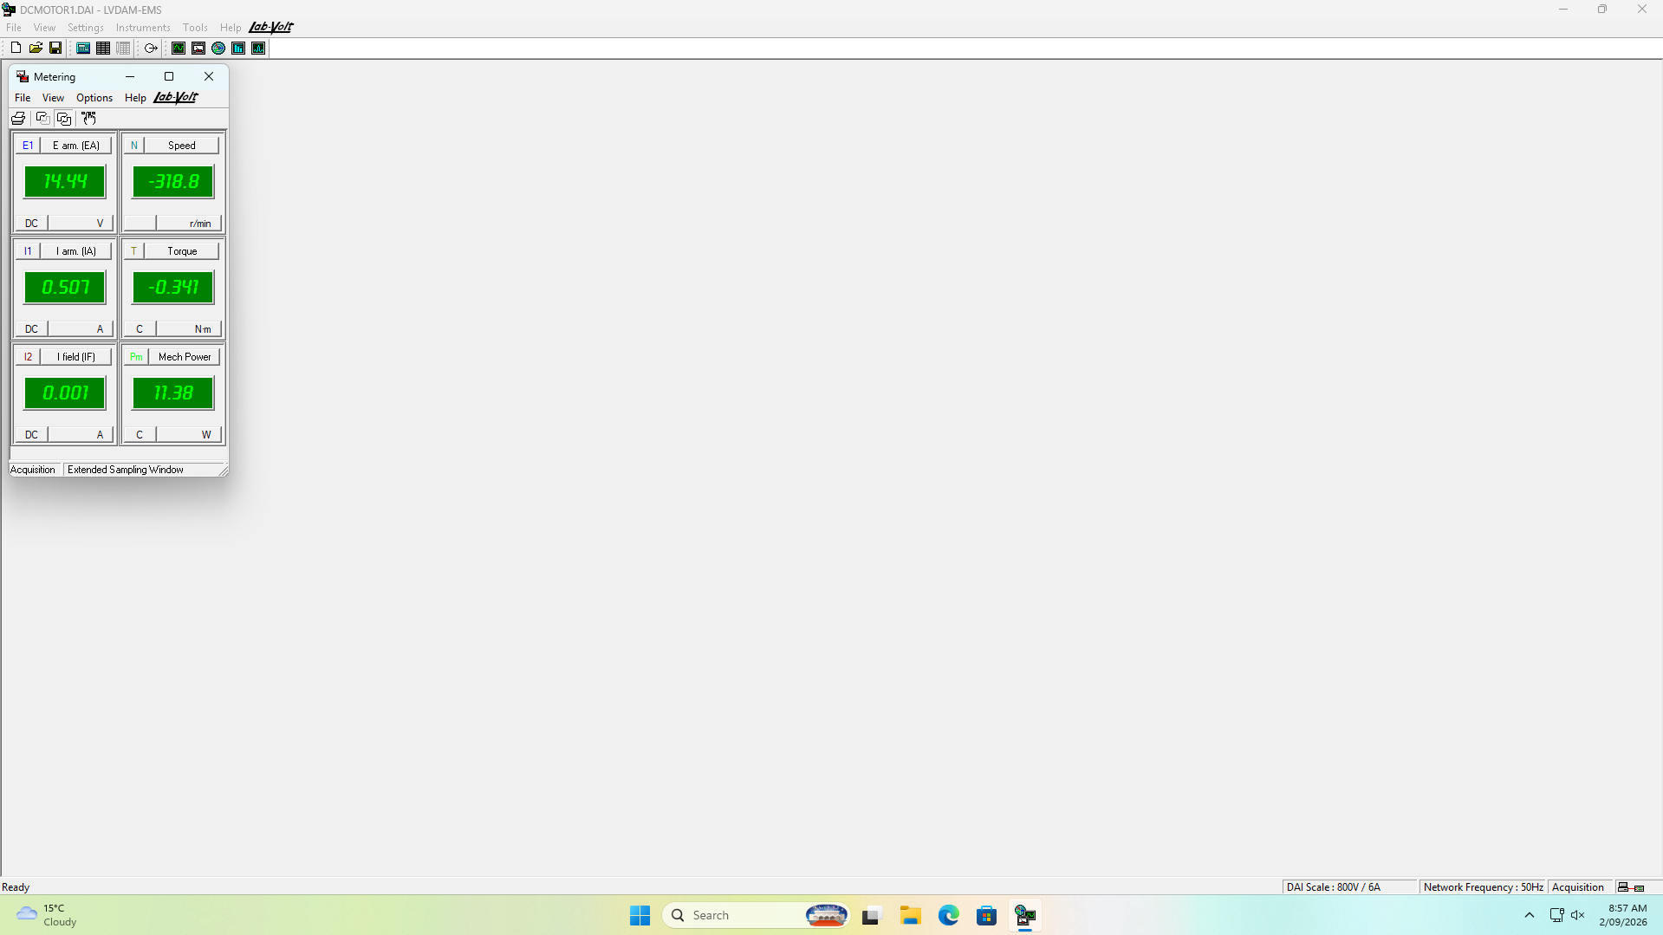
Figure 14: 08:58 — Metering window during the armature resistance test (step 7). The field current of 0.001 A confirms the stator was unexcited; E arm. 14.44 V and I arm. 0.507 A.
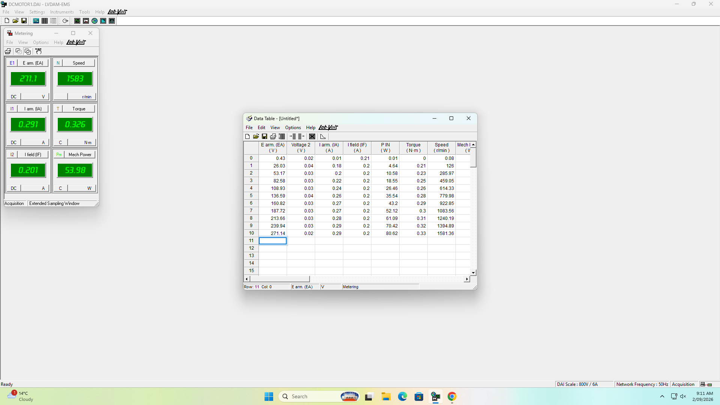
Figure 15: 09:11 — Data table DT211 complete, showing all eleven no-load operating points from 0.43 V to 271.14 V.

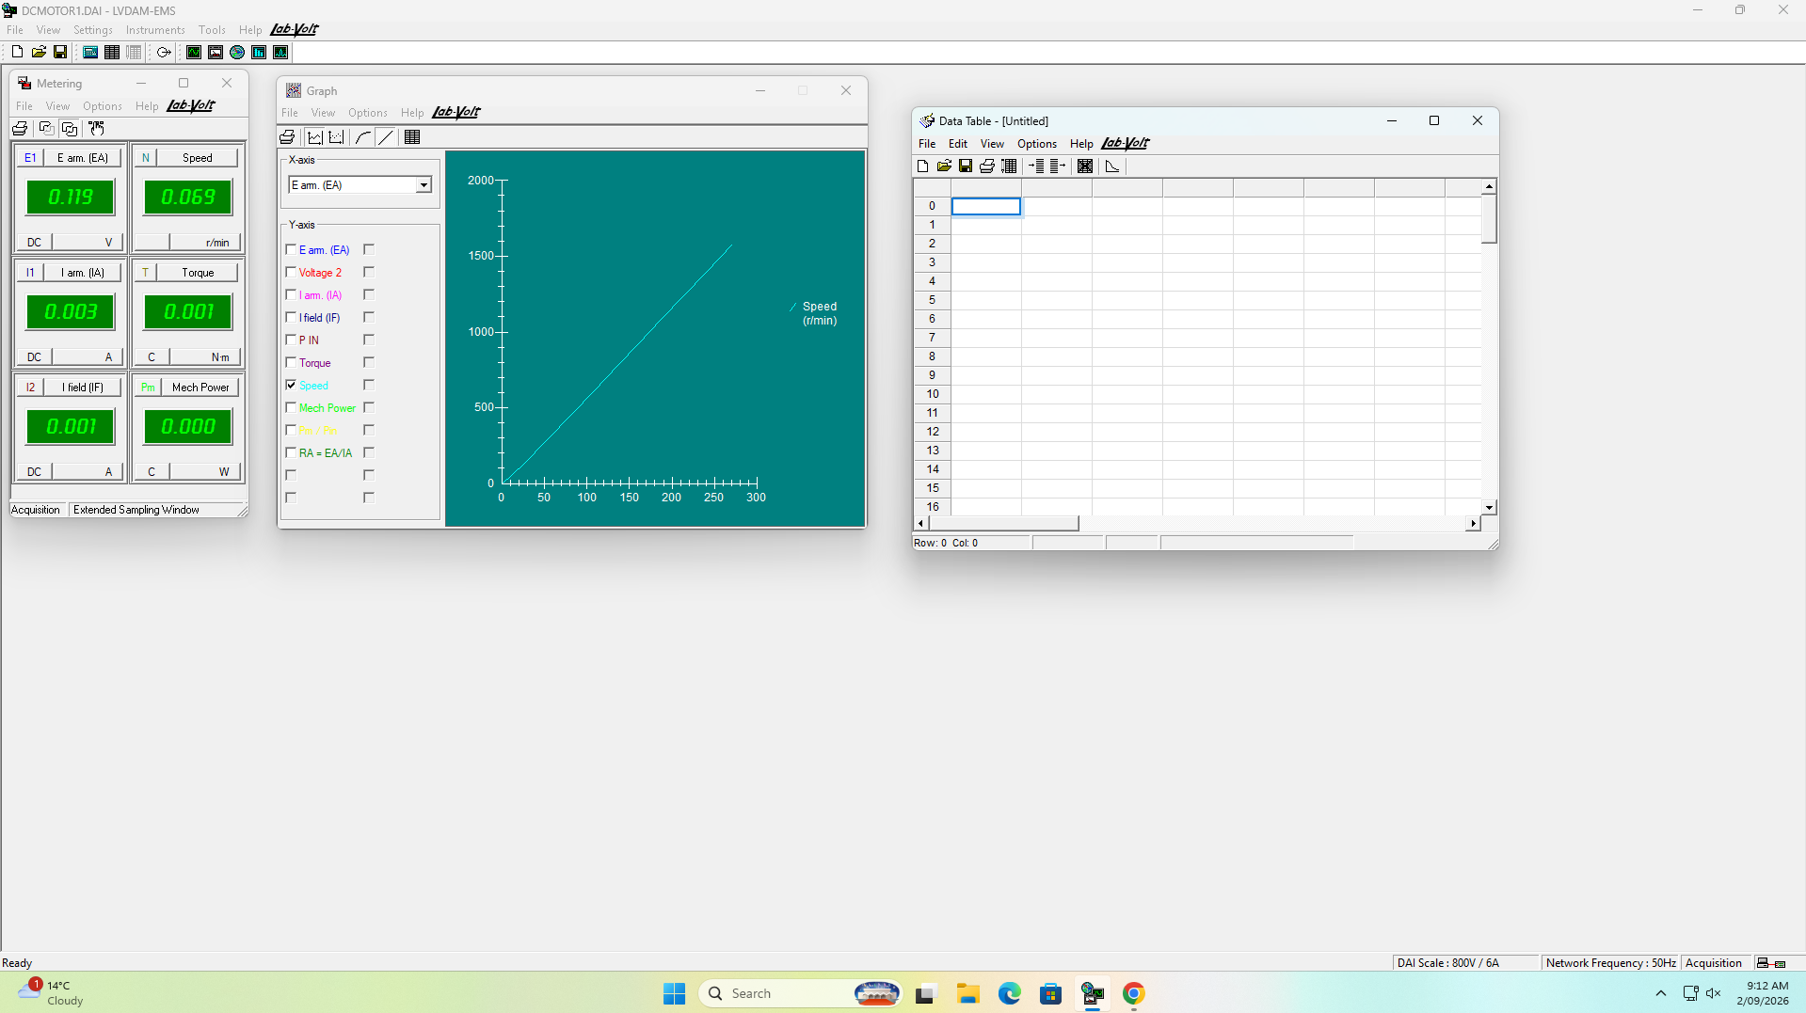
Figure 16: 09:12 — Graph G211, motor speed as a function of armature voltage.
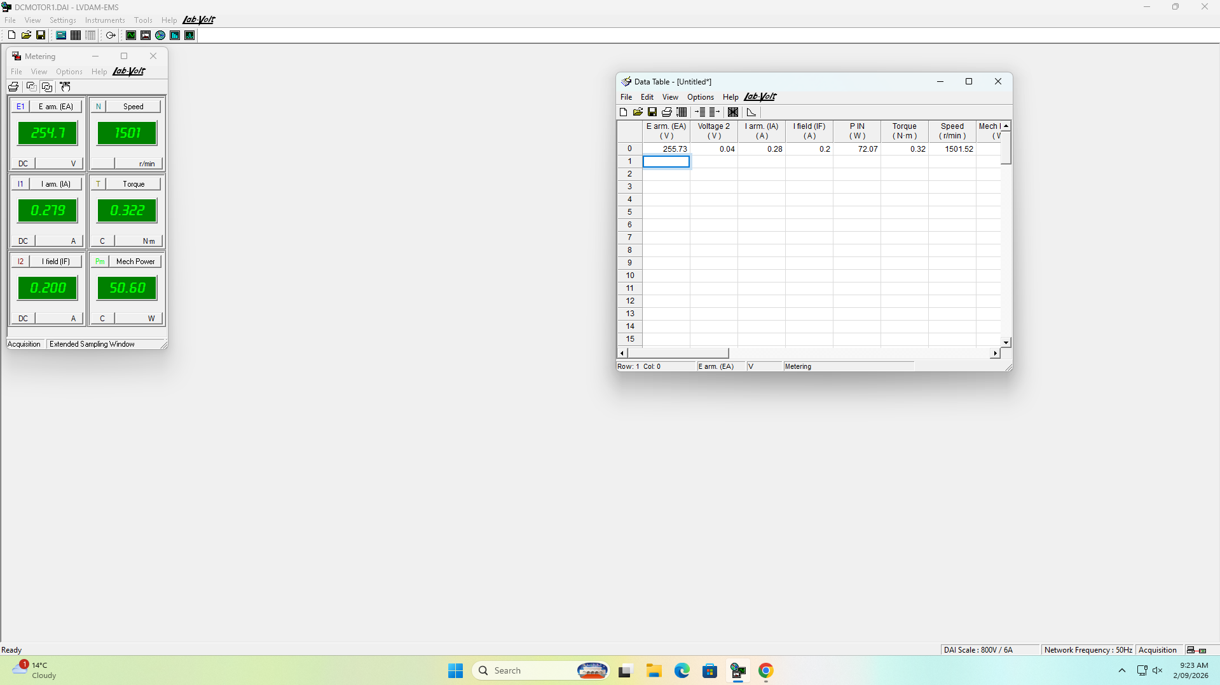
Figure 17: 09:23 — Step 14: armature voltage set to give a no-load speed of 1500 r/min. E arm. 255.73 V, speed 1501.52 r/min, recorded as the first row of DT212.

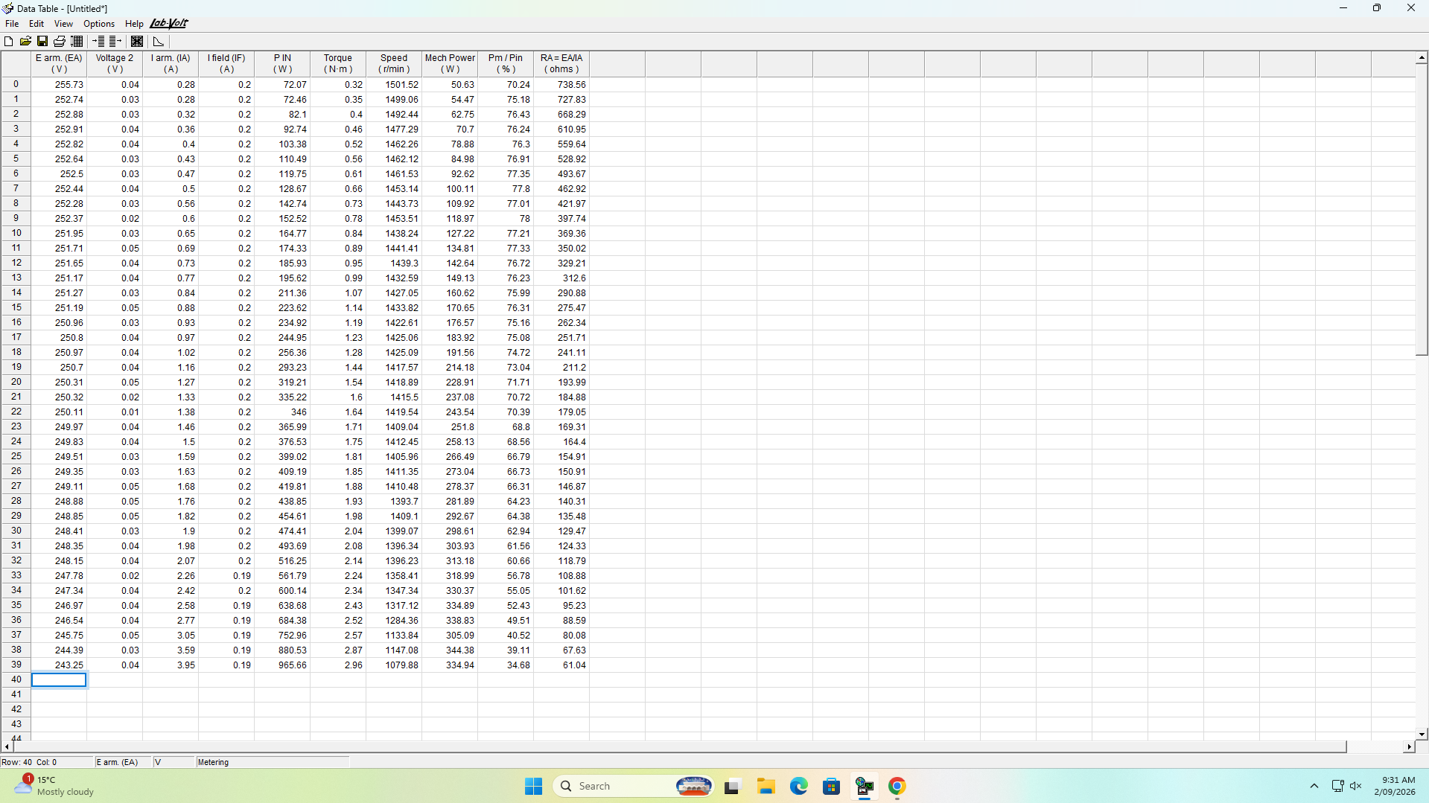
Figure 18: 09:31 — Data table DT212 complete, showing all forty loaded operating points from 0.28 A to 3.95 A. This is the dataset used throughout Sections 5 and 7.
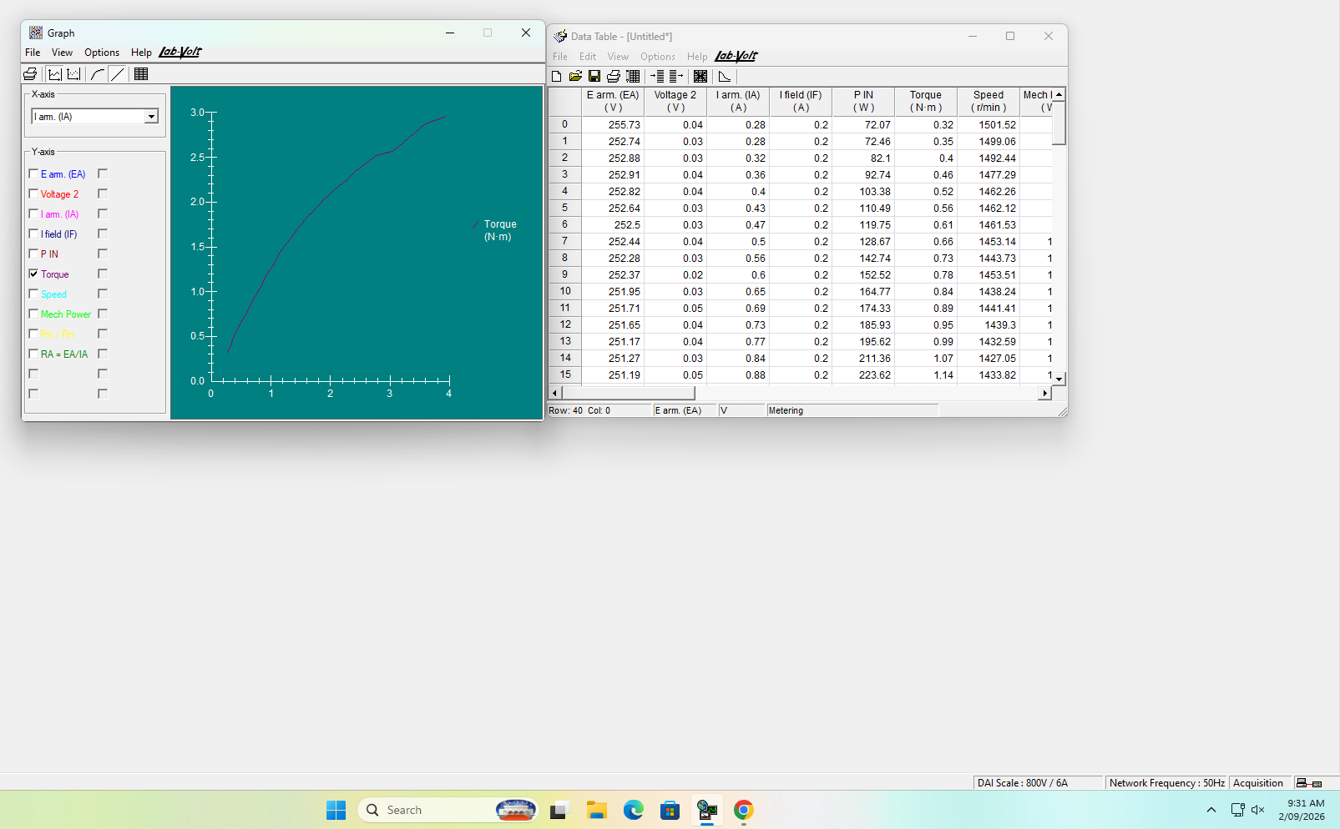
Figure 19: 09:31 — Graph G212, motor torque as a function of armature current, showing the departure from linearity above approximately 1.5 A.

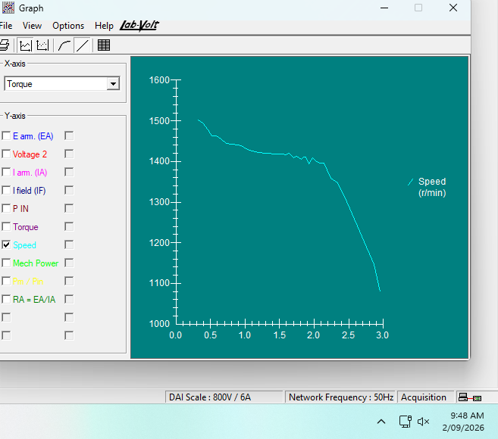
Figure 20: 09:48 — Graph G212-2, motor speed as a function of developed torque.
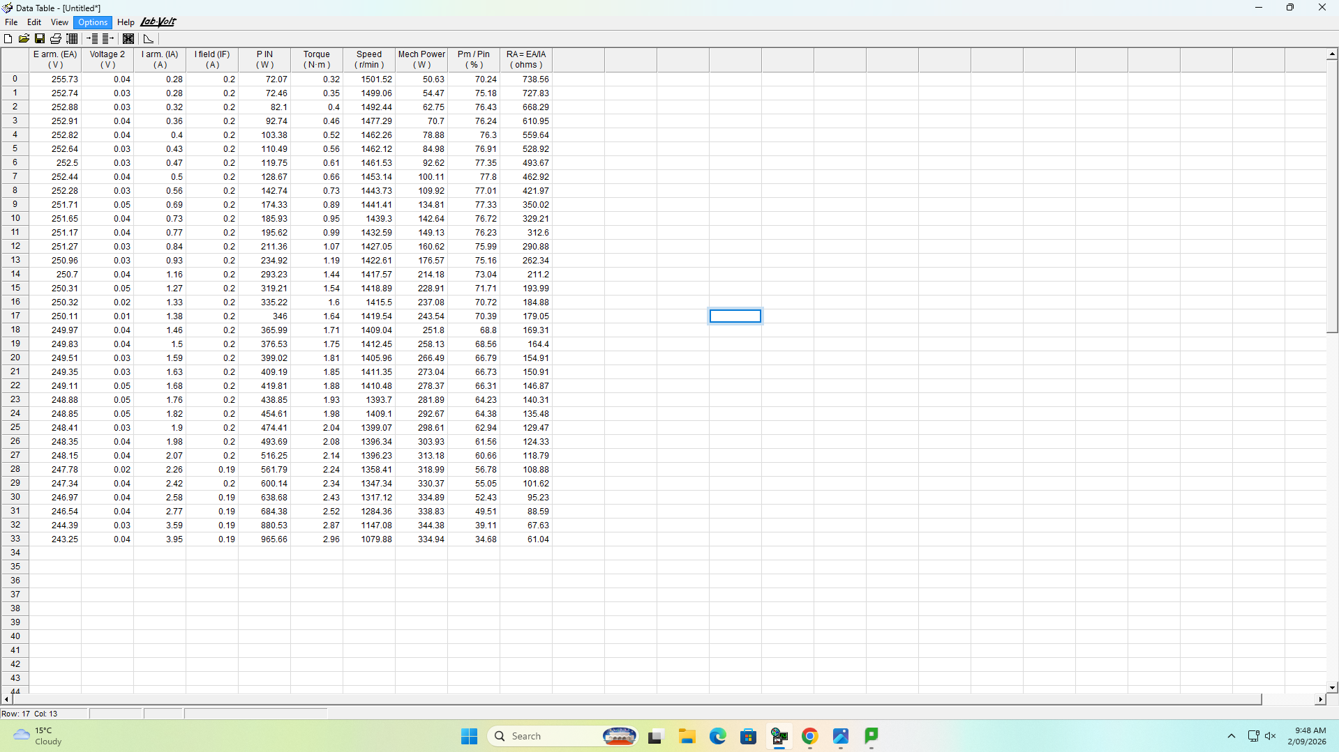
Figure 21: 09:48 — Data table displayed alongside graph G212-2.

