Network Topology Simulator - Detailed Report

Input Parameters
Topology Type | Tree
Number of Nodes | 7
Cost per Port (₹) | 100
Cable Length per Connection (m) | 10
Cost per Unit Cable (₹/m) | 50
Total Connections | 6

Cost Analysis Results
Topology: Tree
Nodes: 7
Connections: 6
Total Cost: ₹4200.00
Step-by-step cost calculation:
1) Number of nodes = 7
2) Number of connections (edges) = 6
3) Cost per port = 100.0
4) Total port cost = connections * 2 * cost_per_port
= 6 * 2 * 100.0 = 1200.00
5) Cable length per connection = 10.0 m
6) Cost per unit cable = 50.0 per m
7) Total cable cost = connections * cable_len * cable_cost
= 6 * 10.0 * 50.0 = 3000.00
8) Total cost = total_port_cost + total_cable_cost = 1200.00 + 3000.00 = 4200.00

Network Topology Diagram
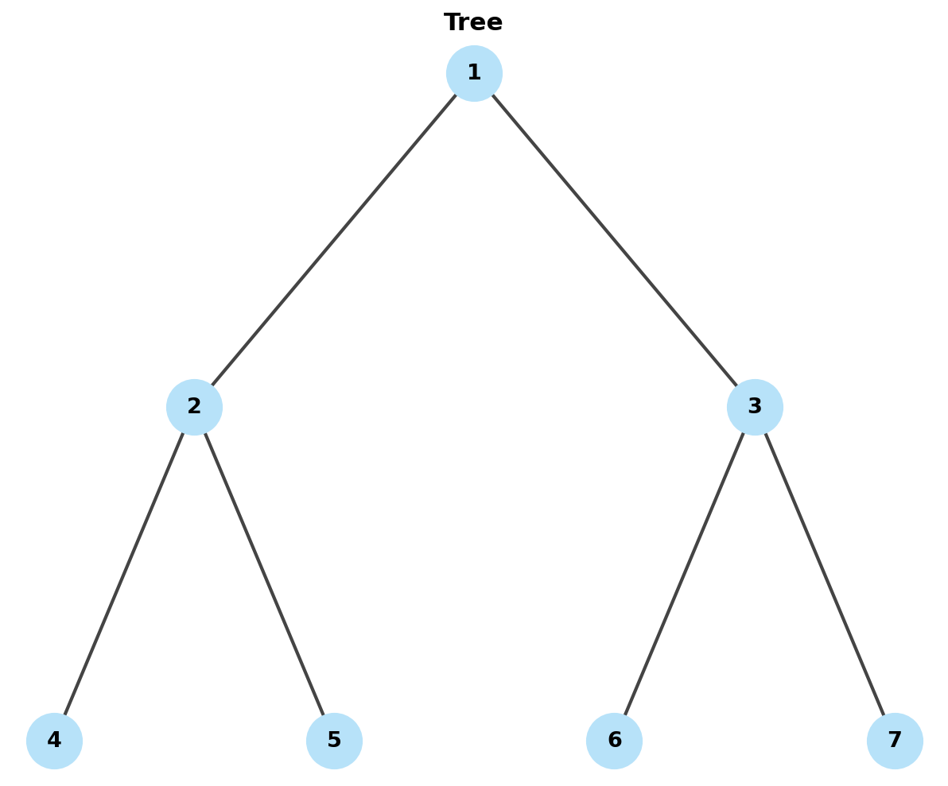

Network Connections
• Node 1 ↔ Node 2
• Node 1 ↔ Node 3
• Node 2 ↔ Node 4
• Node 2 ↔ Node 5
• Node 3 ↔ Node 6
• Node 3 ↔ Node 7

──────────────────────────────────────────────────────────────────────
Generated by Network Topology Simulator

