# **MERCURY**

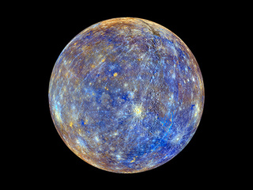

## Specific details:

Mass: 330,104,000,000,000,000,000,000kg

Density: 5.427g/cm3

Average Orbit Distance: 57,909,227km

Mean Orbit Velocity: 170,503km/h

Orbit Eccentricity: 0.20563593

Equatorial Inclination: 0 degrees

Equatorial Radius: 2,439.7km

Equatorial Circumference: 15,329.1km

Surface Area: 74,797,000km2

Surface Gravity: 3.7m/s2

Escape Velocity: 15,300km/h

## Water possibilities:

* Percentage: Not mentioned
* Mercury may have water ice at its north and south poles inside deep craters, but only in regions of permanent shadow. There it could be cold enough to preserve water ice despite the high temperatures on sunlit parts of the planet.

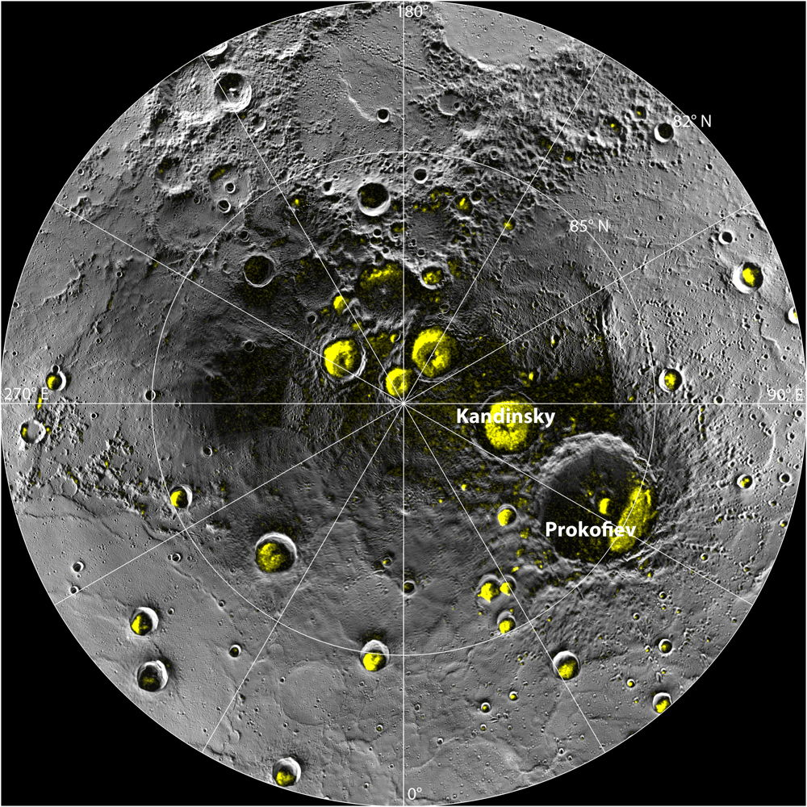

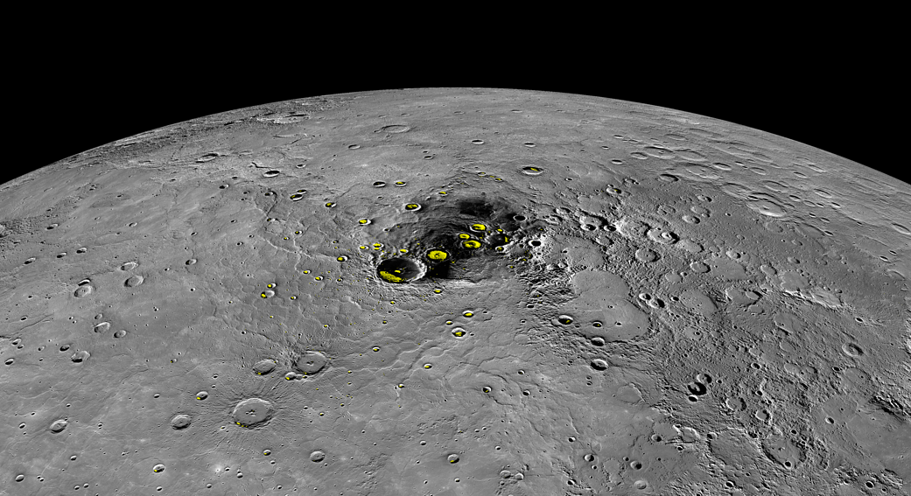

## Structure and Composition:

* Mercury’s Outer core composed of liquid metal
* It has a large metallic core with a radius of about 1,289 miles (2,074 kilometers), about 85 percent of the planet's radius. There is evidence that it is partly molten, or liquid. Mercury's outer shell, comparable to Earth's outer shell (called the mantle and crust), is only about 400 kilometers (250 miles) thick.
* 412 named Mercurian craters
* Craters larger than 250km is referred as basins.

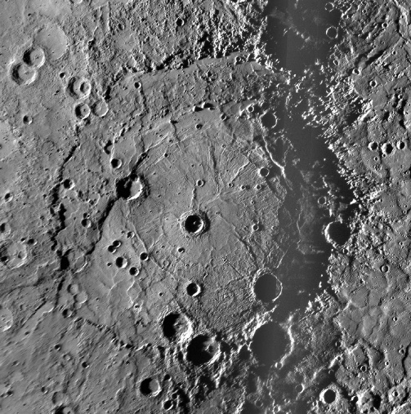 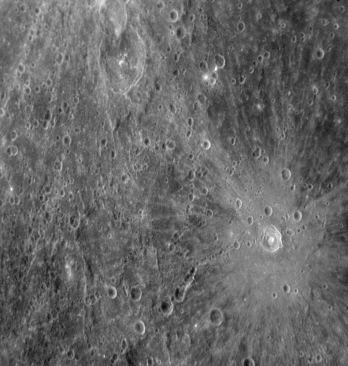

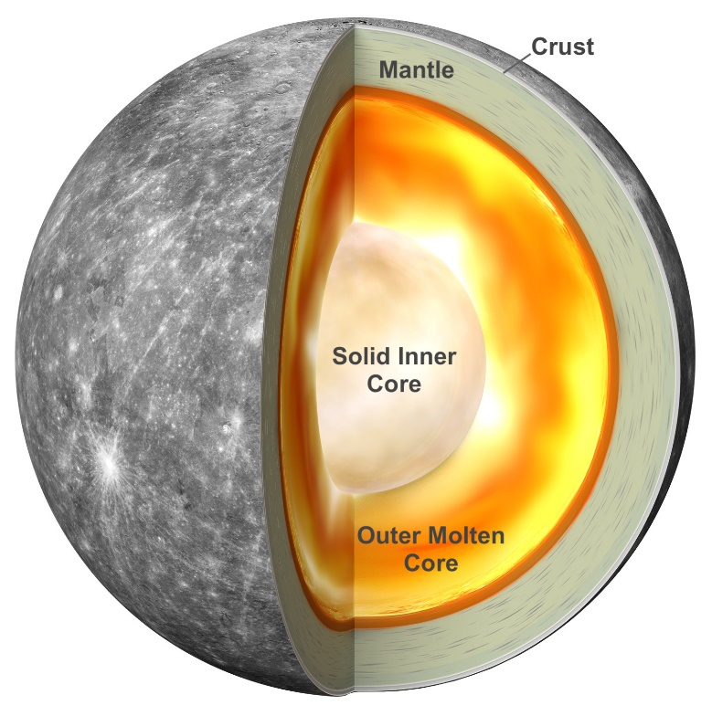

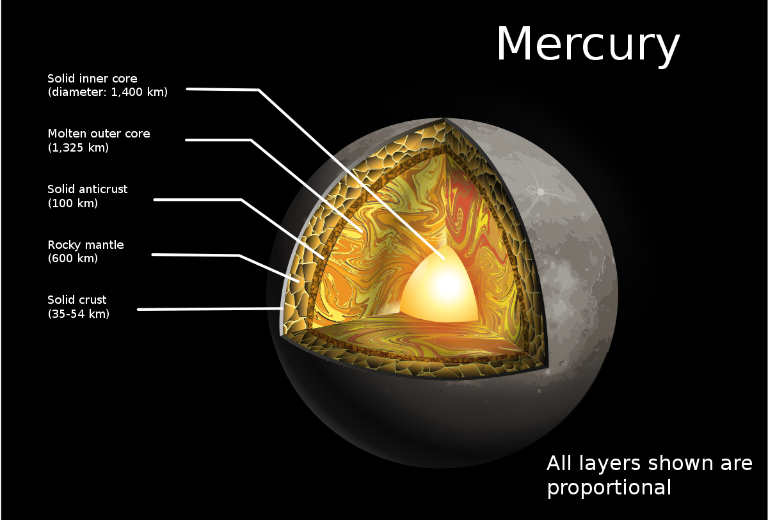

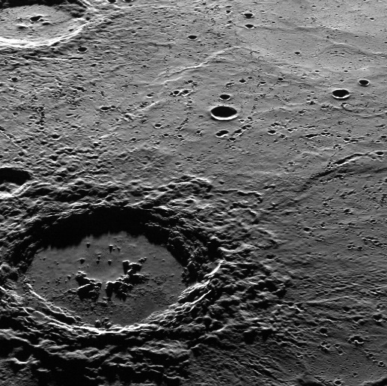 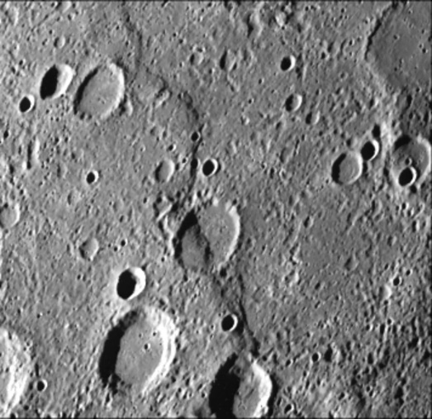

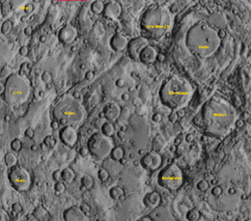

## Atmosphere:

* Instead of an atmosphere, Mercury possesses a thin exosphere made up of atoms blasted off the surface by the solar wind and striking meteoroids.
* Mercury's exosphere is composed mostly of oxygen, sodium, hydrogen, helium and potassium.
* Combined pressure level of about 10−14 bar (1 nPa).
* Surface pressure: <~5 x 10-15 bar (0.005 picobar)
* Total mass of atmosphere: <~10000 kg

**Atmospheric composition (Column abundances in 106 per cm2):**

* Sodium 12,000-200,000; Magnesium 100,000; Oxygen <40,000; Hydrogen 5000, Potassium 800-1300,
* Calcium 300-1000; Iron <300; Aluminum 15; and
* possible trace amounts of Argon (Ar), Carbon Dioxide (CO2),
* Water (H2O), Nitrogen (N2), Xenon (Xe), Krypton (Kr),
* Neon (Ne), Helium (He)

## Temperature:

* During the day, temperatures on Mercury's surface can reach 800 degrees Fahrenheit (430 degrees Celsius)
* During night time temperatures on the surface can drop to minus 290 degrees Fahrenheit (minus 180 degrees Celsius).
* Average temperature: 440 K (167 C) (590-725 K, sunward side)

## Orbit Rotation:

* Orbit type and Distance: Egg-shaped orbit which takes the planet as close as 29 million miles (47 million kilometers) and as far as 43 million miles (70 million kilometers) from the Sun.
* Period of revolution:88 earth days
* Rotation: 59 earth days
* Angular velocity:47km or 29 miles per second
* Direction of rotation: Counterclockwise
* Revolution: Counterclockwise
* One mercury solar day equals 176 day earth day
* Axis of Rotation: Tilted 2 degrees with respect to the plane of its orbit around the sun.

## Magnetic Field and Electric Field:

* Magnetic field's strength of mercury is 1.1% that of [Earth's magnetic field](https://en.wikipedia.org/wiki/Earth%27s_magnetic_field).

**Internal Field:**

* Dipole field strength: 0.002 Gauss-Rh3
* Dipole tilt to rotational axis: 0.0 degrees
* Dipole Offset: 0.17 Rh
* Surface (1 Rh) field strength: 0.0025 - 0.007 Gauss
* Magnetic Moment: 2 to 6 × 1012 [T](https://en.wikipedia.org/wiki/Tesla_(unit))•[m3](https://en.wikipedia.org/wiki/Cubic_meter)
* Equatorial Field Strength: 300 nT

(Rh denotes Mercurian model radius, here defined to be 2,440 km )

**Solar Wind Parameters:**

* Speed: 400km/s

**Magneto spheric Parameters:**

* Type: Intrinsic
* Magnetopause Distance: 1.4 *RM*
* Magneto tail Length: 10–100 *RM*
* Main Ions: Na+, O+, K+, Mg+, Ca+, S+, H2S+
* Plasma Source: Solar Wind
* Maxm Particle Energy: up to 50 keV

## Appearance of planet:

Reflective properties:

* Bond Albedo: 0.068
* Geometric Albedo: 0.142
* V-band Magnitude V(1,0): -0.613
* Solar irradiance (W/m2): 9082.7