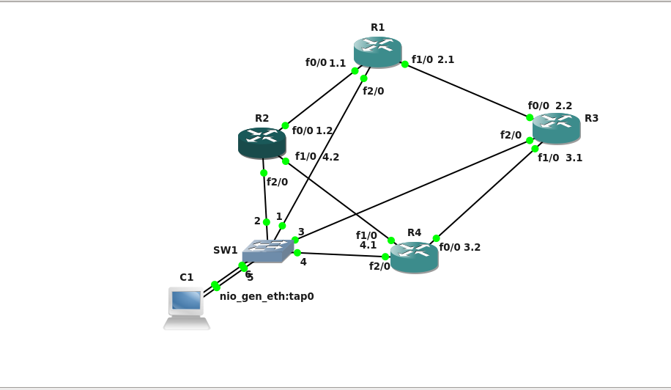

**Links**

Host C1 – Switch – f2/0 -R1

– f2/0 -R2

– f2/0 -R3

– f2/0 -R4

IP-Addresses

R1 – 'ip':'198.51.100.21'

R2 – 'ip':'198.51.100.22'

R3 – 'ip':'198.51.100.23'

R4 - 'ip':'198.51.100.24'

For interfaces we hace taken 192.161.x.x/24 network

All interfaces have been advertised in OSPF.

And are reachable.

Synopsis –

In a production environment we may require draining traffic to move traffic away from a particular device to undertake maintenance. and undrain traffic to return to before.

**DRAIN R3**

After we drain R3,

Traffic will move from R2

Before - Traceroute to both R1 interfaces from R4 show different hops,

1st traceroute hop at R2

2nd traceroute hop at R1

After - Traceroute to both R1 interfaces from R4 show, hop at R2 then R1

**Before**

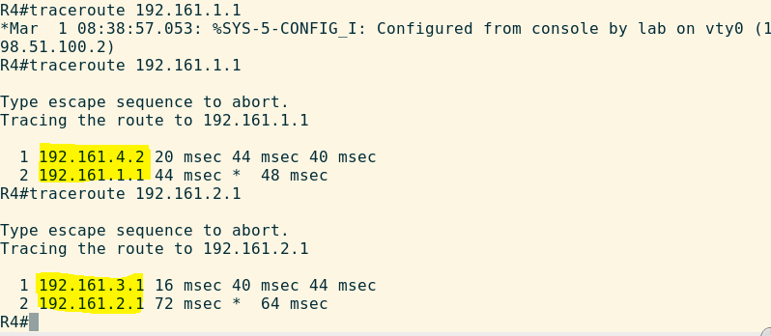

**After**

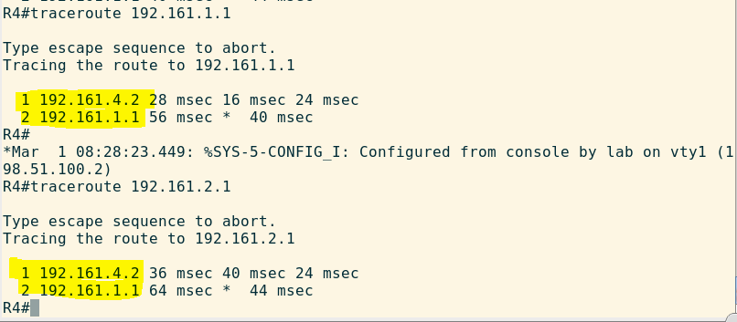

**DRAIN R2**

After we drain, R2

Traffic will move from R3

**Before -** Traceroute to both R1 interfaces from R4 show different hops,

1st traceroute hop at R2

2nd traceroute hop at R1

**After -** Traceroute to both R1 interfaces from R4 show, hope at R3 then R1.

**Before**

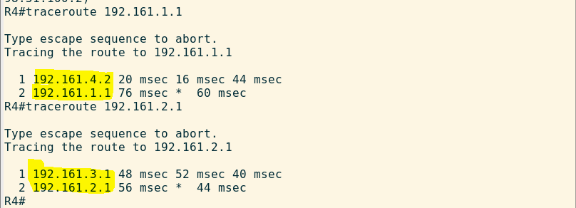

**After**

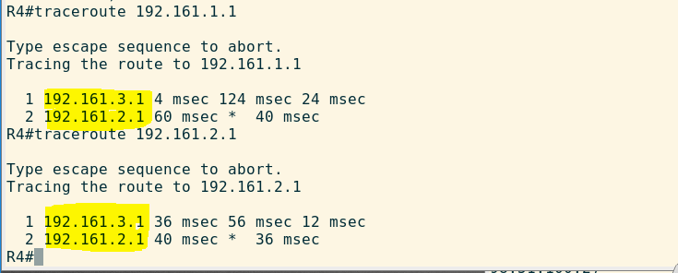**DEFAULT and UNDRAIN**

When we undrain traffic on all devices,

Traceroute to both R1 interfaces from R4 show different paths.



Traceroute to R1-f0/0 interface goes through R2

Traceroute to R1-f1/0 does through R3

**Assumptions and future improvements –**

Traceroute will always be done from a host on R4 –.

Currently I have written different scripts for

Undrain

Drain R3

Drain R2

Have to merge into 1 script which provides options for user to choose.