PROJECT END-TO-END PLANNING
Food Delivery Data Engineering & Natural Language Analytics Platform
Team Planning Document • 03 October 2026
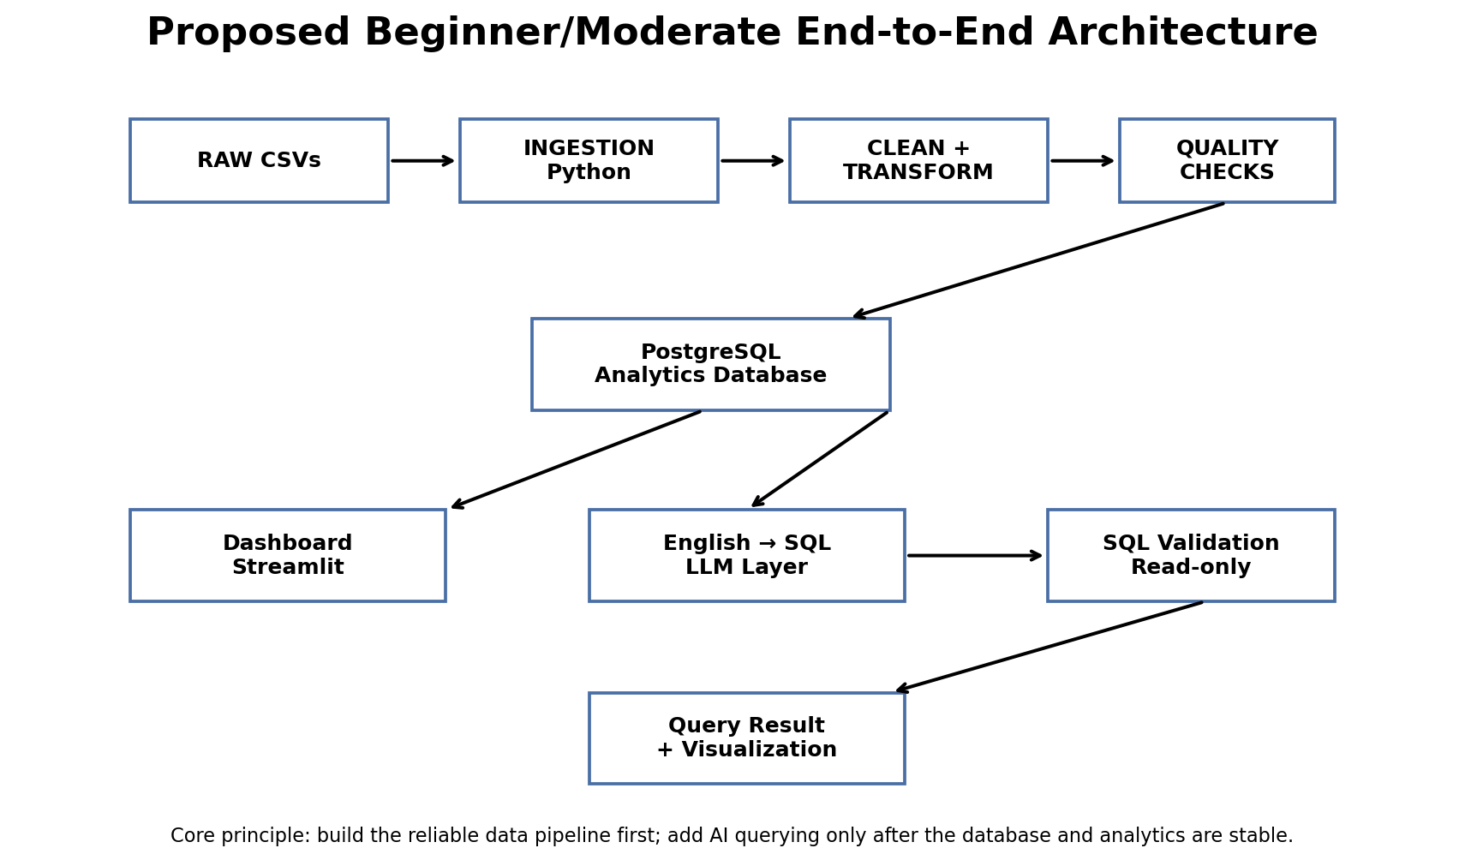

1. Project Vision
The project will build a beginner-to-moderate, end-to-end Data Engineering pipeline for food-delivery data. The pipeline will take raw CSV data, ingest it, clean and transform it, validate its quality, store it in PostgreSQL, and expose the resulting data through an interactive analytics dashboard. The final differentiator is an Ask Your Data feature: a user can type an analytical question in simple English, an LLM converts the question into a safe read-only SQL query, PostgreSQL executes it, and the dashboard displays the result as a table, KPI, or chart.
The project is intentionally simpler than the advanced Zomato AI reference project. We will learn and demonstrate the engineering concepts ourselves instead of copying a production-style cloud stack.

2. Reference Projects
Primary dataset/reference:
https://github.com/Harsh-Belekar/Swiggy-Sales-Analysis
This repository documents a synthetic food-delivery dataset with five core tables, PostgreSQL loading, a normalized schema, aggregated analysis tables and a Power BI dashboard. Its README states that the raw data contains 600,000 orders from 2022–2025 and five CSV tables. Our project uses the dataset but builds a different, more beginner-friendly pipeline and adds the natural-language SQL dashboard feature.
Architecture inspiration:
https://github.com/darshilparmar/zomato-ai-data-engineering-end-to-end-project
This is the advanced reference that inspired the idea of an end-to-end food-delivery data platform and AI/text-to-SQL analytics. We will not reproduce its cloud-heavy or advanced AI architecture.

3. Actual Dataset We Will Use
The uploaded Swiggy_Data.zip was inspected directly. It contains five CSV files. The dataset is synthetic, which is appropriate for an educational project and avoids exposing real customer data.
File | Rows | Columns | Purpose
users.csv | 10,000 | 6 | Customer/demographic dimension
restaurants.csv | 1,000 | 6 | Restaurant, city, cuisine and rating dimension
menu.csv | 15,658 | 6 | Menu item, category, price and vegetarian dimension
orders.csv | 600,000 | 8 | Central order transaction/fact table
order_items.csv | 1,667,399 | 5 | Line-level food quantities and prices
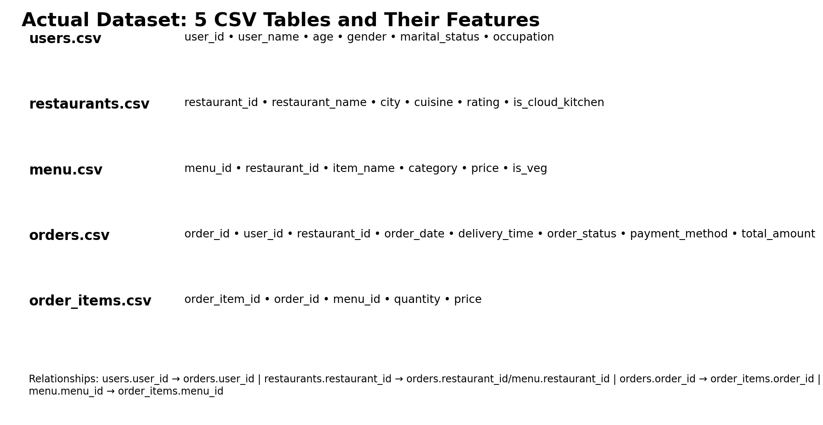

4. Dataset Schema — Explained Simply

users.csv
Features: user_id, user_name, age, gender, marital_status, occupation
Stores who the customer is. It lets us perform customer and demographic analysis.

restaurants.csv
Features: restaurant_id, restaurant_name, city, cuisine, rating, is_cloud_kitchen
Stores restaurant information. It enables restaurant, cuisine, city and rating analysis.

menu.csv
Features: menu_id, restaurant_id, item_name, category, price, is_veg
Stores individual food/menu items. It enables food-item, category, price and veg/non-veg analysis.

orders.csv
Features: order_id, user_id, restaurant_id, order_date, delivery_time, order_status, payment_method, total_amount
Central transaction table. It tells us who ordered, from which restaurant, when, status, payment and order value.

order_items.csv
Features: order_item_id, order_id, menu_id, quantity, price
Line-level bridge between orders and menu items. It lets us calculate item popularity and category revenue.

5. Relationships Between Tables
The database is relational. We do not physically copy all fields into one huge table. Instead, tables are connected through keys and SQL JOINs. This is important because it teaches real database/data-engineering concepts.
- users.user_id → orders.user_id
- restaurants.restaurant_id → orders.restaurant_id
- restaurants.restaurant_id → menu.restaurant_id
- orders.order_id → order_items.order_id
- menu.menu_id → order_items.menu_id
Example: to answer 'Which restaurant generated the highest revenue?', SQL joins orders to restaurants using restaurant_id, groups by restaurant, and sums total_amount.

6. Important Findings and Limitations
- The uploaded dataset has no drivers.csv and orders has no driver_id. Therefore driver-performance analytics are not currently supported.
- orders.delivery_time contains a clock time (approximately 08:00–23:59), not elapsed delivery duration. We can analyze ordering time/peak hours, but we should not claim average delivery duration.
- The dataset spans 2022-01-01 to 2025-12-31.
- order_status contains Delivered and Cancelled; payment methods include UPI, Credit Card, Debit Card, Cash on Delivery and Wallet.
- Restaurants contain city, cuisine, rating and cloud-kitchen information.
- Menu contains item name, category, price and vegetarian indicator.
- Users contain age, gender, marital status and occupation.
- The tested primary/foreign-key relationships are valid, making the dataset suitable for relational modeling.

7. What Is Our Data Engineering Pipeline?
The pipeline is the controlled process that converts raw files into trustworthy, queryable information. Each stage has a purpose.

1. Raw Data
Keep the original CSVs unchanged. This is the source-of-truth landing area.

2. Ingestion
Read the CSVs and load them into the raw layer/database using Python. Record row counts and ingestion status.

3. Cleaning
Handle data types, missing values, duplicates, invalid values and formatting issues.

4. Transformation
Create useful derived fields such as year, month, day-of-week, weekend flag, order hour, price bands and revenue measures.

5. Data Quality
Run checks such as primary-key uniqueness, foreign-key integrity, valid status/payment values, non-negative amounts and order-total consistency.

6. Structured Storage
Load validated tables into PostgreSQL with primary keys, foreign keys and appropriate data types.

7. Analytics Layer
Create SQL views or simple analytical tables for common dashboard metrics without destroying the normalized source tables.

8. Dashboard
Build an interactive interface for KPIs, filters, charts and natural-language queries.

9. AI Query Layer
Translate supported English questions into SQL, validate the SQL, run it using a read-only connection and return the result.

8. Data Quality Examples
- Primary key check: No duplicate user_id, restaurant_id, menu_id, order_id or order_item_id.
- Foreign key check: Every order user_id exists in users; every order restaurant_id exists in restaurants; every order_item order_id exists in orders; every menu_id exists in menu.
- Domain checks: order_status must be Delivered or Cancelled; payment_method must be one of the known methods.
- Numeric checks: quantity, price and total_amount should be non-negative.
- Business reconciliation: For each order, SUM(order_items.price × quantity) should reconcile with orders.total_amount where the dataset's pricing rules permit it.
- Date checks: order_date must be a valid date and remain inside the dataset's expected period.

9. Database Design
PostgreSQL will be our main analytical database. The five source tables remain understandable and normalized. We can create read-only analytical views for dashboard queries. We will avoid unnecessary complexity such as a full cloud warehouse at the beginning.
Core tables: users, restaurants, menu, orders, order_items.
Central fact table: orders. Supporting dimensions: users, restaurants, menu. order_items provides line-level detail.

10. Dashboard — Not Just a Query Box
The dashboard should feel like a complete food-delivery analytics product. The English query feature is the main differentiator, but the dashboard must also contain conventional analytics so users can explore the data without AI.
- Executive Overview: total orders, total revenue, average order value, cancellation rate, order-status distribution.
- Revenue Analytics: revenue by month, city, cuisine and restaurant; average order value.
- Restaurant Analytics: top restaurants, rating distribution, cloud-kitchen comparison, orders and revenue by restaurant.
- Food/Menu Analytics: top food items, category performance, vegetarian vs non-vegetarian, average item price.
- Customer Analytics: customer order frequency, spending, age groups, occupation, marital-status analysis.
- Time & Operations: orders by hour, day-of-week, month, weekday vs weekend, cancellation patterns.
- Payment Analytics: payment-method distribution and revenue by payment method.
- Ask Your Data: natural-language question box with answer, result table/chart and a Show SQL button.
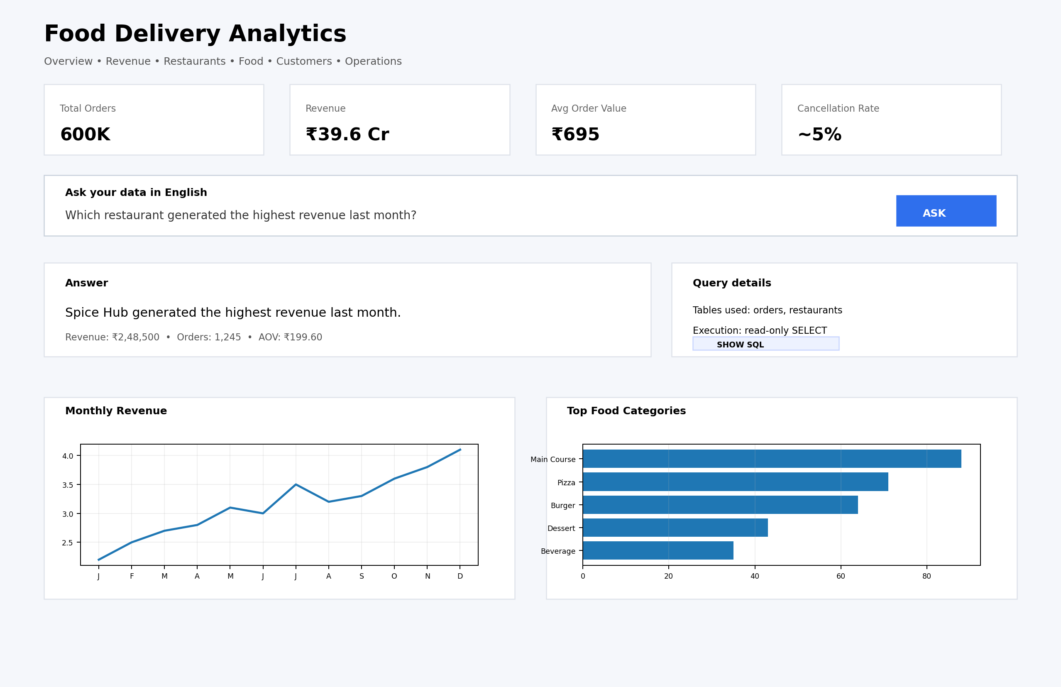
Illustrative dashboard mockup. This is a design target, not a screenshot of the final application.

11. English Question → SQL → Result
This is the core innovation. The user does not need to know SQL. They ask an analytical question in normal English.
- User: Which restaurant generated the highest revenue last month?
- LLM: Understands that the question needs restaurant name, order revenue, date filtering and ranking.
- SQL generation: Creates a SELECT query using the known database schema.
- SQL validation: Checks that the query is read-only and references valid tables/columns.
- PostgreSQL: Executes the approved query.
- Result processor: Determines whether the result is best shown as a KPI, table or chart.
- Dashboard: Shows the answer and provides a Show SQL button so the user can inspect the exact query.

12. Example English Questions
- What was the total revenue in 2025?
SQL idea: SUM(total_amount) with a date filter.
- Which restaurant generated the most revenue?
SQL idea: JOIN orders + restaurants, GROUP BY restaurant, ORDER BY revenue DESC LIMIT 1.
- What are the top 10 food items?
SQL idea: JOIN order_items + menu, aggregate quantity, order by quantity.
- Which city has the most orders?
SQL idea: JOIN orders + restaurants, GROUP BY city.
- What is the most popular payment method?
SQL idea: GROUP BY payment_method and COUNT orders.
- Which cuisine generated the highest revenue in Mumbai?
SQL idea: JOIN orders + restaurants, filter city, GROUP BY cuisine, SUM revenue.
- Which food category has the highest average price?
SQL idea: GROUP BY menu.category and AVG(menu.price).
- What percentage of orders were cancelled?
SQL idea: COUNT cancelled / COUNT total × 100.

13. Show SQL Button — Transparency Feature
Every AI-generated answer should have a Show SQL control. When clicked, the dashboard displays the exact SELECT query used. This makes the AI explainable and allows the professor/team to verify that the answer came from the database rather than an invented response.
Example:
SELECT r.restaurant_name, SUM(o.total_amount) AS revenue FROM orders o JOIN restaurants r ON o.restaurant_id = r.restaurant_id WHERE o.order_date >= ... GROUP BY r.restaurant_name ORDER BY revenue DESC LIMIT 1;

14. SQL Safety
The AI must never have unrestricted write access. The analytics connection should use a read-only PostgreSQL user. The application should reject dangerous statements such as INSERT, UPDATE, DELETE, DROP, ALTER and TRUNCATE. The initial version should permit SELECT-based analytical operations such as WHERE, GROUP BY, ORDER BY, JOIN, COUNT, SUM, AVG, MIN, MAX and LIMIT.

15. What Happens If the Professor Asks Something Unsupported?
The system should not hallucinate. It should check whether the required data exists. For example, 'Which driver delivered the most orders?' cannot be answered because the current dataset has no driver table or driver_id. Similarly, true delivery-duration questions cannot be answered because delivery_time is a clock time. The system should clearly state the limitation instead of inventing an answer.

16. Recommended Development Phases

Phase 1 — Understand & Profile
Dataset inspection, schema, relationships, data dictionary, initial quality report.

Phase 2 — Ingestion
Python ingestion scripts, raw layer, logging and row-count checks.

Phase 3 — Cleaning & Transformation
Data types, derived date/time features, standardized values and business transformations.

Phase 4 — Data Quality
Automated validation rules and quality report.

Phase 5 — PostgreSQL
Create tables, keys, constraints, load validated data and create analytical views.

Phase 6 — SQL Analytics
Write and test common business queries.

Phase 7 — Dashboard
Build overview, revenue, restaurant, food, customer, time and payment pages.

Phase 8 — Natural Language SQL
Add LLM schema context, SQL generation, validation, execution and result formatting.

Phase 9 — Integration & Testing
Test normal analytics, random supported questions, invalid questions, SQL safety and performance.

Phase 10 — Presentation
Documentation, architecture diagram, demo script, limitations, future work and GitHub cleanup.

17. Team Collaboration
We will not permanently divide the team into roles at the beginning. First everyone should understand the common architecture. As the project reaches parallelizable stages, tasks can be split around ingestion/quality, database/SQL, dashboard and AI-query integration. All work should merge into one agreed schema and Git repository.

18. Git/GitHub Working Rules
- Use one main repository for the project.
- Create feature branches rather than directly changing main.
- Use meaningful commit messages.
- Keep raw data out of Git if the files are large; document how to obtain them.
- Store configuration/secrets in environment variables, never hard-code credentials.
- Document every major pipeline stage in README/docs.
- Before merging, test the relevant pipeline stage and update documentation if behavior changed.

19. Future Improvements
- Airflow: automate and schedule ingestion/ETL once the manual pipeline is stable.
- dbt: manage SQL transformations, models and tests in a structured transformation layer.
- Docker: package PostgreSQL, backend and dashboard consistently.
- Cloud storage: move raw data from local storage to S3/Azure/GCP when cloud learning is desired.
- Cloud warehouse: optionally migrate analytics to Snowflake/BigQuery later.
- Better LLM routing: use schema retrieval and query templates to improve SQL generation.
- Semantic validation: check generated SQL against allowed schema, columns and business metrics.
- Query history: let users see previous questions and generated SQL.
- Caching: cache repeated analytical queries for faster dashboard responses.
- Additional source data: add a real delivery-duration field or driver table if a suitable source becomes available.
- Deployment: publish the dashboard/backend for demonstration if practical.

20. What We Should Be Able to Explain to the Professor
- Why we chose this dataset and what each table represents.
- How the tables are related and why primary/foreign keys matter.
- How raw data moves through ingestion, cleaning, transformation and validation.
- Why PostgreSQL is used and how the schema supports analytical queries.
- What data-quality checks protect the pipeline.
- How dashboard metrics are calculated.
- How an English question becomes SQL.
- How we prevent the AI from executing dangerous SQL.
- Why the system sometimes refuses a question when the dataset does not contain the required information.
- Which parts are beginner implementation choices and which future features could make it more production-grade.

21. Final Project Statement
We are building a reliable, beginner-to-moderate end-to-end food-delivery Data Engineering platform. The system will transform raw multi-table order data into validated PostgreSQL data and expose it through a rich analytics dashboard. The final differentiator is a transparent natural-language analytics interface where users can ask questions in English, inspect the generated SQL, and receive database-backed answers and visualizations.

22. Immediate Next Step
Start Day 1 with dataset profiling and the data dictionary. We will document every table, column, data type, key, relationship, business meaning and quality rule before writing the production pipeline.
Source/reference links:
1. Swiggy dataset/reference repository: https://github.com/Harsh-Belekar/Swiggy-Sales-Analysis
2. Advanced Zomato AI reference: https://github.com/darshilparmar/zomato-ai-data-engineering-end-to-end-project

Repo : https://github.com/Abikrishnanms/data_engineering_food_analytitcs_platform.git

