**КИЇВСЬКИЙ НАЦІОНАЛЬНИЙ УНІВЕРСИТЕТ**

**ІМЕНІ ТАРАСА ШЕВЧЕНКА**

**ФАКУЛЬТЕТ ІНФОРМАЦІЙНИХ ТЕХНОЛОГІЙ**

**КАФЕДРА ІНТЕЛЕКТУАЛЬНИХ ТЕХНОЛОГІЙ**

**Лабораторна робота №**8

з дисципліни «Інтелектуальний аналіз та візуалізація даних»

тема «КЛАСИФІКАЦІЯ, ДЕРЕВА РІШЕНЬ»

**Варіант №8**

Виконала студентка

групи КН-21

Іванова А.О.

Перевірив(-ла):

МІнаєва Ю.І.

**Київ – 2025**

**Мета роботи:**

Вивчення алгоритмів побудови дерев класифікації.

import numpy as np

import matplotlib.pyplot as plt

import pandas as pd

from sklearn import datasets

from sklearn.datasets import load_wine

from sklearn.tree import DecisionTreeClassifier, plot_tree

from sklearn.model_selection import train_test_split, GridSearchCV

from sklearn.metrics import accuracy_score

# Завантаження датасету Wine

wine = load_wine()

X = wine.data

y = wine.target

X_train, X_test, y_train, y_test = train_test_split(X, y, test_size=0.2,

random_state=42)

full_tree = DecisionTreeClassifier(random_state=42)

full_tree.fit(X_train, y_train)

y_pred_full = full_tree.predict(X_test)

full_tree_acc = accuracy_score(y_test, y_pred_full)

print(f"Unpruned Decision Tree Accuracy: {full_tree_acc:.4f}")

Unpruned Decision Tree Accuracy: 0.9444

pre_pruned_tree = DecisionTreeClassifier (max_depth=5,

min_samples_split=10, min_samples_leaf=5, random_state=42)

pre_pruned_tree.fit(X_train, y_train)

y_pred_prepruned = pre_pruned_tree.predict(X_test)

pre_pruned_acc = accuracy_score(y_test, y_pred_prepruned)

print(f"Pre-Pruned Decision Tree Accuracy: {pre_pruned_acc:.4f}")

Pre-Pruned Decision Tree Accuracy: 0.9444

param_grid = {

'max_depth': [3, 5, 10, None],

'min_samples_split': [2, 5, 10],

'min_samples_leaf': [1, 5, 10]

}

grid_search = GridSearchCV(DecisionTreeClassifier(random_state=42),

param_grid, cv=5, scoring='accuracy')

grid_search.fit(X_train, y_train)

best_params = grid_search.best_params_

best_tree = grid_search.best_estimator_

y_pred_gridsearch = best_tree.predict(X_test)

gridsearch_acc = accuracy_score(y_test, y_pred_gridsearch)

print(f"Grid Search Decision Tree Accuracy: {gridsearch_acc:.4f} with params: {best_params}")

Grid Search Decision Tree Accuracy: 0.9444 with params: {'max_depth': 3, 'min_samples_leaf': 1, 'min_samples_split': 2}

ccp_alphas = full_tree.cost_complexity_pruning_path(X_train,

y_train)['ccp_alphas']

accuracies = []

for alpha in ccp_alphas:

pruned_tree = DecisionTreeClassifier(random_state=42,ccp_alpha=alpha)

pruned_tree.fit(X_train, y_train)

y_pred_pruned = pruned_tree.predict(X_test)

accuracies.append(accuracy_score(y_test, y_pred_pruned))

best_alpha = ccp_alphas[np.argmax(accuracies)]

post_pruned_tree = DecisionTreeClassifier(random_state=42,

ccp_alpha=best_alpha)

post_pruned_tree.fit(X_train, y_train)

y_pred_postpruned = post_pruned_tree.predict(X_test)

post_pruned_acc = accuracy_score(y_test, y_pred_postpruned)

print(f"Post-Pruned Decision Tree Accuracy: {post_pruned_acc:.4f} (Best alpha: {best_alpha:.4f})")

Post-Pruned Decision Tree Accuracy: 0.9444 (Best alpha: 0.0000)

fig, axs = plt.subplots(2, 2, figsize=(20, 16))

plot_tree(full_tree, filled=True, feature_names=wine.feature_names, class_names=wine.target_names, ax=axs[0, 0])

axs[0, 0].set_title(f"Повне дерево (acc: {full_tree_acc:.4f})")

plot_tree(pre_pruned_tree, filled=True, feature_names=wine.feature_names, class_names=wine.target_names, ax=axs[0, 1])

axs[0, 1].set_title(f"Попередньо обрізане дерево (acc: {pre_pruned_acc:.4f})")

plot_tree(best_tree, filled=True, feature_names=wine.feature_names, class_names=wine.target_names, ax=axs[1, 0])

axs[1, 0].set_title(f"Налаштоване дерево (acc: {gridsearch_acc:.4f})")

plot_tree(post_pruned_tree, filled=True, feature_names=wine.feature_names, class_names=wine.target_names, ax=axs[1, 1])

axs[1, 1].set_title(f"Пост-обрізане дерево (acc: {post_pruned_acc:.4f})")

plt.tight_layout()

plt.show()

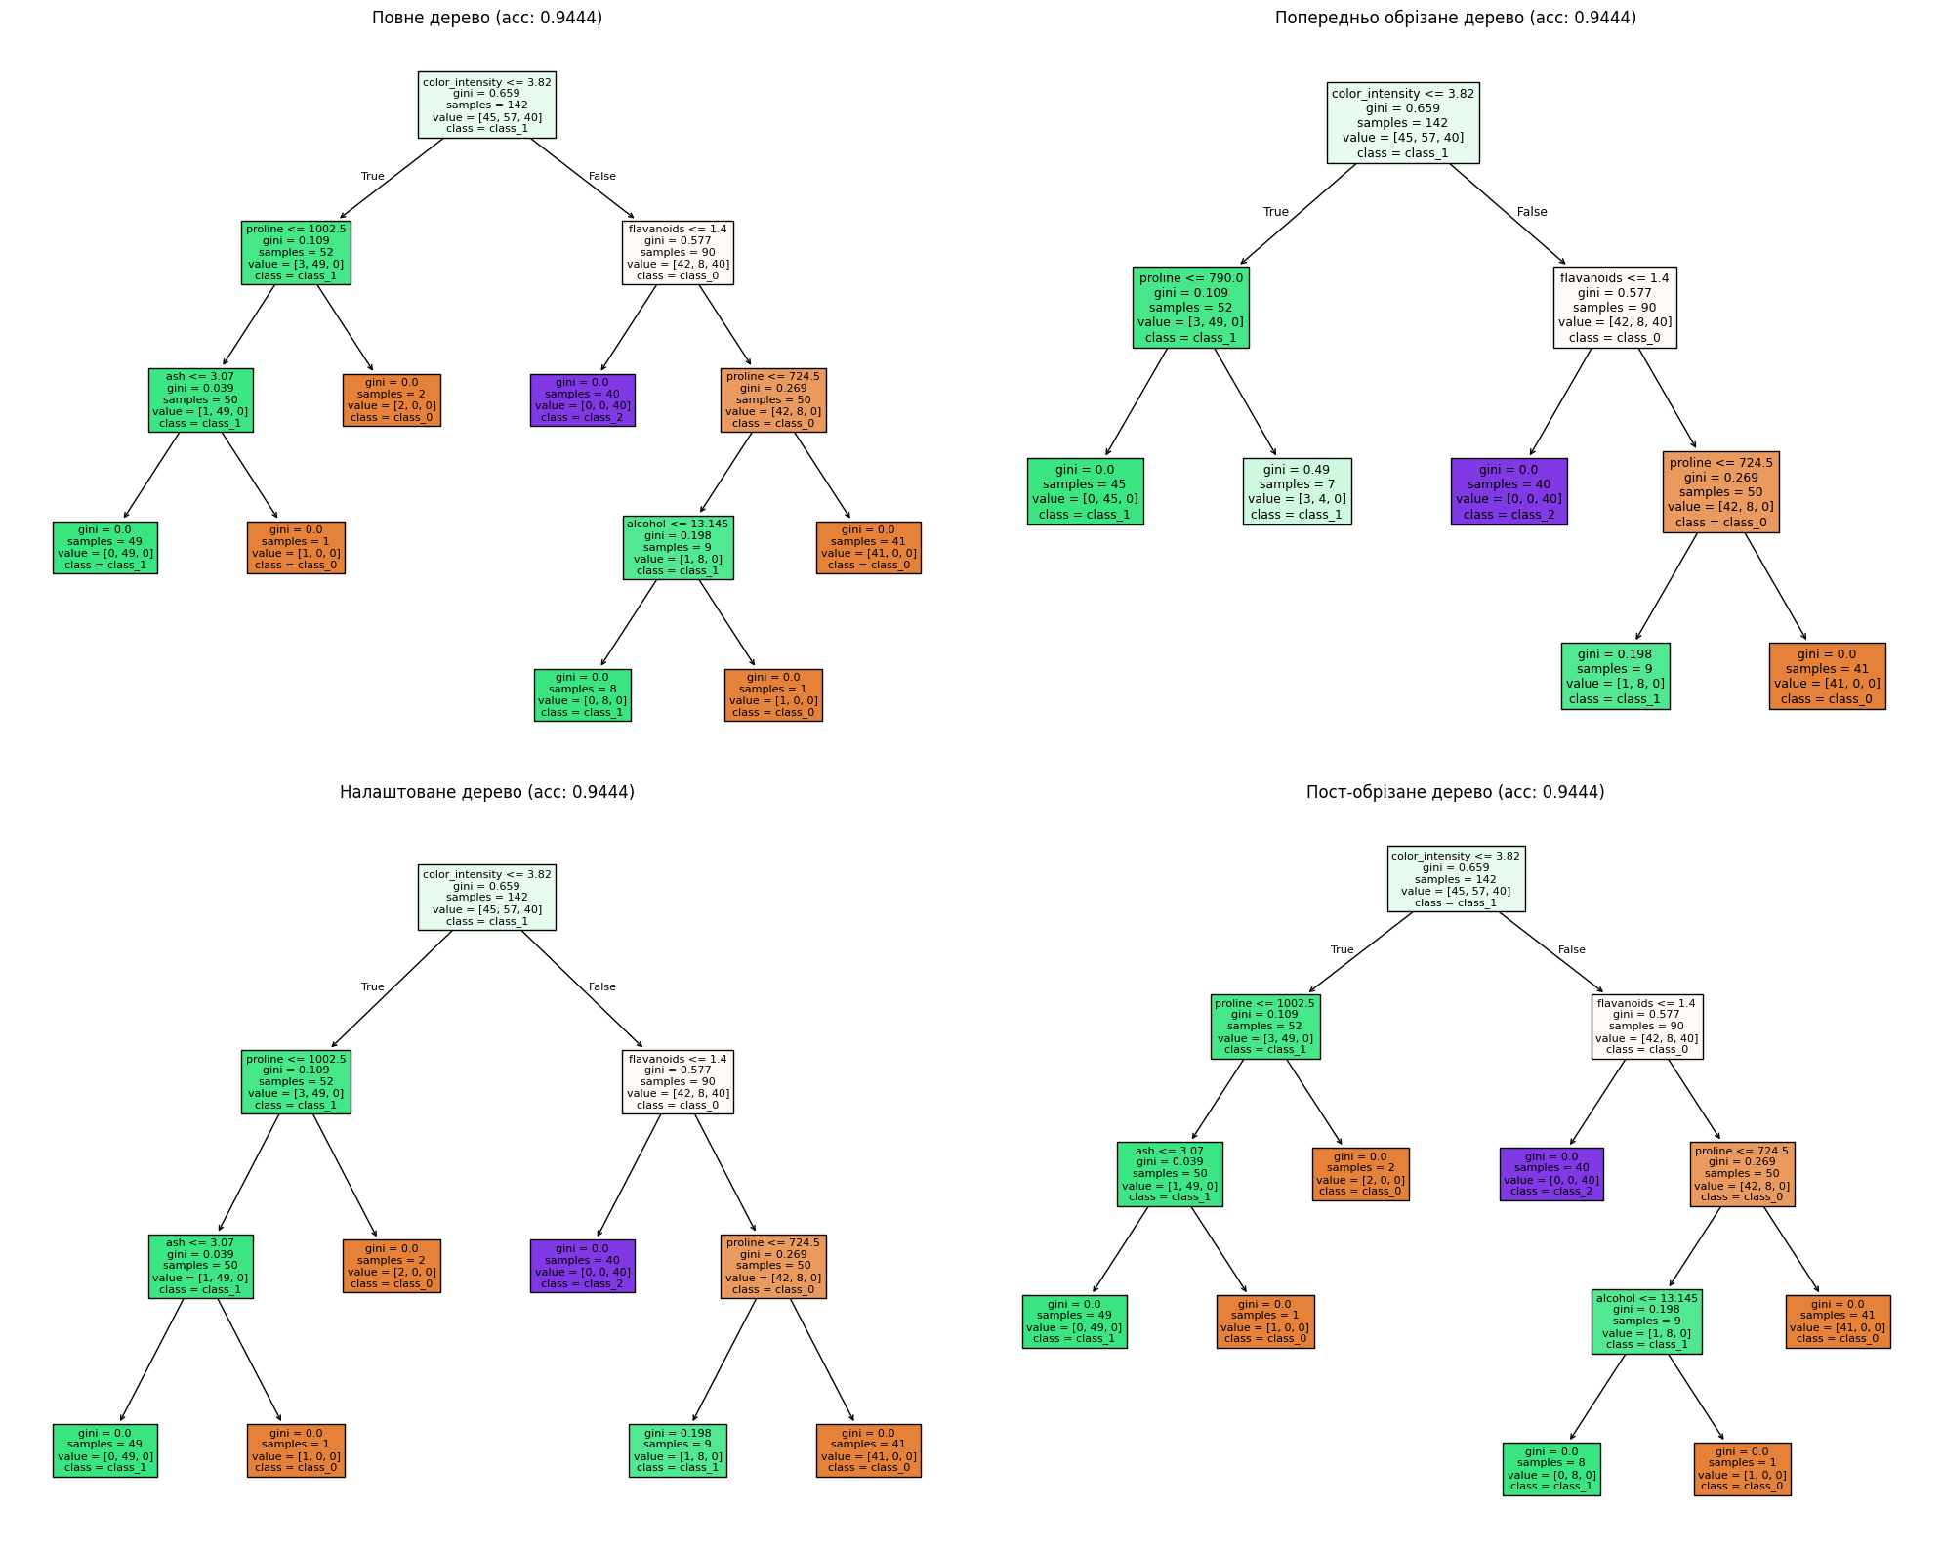

wine_tree = DecisionTreeClassifier(criterion='entropy')

wine_tree.fit(X_train, y_train)

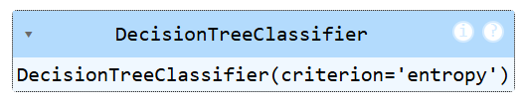

plt.figure(figsize=(10, 6))

plot_tree(wine_tree, feature_names=wine.feature_names, class_names=wine.target_names, filled=True, rounded=True)

plt.show()

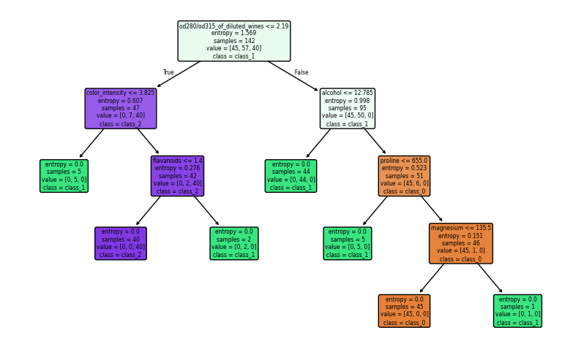

accuracy_iris_tree = accuracy_score(y_test, wine_tree.predict(X_test))

print('Decision tree accuracy',accuracy_iris_tree)

Decision tree accuracy 0.9166666666666666

**Висновок:** лабораторній роботі було вивчено алгоритмів побудови дерев класифікації.