FIFA WORLD CUP
MATCH PERFORMANCE ANALYSIS
2006 – 2026
End-to-End Cloud Analytics
Amazon S3| AWS IAM| AWS Glue |Amazon Athena SQL |Simba Athena | Power BI |Power Query |DAX |Cloud .

Prepared By: S.Abisha Lily Pushpam
Student ID : AF05251071
Course :DBA[Data And Bussiness Analysis]
Batch Code : ANP-D6641

1. Project Objective
This project develops an end-to-end cloud-based football analytics solution using FIFA World Cup match data from 2006 to 2026. The workflow demonstrates how match data is stored in Amazon S3, cataloged using AWS Glue, queried using Amazon Athena SQL, and connected to Power BI through Simba Amazon Athena ODBC for data preparation, KPI creation, and interactive visualization. The analysis focuses on tournament-level match performance, goals, scoring by half, tournament stages, result methods, team performance, opponent analysis, win performance, and comeback performance. The project demonstrates how cloud services, SQL, and business intelligence tools can be integrated to transform raw football match data into an interactive analytical solution.
2. AWS Management Console
Definition
The AWS Management Console is a web-based interface used to access and manage Amazon Web Services and its cloud resources.
Process
- The AWS Management Console was used as the main environment for accessing the cloud services required for the project.
- The project workflow involved Amazon S3, AWS IAM, AWS Glue and Amazon Athena.
- The available AWS account credentials were used to access the required services and configure the cloud-based data analytics workflow.
3. Amazon S3 – Store the Football Dataset
Definition
Amazon Simple Storage Service (Amazon S3) is a cloud object storage service used to store and retrieve files and data.
In this project, Amazon S3 was used as the source location for the FIFA World Cup football dataset.
Process
- Amazon S3 was opened from the AWS Management Console.
- The project source bucket was created or selected.
- The FIFA World Cup CSV dataset was uploaded to the S3 bucket.
- A single lightweight dataset was used for the project.
- The uploaded file was verified in the selected S3 location.
The S3 bucket acts as the starting point of the cloud analytics workflow.
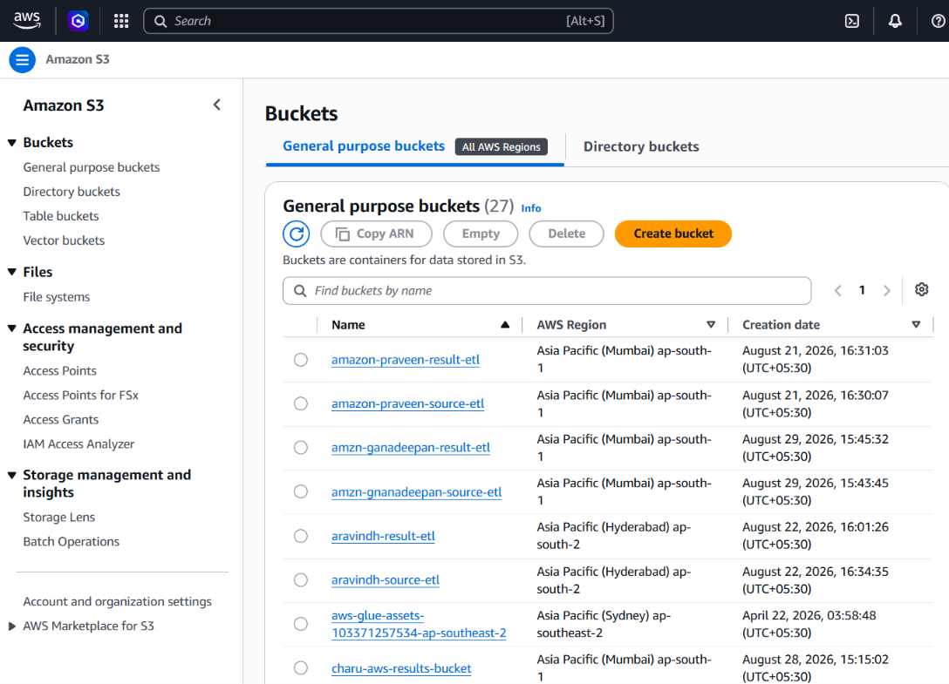
4. AWS IAM – Access and Permissions
Definition
AWS Identity and Access Management (IAM) is a service used to control access to AWS resources and define what actions users and services are allowed to perform.
Process
- The IAM configuration was used to provide the permissions required for the AWS Glue and data-access workfThe required IAM role was selected for thThe
- Glue crawler so that it could access the football dataset stored in Amazon S3 and create metadata in the Glue Data Catalog.
- IAM therefore provides the access-control layer between the AWS services used in the project.
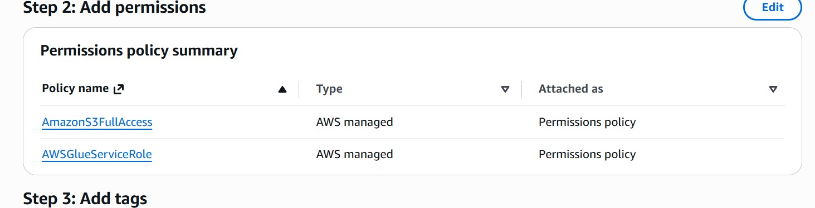
5. AWS Glue – Database, Crawler and Data Catalog
5.1 AWS Glue Database
Definition
AWS Glue is a serverless data integration service that provides capabilities for discovering, preparing and cataloging data.
A Glue database provides a logical container for tables and their metadata.
Process
- AWS Glue was opened from the AWS Management Console.
- Data Catalog was selected.
- A project database was created or selected.
- The database was used as the target for the football dataset metadata.
- 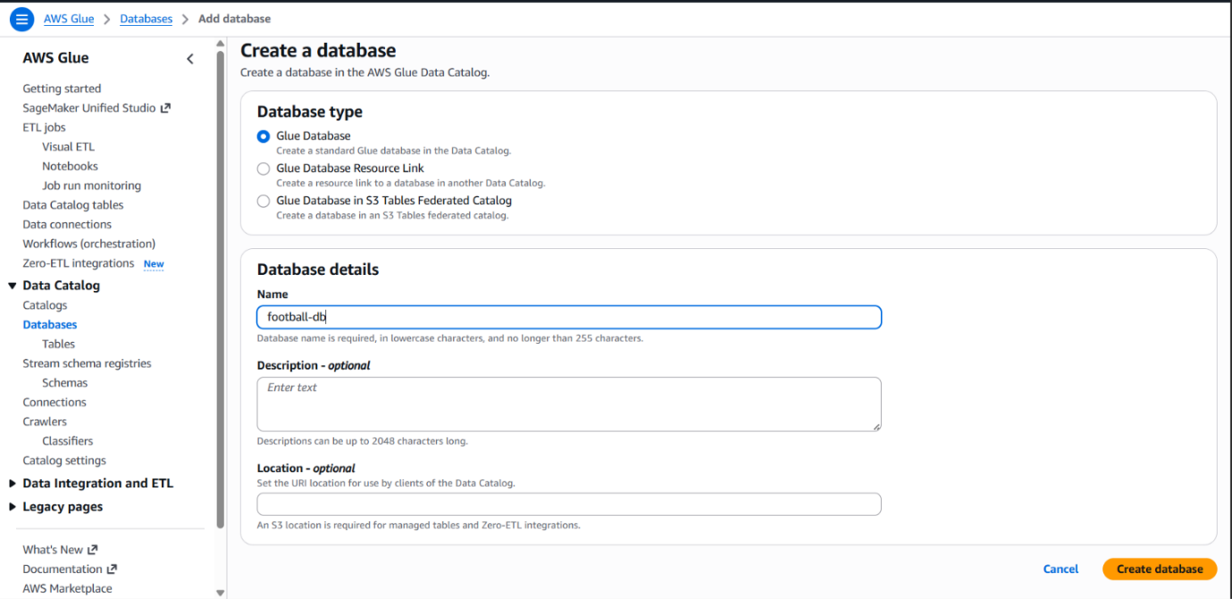
5.2 Glue Crawler
Definition
A Glue Crawler automatically scans a data source, identifies its structure and data types, and creates or updates metadata tables in the AWS Glue Data Catalog.
Process
- A crawler was created for the FIFA World Cup dataset.
- Amazon S3 was selected as the data source.
- The S3 location containing the football CSV file was provided.
- The required IAM role was selected.
- The project Glue database was selected as the target.
- The crawler was configured to run on demand.
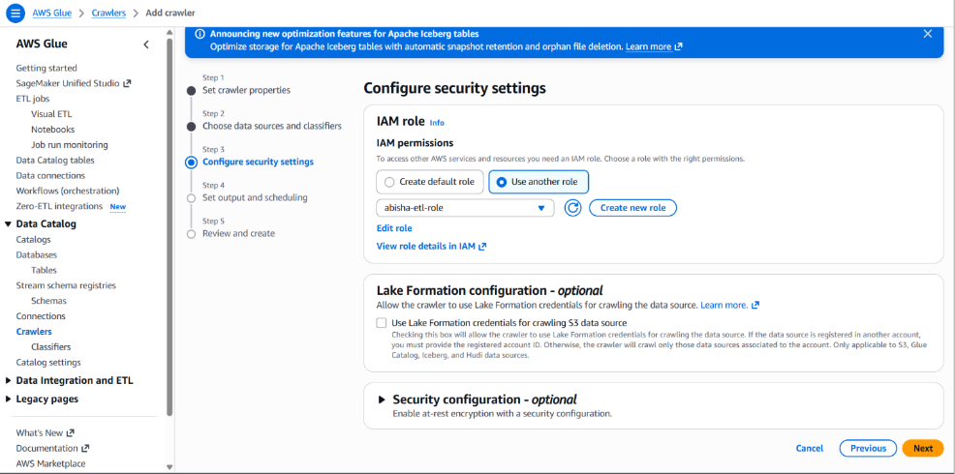
5.3 Run the Crawler and Verify the Table
The Glue Crawler was started manually and monitored until the run was completed successfully.
After completion, the Glue Data Catalog was checked to verify that the football table had been created.
The cataloged table provides the metadata required by Amazon Athena to understand the structure of the football dataset.
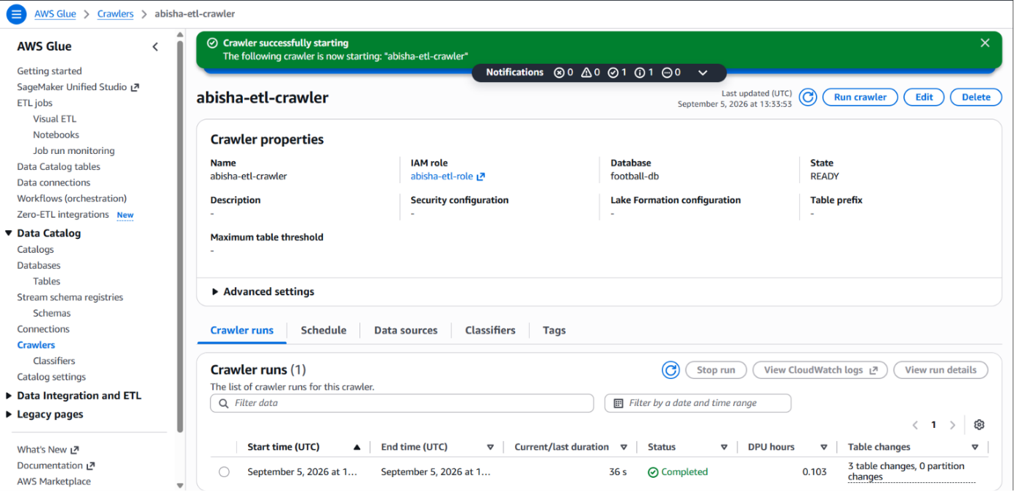
6. Amazon Athena – SQL Analysis
Definition
Amazon Athena is a serverless interactive query service that allows SQL queries to be executed directly against data stored in Amazon S3.
Athena uses metadata from the AWS Glue Data Catalog to understand the structure of the data.
Process
- Amazon Athena was opened.
- The project Glue database was selected.
- The football table was selected.
- The required Athena query-result location was configured.
- SQL queries were written and executed using the Athena Query Editor.
7. SQL Query
Query 1: Total Number of Matches
SELECT COUNT(*) AS total_matches
FROM football_data;
Query 2: Total Goals Scored
SELECT
SUM(fulltime_score_team1 + fulltime_score_team2) AS total_goals
FROM football_data;
Query 3: Average Goals Per Match
SELECT
AVG(fulltime_score_team1 + fulltime_score_team2) AS average_goals_per_match
FROM football_data;
Query 4: Number of Draw Matches
SELECT COUNT(*) AS draw_matches
FROM football_data
WHERE result_method = 'Draw';
Query 5: Matches by World Cup Year
SELECT world_cup_year, COUNT(*) AS total_matches
FROM football_data
GROUP BY world_cup_year
ORDER BY world_cup_year;
Query 6: Total Goals by World Cup Year
SELECT world_cup_year, SUM(fulltime_score_team1 + fulltime_score_team2) AS total_goals
FROM football_data
GROUP BY world_cup_year
ORDER BY world_cup_year;
Query 7: Average Goals by World Cup Year
SELECT world_cup_year, AVG(fulltime_score_team1 + fulltime_score_team2) AS average_goals
FROM football_data
GROUP BY world_cup_year
ORDER BY world_cup_year;
Query 8: Matches by Tournament Stage
SELECT stage,COUNT(*) AS total_matches
FROM football_data
GROUP BY stage
ORDER BY total_matches DESC;
Query 9: Goals by Tournament Stage
SELECT stage, SUM(fulltime_score_team1 + fulltime_score_team2) AS total_goals
FROM football_data
GROUP BY stage
ORDER BY total_goals DESC;
Query 10: Goals Scored in the First Half
SELECT SUM(halftime_score_team1 + halftime_score_team2) AS first_half_goals
FROM football_data
WHERE halftime_score_team1 IS NOT NULL
AND halftime_score_team2 IS NOT NULL;
Query 11: Goals Scored in the Second Half
SELECT SUM((fulltime_score_team1 + fulltime_score_team2)- (halftime_score_team1 + halftime_score_team2))AS second_half_goals
FROM football_data
WHERE halftime_score_team1 IS NOT NULL
AND halftime_score_team2 IS NOT NULL;
Query 12: Result Method Breakdown
SELECT result_method,COUNT(*) AS match_count
FROM football_data
WHERE result_method IN ('Normal Time', 'Extra Time', 'Penalties')
GROUP BY result_method
ORDER BY match_count DESC;
Query 13: Matches Played by Each Team
SELECT
team,
COUNT(*) AS matches_played
FROM (SELECT team1 AS team
FROM football_data

UNION ALL
SELECT team2 AS team
FROM football_data) AS teams
GROUP BY team
ORDER BY matches_played DESC;
Query 14: Goals Scored by Each Team
SELECT team, SUM(goals_scored) AS total_goals
FROM (
SELECT team1 AS team,fulltime_score_team1 AS goals_scored
FROM football_data
UNION ALL
SELECT team2 AS team, fulltime_score_team2 AS goals_scored
FROM football_data) AS team_goals
GROUP BY team
ORDER BY total_goals DESC;
Query 15: Team vs Opponent Match Analysis
SELECT team1, team2,COUNT(*) AS matches_played, SUM(fulltime_score_team1) AS team1_goals,
SUM(fulltime_score_team2) AS team2_goals
FROM football_data
GROUP BY team1, team2
ORDER BY matches_played DESC;
Query 16: Highest-Scoring Matches
SELECT world_cup_year,team1,team2, fulltime_score_team1, fulltime_score_team2(fulltime_score_team1 + fulltime_score_team2) AS total_goals
FROM football_data
ORDER BY total_goals DESC
LIMIT 10;
Query 17: Matches Decided by Extra Time
SELECT world_cup_year, team1,team2,fulltime_score_team1,fulltime_score_team2,result_method
FROM football_data
WHERE result_method = 'Extra Time'
ORDER BY world_cup_year;
Query 18: Matches Decided by Penalties
SELECT world_cup_year,team1, team2,fulltime_score_team1, fulltime_score_team2, penalty_score_team1, penalty_score_team2, result_method
FROM football_data
WHERE result_method = 'Penalties'
ORDER BY world_cup_year;
8. Simba Amazon Athena ODBC – Power BI Connectivity
Process
- The Simba Amazon Athena ODBC driver was installed or configured on Windows.
- An Athena Data Source Name (DSN) was configured.
- The required AWS and Athena connection settings were provided.
- The DSN was used to establish connectivity between Athena and Power BI.
9. Power BI – Data Connection and Preparation
Process
- Power BI Desktop was opened.
- Get Data → ODBC was selected.
- The configured Simba Athena DSN was selected.
- The required authentication and connection settings were provided.
- The football table was selected.
- The data was loaded into Power BI.
10. Dashboard 1 – FIFA World Cup Match Performance Analysis
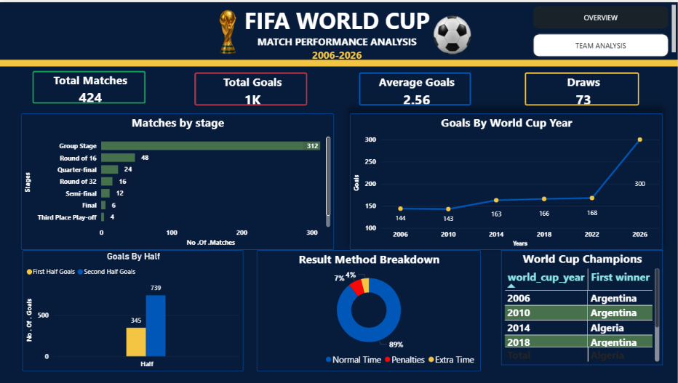

14. Dashboard 2 – Team and Match Analysis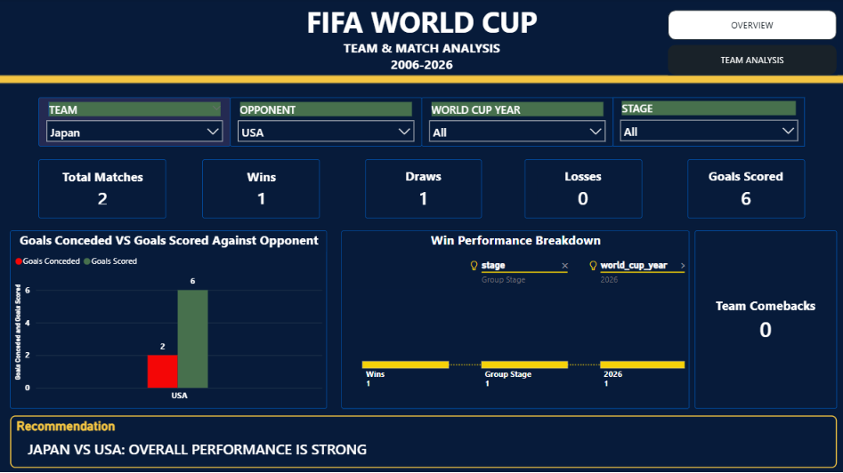
Conclusion
The FIFA World Cup Match Performance Analysis project demonstrates an end-to-end cloud analytics workflow.
The process begins with storing the football dataset in Amazon S3, followed by schema discovery and cataloging through AWS Glue. Amazon Athena is then used to perform SQL-based analysis. The cloud data is connected to Power BI using Simba Amazon Athena ODBC, prepared using Power Query, and analyzed using DAX.
The two Power BI dashboards provide both tournament-level and team-level analysis. Together, they demonstrate how AWS, SQL and Power BI can be integrated to create an interactive football analytics solution.
AWS + SQL + Power BI → Interactive Football Analytics

