Report on task 4

**Name: Abilkaiyr Abish**

**Group: IT-2001**

**E-mail:** [**201595@astanait.edu.kz**](mailto:201595@astanait.edu.kz)

**Main part:**

# Step 1: choose a problem to parallelize with task parallelism

* For a collection of (big) numbers, for each number find how many prime numbers are there less then the number, then sum the results (task - number, integer)

# Step 2: install necessary tools

# Step 3: implement distributed task processing with MPI or with Java RMI

Then run the MPI program with:

mpiexec -np *N* ./app <args>

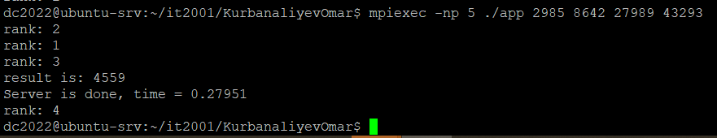

# Step 4: test performance of your distributed task processing

Try launching your application with a different number of workers. Observe changes in execution time, i.e. how long it takes to execute all tasks. You can measure execution time on the server, as a duration in real time from receiving of the first task request to receiving of the last task result.

Choose such parameters that execution of a single task takes some time, i.e. 100 msec - several seconds.

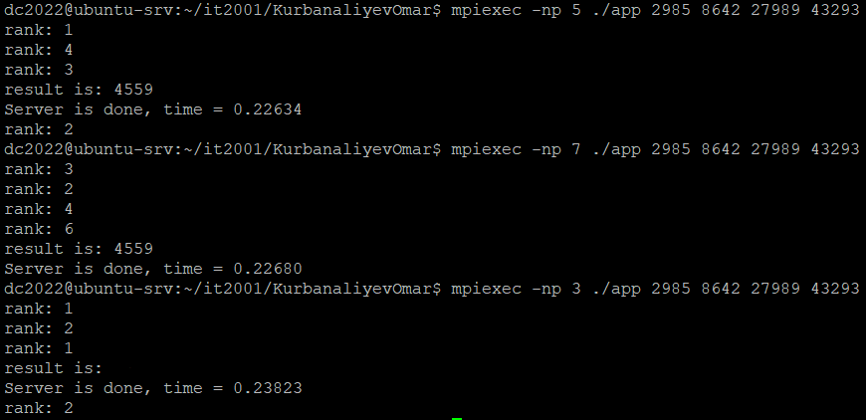

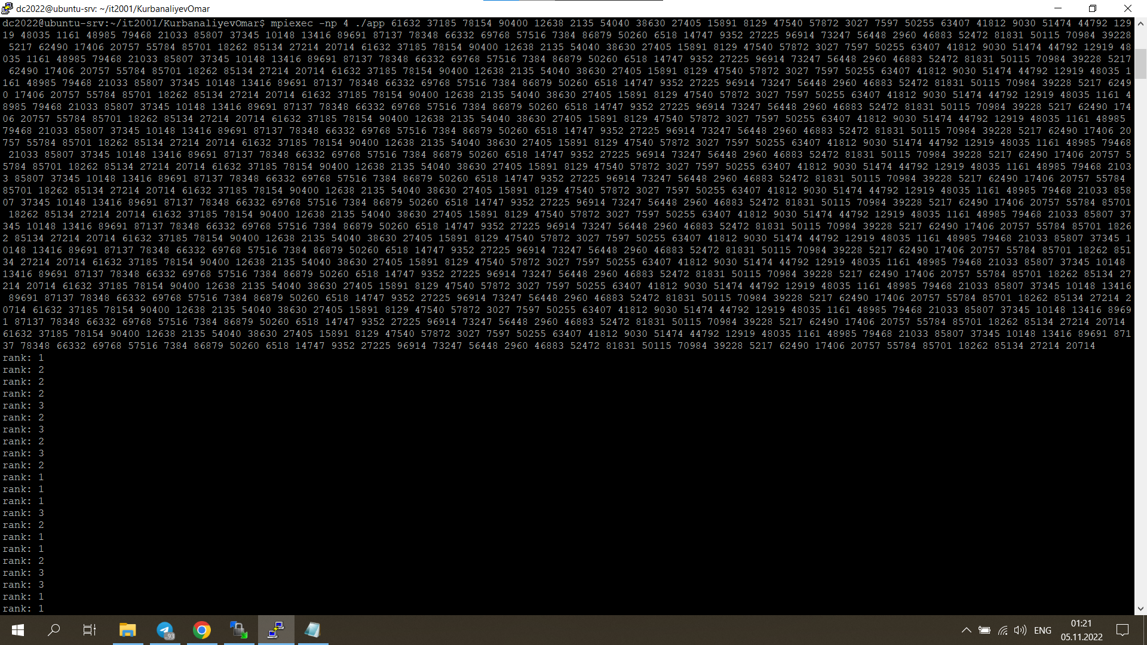

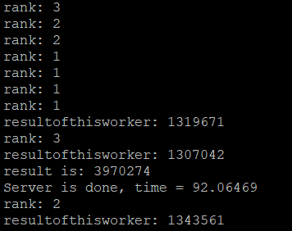

# Step 5: upload your project/source files for Task 4 to the Github repository, include a link to the repository in the report

<https://github.com/Abilkaiyr07/Ass4.git>

# Step 6: conclusion in a free form

I started by implementing the task's example and distributing it among several workers.