Sales Analysis Report

**Abstract:**

The sales analysis report provides valuable insights into the performance of the sales team, revenue generation, and deal stages. By analyzing various metrics, we can identify opportunities for improvement and strategies to optimize sales effectiveness.

**Methodology:**

1. Data Collection and Initial Analysis using Microsoft Excel and Microsoft SQL Server

* A comprehensive dataset of CRM Sales analysis was provided for this challenge, including details on accounts, sales teams, sales pipeline, data directory and product.
* Exploratory data analysis (EDA) was conducted using excel. This included sorting, populating (using VLOOKUP function). Then moved to advanced analysis using SQL queries for statistical analysis to identify trends.

1. Visualization using Microsoft Power bi

* The cleaned dataset was imported into power bi
* Using DAX calculated columns, groupings were created
* Created visualizations with charts and graphs to further illustrate my key insights

**Insights:**

* **Total Revenue Generated**: The total revenue generated is $10,005,534, indicating the overall sales performance.
* **Sales by Sales Agent**: Darcel Schlecht leads in total sales with $1,153,214, showcasing exceptional performance.

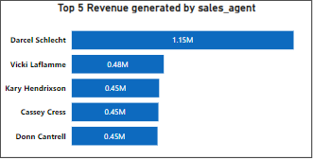

* **Average Time to Close a Deal**: The average time to close a deal by sales agent is 47.99 days, indicating the efficiency of the sales process.
* **Managerial Effectiveness**: Melvin Marxen demonstrates managerial effectiveness with the highest revenue generated as a manager, totaling $2,251,930.

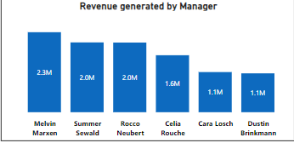

* **Regional Office Performance:** The regional offices contribute to revenue generation as follows: West (35.67%), Central (34.44%), and East (30.89%).
* **Deal Stage Distribution**: Darcel leads in the number of won deals (349) and total deals (747), reflecting strong sales performance.

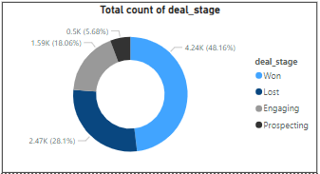

* **Sales Team Composition**: The sales team consists of 30 agents, with 10 agents per regional office, ensuring balanced representation.
* **Product Revenue Distribution:** The GTXPro product generates the highest revenue, with $3,510,578, indicating its popularity and market demand.
* **Deal Stage Distribution**: Deal stages are distributed as follows: won deals (48.16%), lost deals (28.1%), engaging deals (18.06%), and prospecting deals (5.68%).
* **Product Performance Insights**: GTK 500 (most expensive, low revenue. Despite its high price, low purchase suggests it may be overpriced relative to market demand).

GTX Pro (Moderate price, moderate purchases. This shows strong demand and revenue potential, indicating good pricing and market positioning)

MG Special (Cheap price, lowest revenue. This suggests the need to reassess pricing and marketing strategies).

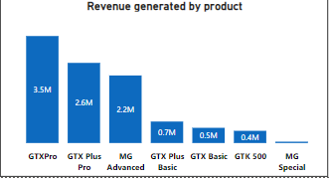

* **Top Revenue Generating Company:** Kan code emerges as the company with the highest revenue generated, totaling $341,455.

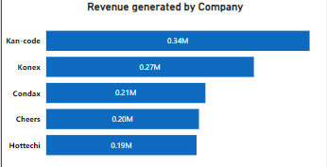

**Recommendations:**

* **Sales Performance Optimization:** Identify and replicate successful sales strategies employed by Darcel Schlecht to improve overall sales performance.
* **Sales Process Streamlining**: Streamline the sales process to reduce the average time to close a deal further, increasing efficiency and revenue.
* **Managerial Support**: Provide support and resources to managers to maintain high revenue generation levels and enhance managerial effectiveness across the sales team.
* **Regional Office Focus**: Allocate resources and efforts based on regional office performance to maximize revenue generation potential.
* **Product Strategy Refinement**: Refine product strategies based on revenue and demand insights, optimizing pricing and marketing approaches for each product.
* **Deal Stage Management:** Focus on moving engaging and prospecting deals through the pipeline to increase the number of won deals and overall revenue.

**Conclusion:**

The sales analysis report provides valuable insights into the performance of the sales team, revenue generation, and deal stages. By leveraging these insights and implementing the recommended strategies, the company can enhance sales effectiveness, optimize revenue generation, and achieve sustainable growth.

**Accounts Analysis Report**

**Abstract:**

The accounts analysis report offers valuable insights into the performance of companies across various sectors and regions. By examining revenue generation, historical trends, and geographic distribution, we can identify opportunities for growth and strategic optimization.

**Insights:**

* **Company and Sector Overview:** There are 85 companies categorized into 10 sectors, providing a diverse landscape for analysis and strategic planning.
* **Sector Revenue Analysis:** Software emerges as the top revenue-generating sector, with $30,950, while Services generated the least revenue at $4,944.

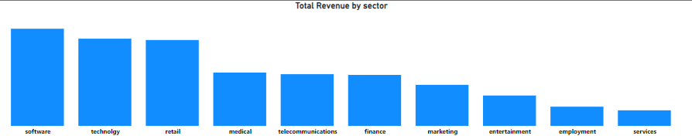

* **Revenue Trends by Year:** The year 1982 generated the highest revenue of $17,108, while 2017 recorded the lowest revenue at $4.54.

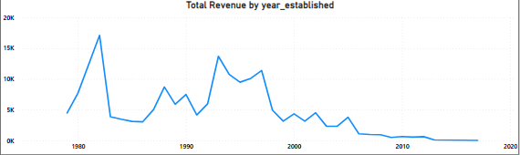

* **Revenue Trends by Decade:** Companies founded in the 1900s collectively generated revenue of $144,598, while those founded in the 2000s generated $25,945.

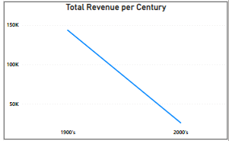

* **Revenue Distribution by Country**: The United States leads in revenue generation with $142,997.85 and the highest number of employees, while China lags behind with the lowest revenue of $40.79 and the lowest number of employees.

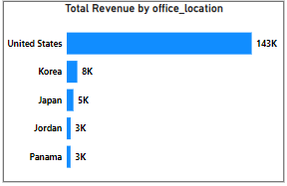

* **Office Location Performance:** With 15 office locations, the total revenue generated amounts to $169.54k, reflecting the importance of geographic presence in revenue generation.

**Recommendations:**

* **Sector-Specific Strategies**: Develop targeted strategies to capitalize on the revenue potential of high-performing sectors such as Software, while exploring growth opportunities in underperforming sectors like Services.
* **Historical Revenue Analysis**: Investigate factors contributing to the revenue disparities between different years, identifying potential market shifts or business model changes that may impact revenue generation.
* **Geographic Expansion:** Consider expanding operations or increasing market penetration in regions with high revenue potential, leveraging the success of the United States market while exploring growth opportunities in emerging markets like China.
* **Decade-Based Revenue Optimization:** Tailor marketing and product development efforts to meet the unique needs and preferences of companies founded in different decades, maximizing revenue potential across all age groups.
* **Office Location Strategy**: Evaluate the performance of each office location and consider reallocating resources or adjusting strategies to optimize revenue generation and operational efficiency.

**Conclusion:**

The accounts analysis report provides valuable insights into revenue generation, sector performance, and geographic distribution. By leveraging these insights and implementing the recommended strategies, the company can enhance revenue generation, optimize market positioning, and achieve sustainable growth across diverse sectors and regions.